Shaking Table (Shaker Table)

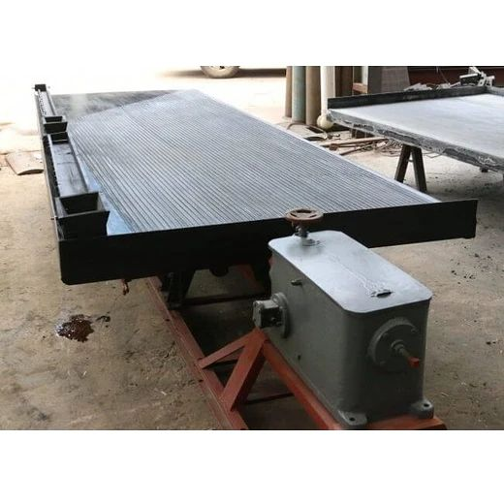
Shaker table (shaking table) has excellent separation accuracy, and stable separation index, it is widely used in the separation of gold ore, tungsten ore, tin ore, tantalum and niobium ore, manganese ore, chrome ore, titanium ore, ilmenite ore, bismuth ore, lead ore and so on. When process tungsten ore, tin ore, gold ore or other high- density ores, the particle size range of effective recovery is 3- 0.022mm, the enrichment ratio of low grade ore could reach about 300 times.

6S shaking table is a gravity separation equipment for fine particle minerals, its separation accuracy is usually higher than other gravity equipment, it can be used for roughing, cleaning, scavenging and other different applications. After long years of improvement and development, the table has developed a variety of grooves with different numbers and shapes, it can be respectively used for the the separation of coarse sand (3-0.5mm), fine sand (0.5-0.074mm), slime ore (-0.074mm) and the needs of other different grain size.

It can be used as a cleaning equipment in combination with our spiral chute, which can achieve the best working efficiency and mineral separation effect, and achieve greater mineral processing capacity at small occupation area.
Shaking table diagram
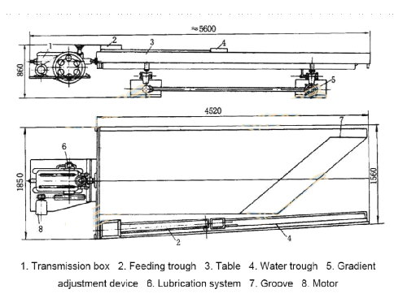

Advantages and features
- Low equipment price and quick revenue
- High concentrate grade, high recovery, stable separation index
- Easy installation and operation, stable running
- Lateral slope adjustment range (0 °-10 °), easy stroke adjustment, the table can keep the smooth operation in adjustment
- Fiberglass table, high stiffness and strength, no deformation, no crack, no rust, corrosion resistance, wear resistance, strong weatherability
- 9 different tables are available to meet the requirements of different feeding granularity
- Easy maintenance and long service life

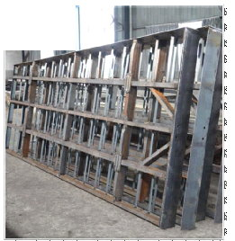 | 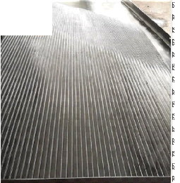
All Steel Framework  Dense spacing, high strength, to ensure that the table does not sag and deformable | Fiberglass Table  High stiffness and strength, no deformation, no crack, no rust, corrosion resistance, wear resistance, strong weatherability
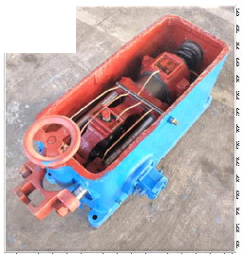 | 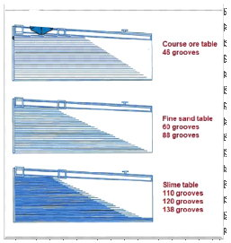
High Quality Gear Box  Smooth running, low noise, long service life | 9 Different Tables are Available  Can be applied to materials of various sizes

Main Technical Parameters
Model |  | 6S 4500 |  |  | 6S 3000 | 6S 2100 | 6S 1100
Table type |  | Coarse ore table | Fine sand table | Slime ore table | Three different kinds of tables are available
Beneficiation area (m2) |  | 7.6 | 7.6 | 7.6 | 4.08 | 1.95 | 0.5
Deck Size | Length  (mm) | 4500 | 4500 | 4500 | 3000 | 2100 | 1100
 | Transmission end width  (mm) | 1850 | 1850 | 1850 | 1320 | 1050 | 500
 | Concentrate end width  (mm) | 1550 | 1550 | 1550 | 1100 | 850 | 430
Feeding size (mm) |  | <3 | <0.5 | <0.074 | Sand <2 Slime  <0.1 | Sand <2 Slime  <0.074 | Sand <2 Slime  <0.074
Capacity (t/h) |  | 1-1.2 | 0.5-1 | 0.3-0.5 | 0.4-1.5 | 0.3-0.8 | 0.05-0.2
Feeding density (%) |  | 20-30 | 18-25 | 15-20 | 10-30
Stroke (mm) |  | 16-22 | 11-16 | 8-16 | 6-30 | 12-28 | 9-17
Frequency of stroke (r/min) |  | 220 | 250 | 280 | 210-320 | 250-450 | 280-460
Water consumption (t/h) |  | 0.7-1 | 0.4-0.7 | 0.4-0.7 | 0.3-1.5 | 0.2-1 | 0.1-0.5
Groove shape on table |  | Rectangular | Saw-tooth | Triangle | Available Rectangular, Saw-tooth,  Triangle
Power (Kw) |  | 1.1 | 1.1 | 1.1 | 1.1 | 1.1 | 0.55

Application

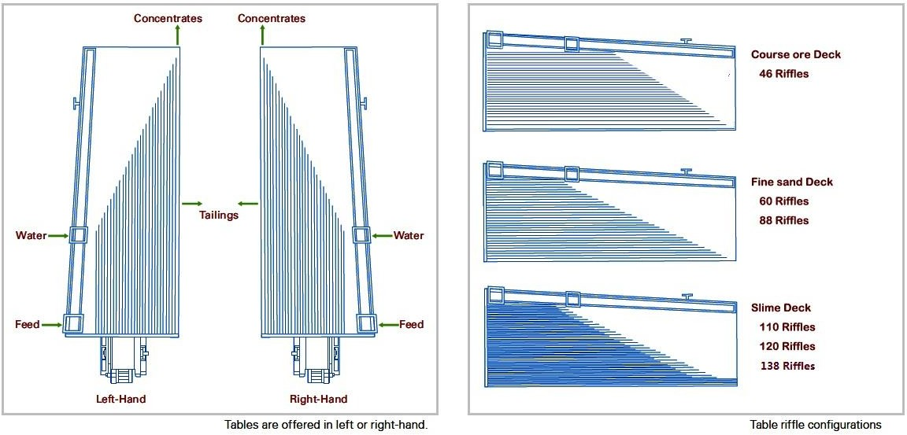
Table and Steel Support Types
Tables are offered in left or right-hand
Table groove configuration

Support Types
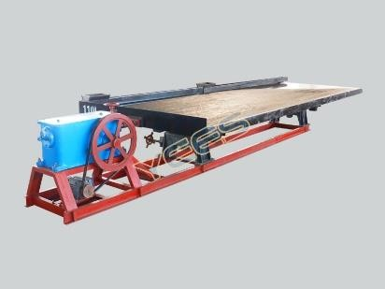  10# channel steel support | The support is made up of 10# channel steel, this type has the same effect as the ordinary support. It has the following characteristic: it does not need the cement to bury the foot bolt in advance, installs and uses quickly, is easy to disassemble, may move, and the cost is relatively inexpensive.
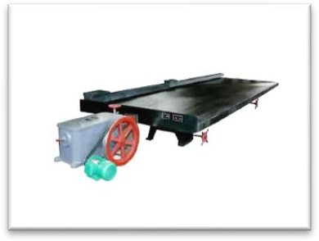  Traditionary type | The type needs the cement to bury the foot bolt in advance, it's not easy to move in the future, but relatively is more cost savings for enterprises.
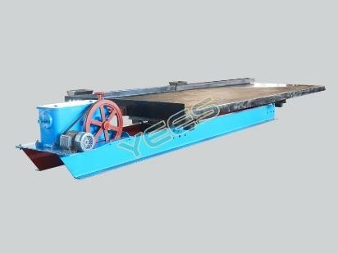  28# Channel Steel Support | The support is made up of 28# channel steel, this type has the same effect as the ordinary support. It has the following characteristic: it does not need the cement to bury the foot bolt in advance, installs and uses quickly, is easy to disassemble, and may move. Is suitable specially for in the surface uneven, not the solid sand and the empty superficial work.

