P42 Electric Wheel Chair Instruction Manual



Introduction
Dear users:

Thank you for the purchase of the Electric wheelchair!

Before you using the electric wheelchair, be sure to read the manual. If you can not fully understand the content, or need some help, please contact us. This manual recorded the part of scooter operation, equipment description, and the event handling of the incident.
This use of manual signs, such as the following explanation: The illustrations in the mark "★"show that prohibitory moves and acts.
Warnings, Attention and Suggestions, please read it in detail.
★ This manual includes: inspection and maintenance record card, as well as the guarantee, please place them in your wheelchair.
★ If you transfer the wheelchair to other people, please give the user manual together.
★ With the design changes, all of information and pictures in the manual are subject to final product, it will without notice, please the users to understand and support
Finally, we believe that the electric wheelchair give you is not only the maintenance of permanent service, more importantly, more convenient and exciting to your life.

Key Hints on P42 Electric Wheelchair

P42 electric wheelchair adopt PC controller, so it’s easy to driv and it can be used indoor and out door .Its indoor operation is flexible and can driving in confined area, also can make driver get closer to work-desk and counter, its performance is nimblest and it can move smoothly on rough ground outdoor for a longer distance.

Catalogue

Chapter one General cautions
Key Hints on Electromagnetic Interference
Chapter Two Instruction of P42 Electric Wheel Chair
- Installation and adjustment of controller
- Battery recharging
- Control system
- Switch
- Speed control
- Battery Power Display
- Alarm (Horn)
- Control rod operation
- Moving forward and backward
- Turn left and turn right
- Brake
- Adjustments
- Adjustment of the height of seat
- Adjustment of the angle of armrests
- Adjustment of the angle of seat back.
Chapter Three Usage of P42 Electric Wheel Chair
- Keep the seat forward
- Manual drive mode.
- Disassemble and reassemble
- Transportation of electric wheelchair
Chapter Four Maintenance of Electric Wheel Chair
- Battery
- Wire connecting of batteries
- Pressure of tires
- Taking down of rear wheel
- Taking down the front wheel
- Wear of tires
- Connecting the electrical components
- Checking the hardware parts
- Waxing and antiquing
- Storage
- Troubleshooting of controller
Chapter Five Specifications and Parameters of P42
Chapter Six Content of warranty
Chapter Seven Usage of charger

Chapter One General cautions

Before using the electric wheelchair, read and understand the following precautions and all items of this manual carefully.
Warning: Operating without following the instructions will cause the damage of the electric scooter or personal injury.

Please read them carefully
- Don’t use it out of the parameter range stipulated. Don’t modify it in any way.
- Don’t drive it when you have bad eyesight influenced by your health (you’re dizzy because of medicine treating), or when you suffer from mental shock.
- Don’t drive it after you have any alcoholic drinks.
- Don’t shift the change-over switch before the scooter stops steadily on smooth ground.
- Don’t drive it across a barrier higher than 40mm or an iron chain.
- Don’t stop while down a slope. If stop is necessary, lean forward when you restart to change the center of gravity to avoid turning backward.
- Don’t slant on the slope, because it will cause instability.
- Don’t drive it across a slope or try to twirl on a slope.
- Don’t move it backward on a slope.
- Don’t shut off the power when it moves.
- Remember that only one person is permitted on it. Don’t use it to drag or carry things exceeding the maximum loading capacity.
- Drive it in a straight line when up or down a slope.
- Shut off the power when it is not in use. This not only extends the service life of batteries, but also avoids accidents.
- Three-wire grounding socket must be adopted to avoid electric shock.
- Slow down the speed while turning.
- Put your arms and legs in the limited range of the wheelchair.
- Take care extremely when climbing a slope or a small hill, or moving on a road.
- Please note the electric wheelchair will slide for some time before it stops completely, if it takes places on a slope or a wet and slippery ground.
- Please note that humidity of air may affect the control system and other parts, when weather is bad or pass the waterway.
- Maintain the pressure indicated on the sidewall of the tire to ensure its function of going.
- The driver must be in the fixed and forward seat when driving.
- Don’t get it in touch with water directly. Don’t drive or stop it near the water pipe.
- Don’t put it in the rain or use it in steam room.
- Don’t charge the battery when it’s under the frozen state.

Key Hints on Electromagnetic Interference

Warning: It’s pretty important to know well about the electromagnetic interference effect maybe received by your wheelchair.
Electromagnetic interference comes from the external electromagnetic wave energy such as radio and TV launching stand, CB radio wave, the opening device of garage door, Radiotelephone and so on. Electromagnetic interference may affect the control system of the wheel chair. Under it, the brake doesn’t work, or the wheel chair goes automatically, or the direction is out of control. It may also cause permanent damage to the control system.
The electromagnetic energy can be divided into three types below:
·Handheld short wave radio transceivers.These radio transceivers have an antenna; e.g. radio wave of the urban wave band, interphone, transceivers for the security department, the fire control department and the police department, network system of the cell-phone and signal transmission device (Electromagnetic interference happens even when there is no signal transmission).
·Mobile radio transceivers of the medium-sized wave band which usually have antennas fixed on buildings or on the top of vehicles; e.g. radio transceivers of the police, the fire control department, the tax bureau, the medical ambulance, etc.
·Radio transceivers of the big wave band which usually have antennas fixed on a transmitter; e.g. transmitting systems of commercial radio televisions and amateur radio operators.
Other types of handheld devices such as cell phone, personal computer, AM/FM radio and other small supplies (e.g. hair drier and electric shaver) also can produce electromagnetic energy, but as we know, the energy is so small that it won’t cause any problems of electromagnetic interference.
The intensity of the electromagnetic interference can be measured by volt per meter. Impedance of the wheelchair against the intensity of the electromagnetic interference is called as immunity competence generally. The general industrial standard is 20 volt per meter. It is the safe immunity competence against radio wave source.
Your electric wheel chair meets the immunity competence of the electromagnetic interference (20 volt/meter).
Warning: even if the wheelchair has the immunity competence of 20 volt per meter, certain preventive actions must be taken to ensure the wheelchair free from the effect of external electromagnetic interference.
- When the power of the wheelchair is on, don’t use the handheld radio transceivers such as CB radio or put through the communication device such as cell phone.
- Keep off radio transmitting system such as radio, television station and so on.
- If the direction is out of control, shut off the power as fast as you can and keep it off till it’s safe.
- If you use radio, cell phone or other devices with power, your wheelchair is easier to receive the external electromagnetic interference.
- If the direction is out of control or the brake doesn’t work, please inform our after- sales department or our agents.

Chapter Two P42 Electric Wheel Chair

Welcome to the world of freedom and independence, after your buying the P42 wheels electric wheelchair and getting out it from the packing case, it is necessary for you to check whether or not there is any damage on its surface. As the diagram 1 shows, your electric wheel chair consists of the following main parts. Should you have any question, please don’t hesitate to contact with our dealer or us.


PG Controller

Charger

Armrest

Portable battery pack

1. Installation and adjustment of controller
Don’t damage any part of its surface when taking out of the packing case and make sure your wheel chair consists of frame with motor parts, seat, cover armrest and two batteries.
Before the electric scooter leaves the factory the controller is fixed on the frame.
Controller installation including install controller and its fixed chip,the chip fixed under the pipe of armrest.
Installation step are as follows:
1):Install the controller on the armrest(left or right) according to user's habit.
2):Uplift the armrest which will install the controller,take out the screw and the gasket.
3):Fix the controller on the pipe of armrest,locked the controller by screw and gasket.is on the armrest
4):Set the cable along with the fix pipe and tighten it .
5):Insert controllers'cable plug into the interface of another port of the controller under the seat at the right side.
facing up. (As shown in diagram above):
- Battery recharging:
Two battery packs can be removed from wheel chair easily before you charging:
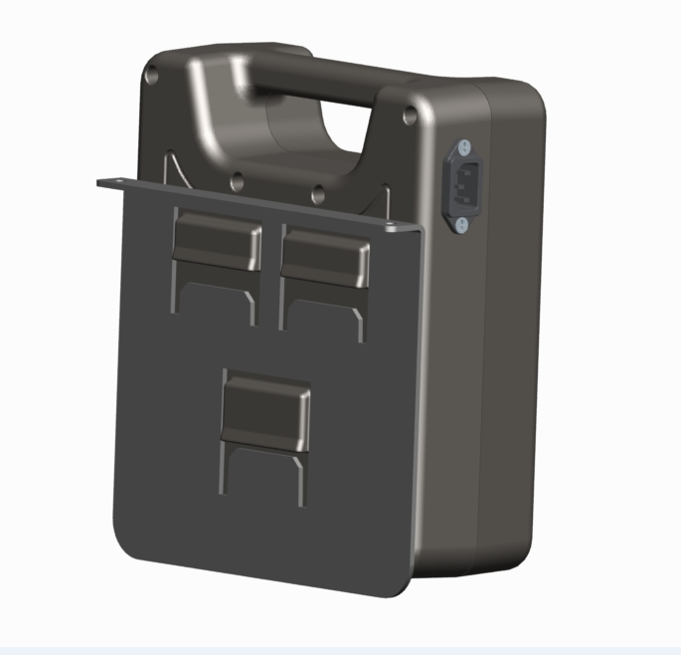
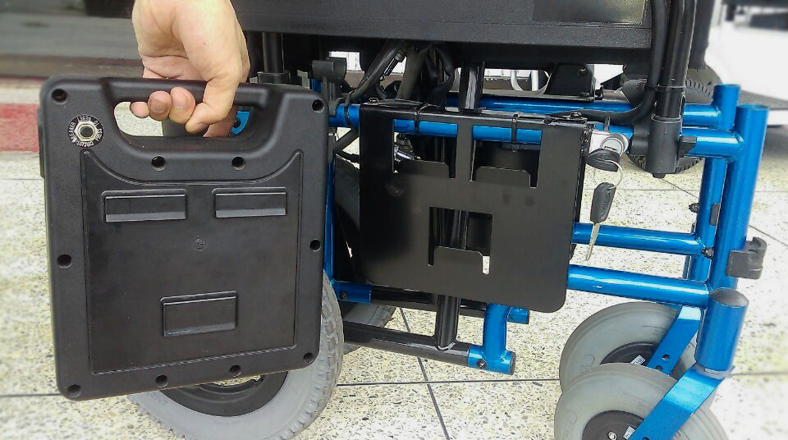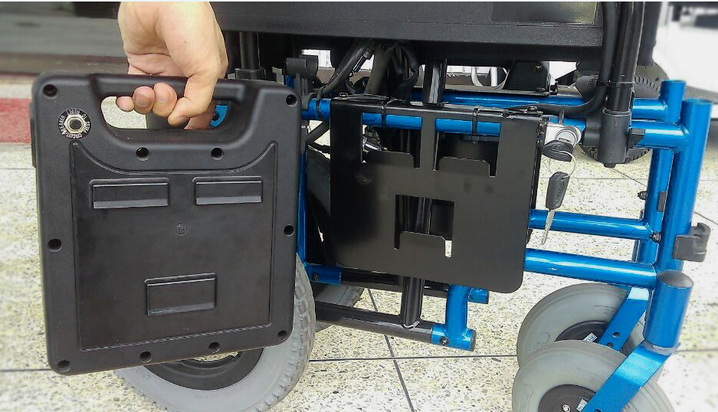

We recommend you to recharge the battery as the following way:
If the five indicators on controller light up (three green lights, a yellow one, a red one) that means the battery is fully charged. If the yellow and red light up, that means the battery needs to recharge. And it is extremely urgent to recharge if there is only the red lights.
No matter how much the battery power is, it should be recharged properly after daily use. If there is a completely self-discharge, perhaps it will reduce the expectation life of the battery.
The recharge should be done according to the following steps:
1) Park your electric wheelchair near the grounded socket.
2) After connecting plug and charging port of the rocker which is on the armrest; then put the plug into the grounded socket.

Warning: Electric shock will occur if you use the ungrounded socket.

3) While connecting power line, and the LED of the charger shows red that means the battery is recharging, and then recharging will be finished as the LED turns to green. At this moment, turn on the power of controller; all the power indicator lights will be flashed on.
Notice: If you drive your electric scooter with a battery that is only partial recharged, the duration will not reach the stated time, and the capability of battery will be reduced and the service life will be shortened.
Notice: 1. It can’t be use during the recharging.
2. Be sure to store the charger temporarily after recharging.
3. Control system:
The controller consists of control rocker, horn button , speed control button, battery power indication LED, power button, charging port, the situation of buttons are shown in the diagram below.
Power button
Speed controller

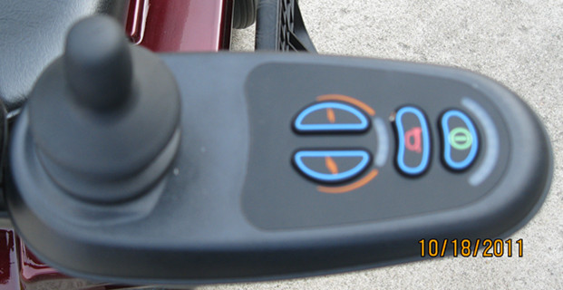

Rocker

Horn button
Battery power indicator

1): Power button：
Power button is beside the rocker,push the button,power on, press it agagin,power off.You can get to know the wheelchair can start or not according to check the indicator light is on or not.If the light is still on,the chair can be start,otherwise,it can't work.
Attention:When it is power on,press the power button durative
more the two seconds,the controller will be locked,prevent your
wheelchair be stolen.Press the power button again,the LEDwill
light up,press horn button twice in 10 seconds,your controller
will be unlocked.
2):speed control
The speed determine by two buttons beside the rocker,press RABBIT button to speed up,and TURTLE button to slow down.
It will be always from low to high speed at the beginning of each driving, before you can operate the electric wheelchair with skill, and then you may speed up gradually to a suitable speed that you want.
- Battery Power Display:
If three green indicator light up, it means the battery is fully charged; if the yellow and red ones light up, it means the battery will be ready for recharging; if only red ones light, that means the recharging is extremely urgent.
4): Horn
Presst the horn button,the horn will make noise to warning people that the wheelchair is coming,and it is useful when you are turning on the corner or when the wheelchair is backward.
4、Rocker operation
The movement of wheelchair detemined by the rocker。

Warning: The driving speed should not be higher than the limit you can control. If the electric wheelchair is out of control, it may result in the serious injury to you or others. If it is difficult for you to control, just loosen the control rod, then the electric wheelchair will automatic slow-down and then it will be stopped completely. Only for the extremely urgent circumstance, the electric wheelchair can be stopped by switch off the power.

1):Move forward and backward
Push the rocker, the wheelchair will move forward, and pull the rocker, the wheelchair will move backward. When you let go of the rocker, the wheelchair will stop. Choose a commodiously space without any roadblock, try to move forward and backward, and going to find how the wheelchair stop when you let go of the rocker.
2):Turn left and right
When the wheelchair is turning right or left,let go of the rocker and see how the wheelchair stop.
3):Brake
When rocker move to any direction from the center position, the electromagnatic brake will apart by itself to make the wheelchair move.When you let the rocker go and make it back to nature position,the wheelchair will slow down and stop smoothly.If unusual situation happen while wheelchair is moving,you have to stop switching the rocker.
5、Adjustments
Your special needs, requests, and any want of comfort about the electric wheelchair will be met after series adjustments, these adjustments including:
- Height of seat
- Angle and width of seat
- Angle of backrest
1): Adjustment of the height of the seat
The pillar components of seat are designed to be adjustable, so that it will be convenient for you to adjust your seat to the most comfortable height.
There are four parts of the height of the pillar of the seat, as 25mm per scope.
To remove the bolt and nut from the seat pillar by using the spanner, and adjust the pillar to the suitable height then tighten the bolt and nut again firmly.
2): Adjustment of the angle of armrests
①: Raise the armrest to the upright position
②: Remove the cover of the syphon
③: Lower the armrest to the horizontal position
④: Raise the armrest of chair that is connected with the screw by turning this screw clockwise with a M8 Allen key, and to lower the armrest by turning it anti-clockwise
⑤: Please replace the armrests cover after the adjustment
3): Adjustment of the width between two armrests
①: If you look down from the armrest holder and cast a glance at the base of the seat you will find out that there are two adjustment screws in the fixed tube of every armrest.
②: Loosen the adjustment screw, and then move the armrests inward or outward to the position you need.
③: Tighten the screws.
④: Be sure the length of the holder that is inside the armrest fixed tube is more than 35mm, so that the adjustment screws may fix the armrest holder in position.
4): Adjustment of the angle of seat back.
For changing of the angle of the back with ease, just to remove its adjustment bolt, and you may choose the most comfortable position that you want, or expect the recommend of medical personnel.。

Chapter Three Usage of P42 electric scooter

Make sure that you have read and understand the whole manual before driving your electric wheelchair.
- Keep the seat forward.
Make sure that your wheelchair is on the flat road and the seat is fixed firmly and forward.
Make sure that the two motors on the frame under the seat is in driving mode. Push your electric wheelchair forwards and backwards to test the brake, if your wheelchair goes, it means the brake doesn’t work. Turn the brake on the gear box downward.
Warning: The wheelchair mustn’t be operated without putting your feet on the foot pedal, or it may cause serious injury to you.
2. Manual drive mode.
Your electric wheelchair can be adjusted to the “free wheel mode”, and at that time, you may need to ask someone’s help to push it, its adjustment will be in the following way: to turn the motor brake handle upward, and it can’t move in the handle mode even the brake doesn’t work.

Warning: You can’t drive on the electric wheelchair while climbing the slope under the manual drive mode.

3. Disassemble and reassemble the electric wheelchair
The electric wheelchair can be disassembled into the following parts for the convenience of transportation and storage.
- Subassembly of seat and controller rocker
- Subassembly of frame and motor
- Cover
- Foot pedestal
- Battery
Please disassemble the wheelchair by the following steps, and reassemble by the opposite steps.
1): Turn off the power.
2): Pull out the batterys’ connection plug and lift the batteries.
3): Fold the wheelchair,make black line go accross left and right armrest to tighten the wheelchair.
4. Transportation of electric wheelchair
By car:
These disassembled parts above can be put in to the back trunk of your car. Make sure there is no any scuff on their surface. Put the battery upwards on the flat place of back trunk. The weight of all parts of the electric wheelchair can exceed 36kg. If you need some help while it is loading and carrying, please contact with our dealers or us, then our agencies concerned will help you to carry these parts.
By air:
Notice: Only the transportation for the Lead-Acid Battery and the colloidal battery sealed needs to be approved.
Call the airline company at least 24 hours before transporting your electric wheelchair by air to make sure whether it is available. And ask them whether the disassembly is needed and whether you can get their assistance at the destination, etc. Remember to take the manual with you for reference. The manual will help you in disassembly and reassembly.
Before leaving the airport, take a seat on your electric wheelchair, is necessary to you to check whether it works. If it doesn’t work after being transported by air, you should ask the airline company for a solution. For leaving for other countries, it is advisable that you bring chargers with different voltage or adapters with you.
By minibus or by truck:
In this way, the electric wheelchair may have no need for disassemble. But the four wheels must be on the ground while being carried.

Warning: Sitting on the wheelchair in the course of transportation is not allowed. Or it will make you injuried,even death.

Chapter Four Maintenance of Electric Wheelchair

The wheelchair must be checked and maintained frequently to ensure the safety of users and its maneuverability. Carry out the following examinations once no less than 1 month to keep the wheelchair in good condition.
You must shut off the power before maintenance.
1、Battery
The lead-acid battery or colloidal battery, which is sealed and free of maintenance, is advisable for your option with the advantage of no need of special maintenance if the normal and corrective recharging can be guaranteed.
Pull out the battery’ connection plug before disassemble the battery.
2. Wire connecting of batteries
Two batteries are used in the wheelchair. To connect the wires to the battery correctly (as shown), refer to the tags on the frame of wheelchair is required. As the diagram shown, the pole of batteries in case A on the frame should be far away from the pillar of seat, while the pole of batteries in case B should be as shown. The black wire is connected to the cathode, and the red one is connected to the anode. Wire connecting is as shown (The anode in case A is connected with wire “A+” and the cathode in the case B is connected with wire “B-”, while the anode in case B is connected with wire “B+” and the cathode in case B is connected with wire “A-”). Make sure the connecting point is clean and tighten all the screw nuts to prevent poor contact.

3. Pressure of tires
Check the pressure of tires at least once a month. Check them with a tire pressure indicator, which you can buy from automobile spare parts store attached with a manual.
The unit for these digits can be found on the tires’ sidewalls. It is pound per square inch (PSI). If the pressure is lower, air inflating will be needed. If the pressure is higher, press the center pin on the air inflating bar and it will deflate till a proper value of pressure reached.
If there is a pinhole in your tire, the sealant on the tire can repair it automatically. If a big hole or many holes appear, new inner tube may be needed. You can get it from your dealer or maintenance center.
4. Taking down of rear wheel
Place the wheelchair on the flat ground, make sure the handle of the motor engaging lever is forward (not the hand-turned mode), lift the scooter, place a block of wood under the motor closing to the tire you want to take down, shake the wheel lightly to make sure whether the scooter is steady, take down the center screw bolts and the gasket with a spanner, seize the wheel and pull out the axle from the center. If the axle is too tight to pull out, beat the wheel lightly with a hammer. Be aware that not to lose the key on the axle.
Do it in the opposite way while assembling tires.
5. Taking down the front wheel
Place the wheelchair on the flat ground, make sure the handle of the motor engaging lever is forward (not the hand-turned mode), place a block of wood under the front part of the frame to make the front wheel away from the ground, shake the wheel lightly to make sure whether the scooter is steady, take down the screws on the axle with a spanner (Pay attention to the position of all gaskets and pads in the front wheels), and take out the wheel from the front fork.
Do it in the opposite way while installing tires.
6.Wear of tires
When the depth of groove between the bottom and the top is less than 0.88mm, it needs to change the tire.
7.Connecting the electrical components
Check the connecting wires of batteries and all connecting end to see whether the joints get loose. It can’t get loose when the vehicle is rocking. If the joint of the battery is eroded and the wire disconnects, clean the joint with a soft copper wire brush, connect the wire again and apply the protective oil to prevent rustiness. (Please note to keep the lubricating oil from cloth, seat, foot pedal, etc to avoid getting dirty)
Warning: All the joints of the connecting wire of batteries and the connecting end should be protected and covered by the protective bag of batteries, otherwise it will cause damages to some parts, and they will lose the guaranteed function.

8. Checking the hardware parts
Check whether all fasteners exist and are fixed, replace the missing fasteners and tighten the loose elements.
9.Waxing and antiquing
Waxing and antiquing the plastic parts with a no-contact type of foam-spray meter, which you can get from stores of automobile spare parts, can prevent scratch or darken in its brightness. Note that the plastic parts must be cleaned and dried before waxing and buffing. In order to get better effect, please carry out waxing and antiquing according to the manufacturer’s introduction.
10. Storage
If you don’t use the wheelchair for a month or longer, you should maintain the scooter and the service life of the batteries according to the following manual.
·Put it in the warm and dry place, neither put it in the place without any protection and easy to be wetted by water, nor put it in the place easy to be crashed or damaged.
·Charge up the batteries before you put them away, but don’t charge it unduly or continuously.
·The temperature for batter storage should be between 0 and 78 degree centigrade.Battery will self-discharge rapidly under the cool circumstance and its cover might be broken soon, If it’s pretty cold.
·Take down the connecting wires of batteries.

11. Troubleshooting of controller
Item | Explanation | Solutions
1 | Time-lapse or wrong operation | Let the rocker go and push it again
2 | Battery fault | Check the battery and cable  Recharge the battery  Change the battery
3 | Fault of left motor | Check left motor,plug and cable
4 | Fault of right motor | Check right motor,plug and cable
5 | Fault of left brake | Check left brake,plug and cable
6 | Fault of right brake | Check right brake,plug and cable
7 | Fault of controller | Check controller’ connection cable and plug  Change controller
8 | Fault of controller  communication | Check controller’cable and plug  Change controller
9 | Unknown fault | Check all cables and plugs  Contact after-service department
10 | Fault of rocker | Fault connection  Check if the two sides of controller connect in the right way.

Chapter five Specifications and Parameters

Chapter five Specifications and Parameter

P42 Electric Wheelchair
Items  Type | P42
Overall dimensions(L*W*H) | 1000 ×600 ×900 (mm)
Front wheel | 7＂×2 Solid wheel
Rear wheel | 13＂× 2 Solid wheel
Speed | 0-8km(adjustable)
Ranges | 24km
Duration | 3.0h
Grove crossing ability | 50mm
Driving mode | Gear driving
Brake mode | Electro-magnetic brake
Weight | 48kg
Capacity | 90kg
Ground clearance | 120mm
Height of seat between ground | 520mm-560mm
Min.Turning gradient | 800mm
Max.Climbing gradient | 10°±2°
Controller | PG-50AMP
Motor | 250W*2 (Taiwan MTM motor)
Charger | DC24V/3A AC 120-250V
Battery | 12V 20AH×2PCS
Colour | Determined by customer

Chapter Six Content of warranty

Three-year warranty
In the first three years after purchase, according to the examination of our company’ sales,if there is any badness due to the wrong materials and processing method we adopt,our company will repair or replace the frame.
One-year warranty
In the first years after purchase, according to the examination of our company’ sales, if there is any badness due to the wrong materials and processing method we adopt,our company will repair or replace the following parts:
·Main controller and rod parts
·Variable speed motor parts
·Front fork, metal pieces in the seat, foot pedal (p42) and rocker arm
·Plastic parts
·Rubber articles (not including the tires)
·Bearing and bush
Batteries: Repair and replace will be guaranteed if the capacity is less than 60% of the rating (8-month warranty ).
The one-year warranty does not include:
Motors: For damage of rectifier caused by no change of carbon brush after being worn out seriously, the carbon brush is out of warranty.
Brakes: one-year warranty includes electromagnetic brakes but excludes wear of brake sheets.
Please note the maintenance may be available in accredited distributors or after-sales service bases.

The warranty does not include:
·Wear and tear of plastic cover
·Tires and wire-cable
·Seat and rack
·Damage for: no operating in accordance with the manual, accidents or events of Force Majeure, carelessness, improper drive, maintenance and storage, abnormal use and changing certain parts without authorization.
·Manpower cost, telephone fees, freight and other costs result from maintenance of products which is not approved by the manufacturer.
·Other cases not specified in the scope of warranty

Chapter Seven Charger-how to use

Warning:
□ Please note to use it in ventilated place indoors.
□ Not available for children.
□Electric shock may occur if taking down by non-professionals.
□ Be away from flammable and explosive gas.
  - Outline
This charger is automatically controlled. It is unnecessary for users to set up or press button. With the features of fast charging, sufficient charging capacity and proper charging which can prolong the service life of batteries, users just insert the output device into the corresponding port of batteries and connect the input one to the power supplier. It will stop charging after finishing.
2．Parameters
Input data | Voltage | 220VAC+20%
Input data | Electric current | 0.5A
Output data | Voltage | MAX29.6VDC
Output data | Electric current | MAX4.0A
Applicable for battery | Voltage | 24V
3．Features
1) Wide range of input voltage and application.
2) Three stages in charging, accurate control in charging, prolonging the service life of batteries. Adopting the technology of intelligent charging, thus shortening the charging time, increasing the conversion efficiency of chargers to as high as over 90% and saving the electric energy.
3)With the protective function against overheat, overvoltage and instantaneous short-circuit.
4．Operating instruction
1) Make sure that the parameter of the battery charged match with the one of charger.
2) Connect the charger and the battery charged first, then connect the charger’s power.
3) The LED of the charger indicates the charging state. When the power light is on, it means the power connected. When the charging indicator light is red, it means the battery is charging. When the light turns green from red, it means the battery can be used and is in the state of floating charge.
The value of continuous current, constant voltage and floating charge current and voltage match precisely with the specification of battery. To protect the battery, don’t change the charger freely.
This charger is guaranteed for one year.

