80MM Thermal Receipt Printer
User Manual

Please read this manual carefully before using it, and keep it for future reference.

About this manual
Thank you for your purchase of our company's 80MM thermal printer.
This manual can help you learn to use this product. Please read this manual before use, and safekeeping, so that all the use of this product can read it.

Note
Due to our constant efforts to improve and upgrade the product's function and performance, our company reserves the right to change the hardware and software specifications in the manual without prior notice.
If you find any errors or missions in the contents of this manual, please tell us or our agent,thank you very much.
Without the prior written permission of our company, the contents of the relevant manual attached to the product shall not be reproduced, transmitted, transcribed, stored, etc..

Statement
This product is type A product, may cause the radio interference in the living environment , in this case,the user need to protect the interference with effective protection measures.

Safety tips
●Do not disassemble the printer personally, pls read this manual before use.
●The printer should be installed in a solid place to avoid vibration or impact damage to the printer.

●Do not store and use the printer in the environment of high temperature, high humidity, and heavy pollution.
●The power adapter of the printer should be connected to the grounding socket, should be avoided to connected to the same socket with large motor or other can lead to voltage fluctuation equipments, or may lead abnormal to printer and even damage to the printer.
●Pls use the standard power adapter to the printer.
●When plug connection line, please make sure the printer power is closed.
●When the printer is printing, please do not open the paper cover, otherwise it may cause unexpected situation, and even damage the printer.
●After printing, print head is still at high temperature, pls do not touch, to avoid burn.
●Pls do not use dissolved substances, such as: benzene, thinner or alcohol wipe to clean the printer casing. At the same time, please do not use corrosive chemicals and detergent to contact printer. To avoid damage to the printer.
●Pls use our company approved or regular factory produced printing paper, otherwise it may lead to poor print quality, and even damage the printer core.
●Thermal printing paper printing letter save time is related to thermal printing paper quality, if you want to print the long-term preservation bills, please choose a long-term thermal paper.
●The printer is only suitable for using in the altitude below 2000M.
●The printer is only suitable for use in non tropical climates.

Application Area:
●Electronic cash register POS system printing
●Electronic transfer system printing
●Sports, postal, civil aviation bill printing
●Query, service system bill printing
●Catering industry bill printing
●Tax bill printing

Package:
●Printer 1PC
●Standard power adapter (including power line) 1SET
●Paper roll 1ROLL
●Data line 1PC
●User manual 1PC
●Driver CD 1PC

Printer Features：
●300 mm / second ultra high-speed printing, improve the printing efficiency
●Excellent waterproof, anti - oil, anti-dust structure design
●Support wall hanging function, meet the special environment printing
●Movable baffle design, support 80MM, 58MM different width of the paper roll printing
●Support 80MM large diameter roll
●Support kitchen printing and Internet printing
●Support printer monitoring function,to avoid losing bills
●Using 100M Ethernet card, connect printer faster, to avoid losing bills

●Recover printing after netwok disconnection,to avoid losing bills
●2048K super input buffer,to avoid losing bills
●Support LOGO Graphical download and print
●Support 1D,2D bar code printing
●Support order come remind and error alarm
●Support black mark orientation and re-print Large font
●Support Multi language printing
●Richinterface:Internet(100M)+USB+COM;Internet(100M)+USB+WIFI;USB+GPRS;USB+COM;USB+Bluetooth
●Built-in WEB server,configure printer by IE browser
●Compatible with ESC/POS print instruction mode
●Support Windows,Linux,Android and IOS system printing

Printer Parameters:
Item |  |  | Parameters
Print parameters | Printing Method |  | Thermal Line
Print parameters | Printing width |  | 72mm
Print parameters | Resolution |  | 576 Dots/Line or 512 Dots/Line（8dots/mm,203dpi）
Print parameters | Print speed |  | 300mm/Second
Print parameters | Interface |  | Internet（100M）+USB+COM;Internet（100M）+USB+WIFI;USB+GPRS;USB+COM;USB+  Bluetooth
Print parameters | Line Spacing | 3.75mm（Can adjust line spacing by command）
Print parameters | Line No. | FontA-48Lines/FontB-64Lines/Simple,  traditional Chinese-24 lines
Print parameters | Character | Standard GB18030 simplified / traditional Chinese Fonts
Print parameters | Character Size | ANK character,Font A:1.5×3.0mm（12×24 dots）;Font B:1.1×2.1mm（9×17 dots） Simplified/Traditional Chinese3.0×3.0mm(24×24 dots)
Bar code Character | Extended character set | PC437/Katakana/PC850/PC860/PC863/  PC865/WestEurope/Greek/Hebrew/  EastEurope/Iran/WPC1252/PC866/PC852/  PC858/IranII/Latvian/Arabic/PT151,1251/  PC737/WPC/1257/ThaiVietnam/PC864/  PC1001/(Latvian)/(PC1001)/(PT151,1251)/  (WPC1257)/(PC864)/(Vietnam)/(Thai)
Bar code Character | Bar code | 1D bar code：UPC-A/UPC-E/JAN13(EAN13)/JAN8(EAN8)/CODE39/ITF/CODABAR/CODE93/CODE128  2D barcode：QRCODE
Graphics printing | Graphics printing | Supports bitmap download and print
Cutter | Cutter Function | Full cut/Half cut
Paper | Type | Thermal
Paper | Width | 79.5±0.5mm
Paper | Diameter | ≤80mm
Paper | Feed method | Easy feed(Clameshell feed)
Print commands | Commands | ESC/POS
Power | Power Adaptor | Input：AC 100V-240V,50～60Hz  Output：DC 24V/2.5A
Power | Cash Drawer output | DC 24V/1A
Buffer | Input Buffer | 2048K bytes
Buffer | NV Flash | 256K bytes
physical characteristics | Weight | 1.2KG
physical characteristics | Dimension | 186*145*133(MM)
Environment | Working | Temp：5 ~ 45℃， Humidity：10 ~ 80%
Environment | Storage | Temp：-10 ~ 50℃ ，Humidity：10 ~ 90%  (No dew)
Reliability parameter | Print Head Life | 100KM（print density≤12.5）
Reliability parameter | Cutter Life | 1000,000times
Software | Driver | Android,IOS,Linux,Win2000,Win2003,WinXP,Win7,Win8,Win8.1

Printer connection:
1 connect the power adapter cable to the printer power supply interface.
2 connect the data cable to the printer's interface.
3 the cashier drawer cable connected with printer interface .
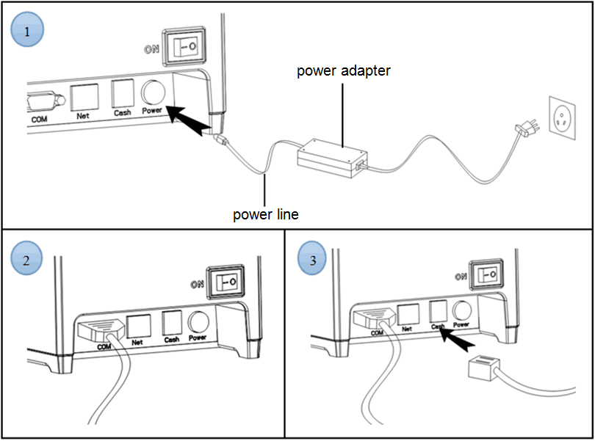

Install the print paper
80MM series thermal printer using 58MM thermal paper, using easy paper structure, convenient to install paper.
1 Pressing down the cover open button, open the printer cover
2 Put thermal print paper in the paper holder according to the pic below
3 Pull a little paper out of the warehouse
4 tear excess printing paper
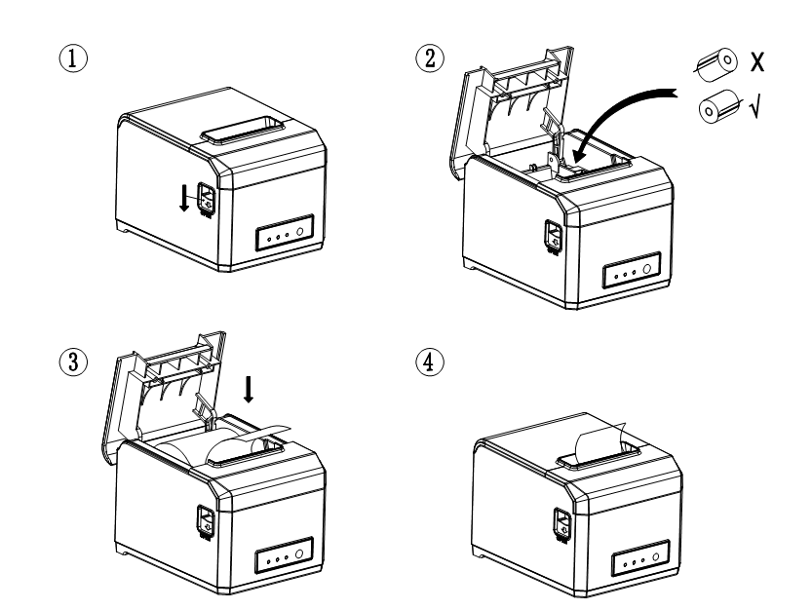
Note: take care of the roll direction, if reverse direction, the content won’t be print out.

Set print mode (DIP switch)
DIP switch settings can change the printer's cutting knife, beep, print density, language, font size, print width, print speed, etc..
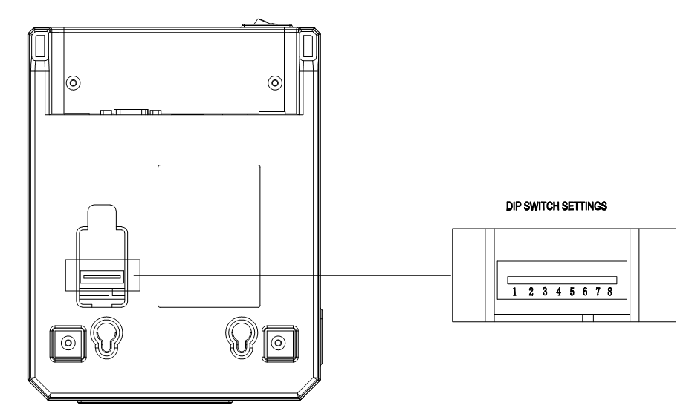
Printer bottom DIP switch function table
No | Function | on | off
SW-1 | self cutter | yes | No
SW-2 | beep remind | on | off
SW-3 | printing density | high density | normal density
SW-4 | Character mode | Chinese  (double byte) | Foreign language  (single byte)
SW-5 | Number of characters per line | 42 | 48
SW-6 | Printing width | 80MM | 58MM
SW-7 | Transmission speed (COM port is valid)
SW-8
SW-7 | off | off | on | on
SW-8 | off | on | off | on
Transmission speed (BPS or bit / sec) | 9600 | 19200 | 38400 | 115200

Switch, key name, indicator and function
1 power switch
The switch can turned on and off the printer power supply.
2 (feed) key (FEED)
Press the button can feed, if keep on press this button will continued to feed.
3 (short paper) light (Paper)
This indicator and the Error lamp flashing at the same time indicates that the printer is short of paper, this indicator and the Error lamp off means the printer has paper.
4 (power) lamp (power)
The indicator light on indicates that the printer is connected to the power supply, this light off indicates that the printer power is off.
5 (error) light (Error)
When the printer is missing paper, print head overheating, the lid is not closed well etc., the indicator lights will flashing.

Self test
Printer self-test method are as follows: when the printer connected to the power adapter, press (feed) key and open the printer power at the same time, released the button after approximately 2 seconds, printers will print out current printer status and settings.

Hex number system:
When the printer connected to the power adapter, ppress (feed) key and open the printer power at the same time, released the button after approximately 6 seconds. The printer print out the words "Dump Hexadecimal".

Printer restore factory settings
When the printer connected to the power adapter, ppress (feed) key and open the printer power at the same time, released the button after approximately 10 seconds, printer is restored to factory settings.

Cutter stuck maintenance
Solution 1:Press the power switch to turn off the printer power, restart, let the cutter back.
Solution 2:Open the printer cover, rotating the printing head cutting knife gear, let the cutter return to its initial position, open the cover and install paper roll then can can print normally.
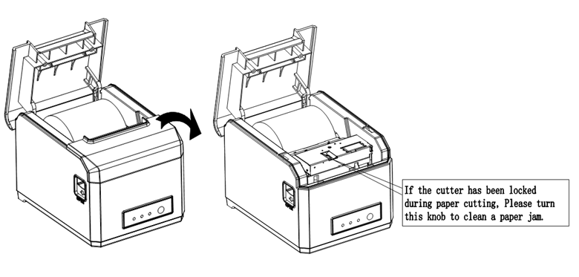
Note: do not force open the cover, as to avoid unrecoverable damage to the print head and the cutter.

Printer driver
80MM series thermal printer driver mode has two kinds, one is using the port for directly drive printing, one is in stall driver in Windows system to print.
1.port direct drive
In this way, do not need to install the driver, only need to output the character (instructions and data) directly to a port, and to achieve character conversion of print by internal printer hard character library , using port directly drive, make the print control more convenient.
If you use port direct drive mode, you need to use the print command set to control the printer's printing, 58MM series thermal printer has been integrated within the ESC/POS instruction set.
2.Install driver in windows system
To install the driver in CD in windows, you only need to call the driver in the program to achieved print. In this way, in fact there is a Windows driver to turn the character into a graphic dot matrix way to print.
Windows driver installation steps and instructions:
- Double click the driver setup ，click "ok"
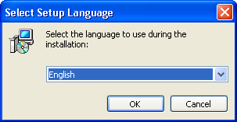

- Click the "next step"
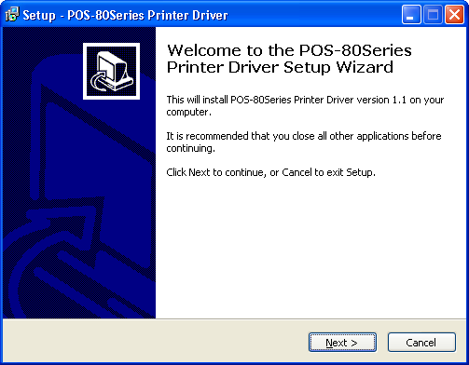
- Select "I accept this Agreement", click "next"
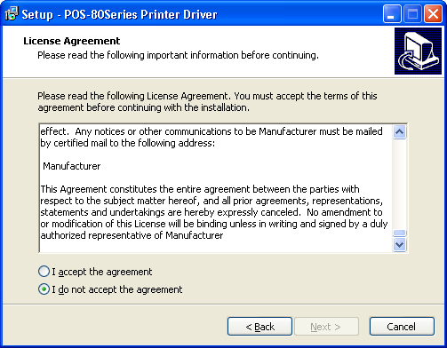

- Click "install"
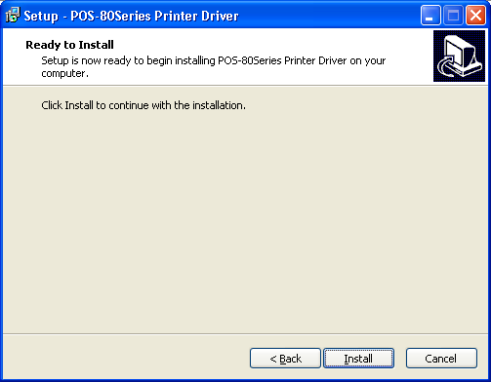
- Setup software will automatically identify the version of the Windows system, click "Next "
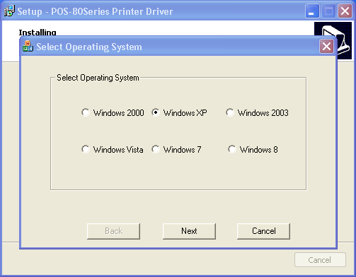

（6） Select the corresponding port and click "OK"
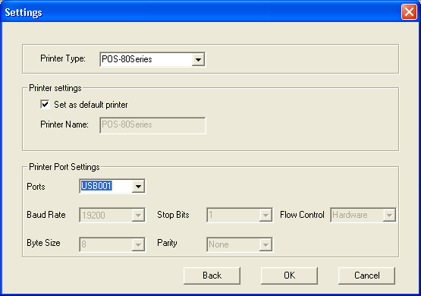
- Click "finish" to complete the driver installation
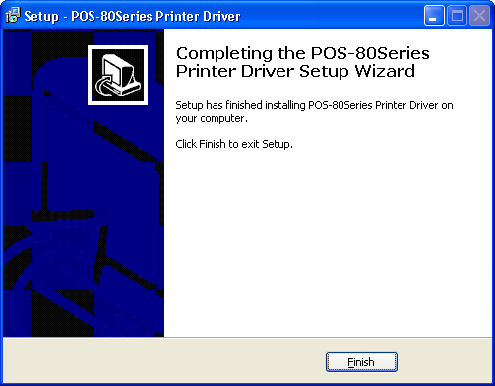

Printer Repair and maintenance
1. printer external and warehouse cleaning: please use a wet cloth gently wipe the printer surface and internal paper warehouse.
2. Printer core clean: printer core must be clean on time, especially the quality of printing is decline, cleaning methods are as follows: put cotton dipped in anhydrous alcohol and gently wipe the printer core ceramic parts as shown in the picture below until clean enough.
3.If find water inside printer, pls immediately disconnect the printer power, and dry the printer naturally.
Failure Analysis:
Failure phenomenon | Failure cause | Solution
Printer paper indicator and Error indicator flashing at same time,and make a Di Di... beep sound | Printer lack of paper | Install paper correctly
Printer error flashing and make a Di Di...beep sound | 1.The printer head is too hot  2. The flip not closed well | 1.Open the cover and dissipate heat fully then go on printing.  2. Cover the flip well
When the printer prints only paper run but not print | Print paper install reverse | Pls install the print paper for a opposite direction
The printer print fuzzy | The print head not clean for a long time | Put cotton dipped in anhydrous alcohol and gently wipe the printer core ceramic parts until clean enough
The printer print fuzzy | The character colour in thermal paper no good | Pls choose high quality thermal paper
There is no response of printer | The power adaptor not connected | Pls check power adaptor is connected well or not,power switch is turn on or not
Printer can self test, but can not print online | Driver port selection error | Pls select the correct print driver port based on the actual connection port
Printer serial port does not print or print garbled | Bit rate slection error | Pls set the COM baud rate accoridng to the COM info on self check page

