SX-CZ60C

On-Vehicle Electric Sprayer

User’s Manual

- Purposes and Features
SX-CZ60C on-vehicle electric sprayer is designed for pest control, herbicides/ growth regulators and liquid fertilizer spraying on farmland, nursery, garden, lawn, shrubs and grasses fences. Mounted on a small tractor, an ATV, or an agricultural flatbed car , and powered by the on-vehicle 12V power supply, the sprayer may be equipped with a gun or a lance to spray. It’s simple in structure, easy to operate, characterized by high working efficiency and being labor/cost/time/effort efficient. Come with a high-quality diaphragm pump to offer steady flow and high pressure. Designed with a pressure-limiting switch for extended service life and high reliability. Running without water for a short time is allowed. The chemical tank made of high-density polyethylene plastic ensures rigidity and resistance to pesticide corrosion. Two-step filtration is available to prevent against foreign substances’ entry to the nozzle so as to ensure spray quality.
- Technical Parameters
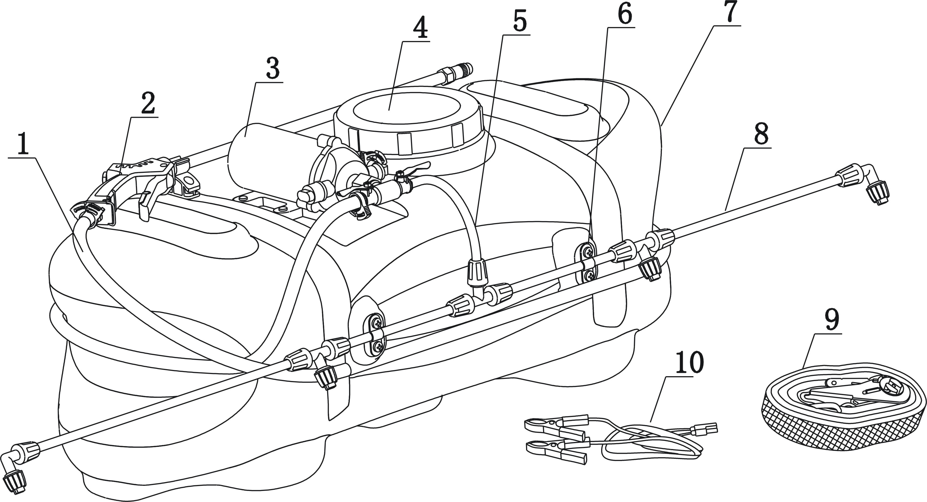
- Outlet hose 2. Adjustable spray gun 3. diaphragm pump 4.Tank Lid 5. Connection hose 6.Tab 7.Tank 8.Spray lance 9.Ratchet Belt 10.Power cord

Sprayer Type |  | Pump Type | Max. Pump Press. | Rated Voltage | Motor Power
On-Vehicle |  | diaphragm pump | 7.5bar | 12VDC | 76W
Tank Capacity |  | Length of Power cord |  | Length of Outlet Hose | Length of Ratchet Belt
60L |  | 5M |  | 5M | 5M
spray gun | Press. | 2-4bar
spray gun | Flow | 2.1-2.7L/min
Spray Lance | Press. | 2.5bar
Spray Lance | Flow | 2.2-2.5L/min

- How to Operate the Sprayer
i. Mount the Sprayer
1. For initial use, please check the components in the package upon unpacking to make sure all that on the packing list are included before proceeding to mount.
2. Place the tank on the rear end of an ATV or small tractor (The side with lance fixing groove facing backward ), and fasten it with a ratchet belt;
3. Spread the outlet hose and insert one end of the hose into the big opening shut-off valve, the other end to the inlet of adjustable spray gun, followed by tightening the two ends with plastic clamps. The outlet hose may wind up around the tank and be fixed within the grooves on both ends of tank ;
4. Press the gun body into the clamp on the tank;
5. Connect the spray lances in series and fasten with lance nuts, before fixing the assembled lances to the lance groove on the side of tank with two clips and four screws. The four nozzles shall be on the same plane, and outward inclined for a certain angle. Meanwhile the spray fan area shall have an angle of 10 degrees with the spray lance to prevent against spraying to the vehicle frame, and maximize the chemical spray onto the crops ;
6.The spray lance shall be installed to be parallel to the ground with a proper height. Insufficient height likely causes missing due to terrain impact; Excessive height may lead to uniform distribution due to influence of wind. Try your best to ensure the nozzle has a ground clearance of 40-60 cm. if necessary, fix the spray lance to the vehicle frame.
7.Connect the spray lance to the smaller opening shut-off valve on the diaphragm pump with a connection hose, and tighten the lance nut. Fasten the hose on the shut-off valve with a stainless steel hose clamp.
Note: If level spraying with the lance is not intended, do not proceed to the installation steps from 5 to 7 , so as to avoid collision in the process of transportation which may result in damage to the spray lance.

ii. Operating Instructions
- You’d better carry out spraying job of pesticides in the morning or afternoon of a cool, windless day , so as to reduce volatilization and drifting of pesticides.
- For initial use, please make a trial spray with water , check the diaphragm pump for possible fault and make sure the joints be free of leakage.
- Close the two shut-off valves. Fill the tank with prepared chemical solution through a large strainer, and then tighten the tank lid;
- Start the motor. Arrange the whole unit according to the scheduled route. An extra-large spraying area should be divided into a number of plots, and the routes shall be determined according to the wind direction. Generally, the sprayer advancing direction shall be wholly or partially perpendicular to the wind direction.
- Insert the output end of the power cord into the input end of diaphragm pump, and connect the two wire clamps on the input end of the power cord to the positive and negative output terminals of the battery or the output end of vehicle’s magneto (red line is positive, black is negative) respectively . Now the diaphragm pump starts working;
- Start up the vehicle to move forward in accordance with the predetermined route, while opening the shut-off valve of the gun or the lance to start spraying.
iii. Precautions
- Prohibit the use of some special solution;
- Handling of pesticides should comply with the safety instructions provided by the pesticide manufacturer.
- Check the terrain, slope, ground roughness, crop growth in the job area and make sure non-presence of obstacles before the unit moves forward..
- In the process of level spraying with spray lances, the unit shall move forward at a rate of no more than 8km / h.
- The spray fan angle shall be complete, unbranched, non-dripping. Try to maintain a uniform stream and steady spray.
- Diaphragm pump comes with a pressure protection switch and allows for short-term non-water running. However, when the pump is intended to be put idle for a long time, or in the process of water-filling, you’d better disconnect the power cord to avoid undesired battery power consumption and prolong pump life.

iv. Cleaning and warehousing
After operation, the machine should be cleaned at an allowed place. Cleaning method: Fill the sprayer with fresh water and start the diaphragm pump to spray out; For external surfaces, clean with a damp cloth.
Note: The diaphragm pump shall never be immersed in water for cleaning .
The cleaned machine should be placed in a dry, ventilated room, out of the reach of children. The spray lance may be disassembled for separate cleaning and kept in a box after drying.

IV. Exploded View and Detailed List
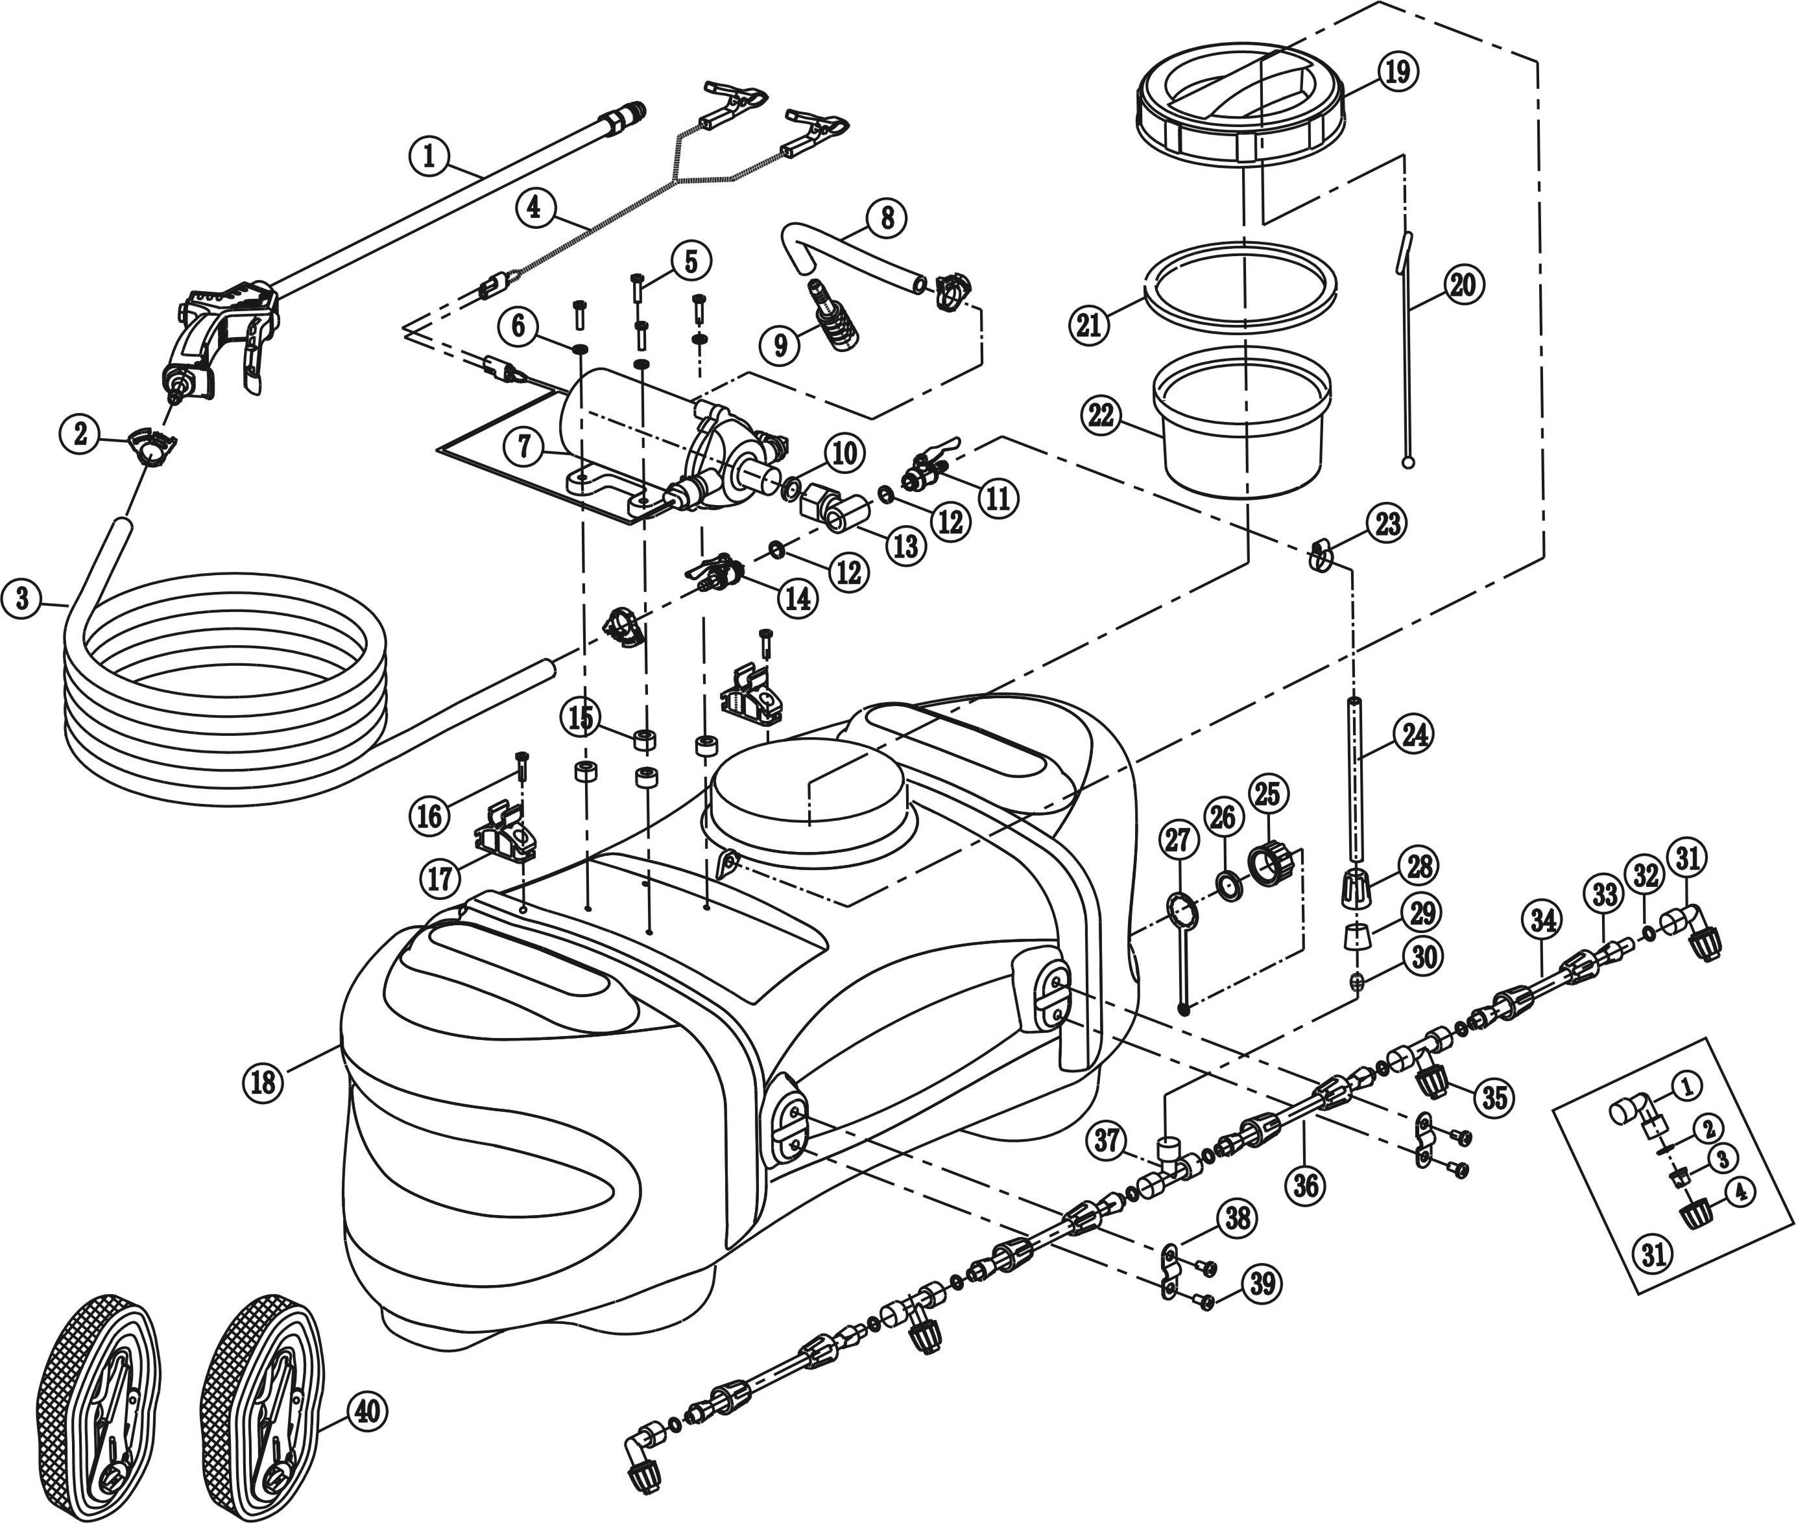

S/N | Description | Qty. | S/N | Description | Qty.
1 | Adjustable Spray Gun | 1 | 23 | Stainless Steel Hose Clamp | 1
2 | Plastic Hose Clamp | 3 | 24 | Connection hose | 1
3 | Outlet Hose | 1 | 25 | Bleeder | 1
4 | Power Cord | 1 | 26 | Flat washer | 1
5 | Screw M5X | 4 | 27 | Anti-release belt | 1
6 | Flat washer 5 | 4 | 28 | Spray lance nut | 9
7 | Diaphragm pump | 1 | 29 | Tube sleeve | 1
8 | Suction hose | 1 | 30 | Protection sleeve | 1
9 | Strainer | 1 | 31 | Square nozzle | 2
10 | Pump opening gasket | 1 | 31-1 | Square Bend | 1
11 | Small opening shut-off valve | 1 | 31-2 | Nozzle gasket | 1
12 | Valve seal | 2 | 31-3 | Fan nozzle | 1
13 | Tee assembly | 1 | 31-4 | nozzle cap nut | 1
14 | Big opening shut-off valve | 1 | 32 | O-ring Φ15X3 | 8
15 | Damping sleeve | 4 | 33 | Fastening sleeve | 8
16 | Screw set M5X | 2 | 34 | Long Spray Lance | 2
17 | Spray lance clamp | 2 | 35 | T-nozzle | 2
18 | Chemical tank | 1 | 36 | Short spray lance | 2
19 | Tank lid | 1 | 37 | Tee | 1
20 | Anti-release rope | 1 | 38 | Tab | 2
21 | Seal ring | 1 | 39 | Screw 6X10 | 4
22 | Big strainer | 1 | 40 | Ratchet belt | 2

V. Packing List

S/N | Description | Unit | Qty. | Remarks
1 | Sprayer body | Unit | 1
2 | Adjustable spray gun | Pc(s) | 1
3 | Outlet hose | Pc(s) | 1
4 | Connection hose | Pc(s) | 1
5 | Four-nozzle lance | Pc(s) | 1 | Packaged in a plastic bag
6 | Tee | Pc(s) | 1 | Packaged together with the spray lance
7 | Plastic hose clamp | Pc(s) | 2 | Packaged together with the spray lance
8 | Stainless steel hose clamp | Pc(s) | 1 | Packaged together with the spray lance
9 | Ratchet belt | Pc(s) | 2
10 | Kit | Set | 1 | 4 O-ring Φ15X3 ，4 fan nozzles， 4 nozzle gaskets， 1 plastic hose clamp, 1 stainless steel hose clamp, 1 pump opening gasket， 1 nozzle O-ring

