Centrifugal Gold Concentrator

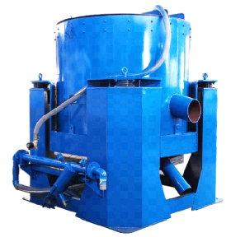
Gold centrifugal concentrator is a high efficiency heavy separation equipment, the principle is high speed rotation to enlarge the centrifugal force of feed particles, and the transverse water jet flush the light particles out of the concentration cone, but the heavy particles can stay because its larger centrifugal force, light out and heavy stay to achieve the purpose of separation. Due to its low weight, the settling speed of fine particles is slow, which makes it difficult to separate in other heavy separation equipment. When the concentration cone works, it can generate 60 times gravitational acceleration at the inner wall. When the centrifugal force enlarges to 60 times, the centrifugal force difference between heavy particles and light particles will increase exponentially. Therefore, gold centrifugal concentrator utilizes it to separate heavy particles and light particles.

Gold centrifugal concentrator is widely used in various types of gold mines, it has an outstanding effect on the free gold at different particle size ranges, it not only can be used in alluvial gold ore, but also can be used in hand rock gold ore as fine gold recovery equipment, and also can be used to recover gold on the tailing as flour gold recovery equipment. Application shows that the recovery of placer gold can be reach 99%, and the concentrating ratio can reach 1,000 times. In the recovery of natural gold in rock gold mines, when the feeding size is less than 0.074mm, the recovery rate of free gold can reach 98%, and 0.04mm of free gold can reach 97%.
Centrifugal gold concentrator diagram
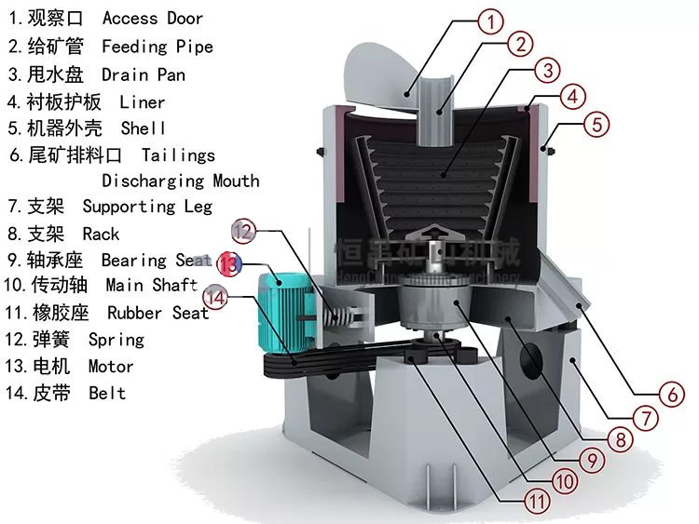

Advantages and features
- High enrichment ratio and high recovery;
- Large capacity and high efficiency;
- Automatic concentrate flushing, save manpower;
- Stable and reliable running and stable separation index;
- No any chemical agents required, environmentally friendly;
- Less water and low power consumption;
- Low production cost, long replacement cycle of wearing parts, simple maintenance;
- Compact design, small floor area, easy to integrate into the existing separating process.

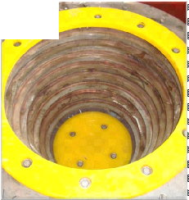 | 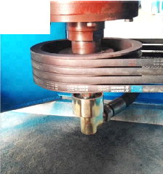
Stainless Steel Concentrating Cone  Wear resistance, rust-proof, polyurethane (PU) lining | High Quality Bearing  Stable running, small vibration, low friction, durable and reliable
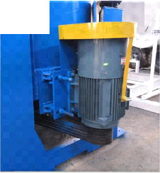 | 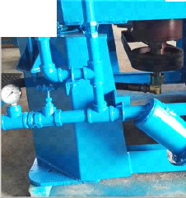
High Quality Variable Frequency Motor Adjustable motor speed, equipped with an independent electric control cabinet, can automatically switch to the cleaning mode | Water Pressure Gauge and Filter  Timely adjust the water pressure, timely control the separation effect. The filter prevents the sewage from blocking the water hole and adopts the washable filter element

Main Technical Parameters
Model | STLB20 | STLB30 | STLB60 | STLB80 | STLB100
Capacity (T/h) | 0-0.6 | 2-3 | 8-12 | 40-45 | 80-120
Fluidization Water  Required (m³/h) | 2-3 | 3-5 | 7-10 | 30-36 | 60-80
Slurry Water  Required (m³/h) | 1.5-4 | 5-7 | 8-12 | 40-45 | 70-100
Feeding Density  (%) | 0-50 | 0-50 | 0-50 | 0-50 | 0-50
Feeding Size (mm) | 0-3 | 0-3 | 0-5 | 0-5 | 0-6
Concentrate  Cleaning Up Cycle | Vein gold 1-3 Hours Placer gold:2-6 Hours
Concentrate  Weight (Kg) | 2 | 3-5 | 10-20 | 40-50 | 70-85
Power (Kw) | 0.75 | 1.5 | 4 | 11 | 18.5
Weight (Kg) | 205 | 380 | 1100 | 2300 | 3200
Dimensions (mm) | 914×700×900 | 1160×885×1165 | 1820×1450×1700 | 2476x2032x2018 | 2849x2085x2426

