Trommel Screen

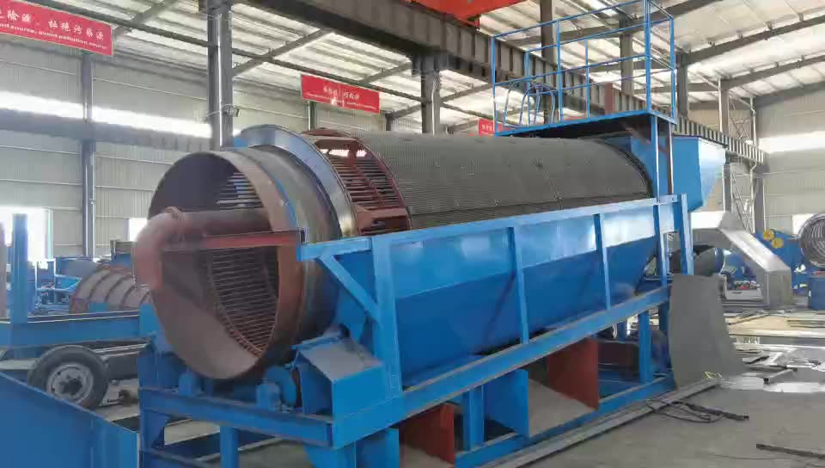
Trommel screen is also known as drum screen, gold mining trommel or trommel gold washing plant, it is a washing and screening equipment for classification according to the particle size of materials, can be used for dry screening and wet screening. Compared to the vibrating screen, the advantages of trommel screen are: in the same volume, the cylinder area is larger than the vibrating screen flat area, so the effective screening area of the cylinder is larger, so that the material can fully touch the screen, therefore, the unit time of the screening capacity is larger. And because of its compact structure, easy installation, easy layout and convenient
discharge collection. It is widely used in mines, gold mining plant, beach placer, sand washing plant, slag metal recovery and so on.

The gold mining trommel screen provides a simple, efficient and economical screening solution for all kinds of materials, it also provides optimization treatment for the subsequent processing. This solution helps reduce operational processes and reduces investment costs and improves product quality, while allowing rapid and large volume processing. After screening, the material can be directly fed into a variety of separation equipment, such as gold centrifugal concentrator, spiral concentrator, jig machine and shaker table etc.
Trommel screen diagram

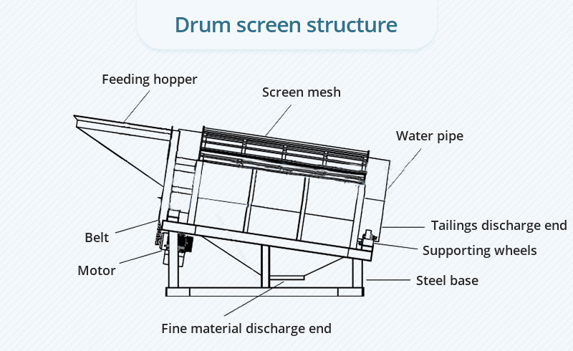

Advantages and features
- Small floor area, low investment cost
- Stable and reliable operation, high screening efficiency and large capacity
- Roller support, allowing heavy load operation, the reinforced cylinder is firm and no deformation
- Multi-layer screen, the inner layer is steel rod grizzly to effectively protect the outer layer of the screen
- It can be equipped with a heavy feeding bin, which can be fed directly by the excavator
- Reasonable structure and long service life
- Wide adaptability, can use a variety of materials: such as ore, sand, coal, composite fertilizer, garbage classification, slag and so on
- Easy to install, easy to maintain and work without debugging
- Single, double or three-layer screen is available according to user’s requirements, and a variety of products can be obtained through one process
- According to user’s demand, it can be made into a full closed or half closed, to minimize dust pollution

Reinforced Structure  Strong rigidity, strong strength, no deformation | Heavy Roller Structure  Strong load capacity, low friction, long service life
Inner Round Steel Grid  Can screen out large stones, the maximum feed particle size up to 200mm | Drive Mode  Gear drive and chain drive are available

Main Technical Parameters
Model | Capacity (t/h) | Power (kw) | Drum diameter (mm) | Drum length (mm) | Screen size (mm) | Dimension (mm) | Weight (kg)
GTL1015 | 10-15 | 4.0 | 1000 | 1500 | <2-10 | 3400*1320*1920 | 2200
GTL1020 | 15-20 | 5.5 | 1000 | 2000 |  | 3400*1320*1980 | 2500
GTL1030 | 20-30 | 5.5 | 1000 | 3000 |  | 5000*1500*2200 | 3000
GTL1225 | 25-35 | 7.5 | 1200 | 2500 |  | 4146*1500*2230 | 3800
GTL1230 | 30-45 | 7.5 | 1200 | 3000 |  | 5563*1500*2250 | 4100
GTL1430 | 50-60 | 11 | 1400 | 3000 |  | 5600*1650*2340 | 4800
GTL1530 | 60-80 | 11 | 1500 | 3000 |  | 5535*1860*2520 | 5200
GTL1545 | 80-150 | 15 | 1500 | 4500 |  | 7040*1900*2525 | 6000
GTL1848 | 150-200 | 22 | 1800 | 4800 |  | 8750*2100*3500 | 7500
GTL2055 | 200-260 | 30 | 2000 | 5500 |  | 9353*2200*3560 | 8600

