Details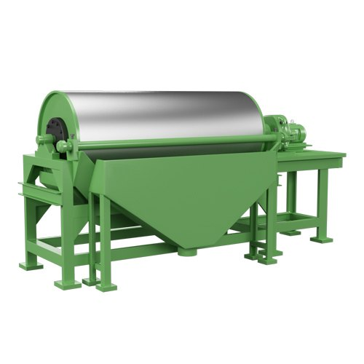
Product introduction
Wet drum permanent magnetic separator is suitable for wet magnetic separation of magnetite, pyrrhotite, roasted ore, ilmenite and other materials of the particle size less than 6mm, it is also used for iron removal of coal, non-metallic ore, building materials, slag and other materials. The magnetic system of wet magnetic separator is made of high quality ferrite material or rare earth magnetic steel. The average magnetic induction intensity of the drum is 1000-7000gs. According to the needs of users, different kinds of surface magnetic intensity of magnetic separator is available.
Wet drum permanent magnetic separator working principle
When the slurry goes into the magnetic field, the ferromagnetic minerals are attracted to the drum surface, then the weak magnetic and non-magnetic minerals are discharged with water. The strong magnetic minerals adsorbed on the surface of the drum rotate due to the adsorption, then brought to the non-magnetic field and washed into the concentrate tank by water jet to complete the separation.
This machine has three kinds of tank: CTB, CTS and CTN, the same kind of drum could match those three tanks, to suitable different works and different requirements.
CTS is suitable for the roughing and cleaning of particle size in 6-0mm;
CTN is suitable for the cleaning and scavenging of fine particle size in 0.6-0mm , and it is often applied to recycle heavy medium in coal;
CTB is suitable for the roughing and cleaning of ores in size of 0.5-0mm, especially suitable for the cleaning of ores in size of 0.15-0mm.
Advantages and features
1. Large capacity, continuous feeding and discharging;
2. Easy operation and maintenance;
3. The loss (attenuation) of magnetic force shall not exceed 5% within ten years.
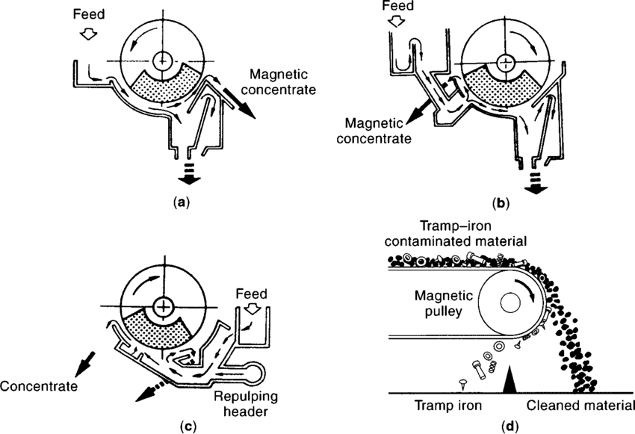
Main technical parameters
