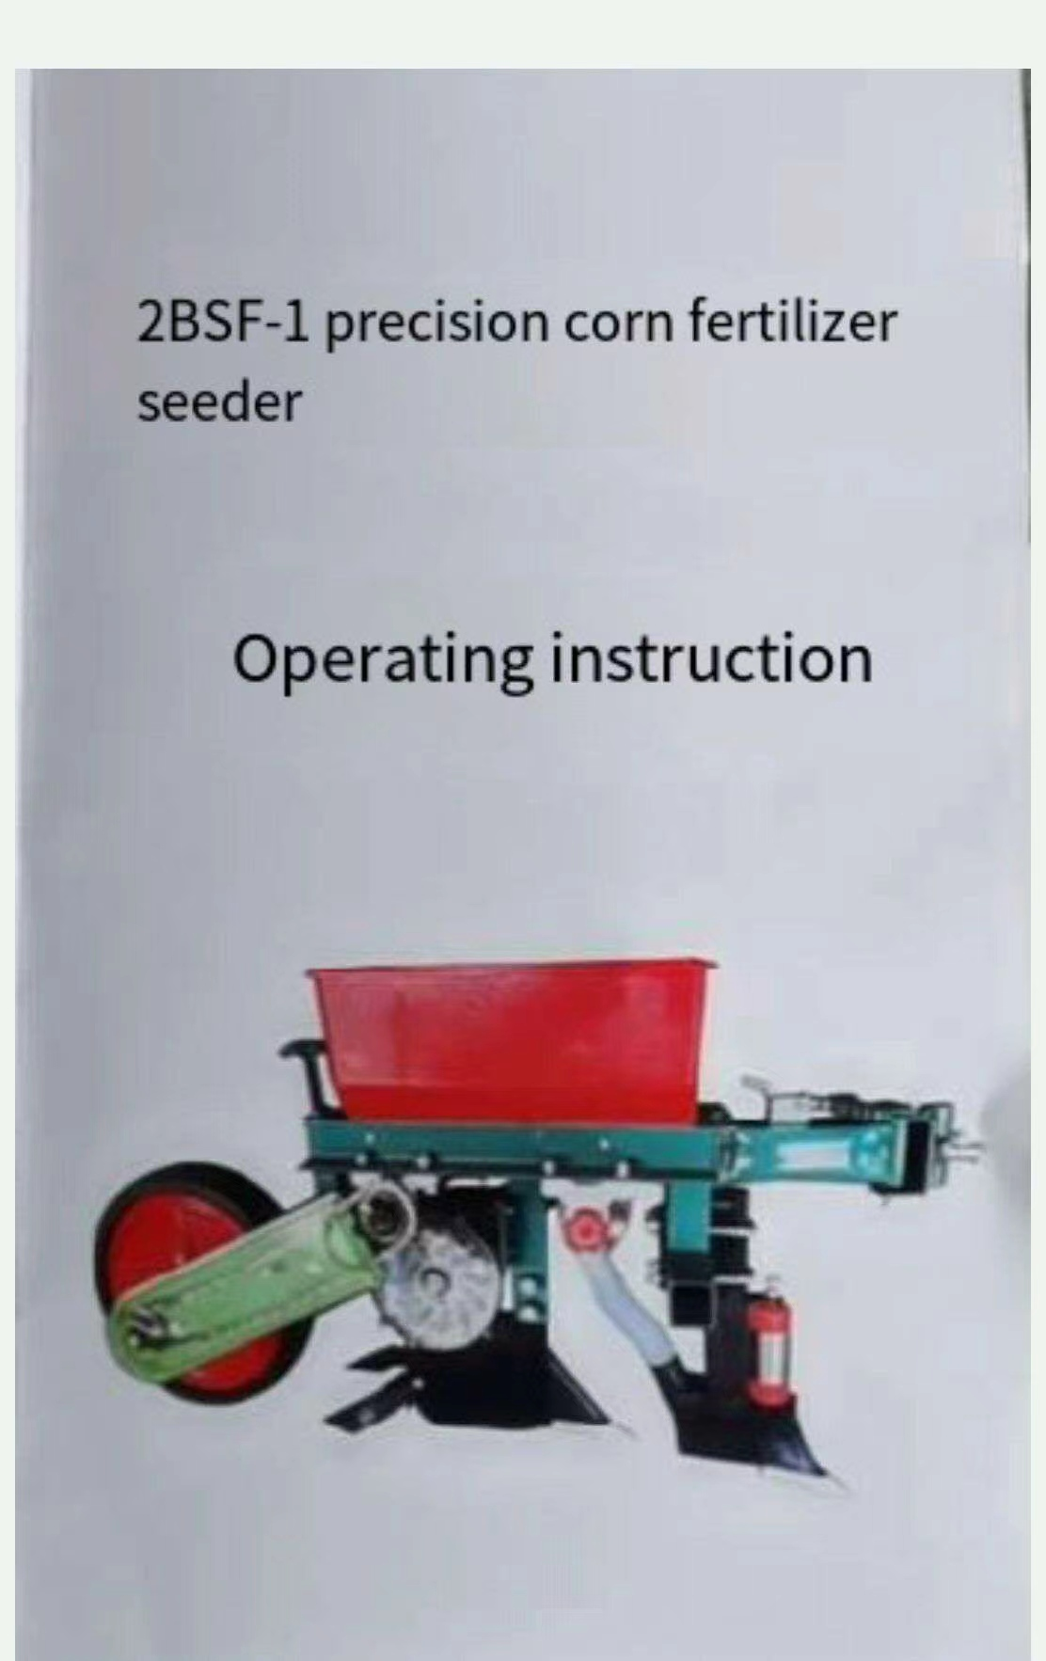

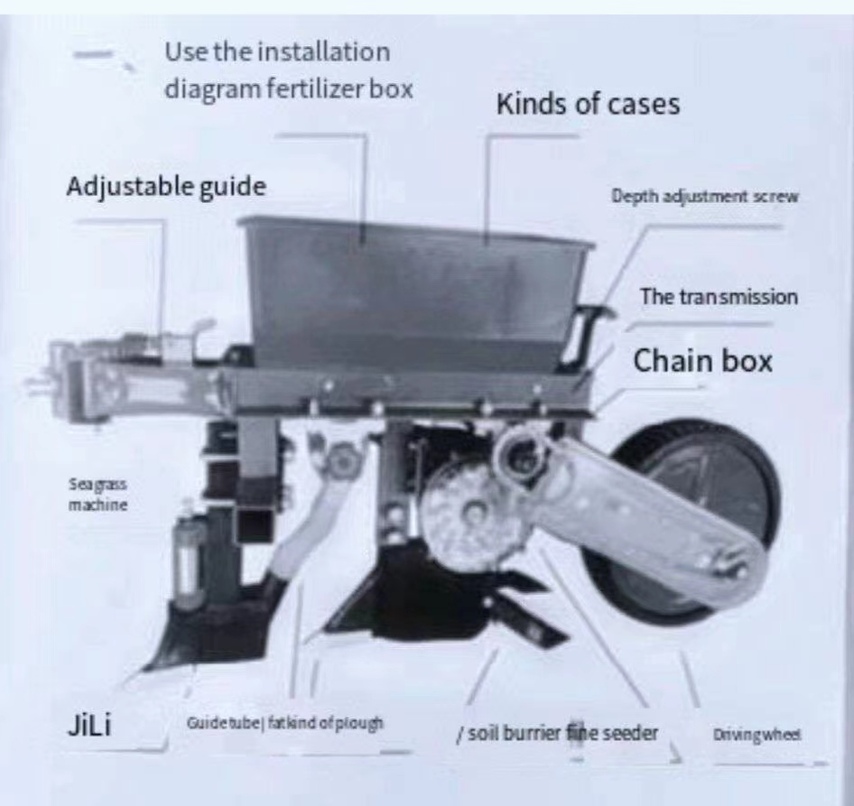
二 Pre-broadcast adjustment:
1. Read the instructions carefully before sowing and debug in strict accordance with the instructions.
2. Check whether the components are complete and whether they are deformed or damaged.
3. Check whether the bolts and nuts are fastened.
4, check whether the adjustment mechanism is flexible, transmission and other wear parts should add lubricating oil.
5. After installation and debugging, test run is required.
三operation adjustment:
1. Adjust the amount of fertilizer
① First adjust the hand wheel of fertilizer sower to "0", then rotate the hand wheel to the left to adjust the required amount of fertilizer, and then lock the hand wheel nut.
② When sowing fertilizer, fertilizer should not melt or harden, which will affect the normal amount of fertilizer sowing.
2. Bias adjustment
Fan-shaped plough teeth can be adjusted according to different terrains
Our seeding position can be adjusted around 45° as needed.
After adjustment, the plough tooth is returned to its original position.
3. Plant spacing adjustment
The spacing of the machine can be adjusted from 1 to 6 gears by transmission.
Plant spacing is 18 cm,21 cm,24 cm, 27 cm, 30 cm 34 cm, easy to adjust the sowing depth adjustment
The sowing depth can be adjusted arbitrarily, large frame and backspin float frameThe depth adjustment mechanism is set to adjust the sowing depth method as follows: if deep sowing is needed, the hand wheel can be turned counterclockwise until the depth is reached; otherwise, if necessary, the plow Angle can be adjusted up and down to achieve the purpose of depth.
四 safety precautions:
1. Before sowing, ensure that there are no other sundries in the seeds and seed metering device.
2. Before each sowing, test run and spacing check should be made to ensure the sowing accuracy.
3. Driving at a uniform speed is strictly prohibited.
4. When not working, the machine should be lifted off the ground.
五, main technical parameters
Dimensions: length 1100 width 400 height 660
lines: single line
Supporting power: 6-12 walking tractors
Depth: 20-105
Capacity of seed box: 3 Kg
Capacity of fertilizer box,10 Kg
Structure quality: 36 kg
Productivity: 4-BA/hour
Displacement range of 1-2kg/ mu
六, common failures and cause analysis
1. Abnormal fertilization or seeding
There may be transmission fault, should check whether the transmission chain or sprocket loose or drive wheel running is normal, such as the above are normal; Check the fertilizer discharging device, seed discharging device whether there are sundries or fertilizers, pesticides, blocked causes, should be cleaned up in time.
2. Reduced seed discharge
Seed box too few seeds or seeds in sundries caused by, seeds need to be screened.
3. Transmission chain bites or drops
The two sprockets are not in the same plane, should adjust the shaft to the sprocket
Align it with the sowing sprocket in the horizontal position and tighten the sprocket fastening bolts. At the same time, adjust the tightness of the chain.
七, the maintenance and storage of corn seeding machine
1. After each sowing, fertilizer box and seed box should be fertilized, planted
Clean up, to prevent insects, rats, bite damaged parts.
2. After the end of the seeder and sowing in one season, the soil should be removed and then oiled on the adjustment, transmission parts and chains, and placed in the indoor dry place for sealing.

