R6B CCD COLOR SORTER

RATI AN AL
Version: 2.7 i

Advice

"User manual" mainly introduces our color sorter machine on installation, using, the way and requirements of maintenance. Please read "user manual” carefully before using products, operate and maintain them according to the instructions, or we will not be obliged for any damage and breakdown.

ZX RGB CCD color sorter user manual

Some parameters of this manual are based on six chutes model.
The manual has been updated in latest version, Some pictures in this manual is the schematic diagram for reference only, if the pictures do not match the real machine , please take for reference.

Contents

- SUMMARY 5
- OPERATION PRINCIPLE 6
- TECHNICAL PARAMETER 6
- MACHINE STRUCTURE AND FUNCTION 6
STORAGE HOPPER 错误！未定义书签。
VIBRATION FEEDING DEVICE 错误！未定义书签。
CHUTE 错误！未定义书签。
TOUCH SCREEN 错误！未定义书签。
POWER CONTROL & EJECTOR 错误！未定义书签。
ELECTRICAL CONTROL CABINET MAIN MACHINE 错误！未定义书签。
SORTING BOX 错误！未定义书签。
AIR CONTROL SYSTEM 错误！未定义书签。
OUTLET HOPPER 错误！未定义书签。
EJECTOR 错误！未定义书签。
HEATING DEVICE 错误！未定义书签。
- INSTALLATION 10
UNPACKING AND INSPECTION 10
INSTALLATION 10
ELECTRICAL INSTALLATION 14
AIR SUPPLY INSTALLATION 15
DUST COLLECTION PIPE INSTALLATION 15
- OPERATION 15
PER-OPERATION 16
ON AND OFF 19
- SETTING AND OPERATION 21
ELECTRIC DATA SETTING 21
VIBRATOR ADJUSTING 41
- MAINTENANCE 42
- FAULT TREATMENT AND METHOD 42
COMMONAC FAULTS TREATMENT AND METHOD AS FOLLOWS 43
APPENDIX 1:COLOR SORTERSTRUCTURAL DIAGRAM 43
2:CONSUMABLE PARTS LIST 44
APPENDIX 3:DELIVERY LIST OF COLOR SORTER’S ACCESSORIES 45
APPENDIX 4: SORTING ACCURACY AND CARRYOVER 45

Summary

ZX series Color sorter is the latest vision color sorting equipment manufactured by Our company Different models available to meet the processing needs of all types of small and medium enterprises. Color Sorter is a equipment with double side identification and multiple sorting equipment. It adopts the most advanced industrial-grade custom lens, imported ultra-high sensitivity 5400 pixel CCD sensor, high-speed FPGA data processing control system and high-speed electromagnetic valve system, and with intelligent color display interface. The user-friendly operation interface can be identified independently and adjusted automatically. A combination of color and shape sorting can dramatically improve the sorting accuracy . It is widly used for sorting granular materials such as rice, sesame, sea buckthorn, small yellow rice, sunflower kernel, all kinds of beans, wolfberry, raisin and industrial and mining raw materials .

This manual includes ZX series models ZX1 / ZX2 / ZX4 / ZX6 / ZX8 / ZX10 and other series of models, this manual take ZX6 model for example, describes the product performance, installation, operation, maintenance and other functions, other models Basically the same, this can be a reference. For any difference will be additional instructions.

Color sorter is kind of optoelectronic high-tech equipment with a strict requirement for installation, commissioning, operation and maintenance . Therefore, must be operated by a full-time professional operator ,and the operator must be well- trained by ’s after-sales team . Each time for operation it is required the operator refer to the instruction manual for details.
Any technical upgrades or improvement of the performance of the machine technology will be occurred without notice.

Operation principle

- The material comes from the top hopper into the machine, goes through the vibration device, decline along the chutes ,enter into the top of channels, then fall into sorting box and pass through the monitor and background board. Under the lights, CCD sensor received synthesis of light from the selected materials, make the output signal, drive the ejector operation which can blow the discolor materials to the rejected hopper, and the good materials will fall into the finished hopper.

Technical parameter

ZX Technical parameters

Name | ZX1 | ZX2 | ZX3 | ZX5 | ZX6 | ZX7 | ZX8 | ZX10
Channels | 63 | 126 | 189 | 315 | 378 | 441 | 504 | 630
(Primary:Secondary) | 49:13 | 104：21 | 126:63 | 252:63 | 104:21 | 315:126 | 378:126 | 441:189
Capacity（t/h） | 0.6~1 | 1.0~2.0 | 1.5~3 | 3~6 | 4~7 | 5~8 | 6~10 | 8~15
Sorting accuracy | ≥99% | ≥99.99% | ≥99.99% | ≥99.99% | ≥99.99% | ≥99.99% | ≥99.99% | ≥99.99%
Optimized  carryover(bad:good) | ﹥8:1 | ﹥8:1 | ﹥8:1 | ﹥8:1 | ﹥8:1 | ﹥8:1 | ﹥8:1 | ﹥8:1
Voltage(V) | AC220V  50/60Hz | AC220V  50/60Hz | AC220V  50/60Hz | AC220V  50/60Hz | AC220V  50/60Hz | AC220V  50/60Hz | AC220V  50/60Hz | AC220V  50/60Hz
Power （KW） | ﹤1.5 | ﹤2 | ﹤2.4 | ﹤3.0 | ﹤3.0 | ﹤4.0 | ﹤4.0 | ﹤4.0
Air Pressure（MPa） | 0.6-0.8 | 0.6-0.8 | 0.6-0.8 | 0.6-0.8 | 0.6-0.8 | 0.6-0.8 | 0.6-0.8 | 0.6-0.8
Air Consumption（㎥  /min） | ﹤0.8 | ﹤1.25 | ﹤2.5 | ﹤3 | ﹤3.0 | ﹤3.6 | ﹤3.6 | ﹤3.6
Weight（Kg） | 500 | 700 | 800 | 1250 | 1400 | 1600 | 1800 | 2500

Machine structure and function
All the parts which can meet materials are stainless steel or non-toxic metal material as picture 4-1.
！
Caution

- the above parameters decreased slightly when impurity more than 5%

- The second sorting is to sort the rejected material on first sorting

- The elevator is on customer’s side

- Any data changes owing to the technique improving would not be informed

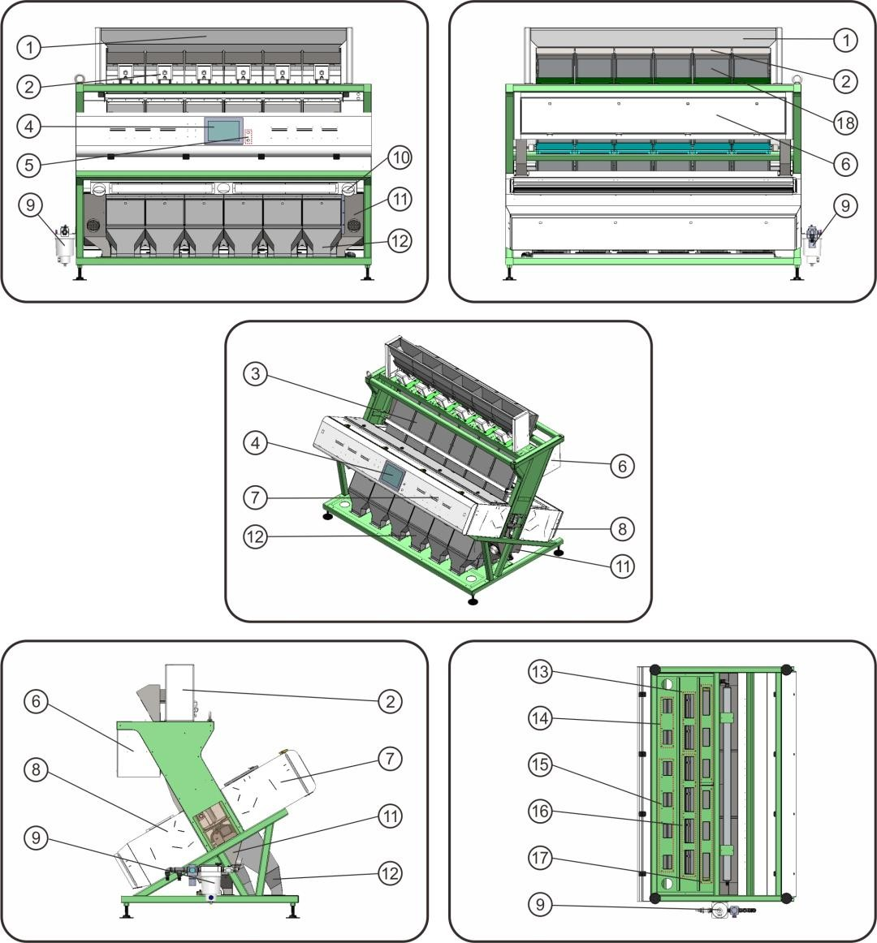
Figure 4-1 machine six chute structure

① storage hopper
② Vibration feeding device
③ Chute
④ Touch screen
⑤ Power switch
⑥ Electrical control cabinet
⑦ Fore sorting box
⑧ Rear sorting box
⑨ Air control system
⑩ Dust suction device
⑪Rear outlet hopper
⑫Fore outlet hopper
⑬Second sorting accepted(transferred into first sorting or raw material )
⑭Second sorting rejected( final rejected)
⑮First sorting rejected(transferred into second sorting )
⑯First sorting accepted( final good )
⑰Missed material ( transferred into first sorting or raw material)
⑱Heating device

Storage hopper

Storage hopper of raw materials provided to the color sorter.

Vibration feeding device
It is made up of inlet hopper, vibrator and feeder. The material is vibrated into feeder through inlet hopper . The vibrator is controlled by electrical cabinet to adjust material supplying.

Chute
Combined with 6 sets (63 channels per set) sliding channels and fastened frame, the material can go into sorting box accurately.

Touch Screen
Touch screen is the intelligent control center of the machine to complete parameter setting , machine start and stop control .

Power switch
Start and stop the machine power control

Electrical control cabinet
It is a completely sealed cabinet, the cybernetics core of the whole machine and made up of microcomputer and FPGA. Electrical control cabinet is used to automatically collect, enlarge and analyze optoelectronic signal and send order to drive ejector by control part. After receiving order, the ejector will blow out compressed air, shot rejected material and realize sorting function.

Sorting box
It is made up of light source, background setting device, CCD lens device, sampling observation window and dust cleaning. When the material enters sorting box, CCD lens device will take pictures and transfer them to FPGA system for analysis. Dust cleaning device will work automatically on time.

Air control system
It is at the back of the machine upper part. It is configured with ball valve, air filter, pressure gauge and pressure regulating valve to provide clean compressed air to whole machine.

Outlet hopper
The front hopper is for rejected material and the back hopper is for accepted material. Also there is dust collection beside the outlet hopper with diameter of Φ100mm which is made by matel and customized according to client’s requirement.
！
Caution:
Users must connect dust collection to reduce dust in sealed cavity. Otherwise it will reduce the usage life and effect the sorting performance.

Ejector
When ejector receives order from the control system, it will blow compressed air to shot unwanted material timely.

Heating device
It is at the back of channel, controlled by air switch and automatic temperature control system in electrical control cabinet to keep channel temperature around 40℃.

Installation

Unpacking and inspection

When getting the machine, users should be very carefully to unpack it to avoid unnecessary damage and check the spare parts according to the packing list .and confirm with the manufacturer timely . Please contact with us immediately if any damage or broken . Or we will not be obliged for any damage.

Installation

    - The working environment should not be of low-temperature, high-temperature, high-humidity or much dust and maintain good air flow. The floor of installation site should not be in shaking situation. Avoiding electromagnetic interference such as electro welding and high frequency transmitting around the installation site.
    - Machine should be put in solid platform with handrails or hard level ground (the distance between platform and ground is suggested to be 1.8m at least). Level gauge should be used to adjust the machine level degree to below 2/1000mm
    - Passageways should be left around the machine for convenient operation, observation, maintenance . Not less than 0.8m in the front , no less than 0.5m at the back and both sides .
    - The outlet of first and second sorting elevator are corresponds to the middle position of first and second storage hopper.
The outlet should be connected proper pipes (for example: Φ100) to load the accepted and rejected material of first and second sorting. Users should configure elevating devices according to actual plant situation, configuring method is shown in figure 5.2-1, 5.2-2, 5.2-3

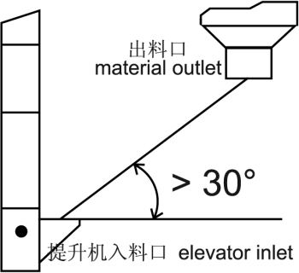

Figure 5.2-1 Tube angler Installation drawing

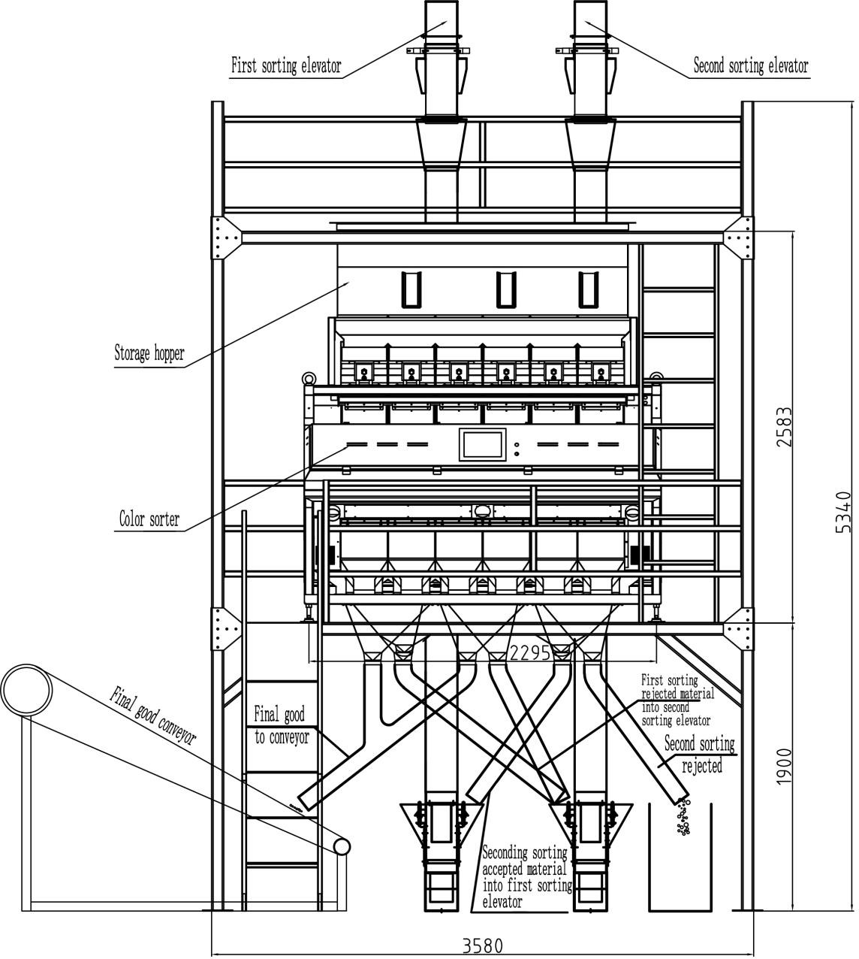
Figure 5.2-2 Elevator and material pipe installation drawing(1)

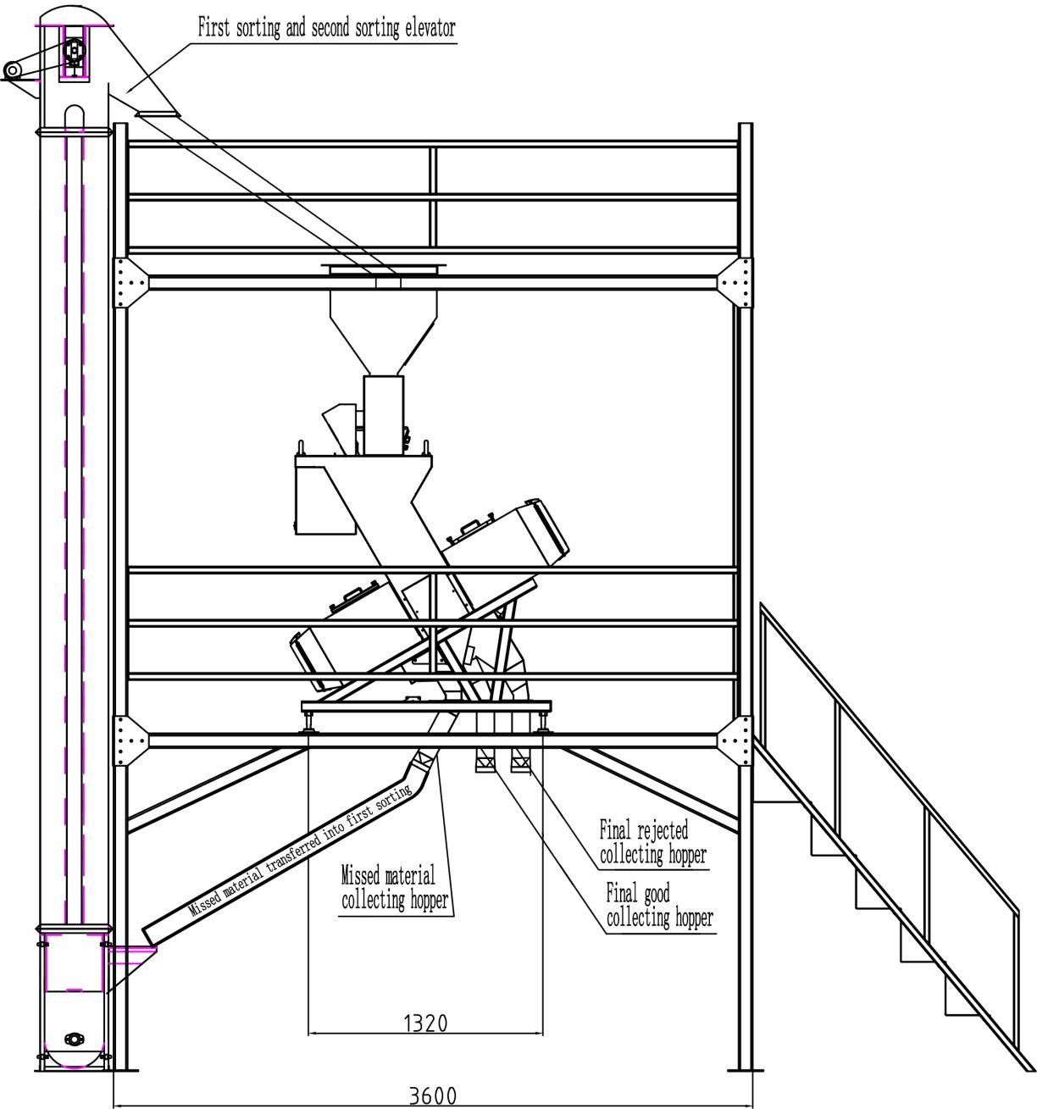
Figure 5.2-3 Elevator and material pipe installation drawing(2)

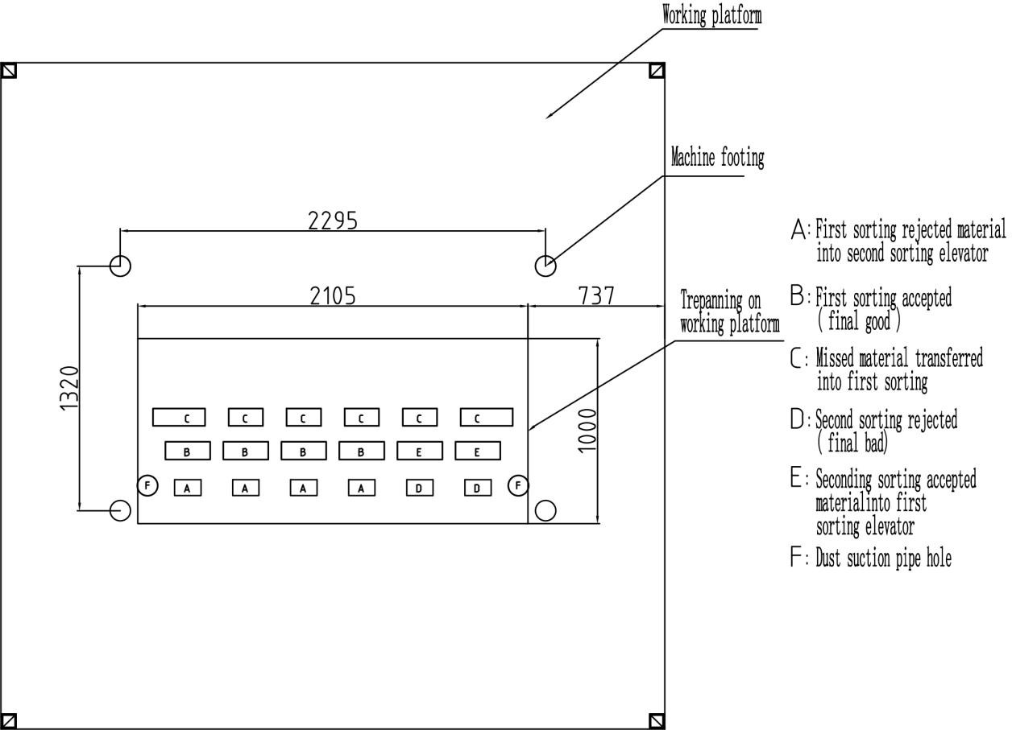
Figure 5.2-4 Material outlet drawing
Instruction :
- Users can choose proper elevator and conveying equipment according to material’s feeding methods and properities .
- The dimensions shown in Figure 5.2-2 and 5.2-3 are all reference dimensions except the main dimension. Users can arrange the installation location and accessories according to the production conditions on site without prejudice to the production and maintenance.
- The platform shown in Fig. 5.2-2 and 5.2-3 is a double-deck platform. Users can decide whether or not to make a double-deck platform according to the production situation. If the double-deck platform is not made, the hopper shown in the figure should be suspended or other ways to install, can not be directly installed on the machine, so as not to pass the vibration to the machine affect the color sorting effect, but also to avoid additional weight of storage hopper for color sorter machine damage.
- The user can choose the suitable height and output elevating equipment according to his own situation. The first and second elevators shown in the figure are installed behind the platform. The user can install on both sides of the platform or one front and other one rear according to the site conditions. The outlet of first sorting elevator should basically fall on the middle of the two / three

channel’s vibrator .
- The footing of color sorter machine should have effective support. It is suggested to install damping rubber if production environment vibration is too large.

Electrical installation

Users need to have a three-phase AC 380V , single phase 220V ± 5% power supply and good grounding wires, should prepare voltage stabilizer.

Main power supply

Control panel should be set within 5 meters from the power inlet. Power supply should be single phase AC 220V ± 5%, 50Hz.

The machine (including the machine-channel heater 1.6KW) capacity is 3.0KW, with a flat three sockets (16A, 250V) connected to single-phase air switch bottoms head 20A (220V).

To avoid interference, there must be a separate ground wire connected to the machine.

Air compressor power supply

Air compressor installation is based on closer distance principle according to installation site specific condition, configure an air switch of three phase 380V 50A.

Air supply installation

User must use an air compressor without any oil or water and also configure water filters. Each gas path components must be connected by Dg 25 mm galvanized pipes or higher level pipes. It is suggested to install the air compressor in an isolated room near the machine (less than 20meters). In this way, it can reduce noise and provide machine enough pressure at the same time.

Dust Collection pipe installation

User must equip a dust collection pipeline to avoid too much dust in sealed cavity which can affect sorting effect. Usingφ100mm metal tubes to connect ventilation system or draught fan and make the pipelines grounded at the same time.

Operation

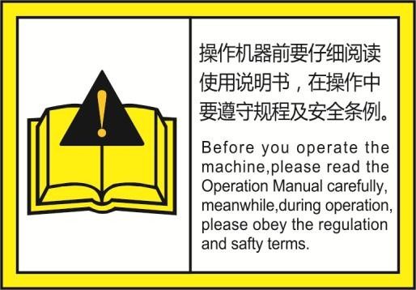
This machine is the equipment for grain processing, so it has serious requirements for the raw material, which should be go through separating, stoner, peeling, deashing, polishing etc. process. otherwise if the impurity rate is too high, or with much dust, will make the sorting effect worse.

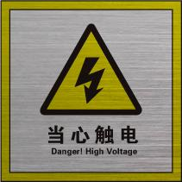

The machine has been adjusted as qualified before ex-factory. Owing to some reason that will make the data changed during the transportation, our engineer will debug again according to the material and environment in your factory. After the debugging, any dismounting is prohibited, or it will affect the life and normal operation of this machine.

Before operating the machine,please read the operation manual carefully,obey the regulation and safety terms during operation.

Pre-operation

Before operating the color sorter machine, we must make the belows ready:
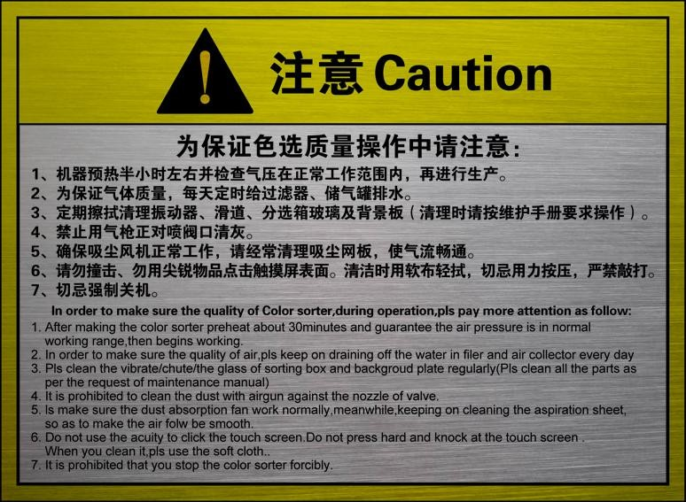

Inspect if there is any foreign body in the inlet, if yes, please remove.

Open the air compressor, adjust air compressor pressure gauge over 0.7MPA, (normally the first debugging, make air compressor max pressure as 0.8MPA.)
Confirm the pressure gauge(as figure 6-1) is set as 0.2-0.5MPA.If the compressor can

！
Caution
Usage for the air compressor, please check the instruction.

Before opening the air compressor, we need drain the wasted liquid every time.

not reach this standard, the whole machine can not work.Pressure gauge has been set as 0.5MPa when first sorting rice,users do not change please.

Ejector pressure gauge operating method: please pull off he lower side of the pressure regulating valve, then turn it. While clockwise, the pressure will enlarge, anti-clockwise, the pressure will reduce. When finished, please put it back.

If there is some leakage of air, please confirm all the leaking point is inserted and tightened well, attention, little leakage is normal.

Inspect if the waste liquid of air filter can flow out automatically, as figure 6-1.

Inspect that if there is some sundries or rice bran on the plate on the vibrator, channels and the surface of glass in the sorting box, please clean them with rag or air flower, do not clean them

with metal or other hard tools.

Confirm the socket of power supply is reliable.

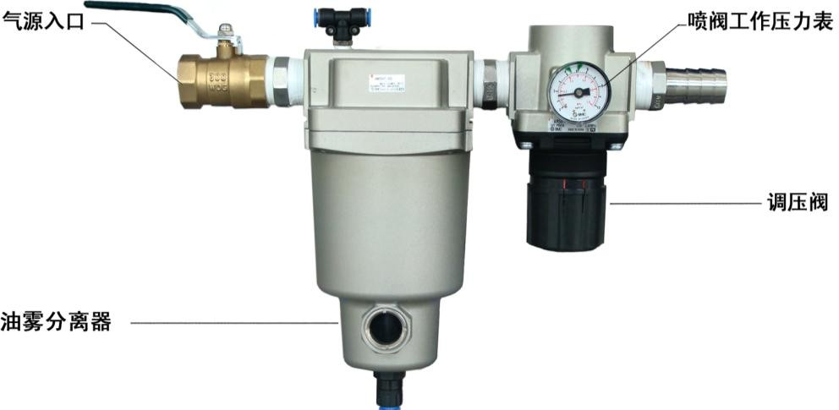
A
air entrance
B
pressure gauge
D
pressure regulating value
C
oil mist separator

Figure 6-1 Air path system
！
Caution
All hard tools is prohibited to clean the channels, or it will damage the surface of channels, and affect the sorting effect.

On and Off

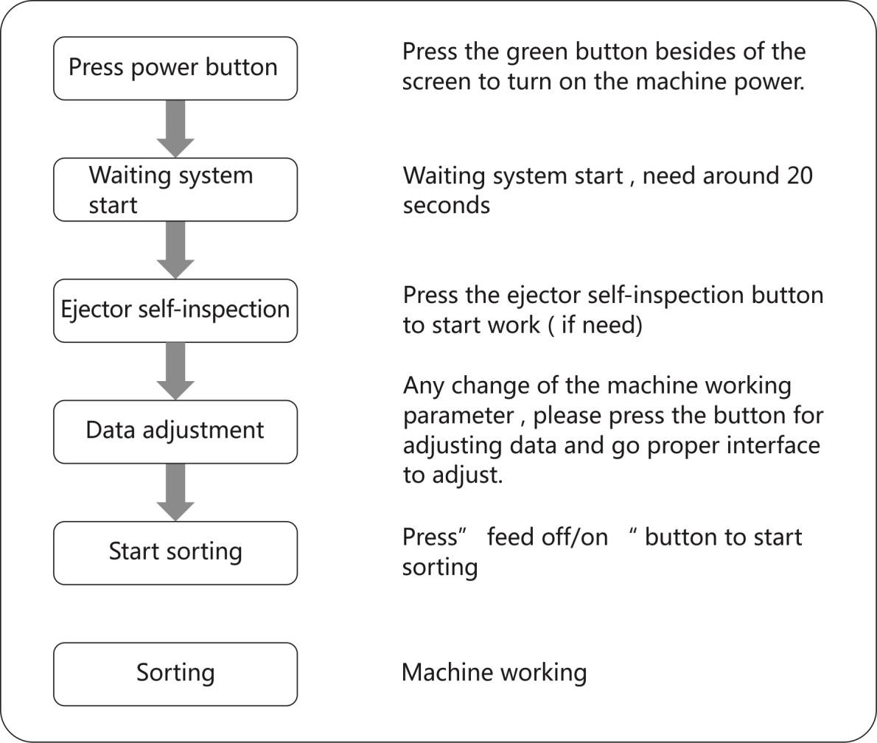
- Opening procedure

- Turn off procedure
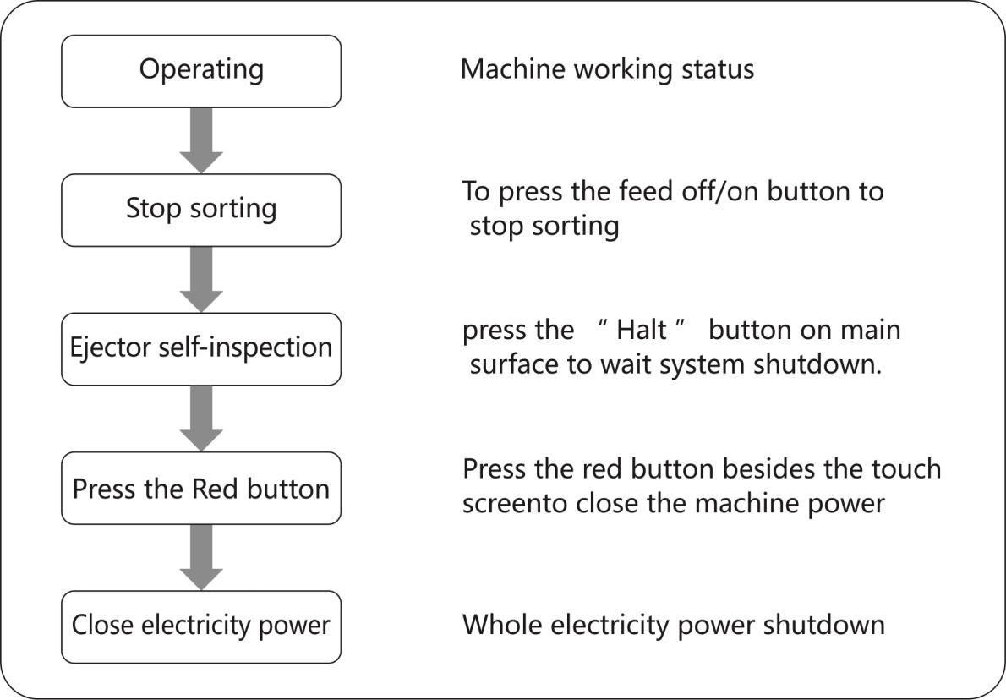

Please pay attention to the following tips when machine operating :

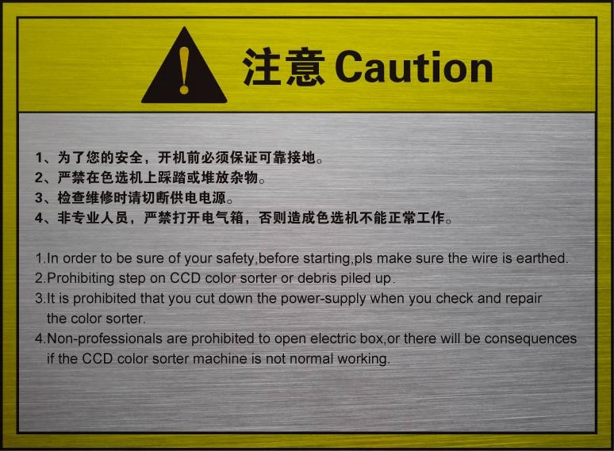

Setting and operation

Electric Data Setting

Operation interface
- Main interface
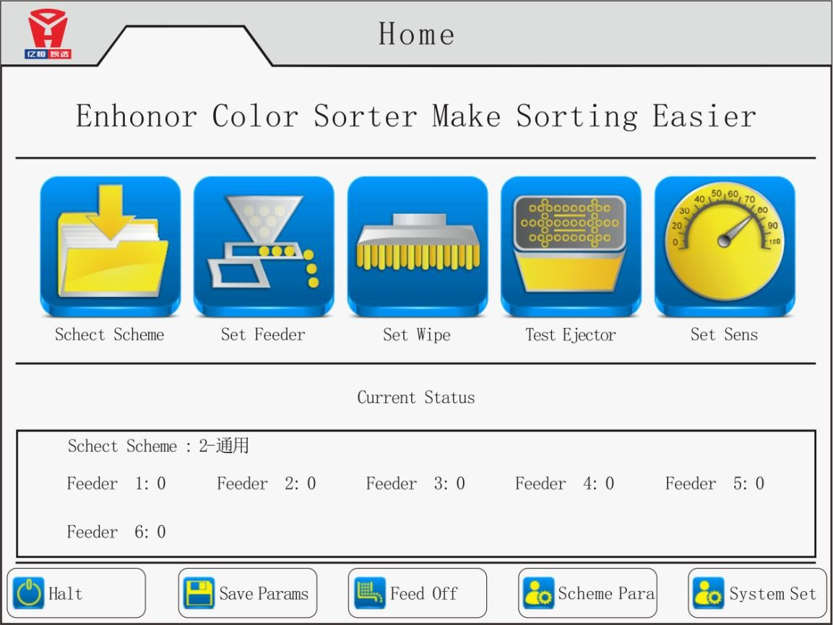
11

Figure 7-1 main interface

20 seconds after the opening power of the whole machine, it will show this main interface. There are following buttons in the main interface: Schect scheme, set feeder, set wipe, test ejector , set sens, Halt, save params, feed off, sechme para, system set

Schect Scheme：
This function selects the corresponding color sorting mode according to the current color sorting material, and clicks the "schect scheme" button to enter the interface; To choose proper schect scheme in this interface.

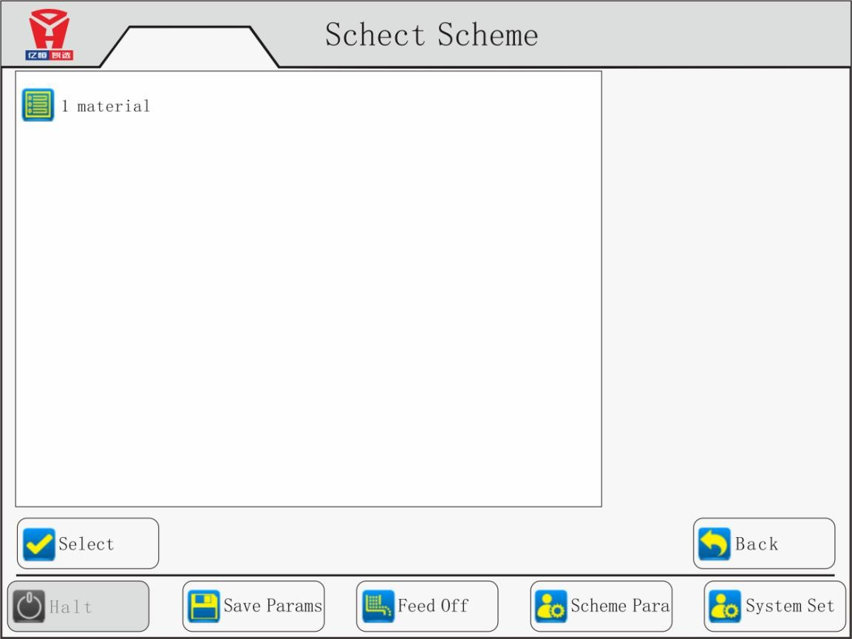

Set Feeder：
Press set feeder button in the main manu to enter set feeder interface, Feeding vibrators corresponding to each channel can be individually adjusted.
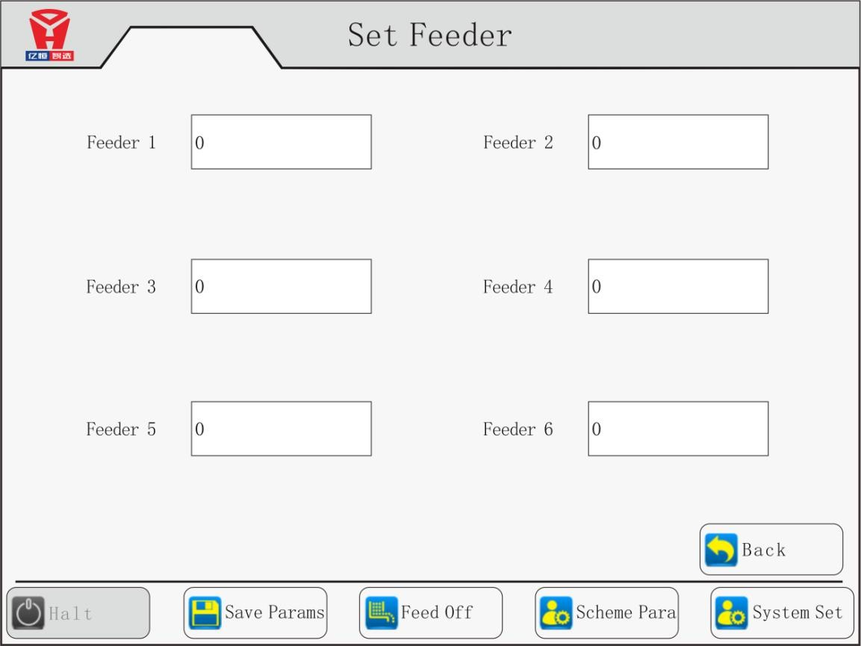

set wipe：
Press set wipe button in the main manu to enter set wipe inerface. This interface sets the time when the system automatically cleans a single cleaning time, in seconds; and the interval between two cleaning, in minutes;
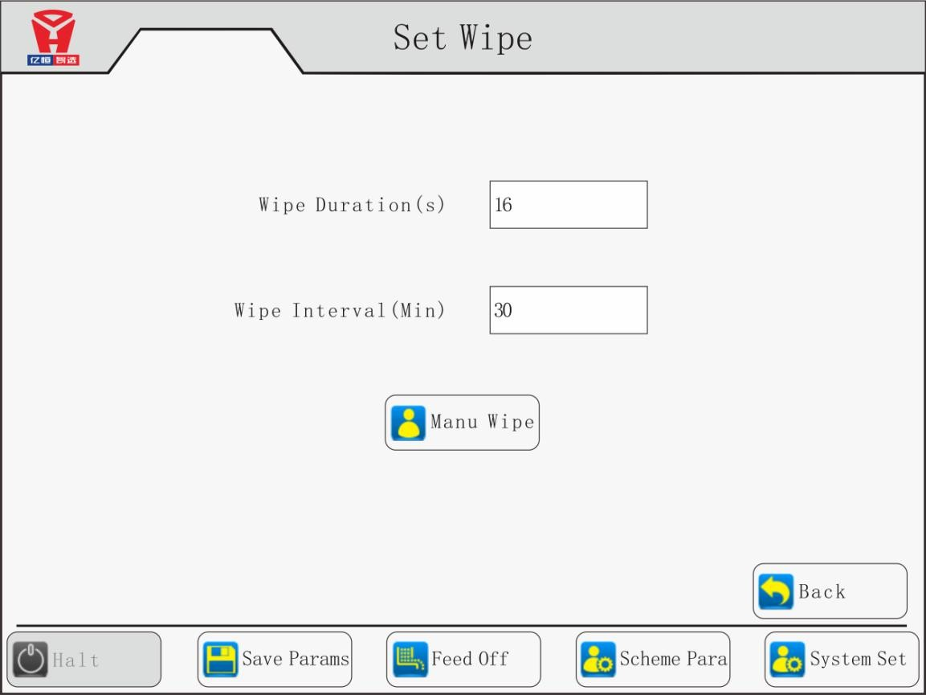

Test ejector：
Press test ejector button in the main manu to enter test ejector interface, In this interface the user can check whether the ejector is normal or not. If select single ejector detection button and click start, the user can carry out the nozzel detection for the currently selected ejector . If it is not selected, click Start, the system will automatically test the whole ejectors one by one from the current position .
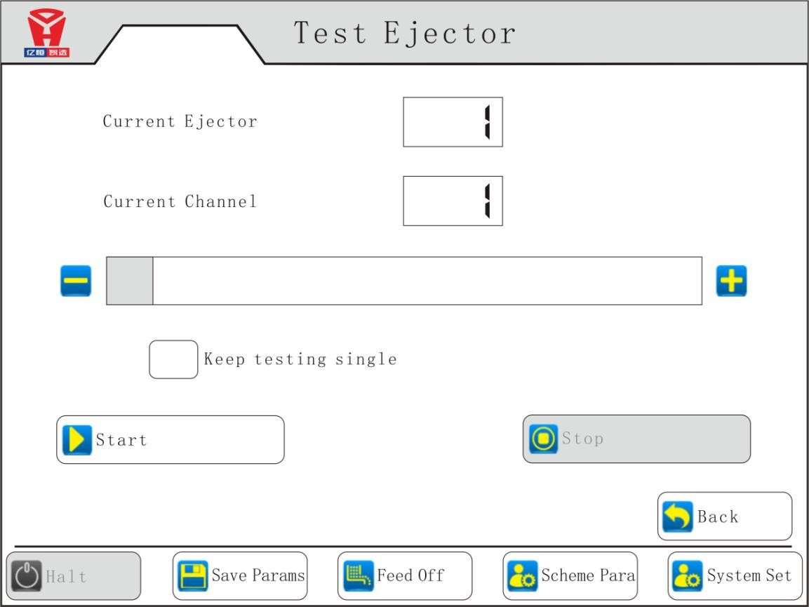

Set sens：
Press set sens button in the main manu to enter sensitivity setting interface. In this interface, the algorithm implementation selected in " Scheme params " -> "Recognition Parameters" is displayed. Contains common RGB algorithms, shape algorithms and other machine identification methods; in this interface, the user can adjust the material to be selected according to the accuracy requirements: sensitivity, size, defects and other values.
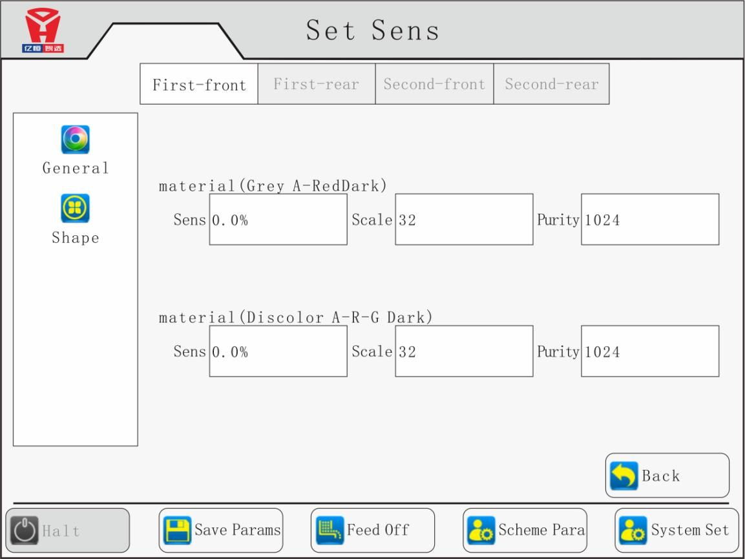

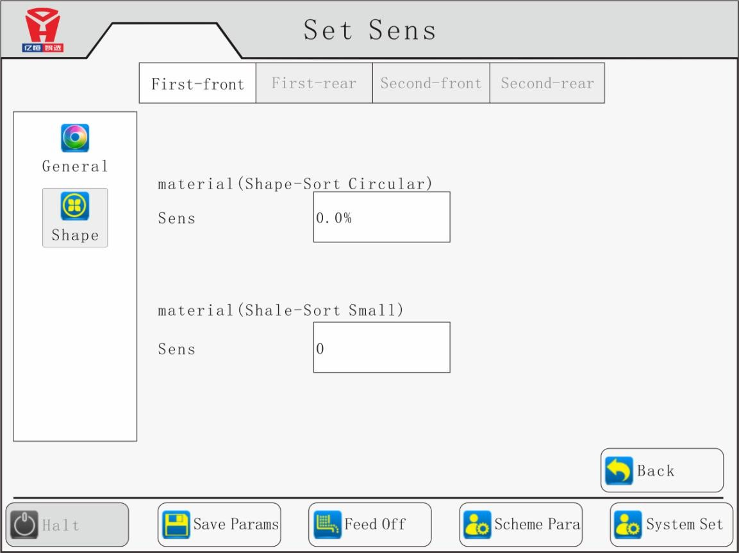

Scheme params：
Press scheme params button in the main manu to enter parameter setting interface. In this interface contains arith list, tick ,eject time, set lamp , background ,AI analysis .
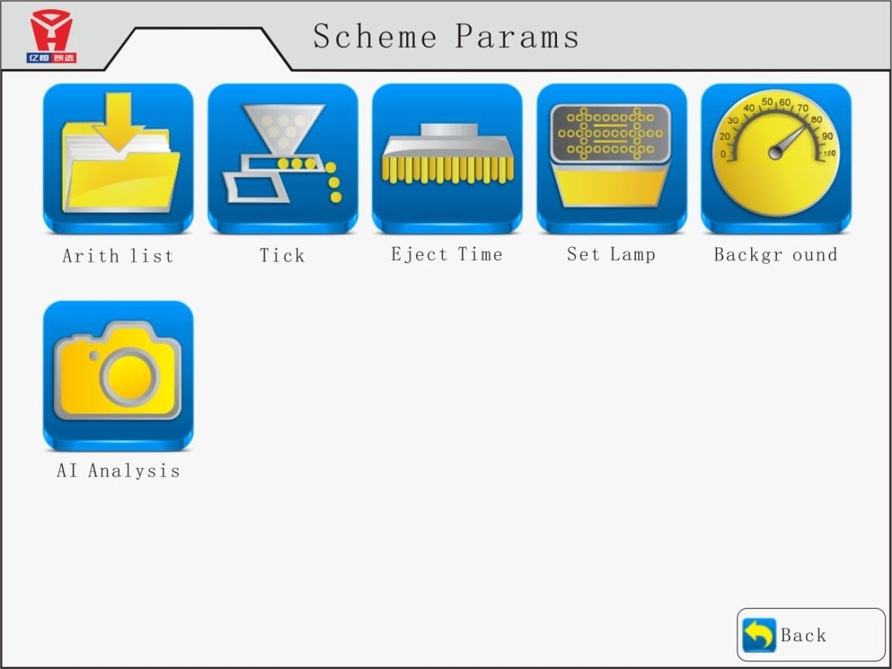

Arith List：
Press Arith List button to enter the recognition algorithm selection interface . In this interface, according to the characteristics of the current material needs, select the appropriate algorithm to identify; machine recognition algorithm includes gray A, gray B, Discolor A, Discolor B, shape , size . Press the corresponding button to enter the detailed setting interface of the selected algorithm; the interface includes sensitivity, size, flaw, and color mode; the setting mode is the same as the sensitivity setting mode;
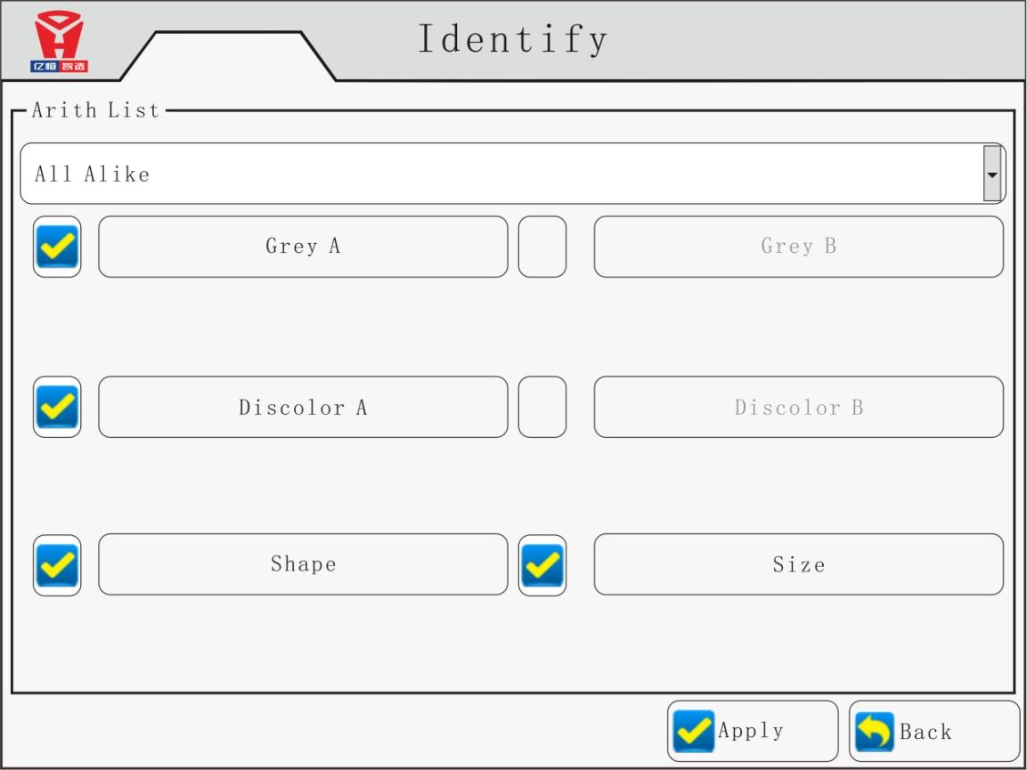

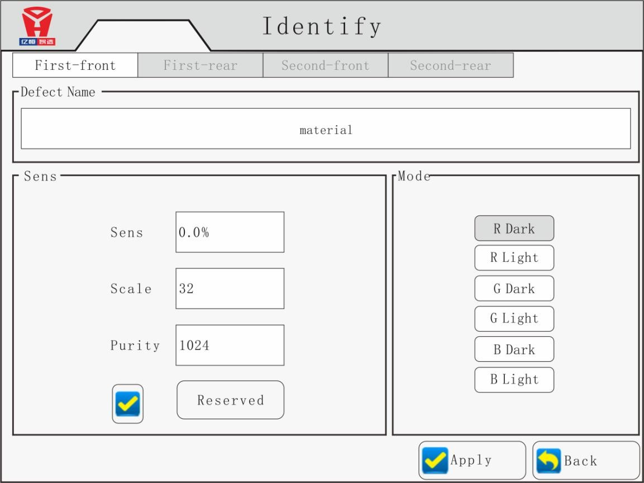

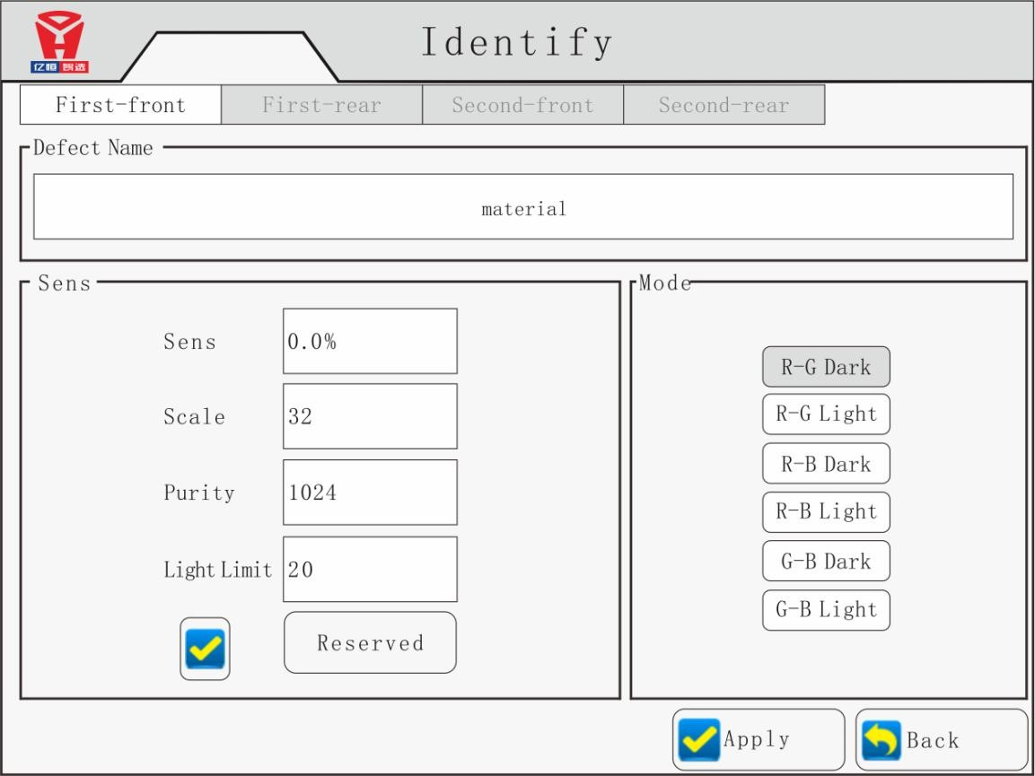

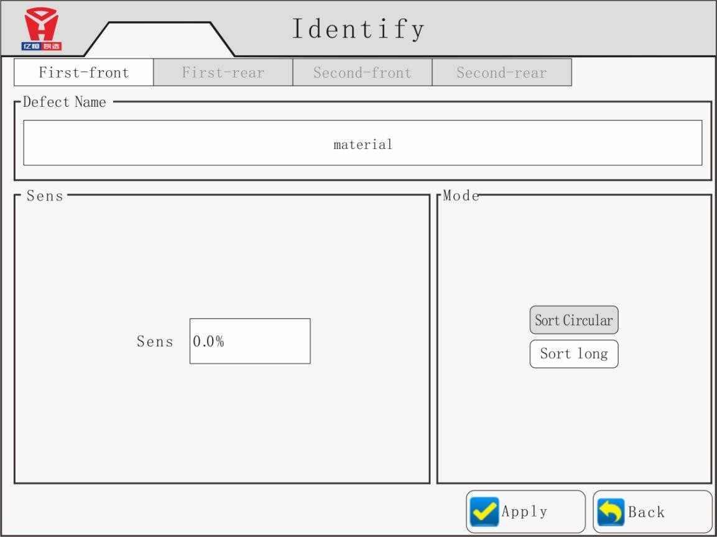

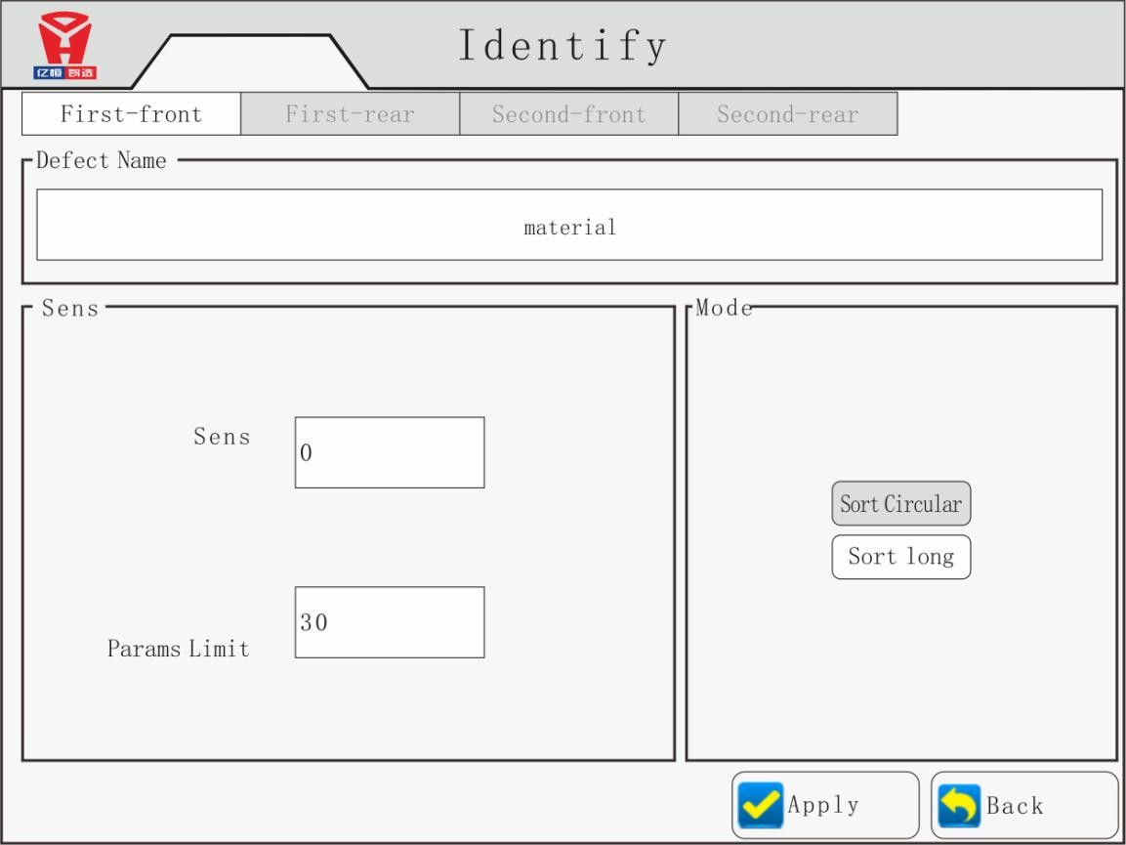

Tick：
ejector mode, infection , cut edge, relation , sort mode, bad number function available in this interface.
Saving and well-chosen two mode available re the eject mode , “saving “ to save the air consumption with better carryover , but with a slightly worse sorting accuracy of the final good. “Well-chosen “ with a slightly bigger air consumption but with better sorting accuracy and slightly worse carryover.

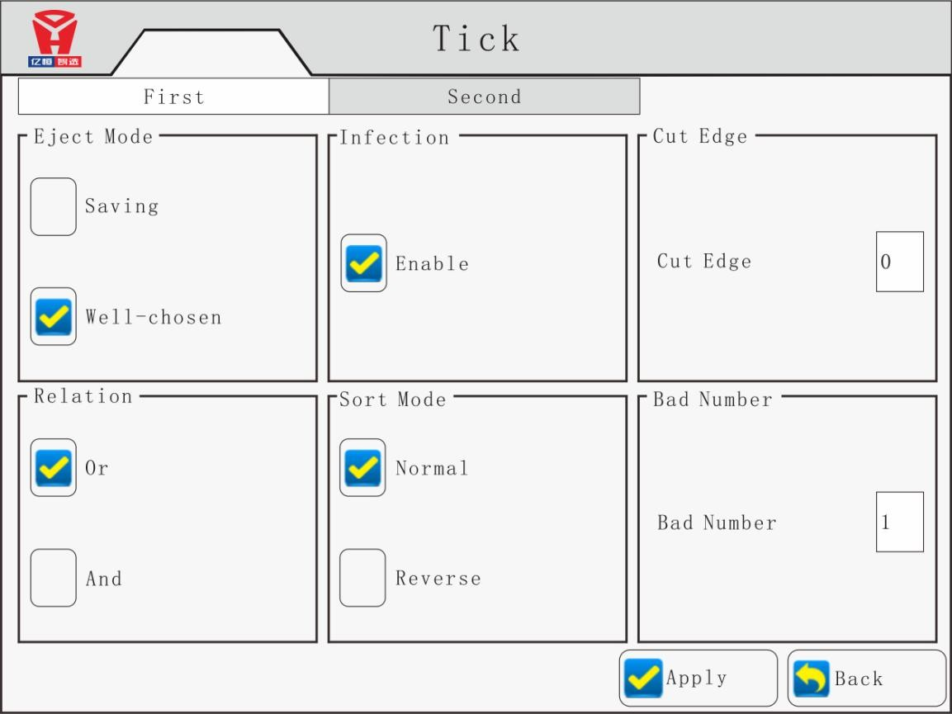

Eject time ：
Eject time interface can setting first sorting and second sorting ejector’s blowing time, as well as the ejector action delay time;
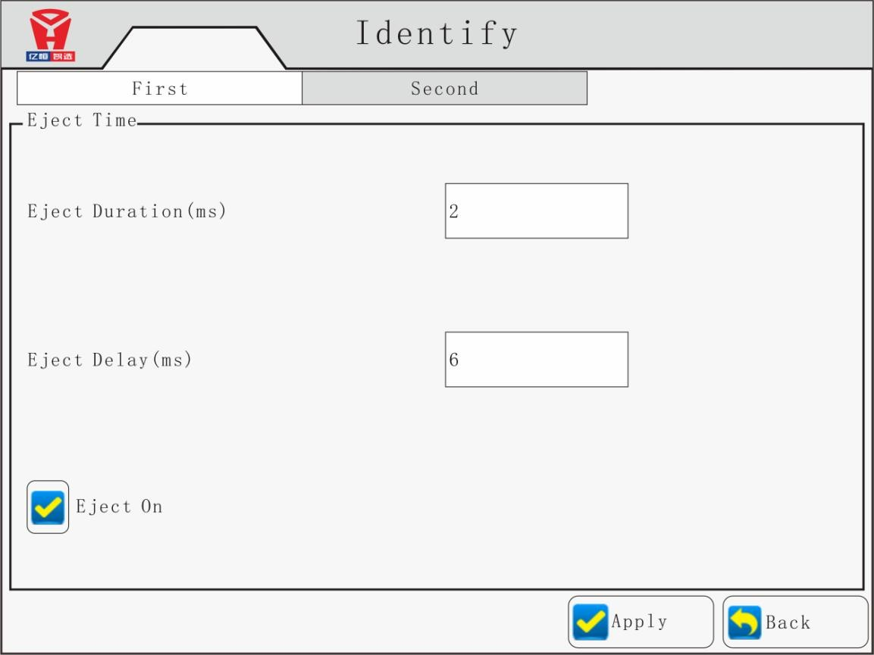

Set lamp：
In this interface is available to make setting of corresponding light on and off according to the current color sorting mode

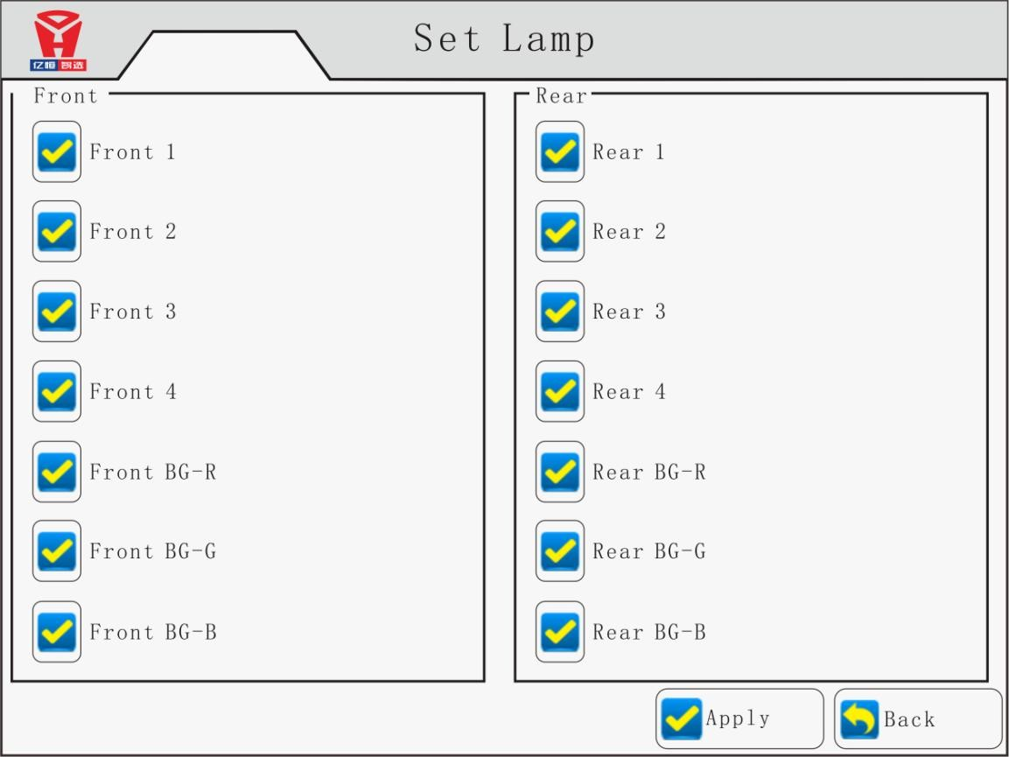

Background：
Adjust the background color, and set the identification parameters of the material reference background range, including the background color, background limits, background ratio and other parameters; to distinguish the background reference surface and the material.
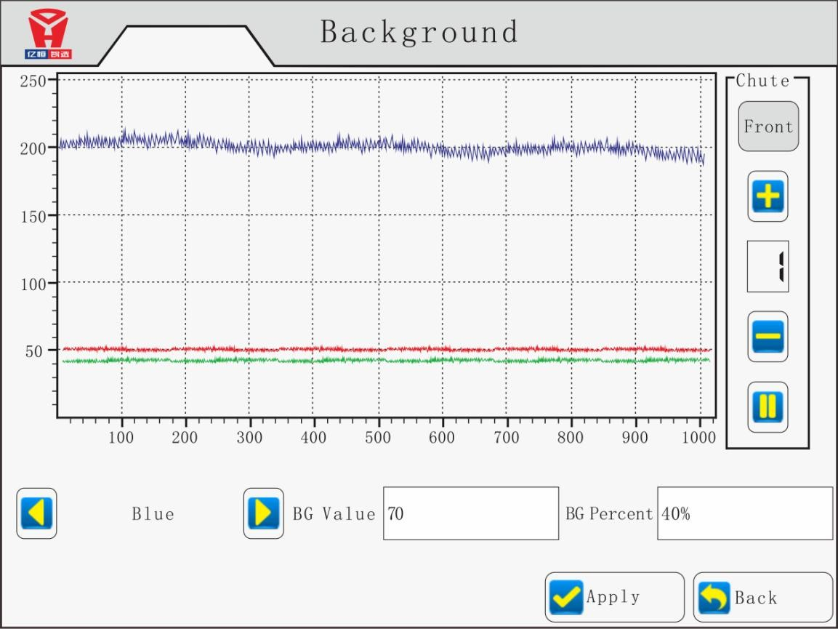

AI analysis：
Press "AI analysis" button to enter the AI camera interface, in this interface the operator can appoint which chute is currently used to take picture of material, and then click the "open camera mode" button, and then click the "capture" button, waiting for the material falling and capture the photo. Click the "capture" button there must be falling materials within 8 seconds, or the system will automatically exit the capture waiting process.
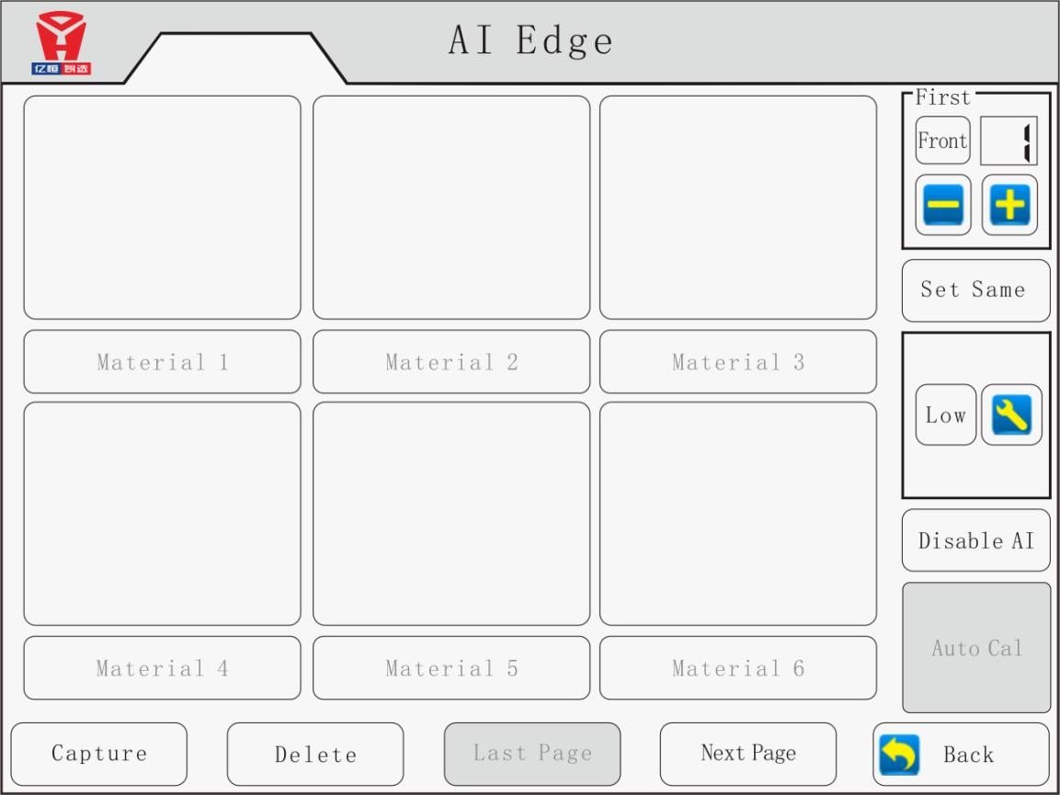

Set Language：
In this interface to choose the display language. Currently Chinese and English interface available . Default to Chinese interface.
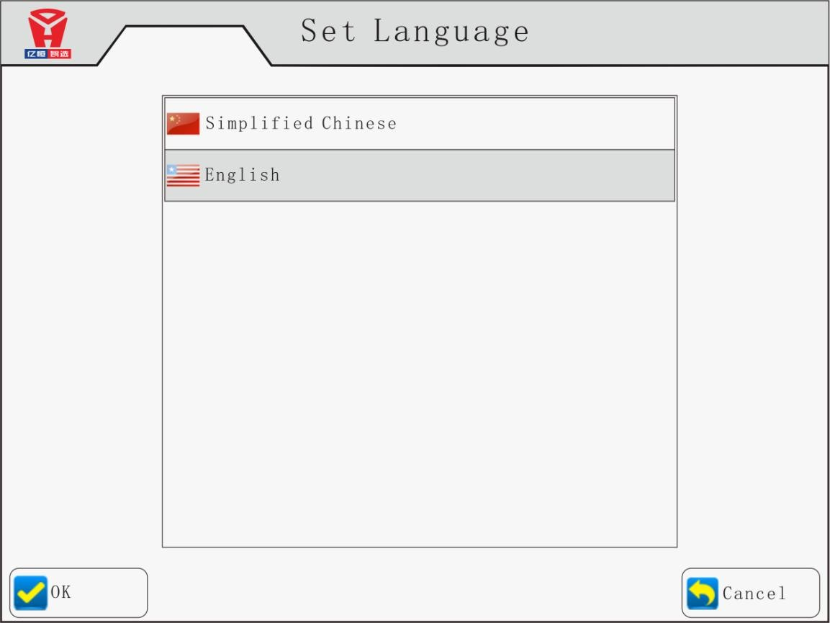

Set Product：
In this interface, the current machine model can be selected according to the actual number of channels of the machine; and the ratio of the current machine once, twice, three times (if necessary). As well as the number of nozzles in a single channel; It is well set when ex-factory.
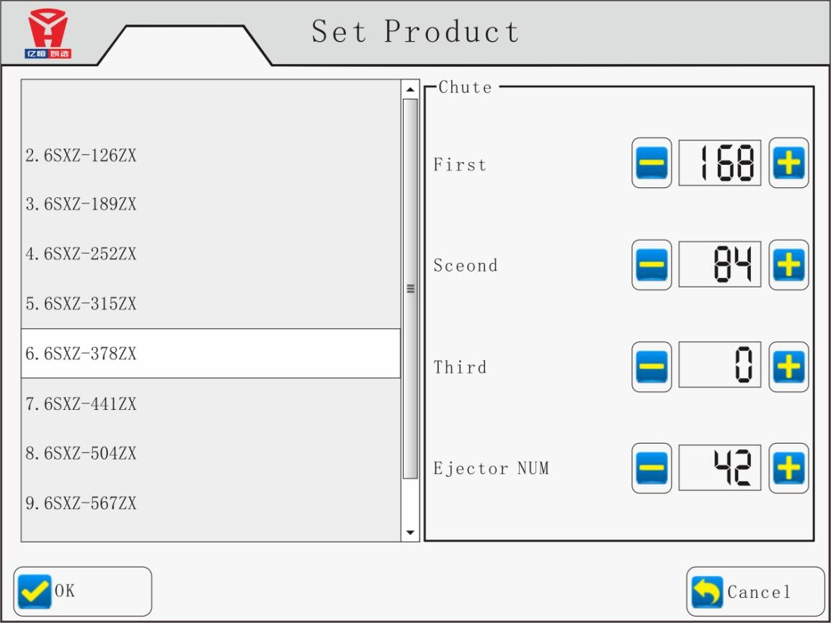

Set Lamp：
As the lighting system adopt high-tech electrodeless light adjustment system, according to the spectral properties of the sorting material to set the current mode of light brightness requirements, the factory has been set by default to 200. It is recommended maximum not more than 280 when adjusting the lighting brightness in order to ensure the light life.
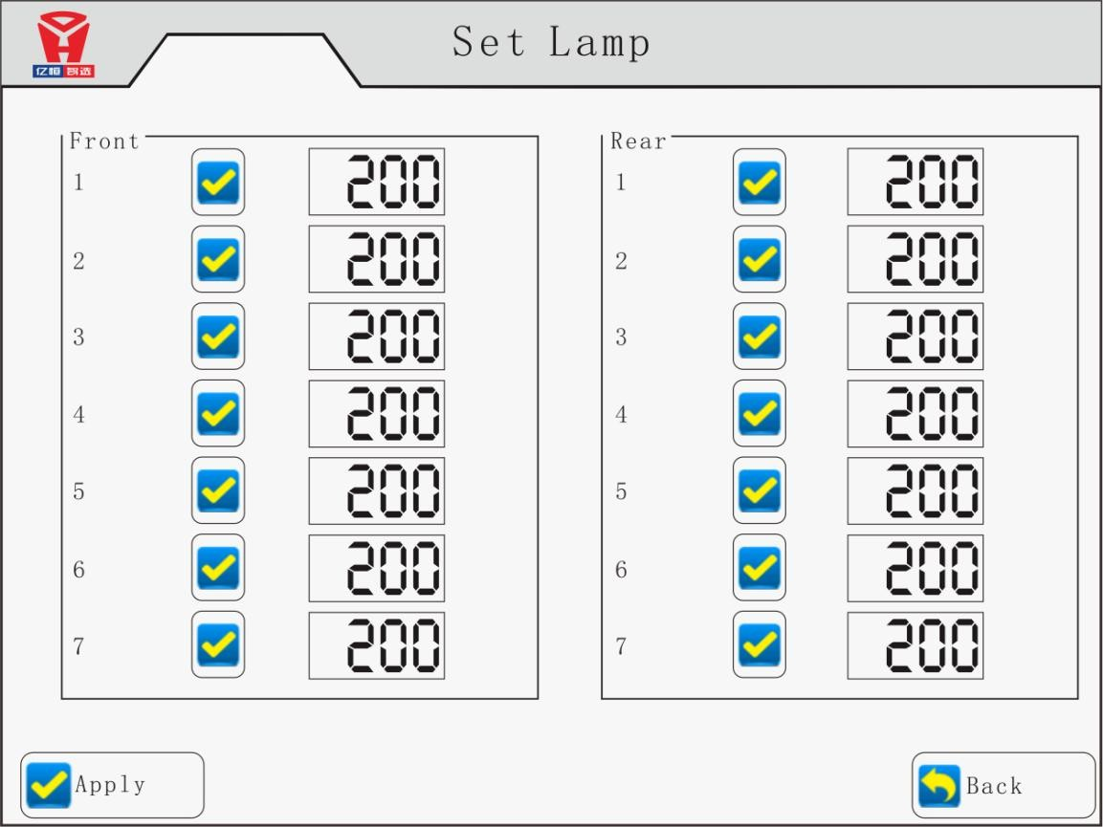

Set Pixel：
In this interface to set the pixel setting of the current single channel to ensure the calibration of the ejector and the sensor detection position of the current group of channels.
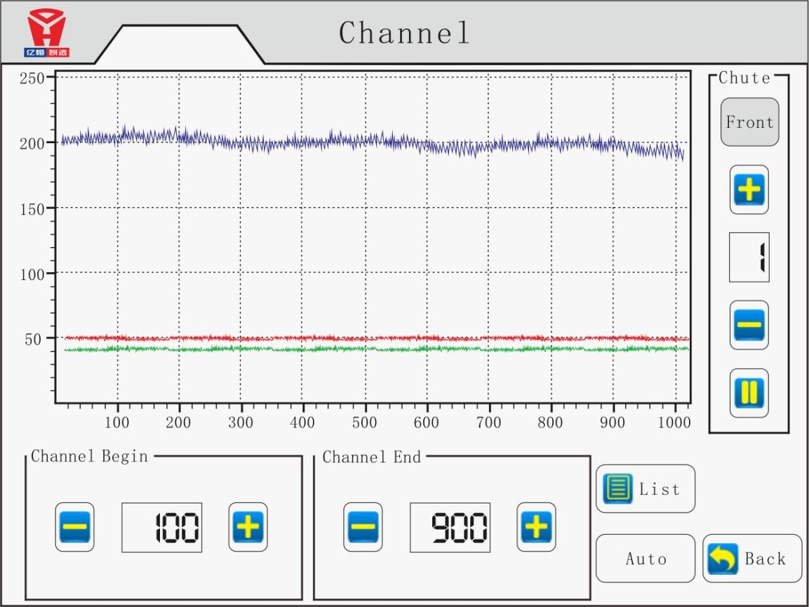

Additional Function

Heating device

color sorter provides chute heating function, to keep the heating temperature stable. Start heating device when chute is cool, need to wait a moment, when chute reaches suitable temperature then start sorting.

Dust-Wiping instruction

When machine is wiping, screen displays (cleaning dusty......, please wait a moment...).when wiping, interface don't appear.

Vibrator Adjusting
Touch and feel the vibrator by hand after turn it on and check whether the amplitude of vibration is
on the same lever, if not, please adjust it by rotating the screw. As figure 7-14, adjusting method： first loose the screw nuts □2 and bolts □3 (both side). Second adjust□1
rotate the adjusting bolt clockwise, the amplitude of vibration will increase, counter-clockwise slow, when adjust properly, tighten the adjusting nuts and bolts.

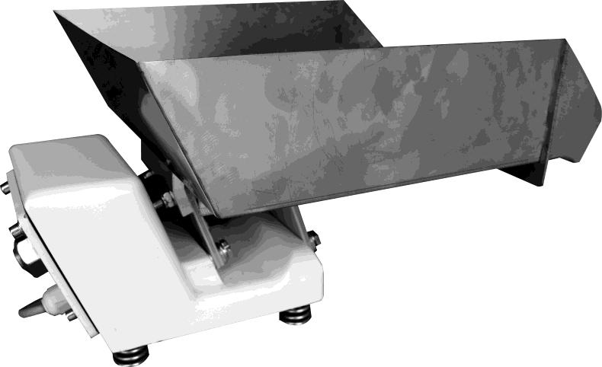

Figure 7-14 vibrator adjusting

Maintenance

Daily maintenance:

Use air gun to clean channels and sorting box and testing ejector before maintenance.
！
Caution
Absolutely do not use air gun to blow nozzle When using air gun to clean sorting box

Check the signal indicate (including work indicate, alarm indicate) and ejector action;
- Check air compressor, air pressure, oil temperature, machine noise, min 3 times to outlet water for air compressor each shift(8hours).
- 15 minutes after machine stopping, turn off power and air compressor, then outlet water for compressor.
- Use air gun to clean ejector, channels, sorting box and others dirty after power off.

- Use air gun to clean vibrator, machine inside, hopper and brush after power off.

Each week：
- Check filter core;

- Check cleaning brush.

Each half year：
- Change compressor oil.

Fault treatment and method

Machine has fault self-checking function, all the failed parts have corresponding alarm display, and may lead to machine stop. If so, please solve as below methods, if still can not be working, please Notify supplier immediately. users can solve general fault by himself, except for microcomputer control system breakdown.

Common faults treatment and method as follows:

Fault phenomenon | Reasons | Solving methods
The vibrator not working | Bad or fuse burned circuit | Repair or replace the fuse tube circuit
Ejector leak | Ejector have foreign matter | Blowback, Repeated testing  valve
 | Ejector part wear | Replacement
Ejector not shooting | The ejector wire connect not well. | Check with wires connected to  ejector.
 | Ejector core broken | Replacement
 | Control circuit board broken | Replacement
Ejector shooting weak | Ejector not in the specified position | Re-adjust or replacement
 | Pressure low | Check pressure gage
Material jump | Humidity is too big | Dehumidification or Dry
 | Chute is dirty | Use soft thing to clean chute
 | Chute scratches | Replacement
Display light and Ejector high frequency. | Led broken or poor connection | Check led and line connection
 | Sorting model choose wrong | Choose correct sorting model
 | Led power broken | Change led power
 | Background panel stuck | Repair
 | Background wave not adjust well | Readjust background panel
Circuit fault tips | Circuit fault | Contact us
Almost not sorting | Sensitivity low | Re-adjust
 | Background plate wrong adjustment | Re-adjust
Sorting performance worse and worse over a period of time | dust in sorting glass. | Cleaning glass and change  brush
 | Sensitivity, background panel data change | Re-adjust
 | Chutes without heating | check heating system
 | Brush damage | Replacement
The single side  performance not well | Cylinder cleaning not good,poor  performance | Adjust the brush and speed
Often shut down | Sensitivity too high | Re-adjust
 | Background plate waveform not well | Re-adjust
 | Impurity is too much | Reduce capacity
 | Lack of air pressure | check the air pressure，air path， and re-adjust
 | Pressure often protection | Keep the air path smooth or  change filter element.

Appendix 1:Color sorter Structural diagram ( ZX6)

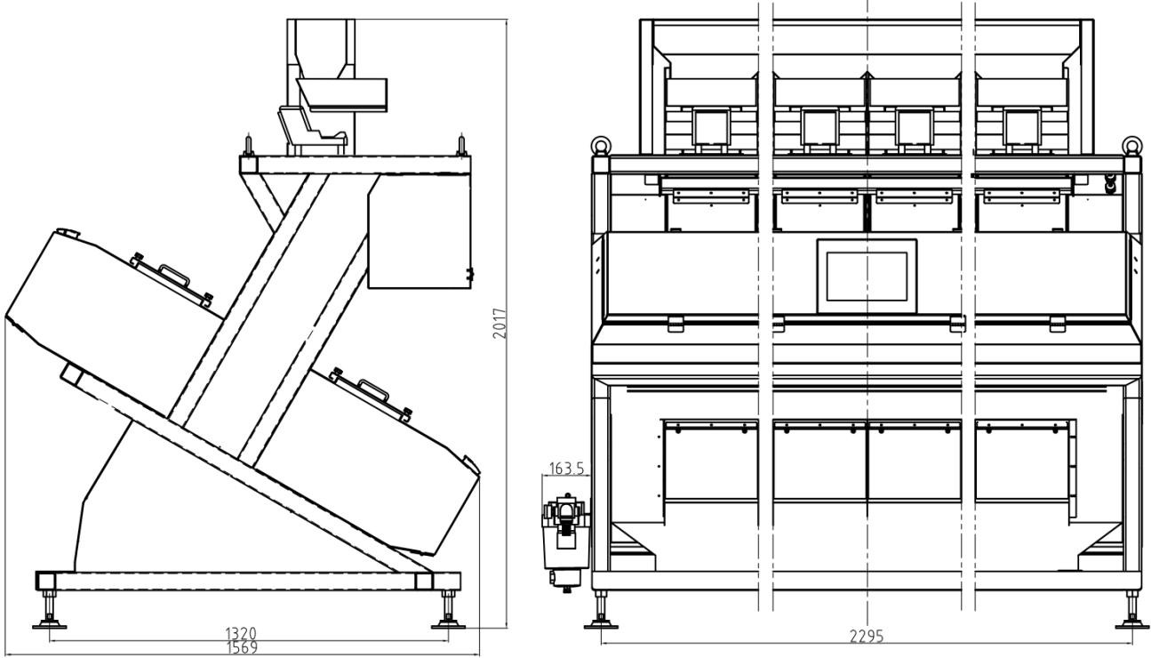

Appendix 2:Consumable parts list

NO. | Part NO. | Part name | AVG life | Judging method | Replacement method
1 | 084-02.GJB | Silicon rubber | Depend on the situation | unable to remove dust on the glass | Remove the brush ,replacement the  silicon rubber
2 | 084-02.06.BXS | Various  Fuse |  | Broken circuit | Replacement
3 | 084-02.GLQ | Filter component | 1000h or Half year |  | Replacement
4 | 084-02.WGQ | Rodless cylinder | 1200h | Cylinder can not drive  the brush to work normally | Remove and clean or contact us
5 | 084-02.DCF | Valve | 1 billion time | Can not work normally | Remove and clean or contact us

Appendix 3:Delivery list of color sorter’s accessories

NO. | Name | Model and Specification | Unit | Qty | Remark
1 | CCD  CCD Color Sorter | 6SXM-378（CCD） ZX6( RGB) | Pc | 1 | Color sorting equipment
2 | Air compressor | 2-15KW | Pc | 1
3 | Air tank | 1000L | Pc | 1
4 | Air tank accessories box |  | Box | 1 | Accessories box contains: pressure gauge, ball valve, safety valve, pressure vessel  quality certificate
5 | Key |  | Set | 2
6 | Air gun |  | Pc | 1
7 | Pipe connect | 8-02 | Pc | 2
8 | PU Spring tube | Φ8 | Pc | 1
9 | Double outer wire | 1.5" | Pc | 2 | For air compress or and air  filter grounded
10 | Main line filter | YIigni 001 | Pc | 1 | Filter units
11 | Reducer | 3/4" reducer to 1" Stainless  steel | Pc | 3
12 | Double outer wire | 1/2" | Pc | 2
13 | Automatic drainer | AD402 | Pc | 1
14 | Quick Connector | Φ8 | Pc | 2
15 | 1”rubber tube | 3m+10m | Pc | 13
16 | 1”Stainless steel ball  valve |  | Pc | 1
17 | Clean brush rubber | No card slot | Pc | 1
18 | Teflon tape |  | Box | 5
19 | Allen wrench |  | Set | 1
20 | User manual | Chinese vision or English vision | Set | 1

Other Accessory: 1 pc vertical type 6200mm elevator, 1pc storage hopper

Appendix 4: sorting accuracy and carryover

一 、 sorting accuracy
1、Definition: after sorting, accepted material is expressed as a percentage.
2 、 Sorting accuracy examination : color sorter mark a single rice as raw material, different color particles in the raw material content is 1%, input Capacity is 30 kg/h ~ 45 kg/h per channel, after 0.5 h running , to get original sample from accept outlet and more than 0.5kg per time, and get one time each 10 minutes. a total of three times. Original sample selected by GB5491, 50 g sample taking, according to the GB5496 pick out the different color particles, then According to the following formula:
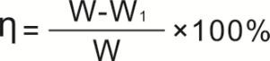

η- sorting accuracy
W₁ - discolored materials quantity W - sample materials quantity
When sorting accuracy η is bigger or same as standard, that is accept

二 、 carryover
1、Definition: after sorting, in rejection, percentage of discolor material to accept materials

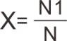
2 、 calculating : color sorter mark a single rice as raw material, different color particles in the raw material content is 1%, input Capacity is 45 kg/h ~ 50 kg/h per channel, after 0.5 h running , to get
original sample from rejection outlet and more than 30s per time, and get one time each 15 minutes. a total of three times.Original sample selected by GB5491, 50g sample taking, according to the GB5496 pick out the different color particles, then According to the following formula:
X - carryover
N1- discolored materials quantity in rejection N - accepted materials quantity in rejection
That is accept when x≥carryover of standard. That is accepted

