TM-035
HAZELNUT HARVESTINGMACHINE
USER MANUAL

Index

- PRODUCT DESCRIPTION AND TECHNICAL SPECIFICATIONS
- TERMS OF USE
- SAFE USE RULES
- OPERATION AND USE OF THE MACHINE
- MAINTENANCE

- PRODUCT DESCRIPTION AND TECHNICAL SPECIFICATIONS
CYCLON MAINTENANCE COVER FAN

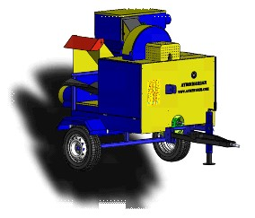
SEPERATOR FLAP
SUCTION FAN MAINTENANCE FAN
PTO DRIVE SHAFTS
(TRACTOR TAIL SHAFT)

TRACTOR TOW BAR

MAINTENANCE COVER 1

HOSE CONNECTION PIPE
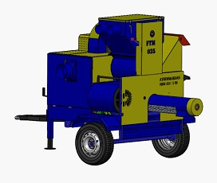
CELL WHEEL
SACK CONNECTION PART
SEPERATORFLOW ADJUSTMENT ARM
MAINTENANCE COVER 2
FAN EXHAUST OUTPUT
DUST, SOIL ETC. DUMPING PART (SIEVE)

- TERMS OF USE
This manual will give you an overview of the operationand maintenance of the machine. If you encounter anytechnical problems, please contact us.
—This machine has been designed as HAZELNUT COLLECTING MACHINE and it is used according to the safety instructions in this manual.
— Our company is not responsible for any damage when the machines not used as specified. The responsibility is fully owned by the user.
— The usage, maintenance and repair materials recommended by the manufacturer are an integral part of machine operation.
— Machine must be used by the experts who know the machine. Maintenance and repair must be done by experts.
— The manufacturer is not responsible for any damages caused by modifications are made without prior approval of the manufacturer.

3- SAFE USE RULES
—Read this manual until you fully understand the control and operation of the machine. Learn how to control and stop the machine.
—Be sure to follow the general traffic rules on roads that are open to traffic.
—Those under 18 years of age and who do not know the machine cannot use the machine.
—Make sure that there are no people on the machine during operation.
—Always wear work gloves while working not to cause any injuries.
—Always use original spare parts for safe operation.
—Never operate and use this machine in confined areas. (Exhaust gas is harmful to health.)
—Check the tightness of all fasteners.
—Never leave the machine running without user.
—If there is jamming and clogging while working, stop the machine and remove the blockage.
—Install the shaft without starting the anchor motor.
—Do not remove the original parts of the machine. Do not repair and modify.

4- OPERATION AND USE OF THE MACHINE

USAGE OF THE SHAFT
The tractor must not be in operation during installation or removal of the shaft. There must be no one else around the shaft when there is a process on it. The shaftcontinues to rotate for a while due to the centrifugal effect after the tractor tail shaft movement has been interrupted. During this time the machine is not approached. Any action can be taken after the shaft has stopped completely. When installing the shaft on the tractor, be careful not to have any people around and the tail shaft must never be operated on the permitted speed.

FIXING OF THE MACHINE TO TRACTOR
Tractor and machine must be positioned parallel to each other before fixing. Machine’s tow bar is connected to tractor’s drawbar.The fixing foot on the machine is lifted by the lever on it.Mounting of shaft is done from power take-off shafts.

COMMISSIONING OF THE MACHINE

All bearings in the drivetrain are lubricated with grease before the machine starts. It is enough to pump the grease oil 2 or 3 times with the pump.
Covers on both sides of the machine will not open when the machine is running.
If there is any problem with the machine's drivetrain, the problem will be solved when the machine is in stop position.
If there is any blockage or dirt in the cyclone tank or in the spiral augersieve section that serves as cleaning and unloading, it must not be intervened without stopping the tractor.While machine is operating, there must be an operator with it, and children and unconscious people should be kept away from the machine.

COLLECTING OF HAZELNUTS

—The tractor tail shaft must not be driven suddenly when commissioning. (The instantaneous cycle will cause the wheels to warm up and burn.)
This machine is used at min 400rpm.
—The sack is attached to the sack tie section at the end of the spiral auger sieve.
—Hoses are connected to start the collection process.
—When the soil is wet, the collection efficiency of the machine can be reduced. That’s why, when the soil is dry, it should be preferred.
—If there is any problem in the drivetrain of the machine, the tractor will be stopped and intervened.
—The customer will inform the producer about the any problem in the machine.
—When the collecting hoses are clogged, remove the hoses from the connection points. After cleaning the hose, connect it to the device again.
—During the collection process, clean the outlet of the leaves and dust part not to cause fill up. There is a routing cover under the outlet of the leaves, dust etc. It must be controlled oftenly and cleaned.
—When the hazelnuts are damp, the flap and covers are opened and the blowing is increased.Thus,dust, leaves etc are adhered to hazelnuts due to the moisture, are thrown out.As the hazelnuts dry, the flaps and covers are slightly close to reduce blowing. It this way, it is prevented to trown out the good hazelnuts with dust and leaves.

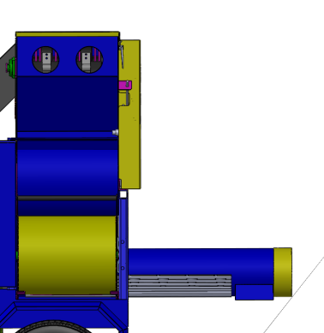
BLOWING FAN FLAP SETTING

CLOSE

OPEN

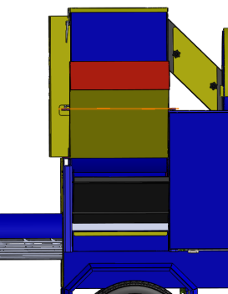
SEPERATORFLAP ADJUSTMENT

5-MAINTENANCE

Clean the machine before each use.

Before every use,grease all bearings inside the machine.

Before every use, control the oil level of the tractor.

Please control the bearins and V-straps in every 24 hours. Check the strap tension.

Check and tighten all bolts in every 24 hours.

Change the V-straps after the usege for 360 hours.

Change the bearings after the usage for 720 hours.

Inspect and maintain the machine at the end of each year.

If not used for a long time, clean the machine indetail, oil and keep it water-free environment.Pressurized water can be used, but after cleaning you must be sure to dry thoroughly and oil the connection parts.

STRAP LIST

STRAPS
SUCTION FAN | 17X1725 | 4 PCS
TRANSMISSION 1 | 17X1850 | 4 PCS
TRANSMISSION 2 | 17X1100 | 3 PCS
BLOWING FANI | 17X1125 | 1 PCS
SPIRAL (AUGER) | 17X1875 | 1 PCS
CYCLONE | 12,5x1325 | 1 PCS
6-WARRANTY CONDITIONS
—The machine is out of warranty if used without the initial start-up specified in this manual.
—The device is under warranty of our company together with all its parts.
—The manufacturer's liability does not cover damage to persons and wares during the use of the machine, even if it depends on defect or manufacturing defects. Therefore, the costs of damages occured directly and indirectly will not be paid.
—If there is a problem on the machine during the warranty period, spare parts will be supplied as free of charge.
—If any changes have been made to the machine, if the machine has been subject to an accident, if the maintenance has not been done by the authorized persons of the installation company, if there is modification and repair has been made without the approval of the manufacturer, the warranty will not valid.

