**T2**

**SELF-PROPELLED HAZELNUT COLLECTING MACHINE**

**USER MANUAL**

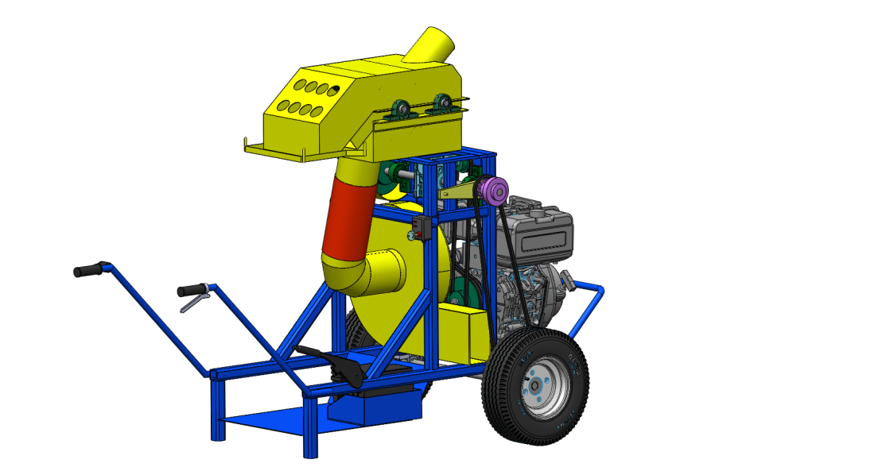

**Index**

1. PRODUCT DESCRIPTION AND TECHNICAL SPECIFICATIONS
2. TERMS OF USE
3. SAFE USE RULES
4. OPERATION AND USE OF THE MACHINE
5. MAINTENANCE
6. WARRANTY

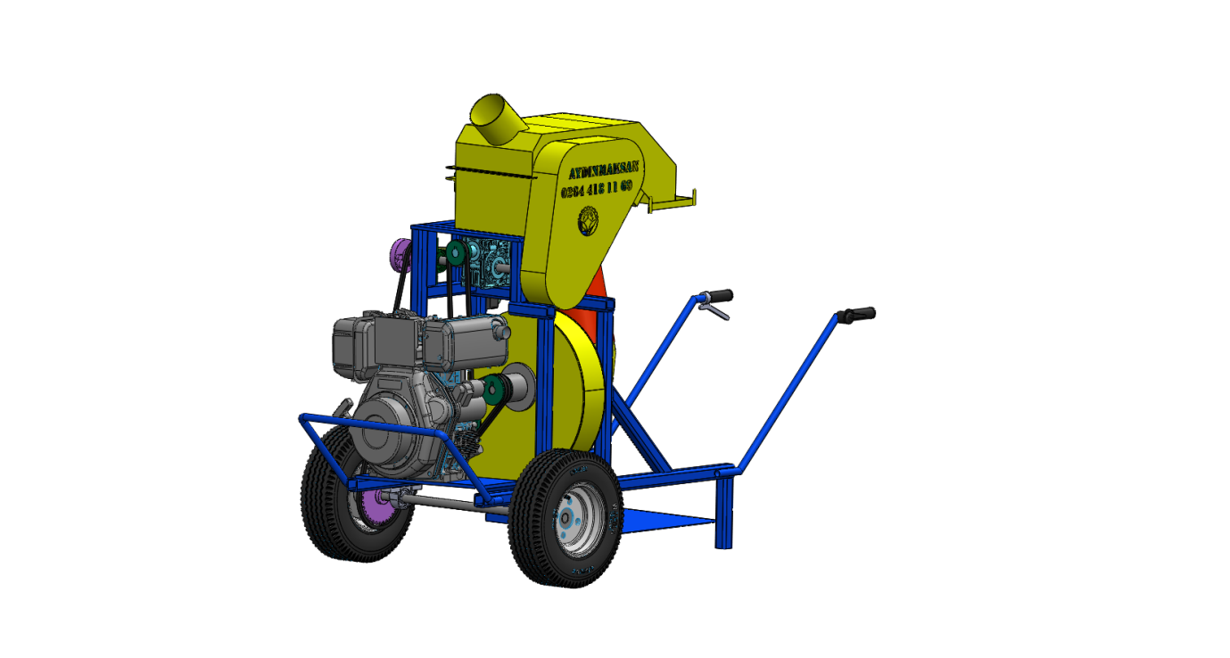

**1-PRODUCT DESCRIPTION AND TECHNICAL SPECIFICATIONS**

CYCLON MAINTENANCE COVERFAN

SACK CONNECTION PINS

HOSE CONNECTION PIPE

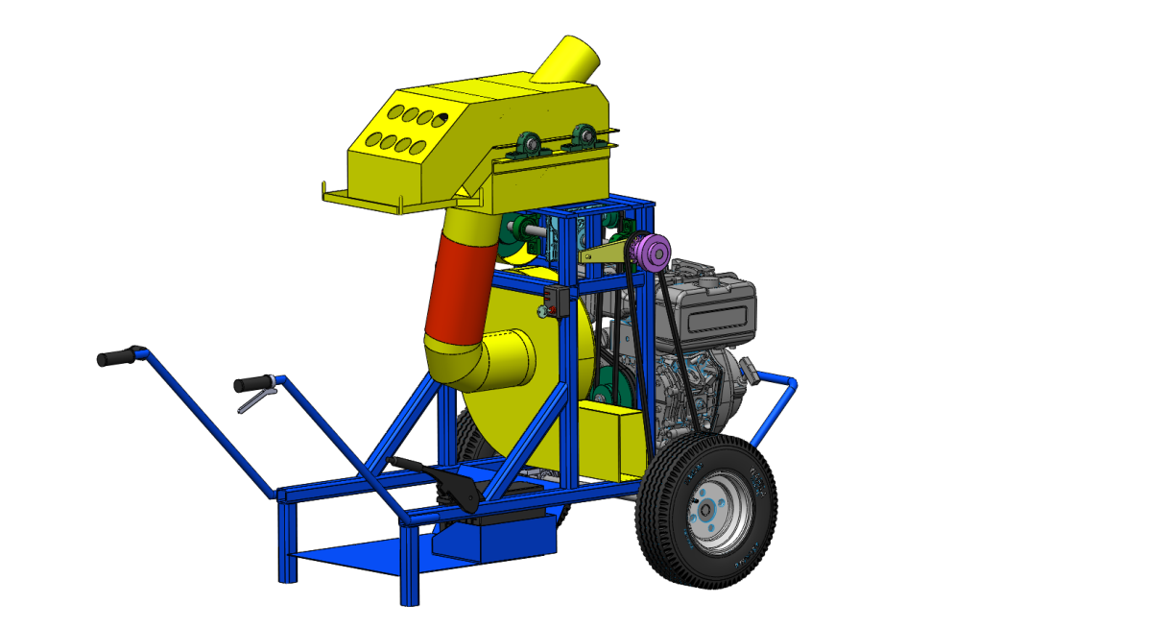

FAN EXHAUST OUTPUT

DIESEL ENGINE

SUCTION FAN MAINTENANCE COVER

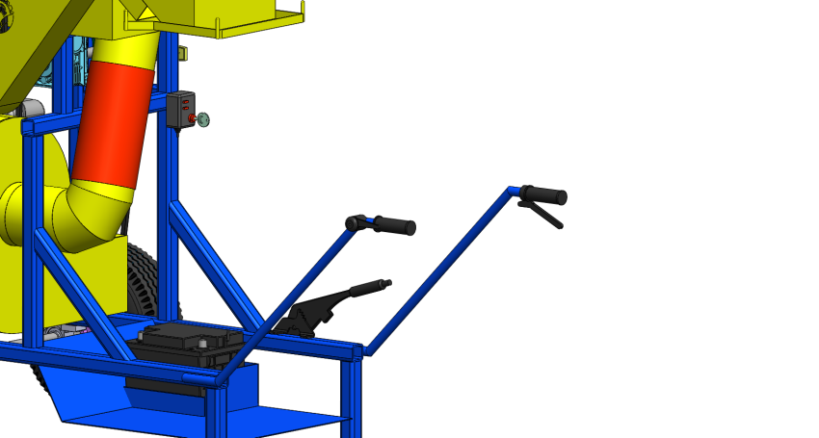

KICK-STARTER

ENGINE GAS LATCH

PROPULSION LATCH

ENGINE TENSIONER ARM

**2- TERMS OF USE**

This manual will give you an overview of the operationand maintenance of the machine. If you encounter anytechnical problems, please contact us.

—This machine has been designed as HAZELNUT COLLECTING MACHINE and it is used according to the safety instructions in this manual.

— Our company is not responsible for any damage when the machines not used as specified. The responsibility is fully owned by the user.

— The usage, maintenance and repair materials recommended by the manufacturer are an integral part of machine operation.

— Machine must be used by the experts who know the machine. Maintenance and repair must be done by experts.

— The manufacturer is not responsible for any damages caused by modifications are made without prior approval of the manufacturer.

**3- SAFE USE RULES**

—Read this manual until you fully understand the control and operation of the machine. Learn how to control and stop the machine.

—Be sure to follow the general traffic rules on roads that are open to traffic.

—**Those under 18 years of age and who do not know the machine cannot use the machine.**

—Make sure that there are no people on the machine during operation.

—Always wear work gloves while working not to cause any injuries.

—Always use original spare parts for safe operation.

—Never operate and use this machine in confined areas. (Exhaust gas is harmful to health.)

—Check the tightness of all fasteners.

—Never leave the machine running without user.

—If there is jamming and clogging while working, stop the machine and remove the blockage.

—Install the shaft without starting the anchor motor.

—Do not remove the original parts of the machine. Do not repair and modify.

**4-BEFORE THE COMMISSIONING OF THE MACHINE**

According to the maintenance parameters in the engine operating and maintenance manual, the engine oil must be checked, the filters cleaned and liquid fuel added.

All bearings in the drivetrain are lubricated with grease before the machine starts. It is enough to pump the grease oil 2 or 3 times with the pump.

Cover of the strap will not open when the machine is running.

Connect the sack to the connection pins.

Connect the hose to the pipe.

**COMMISSIONING OF THE MACHINE**

First movement is given to the engine by turning the kick-starter.

Wait until the engine warms up.

Give the gas to the engine by using the engine gas latch.

To supply power transmission from the engine, engine tension arm is pulled.

Now machine is activated.

**THE MOVEMENT OF THE MACHINE**

While low gas is given to the machine, tighten the propulsion latch to give movement to machine.

When the machine reaches the desired position, the tensioner latch is released.

Now machine will wait on stable position.

**COLLECTION OF HAZELNUT**

Gas is supplied to the engine at the desired distance for suction.

Hazelnuts are collected by vacuuming through hoses.

Dust and pacticles are smaller than hazelnuts are throwned out from the suction fan exhaust part.

Hazelnuts are gathered inside the sack.

When the sack is full, it is changed and continue to collection of hazelnuts.

**RECOMMENDATIONS FOR OPERATION**

When the soil is wet, the collection efficiency of the machine can be reduced. That’s why, when the soil is dry, it should be preferred for the collection.

When the collecting hoses are clogged, remove the hoses from the connection points. After cleaning the hose, connect it to the device again.

During the collection process, clean the outlet of the leaves and dust part not to cause fill up. There is a routing cover under the outlet of the leaves, dust etc. It must be controlled oftenly and cleaned.

**5- MAINTENANCE**

SNELL

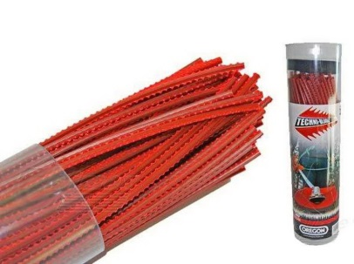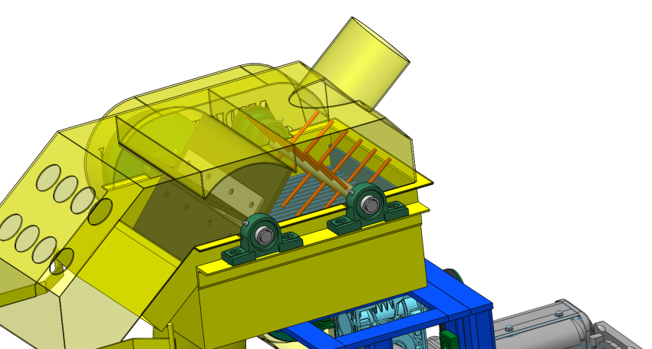

CYCLONE

AIR LOCK PALLETS

BEARING GREASE FITTING

PRIMARY SUCTION PIPE

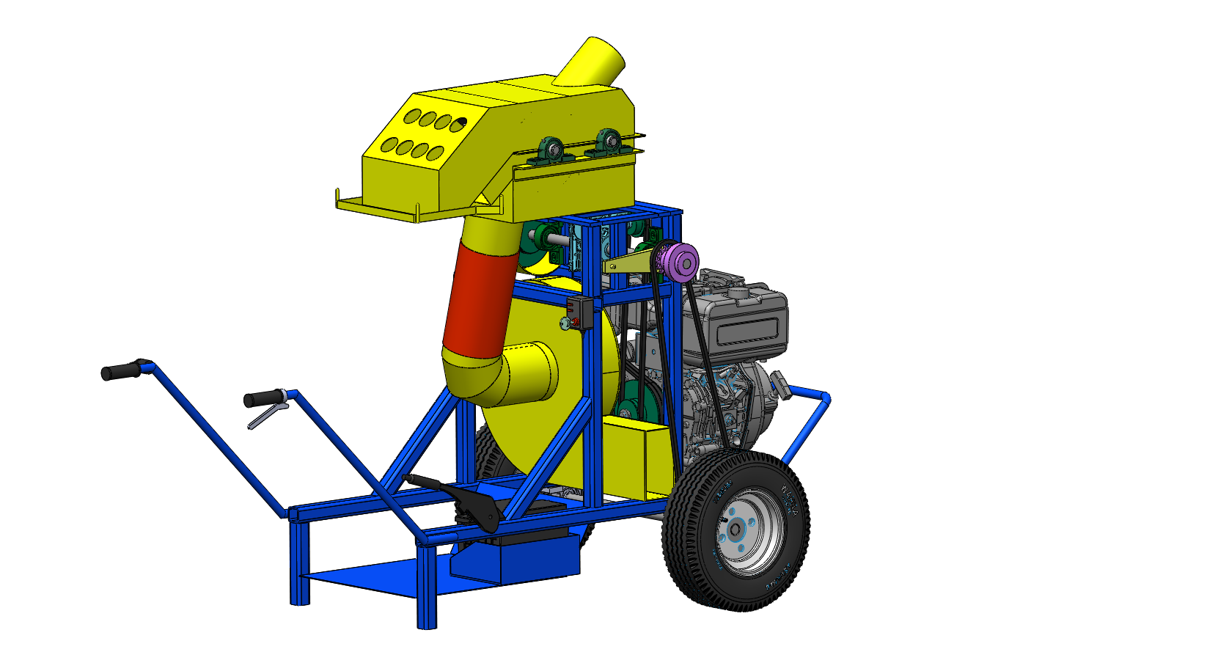

FAN MAINTENANCE COVER

FAN ELBOW

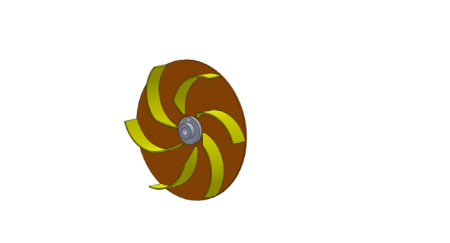

FAN ROTOR

Clean the machine before each use.

Before every use,grease all bearings inside the machine.

Before every use, control the oil level of the tractor.

Before every use, open the cyclon maintenance cover and clean.

Before every use, control the fan elbow and red color suction hose and if there is mud inside it, clean.

(Note: Especially, if the weather is rainy and the field is wet, muds can be accumulate inside the hoses and harden. This case causes narrowing inside the pipes and hosesthis directly affects the suction capacity and causes the motor to be forced)

Please control the bearins and V-straps in every 24 hours. Check the strap tension.

Check and tighten all bolts in every 24 hours.

Change the V-straps after the usege for 360 hours.

Change the bearings after the usage for 720 hours.

replace the snells each time when it ruptures.

Change the air lock pallets after the usage for 720 hours.

In case of vibration in the machine, remove the fan rotor by opening the fan maintenance cover and make balancing.Due to the abrasion effect of the soil in the fan rotor, the wings will wear off over time. Replace the fan if there is wear on the fan blades.

CHECK THE ENGINE OPERATION ANDMAINTENANCE BOOKLET FOR THE DETAILED ENGINE MAINTENANCE.

Inspect and maintain the machine at the end of each year.

If not used for a long time, clean the machine indetail, oil and keep it water-free environment.Pressurized water can be used, but after cleaning you must be sure to dry thoroughly and oil the connection parts.

**6-WARRANTY CONDITIONS**

—The machine is out of warranty if used without the initial start-up specified in this manual.

—The device is under warranty of our company together with all its parts.

—The manufacturer's liability does not cover damage to persons and wares during the use of the machine, even if it depends on defect or manufacturing defects. Therefore, the costs of damages occured directly and indirectly will not be paid.

—If there is a problem on the machine during the warranty period, spare parts will be supplied as free of charge.

—If any changes have been made to the machine, if the machine has been subject to an accident, if the maintenance has not been done by the authorized persons of the installation company, if there is modification and repair has been made without the approval of the manufacturer, the warranty will not valid.