INSTRUCTION MANUAL

CONTENTS

Warranty 2
Introduction 3
Environmental protection 3
Specifications 3
Description of symbols 3
General safety instructions 4
Additional safety instructions for the inbuilt battery pack 5
Additional safety instructions for the charger 6
Additional safety rules for pole trimmers 6
General notes 7
Unpacking 7
Contents of carton 7
Know your product 8
Assembly 9
Adding chain oil 10
Charging the internal battery 11
Mixing the fuel 11
Filling the tank 12
Starting the pole saw 12
Warm start 13
When to recharge the batteries 13
Stopping the pole saw 14
Running in the engine 14
Changing of the saw chain 14
Working with the pole saw 15
Chain sharpening and maintenance 15
Pole saw maintenance 15
First time user 16
General inspection 16
Storage 16
Repairs 16

Introduction
Your new pole saw will more than satisfy
your expectations. It has been manufactured under stringent Quality Standards to meet superior performance criteria.
You will find your new pole saw easy and safe to operate, and, with proper care, it will give you many years of dependable service.
CAUTION. Carefully read through this entire Instruction Manual before using your new pole saw.
Take special care to heed the Cautions and Warnings.
Your pole saw has many features that will make your job faster and easier. Safety, performance, and dependability have been given top priority in the development of this pole saw, making it easy to maintain and operate.

Environmental protection
Recycle unwanted materials instead
of disposing of them as waste. All tools, hoses and packaging should be sorted, taken to the local recycling centre and disposed of in an environmentally safe way.

Specifications
Engine: 26 cc, 2 stroke
Max. engine speed: 8500 min-1
Idle speed 3000 min-1
Chain Bar Length: 10” (254mm)
Fuel tank capacity: 600 ml
Oil tank capacity: 120ml
Fuel Mixture: Unleaded Petrol/ 2-Stroke Oil (40:1)
Weight: 7.0kg

Description of symbols
The rating plate on your tool may show symbols. These represent important information about the product or instructions on its use.
Conforms to relevant safety standards.

Wear hearing protection. Wear eye protection.
Wear head protection.

Read these instructions for use carefully. Wear safety footwear.
Wear safety gloves. Warning.
Explosive material.
Use at a distance of at least 15 m from other people.

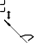DANGER! Risk of electrocution! Do not operate within 15m of overhead electrical lines.
15m

Keep hands away from moving parts.
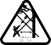
Do not stand under the branch you are cutting. Branches may fall without warning. Work at an angle of no more than 60°.

Noise label rating 85dBA (taken at 7.5 metres) you must wear ear protection at all times.

General safety instructions for handling power tools
WARNING: Read all safety warnings and all instructions. Failure to follow the warnings and instructions may result in electric shock, fire and/or serious injury.
This unit may not be used by people (including children) with reduced physical, sensory or mental capacities, with a lack of experience and without the appropriate knowledge, unless they are supervised by someone who is responsible for their safety or have been instructed by such a person with regard to how the unit is to be operated.
Children should be supervised to ensure that they do not play with the device.
Save all warnings and instructions for future reference

Work area safety
- Keep work area clean and well lit. Cluttered or dark areas invite accidents. Rags, cloths, cord, string and similar items should never be left around the work area
- Do not operate power tools in explosive environments, such as in the presence of flammable liquids, gases, or dust. Power tools create sparks, which may ignite the dust or fumes.
- Keep children and bystanders away while operating a power tool. Distractions can cause the operator to lose control.

Electrical safety
- Power tool plugs must match the outlet. Never modify the plug in any way. Do not use any adapter plugs with grounded power tools. Unmodified plugs and matching outlets will reduce risk of electric shock.
- Avoid body contact with grounded surfaces such as pipes, radiators, ranges and refrigerators. There is increased risk of electric shock if your body is grounded.
- Do not expose power tools to rain or wet conditions. Water entering a power tool will increase the risk of electric shock.
- Do not abuse the cord. Never use the cord for carrying, pulling or unplugging the power tool. Keep cord away from heat, oil, sharp edges or moving parts. Replace damaged cords immediately. Damaged or entangled cords increase the risk of electric shock.
- When operating a power tool outdoors, use an extension cord suitable for outdoor use. Use of a cord suitable for outdoor reduces the risk of electric shock.
- To reduce the risk of electric shock, the manufacturer recommends the use of a residual current of 30mA or less at all times.

Personal safety
- To reduce the risk of electric shock, the manufacturer recommends the use of a residual current of 30mA or less at all times.
- Stay alert, watch what you are doing and use common sense when operating a power tool. Do not use a power tool while you are tired or under the influence of drugs, alcohol or medication. A moment of inattention while operating power tools may result in serious personal injury.
- Use personal protective equipment. Always wear eye protection. Protective equipment such as dust mask,
non-skid safety shoes, hard hat, or hearing protection will reduce personal injures.
- Prevent unintentional starting. Ensure the switch is in the “off” position before connecting to power source and/ or battery pack, picking up or carrying the tool. Carrying power tools with your finger on the switch or energising power tools that have the switch on invites accidents.
- Remove any adjusting key or wrench before turning the power tool on. A wrench or key left attached to a rotating part of the power tool may result in personal injury.
- Do not overreach. Keep proper footing and balance at all times. This enables better control of the power tool in unexpected situations.

  - Dress properly. Do not wear loose clothing or jewellery. Keep your hair, clothing and gloves away from moving parts. Loose clothes, jewellery or long hair can be caught in moving parts.
  - If devices are provided for the connection of dust extraction and collection facilities, ensure these are connected and properly used. Use of dust collection can reduce dust-related hazards.

Power tool use and care
  - Do not force the power tools. Use the correct power tool for your application. The correct power tool will do the job better and safer at the rate for which it was designed.
  - Do not use the power tool if the switch does not turn it “on” and “off”. Any power tool that cannot be controlled with the switch is dangerous and must be repaired.
  - Disconnect the plug from the power source and/or the battery pack from the power tool before making any adjustments, changing accessories, or storing power tools. Such preventive safety measures reduce the risk of starting the power tool accidentally.
  - Store idle power tools out of the reach of children and do not allow persons unfamiliar with the power tool or these instructions to operate the power tool. Power tools are dangerous in the hands of untrained users.
  - Maintain power tools with care. Check for misalignment or binding of moving parts, breakage of parts and any other condition that may affect the power tool’s operation. If damaged, have the power tool repaired before use. Many accidents are caused by poorly maintained power tools.
  - Keep cutting tools sharp and clean. Properly maintained cutting tools with sharp cutting edges are less likely to bind and are easier to control.
  - Use the power tool, accessories and tool bits etc. in accordance with these instructions, taking into account the working conditions and the work to be performed. Use of the power tool for operations different from those intended could result in a hazardous situation.

Use and care of the battery pack
- Ensure the key switch is in the OFF position and the key is removed before connecting or disconnecting the battery pack.
- Recharging only with the charger specified by the manufacturer. A charger that is suitable for one type of battery pack may create a risk of fire when used with another battery pack.
- Use power tools only with specifically designated battery packs. Use of any other battery packs may create a risk of injury and fire.
- Avoid contact with any liquid that is emitted by a battery. If the battery pack is abused, liquid may escape from the battery. Liquid emitted from the battery may cause irritation or burns. If liquid comes into contact with the skin, wash the area immediately with soap and water,
and then neutralize the liquid with lemon juice or vinegar. If contact occurs, rinse thoroughly with running water. If liquid comes into contact with the eyes, rinse thoroughly with running water and seek medical help.
- Store battery pack in well ventilated, dry and cool conditions, and avoid direct sunlight and rain.

Additional safety instructions for the inbuilt battery pack
(Applicable if you have a Key Start unit only)
- The inbuilt battery pack for this tool has been shipped in a low charge condition. You should charge the battery pack fully before use.
- To ensure the longest battery life and best battery performance, always charge the battery when the air temperature is between 18–24°C. Do not charge the battery pack when the temperature is below 0°C, or above 40°C. This is important. Failure to observe this safety rule could cause serious damage to the battery pack.
- Do not incinerate the inbuilt battery pack even if it is seriously damaged or can no longer hold a charge. The battery pack can explode in a fire.

  - Never attempt to open the inbuilt battery pack for any reason. If the plastic housing of the battery pack breaks open or cracks, immediately discontinue its use and do not recharge it.
  - The inbuilt battery pack utilizes nickel-cadmium cells. Cadmium is considered to be a toxic material. Use an environmentally safe disposal unit at a municipal waste disposal centre to dispose of a damaged or worn out battery.
Additional safety instructions for the charger (Applicable if you have a Key Start unit only)
  - Before using the charger, read all the instructions and cautionary markings on the charger as well as the instructions on using the battery pack.
  - Only charge your pole saw indoors as the charger is designed for indoor use only.
  - WARNING. Do not allow any liquid to come into contact with the charger. There is a danger of electric shock.
  - To allow the appliance to cool down after charging, do not place it in a hot environment such as a metal shed or open trailer left in the sun.
  - The charger is not intended for any use other than charging the exact type of rechargeable appliance as supplied with the charger. Any other use may result in the risk of fire, electric shock or electrocution.
  - The charger and appliance supplied with it are specifically designed to work together. Do not attempt to charge
the battery pack with any other charger than the one supplied.
  - Do not place any object on top of the charger as it could cause overheating. Do not place the charger near any heat source.
  - Do not pull on the lead of the charger to disconnect it from the power source.
  - Make sure that the charger cable is positioned where it will not be stepped on, tripped over or otherwise subjected to damage or stress.
- Do not use an extension cord unless it is absolutely necessary. The use of an improper extension cord could cause the risk of fire, electric shock or electrocution.
- Do not use the charger if it has been subjected to a heavy knock, dropped or otherwise damaged in any way. Take the charger to an authorised service centre for a check or repair.
- Do not disassemble the charger. Take it to an authorised service centre when service or repair is required. Incorrect re-assembly may result in the risk of fire, electric shock or electrocution.
- To reduce the risk of an electric shock, unplug the charger from the power supply before attempting to clean it. Removing the charging appliance alone does not reduce the risk.
- Never attempt to connect two chargers together.
- Do not store or use the tool in locations where the temperature may reach or exceed 104°F (40°C) such as alongside sheds or metal structures in the summer.
- The charger is designed for use from a standard household electrical supply (230–240 volts). Do not attempt to connect the charger to a supply with a different supply.

Additional safety rules for pole trimmers
For your own safety, please note the included general safety information, and please also note these additional advices:
- Always wear a helmet and safety gloves when working with the pole saw.
- We also recommend strongly wearing eye protection to keep oil spray and sawdust out of your eyes.
- Never use the pole saw while standing on a ladder.
- Do not use the pole saw in rain.
- Do not stand under the branch you are cutting. Branches may fall without warning. Work at an angle of no more than 60°.

  - Do not use the tip section of the chain and bar. Kickback can occur in these conditions.
  - Keep your eyes not only on the branches you are cutting, also keep an eye on the ground to prevent tripping over branches that already have fallen.
  - Always wear gloves when handling the pole saw chain.
Danger!

BEWARE oF KICKBACK!
WARNING! Kickback can lead to dangerous loss of control of the pole saw and result in serious or fatal injury to the saw operator or to anyone standing close by. Always be alert. Rotational kickback and pinch kickback are major chainsaw operational dangers and the leading cause of most accidents.

General notes
The pole saw is a rugged, powerful device, but you should nevertheless note a few words of advice. Always make sure that there is enough oil in the oil tank.
Before using the pole saw to cut, always check the oil is being pumped onto the chain. Do not use the saw if the chain is not oiling. If the chain is not oiling, turn off the motor and remove and clean the bar mount and bar. Some light smoking is inevitable and no reason for concern. Lift off the black plastic cover after every use and clean the area under it. Also clean the pinhole in the oil container lid after each use. Keep the groove in the guide bar clean at all times.
If the unit fails to oil the chain properly it may well be that the groove is full of saw dust and bark shavings. Remove the chain and clean out the groove with a suitable tool or blow it out with compressed air. To keep the unit at top performance the chain must be sharp.
If you notice that the unit’s performance is not as it should be and the chain does not cut into the wood by itself,
the chain should be sharpened. Either use a saw chain sharpener or have the chain sharpened by a professional.

Unpacking
Due to modern mass production techniques, it is unlikely that your Power Tool is faulty or that a part is missing. If you find anything wrong, do not operate the tool until the parts have been replaced or the fault has been rectified. Failure to do so could result in serious personal injury.

Contents of carton
The electric pole saw is supplied with the following accessories as standard.
- 1 x J Handle Assembly (including mounting screws x 2 & bracket x 2)
- 1 x Tube Spanner / screw driver combination
- 2 x Hex Keys
- 1 x 10mm Spanner
- 1 x Shoulder Strap
- 1 x Mixing bottle with 40:1 markings

Know your product
  - Motor housing
  - On/Off switch
  - Oil Mix Container
  - Throttle trigger
  - Safety lever
  - Main handle

14 4
33
- Air filter cover 28
- Primer 1
- Chain drive cover
- Spark plug/spark plug cover 6
- Spanner 5
- Chain drive sprocket 22

  - J Handle
  - Shoulder strap
  - Upper shaft
  - Lower shaft
  - Shaft pin lock
  - Chain bar
  - Blade cover
  - Throttle lock button
  - Oil tank
  - Tube spanner /screw driver combination
  - Chain
  - Shaft locking knob
  - Chain tensioner screw
  - Chain cover nut
  - Fuel tank
  - Fuel tank cap
  - Choke lever (Red lever)
  - Hex key x 2
- Shoulder strap attachment
- Oil adjustment screw
- Recoil Starter
2

18
31

7

9

11

14

21 25

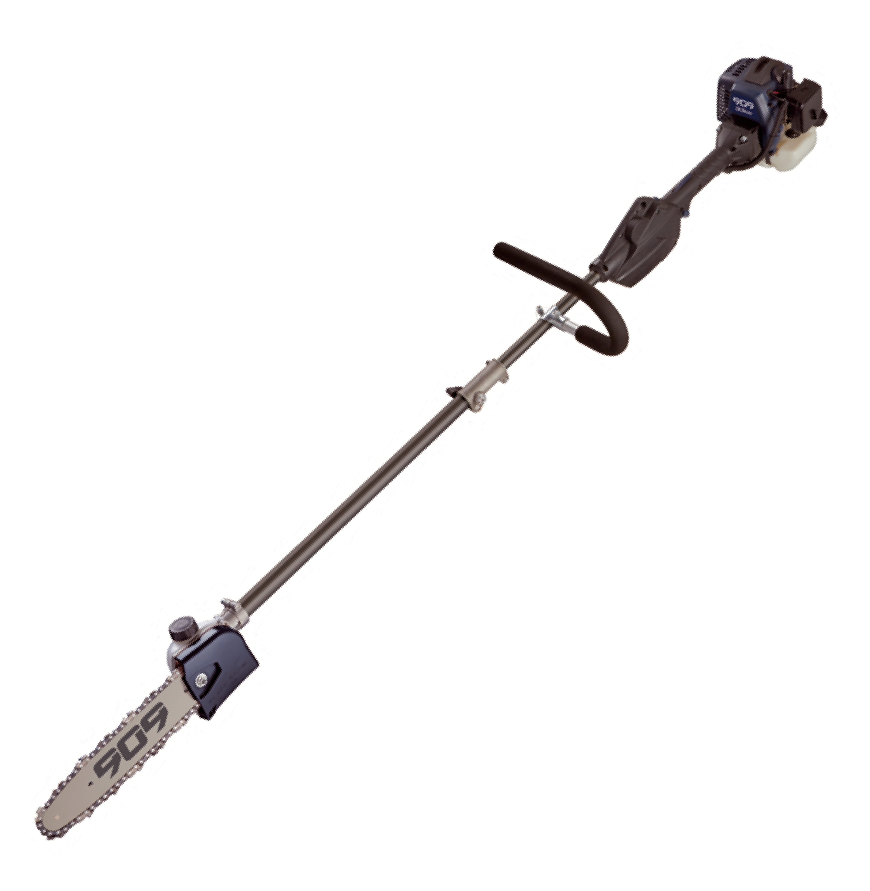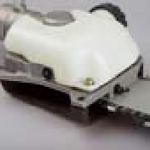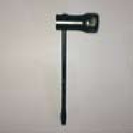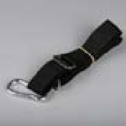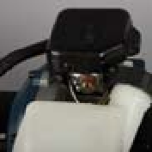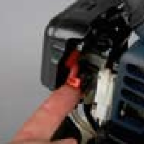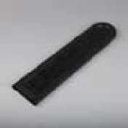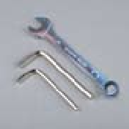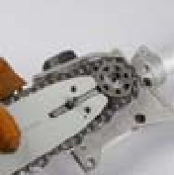10

29

24
23
30

18
13
26
3

15 27

20

12
16
8

17 32

19

8

Assembly
This product is partially assembled.
Prior to use, it is necessary to assemble/fit the upper shaft (9), lower shaft (10), J handle (7), chain (17) and chain bar (12).
Fitting the chain and chain bar
- Remove the chain drive cover nut (20) with the spanner supplied (29) and remove the chain drive cover (27).

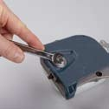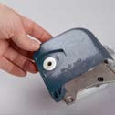
1
1
- 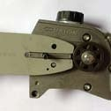Place the bar on the guide rail and hold the bar firmly against the sprocket. Adjust the chain tension by turning the chain tensioner screw
2
(19) so the chain tension locates in the hole in the bar. Then remove the bar.
- Place the chain (17) onto

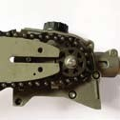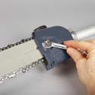
4
5
- With the chain now secure on the chain bar and sprocket, replace the chain drive
6
cover, and using the spanner supplied, tighten the nut lightly to secure the cover back on.
- Tighten the chain tensioner screw (19) using the combination screwdriver
(supplied), by turning the chain tension screw in a clockwise direction until firm and secure. Then tighten the chain cover nut firmly using the spanner (supplied) to fully secure the chain cover.
Note. Check that the chain can be smoothly pulled around the guide bar by hand and that it maintains contact with the guide bar, top and bottom. Do not over tighten, the chain should be able to lift 4 mm from the middle of the bar.
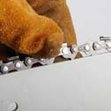CAUTIoN. A new chain will

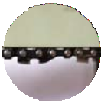the outside of the chain bar, with the chain links in the direction shown in Pic 3, ensuring that the teeth are as shown on the lower side of the bar when fitted.
4. With the chain fitted to the bar, hold the bar on an angle and loop the chain around
the chain drive sprocket until the chain has fully engaged the sprocket.
When the chain has fully engaged in
the sprocket, lower the bar onto the guide rail.
stretch after just a few minutes
3 of use. Check and, if necessary,
re-adjust the chain tension. A loose chain causes rapid wear to both the chain and the guide bar and could derail causing a major safety hazard.
To tighten the chain, loosen the chain cover nut and rotate the
chain tension screw in a clockwise direction.
To loosen the chain, loosen the chain cover nut and rotate the chain tensioner screw in an anti-clockwise direction.
Note: After adjustment, tighten the chain cover nut firmly with the spanner provided.

Connecting the J handle to the upper shaft
- 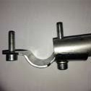Lay the pole saw upper shaft down so that the petrol tank is resting on a secure surface, or on the ground.
2
- Insert both of the mounting screws (+ one flat washer) through the mounting bracket, with one of the screws going through the screw hole in the J handle.
- 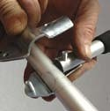Once the screws are in position, place the mounting bracket with the J handle in position onto the upper shaft.
4
- Place the second mounting bracket on the opposite side so that both screws go
through the mounting bracket securing the J handle into position.
- Secure the mounting brackets by adding the nut and 2 washers on each side of the bracket loosely.
Note: It is suggested to loosely secure the nut and washers first so that the handle can be placed into the most appropriate and comfortable position for use.
- The J handle generally sits best so that the top bar of the handle is on the same side of the pole as the Key Start switch.
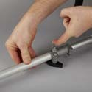IMPoRTANT: Secure and tighten the nuts.
1
Connecting the lower shaft to the upper shaft
- Loosen the shaft locking knob. Then pull out the shaft lock pin (11) and insert the lower shaft (10) into
the upper shaft (9). Rotate the lower shaft until the pin locates positively into the hole in the upper shaft.
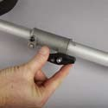Note. When rotating the shaft the middle drive shaft needs to engage so it may require up to a full turn to engage both the middle drive shaft and to
3
locate the shaft lock pin.
- Tighten the shaft locking knob (18), using the 4mm hex key (supplied) to secure both shafts in place.
- Using the 4mm hex key check the connector clamp screw is tight.
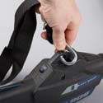Adjusting the shoulder strap
The shoulder strap (8) can be attached to the pole saw by clipping the carabiner on the shoulder strap to the shoulder strap attachment (31) located above the key start switch.
Adjust the shoulder strap accordingly so that it is comfortable to use and supports some weight of the pole saw.
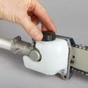Adding chain oil WARNING. Never start work unless the chain and bar are
1
lubricated.
Note: Always make sure the engine is turned off before filling the oil.
- Place the pole saw so that the oil cap is facing up.
Untwist and remove the oil tank cap.
- Fill the tank to approx 80% capacity with a premium blend of Bar and Chain Lubricant.
- Replace the cap and wipe up any oil spillage.

Setting the oil adjustment screw
The pole saw has an adjustment to vary the oil flow to the chain. During manufacturing, this has been set to Maximum.
There are 3 settings; Max, Med, and Low. The setting can be adjusted by:
  - Insert the flat bladed section of the screwdriver supplied
charger is connected and turned on. Note, the indicator will remain on all the time the charger is connected and turned on.
- After 5 hours turn off the charger plug pack and remove the plug from the pole saw housing.
Mixing the fuel

into the head of the oil adjustment screw.
  - Push the screw before attempting to rotate. The screw

MoToR FUEL: MIX AT 40:1 oNLY
40:1

will only rotate approx 100 degrees of rotation so do not attempt to go past these stops.
  - To reduce the oil flow push the screw first and then rotate clockwise. To increase oil flow (note: Set to maximum), rotate in an anti-clockwise direction.
Note: Too much oil flow is better than not enough.

Charging the internal battery
(Applicable if you have a Key Start unit only) The Electric Start pole saw is fitted inside with Nicad batteries which WILL require a full charge prior to use.
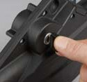Charge time is 3-5 hours. Do Not leave the battery on charge for longer than 24 hrs.
Only use the charger supplied with the pole saw, as detailed in the specification section of the manual.
  - Turn the key to the OFF position and remove the Key.
  - 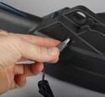Insert the Plug Pack Charger into a standard 240V power point.
  - Insert the output plug of the plug pack charger into the charge port side on the pole saw housing.
  - Turn on the plug pack charger at the power point. The red indicator will
illuminate on the side of the charge port indicating the
IMPoRTANT. Use good quality air cooled 2-stroke engine oil.
This product is powered by a 2-stroke engine and requires pre-mixing fuel with 2-stroke oil.
- Use fresh unleaded petrol. You must use 2-stroke oil specifically made for heavily stressed two-stroke engines.
- Mix the petrol and oil in an approved container. Never mix fuel directly in the line trimmer fuel tank. Use the fuel mixing bottle included with this product.
Note. Mixing has been made easy by including markings on the container included.
For example, if unleaded fuel is filled to the ‘400’ mark in the “GAS” column of the container, place oil in the container until it reaches the next mark (in the 40:1 OIL markings of the container). Therefore, 400ml of fuel would mean 10ml of oil must be added.
WARNING. Never use any type of pre-mixed fuel/oil direct from fuel stations. This may include special blends intended for use in mopeds, motorcycles, etc.
- Mix the fuel thoroughly and also each time before fuelling.
- Always pre-mix in small quantities. Never mix quantities larger than what will be used in a 26-day period.
Note. The mixing bottle provided is NOT for the storage of fuel. This container is solely for mixing of fuel only.
Ensure to keep this container in a safe storage location, empty of fuel and out of reach of children.

Filling the tank
WARNING. Always shut off the engine before fuelling. Never add fuel to a machine with a running or hot engine. Move at least 10m away from the refuelling site before starting engine. Do not smoke when refuelling or operating the line trimmer.
Note. It is normal for smoke to be emitted from a new engine during and after first use.
  - Place the pole saw on the ground or on a sturdy bench and wipe any debris from around the fuel cap.
  - Unscrew the fuel tank cap and pour the mixture into the tank with the aid of a funnel.
  - 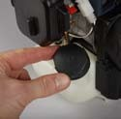Be careful not to spill any mixture. If this happens, wipe the spill with a clean rag.
  - Start the engine at least 10m away from the area where the fuel tank has been filled up in order to avoid any risk of fire.
- Always use extreme care
when handling fuel! Fuel is highly flammable.
- Never attempt to fuel the pole saw if the fuel system components are damaged or are leaking.
- Never attempt the refuel the engine while it is running or still warm, allow it to cool before fuelling.
- Never smoke or light any fires near the pole saw or fuels.
- Always transport and store fuels in an approved container.
- Never place flammable material close to the engine muffler.
- Never operate the pole saw without a properly functioning muffler and spark plug cover installed.
- Never operate the pole saw unless it is properly assembled and in good working condition.
- Do not use petrol which contains ethanol or methanol as it may damage the fuel lines and other engine parts.
- Mix only enough fuel for your immediate needs.
Do not store pre-mixed fuel. Starting the pole saw Choke control
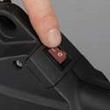Start position (choke closed).
1
Run position (choke open).
- Press the ignition switch
(2) to the ‘on’ position marked with a I.
- Move the red choke lever
(23) upwards to the start position (cold start).
Note. This is not required if the engine is already warm.
- 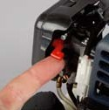Push the primer bulb 6-10 times, until the primer bulb fills with fuel/oil mixture.
2
- Squeeze the safety lever
(5) and the throttle trigger
- and engage the throttle lock button (14). The throttle lock button should engage with the trigger approx half pressed. Release the throttle trigger. With the throttle lock button engaged, the throttle
trigger will be partially depressed ready for starting.
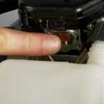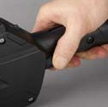
3
4
Note. For cold starting this is an important step.

- 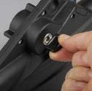Check the ignition On / Off switch is on. (I pressed down) Pull the recoil starter until you hear the engine starting or trying to start. (Under full choke it may only run for 1 or 2 seconds).
5
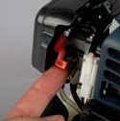Do Not keep trying to start the motor or you will flood the motor. Move the red choke lever downwards. Allow the motor to run and warm up for a further 5 seconds. Then slowly move the red choke lever down to the run position.
6
- 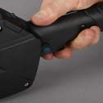If the petrol motor starts and then stops, move the red choke lever down half way and re start. Allow the motor to warm up for approx 20 sec and then slowly move the red choke lever down to the run position.
7
- Once the engine is fully warm ensure the red choke lever is down fully to the run position (warm start) and pull
the throttle trigger and release. This will release the throttle lock.
- To engage the chain drive on the pole saw increase the speed of the motor.
To disengage the chain drive, release pressure on the throttle trigger (4).
To increase the speed of the chain, squeeze the safety lever (5) first, and then squeeze the throttle trigger. To reduce the speed of the chain, release the throttle lever to obtain the required speed.

Warm start
When re starting the pole saw after it has been used and the motor is hot, there is no need to engage the red choke lever. Follow steps 4, 5 6 and 7 opposite.

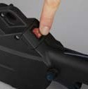Stopping the pole saw
2
- Release pressure to the throttle trigger (4) and allow the engine to idle for a few moments.
- Move the ignition switch
(2) to the off position marked O.

Running in the engine
  - During the first 2–3 hours of work, run the engine at a moderate RPM.
  - We advise you in any case not to maintain your engine at a high speed as the different components must settle with each other during the process of running in the engine.
  - It is at the end of the running in period that the engine will reach its maximum power.
  - After the first two hours of work, stop and make sure that all nuts and screws are securely fastened, and tighten them if necessary.

Changing of the saw chain
WARNING: Note: Always make sure the engine is turned off when making any adjustments to the chain and bar.
Note: The saw chain is full of sharp edges. When handling it you should always wear gloves.
1
- Loosen the chain cover nut and insert the head of the flat bladed screwdriver into the chain tensioner screw and turn in an anti-clockwise direction to enable the chain to loosen.
- 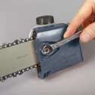Remove the chain drive cover nut using the spanner (supplied) and remove the chain drive cover.
2
- Lift the chain and bar off. After dismounting the bar and chain remove the chain off the guide bar and set the chain aside.

Important Notes:
- Clean oil and saw dust out of the area under the plastic cover with a brush or blow it out with compressed air. Be especially sure to clean out the oil duct.
- Clean the groove of the guide bar with a suitable tool or blow it out with compressed air. Take special care to clean the oil ducts in the guide bar. Inspect the chain guides for wear and if necessary carefully smooth them
with a file and emery cloth. If the guide bar is at some point worn beyond repair it must be replaced with a new one.
7. To replace the chain on the unit, refer to Fitting the chain and bar on page 9.

Working with the pole saw
Do not work with an angle higher than 60°. The pole saw will work under higher degrees, but there is the danger of being injured by branches falling without warning.
Keep an eye at the ground while working to avoid tripping over fallen branches.
Never use the pole saw without oil, use good quality chainsaw oil.
The pole saw is equipped with a low-kickback chain. Nevertheless, do not use the tip of the chain bar when cutting. Always use the lower or upper straight section of the bar to reduce the event of kickback. Always hold the unit firmly in both hands.
Thin branches can be cut off with one single cut. To prevent the branch from slivering and buckling the branch should be cut off in several pieces.
When cutting off larger branches, you should first cut into the branch from below. First cut into the branch from below outside the place where you intend to cut off the branch. The cut should go from one third to halfway through the branch. This prevents the branch from buckling when you cut into the branch from the top outside the first cut. Last cut off the stump with one clean cut. You might want to seal the cut with a suitable compound.

Chain sharpening and maintenance
WARNING. Note: Always make sure the engine is turned off before making any adjustments or maintenance procedures.

Chain sharpening
Sharpen the chain regularly to maintain optimum performance of the saw. Signs of a dull chain are:
- The sawdust becomes powder-like
- Extra force is required to execute a cut
- The cut does not track in a straight line
- Increased vibration
- Increased fuel consumption
WARNING. Wear heavy gloves when handling the chain. Hold the guide bar securely in a vice.
Sharpen each cutter using a chain file. Always use outward strokes.
After sharpening, the cutters must all have the same width and length.
After every 3 - 4 times use a repair centre to professionally sharpen your saw chain. They have the special tools necessary to ensure the correct cutting angles and depths are even.

Pole saw maintenance
WARNING. Note: Always make sure the engine is turned off before making any adjustments or maintenance procedures.
- Always keep the air holes clean on the pole saw body. They tend to become clogged with sawdust during use and this affects the efficiency of cooling, causing
overheating of the motor the other fundamental parts of the pole saw.
- Do not operate the pole saw with the air intake on the ground as this will draw foreign particles into the motor area and damage the windings of the motor.
- Regularly check to see if any dust or foreign matter has entered the grills near the motor and around the on/off switch. Use a soft brush to remove any accumulated

dust. Wear safety glasses to protect your eyes whilst cleaning.
  - If the body of the saw needs cleaning, wipe it with a soft damp cloth. A mild detergent can be used but nothing like alcohol, petrol or other cleaning agent.
  - Never use caustic agents to clean plastic parts.
  - Turn the bar periodically to use both the sides so that it wears evenly.
  - It is essential that motor cooling vents are kept free from a build-up of sawdust and this decreases the engines cooling capacity and causes overheating damage to the motor as well as other important equipment, oil pump etc. It is recommended that this is carried out after every use.
  - Clean the guide and oil holes periodically.
  - Deburr the race sides periodically with a flat file. Time may cause any “Burrs” to detach and damage the bar.
  - The bar needs to be evened with a flat file if one of the races is higher than another and then smoothed with a file and fine sandpaper. If races are considerably worn, check that the height is always greater than the chains transmission links so that the latter do not touch the bottom. Replace the bar if this should occur.
  - Make sure that the oil port is not clogged. Grease the nose sprocket at the tip of the guide bar each time the chain is filed.
  - Grease the head gearbox of the pole saw every 50 hours of operation.
The pole saw should be periodically serviced to check the correct operation of the chain, chain drive and engine.
CAUTIoN. Water must never come into contact with the pole saw.

First time user
If you are not familiar with pole saws and the felling of trees, it is recommended that you obtain informed instructions in addition to reading this manual fully. We also recommend as a minimum that you practice cutting logs on a saw-horse or log cradle.

General inspection
Regularly check that all the fixing screws are tight. They may vibrate loose over time.

Storage
- Clean the pole saw with a dry cloth, do not use aggressive cleaning fluids.
- Replace the pole saw blade cover and store in a dry place. Do not store in hot, dry boiler rooms or other damp places.
- Drain all fuel from the fuel tank
If you do not intend to use the pole saw for some time, e.g. over the winter, the saw oil must be drained from the oil tank and the oil ducts, because it will gum. Pour remaining oil out of the oil tank and store it in a dark, cool place. Pour a spoonful of mineral oil into the oil tank. Spray penetrating lubricant on the chain and let the saw run for a few moments to spread the mineral oil through the oil pump and the oil ducts. When using the pole saw again liberally apply chainsaw oil.

Repairs
Repairs beyond those described above, should only be undertaken by trained personal. Should a malfunction occur do not use the unit any further and do not attempt to repair it yourself. Contact Customer Support or have the unit repaired by a professional.

20

