Instructiong Manual
Electric potato chip machine

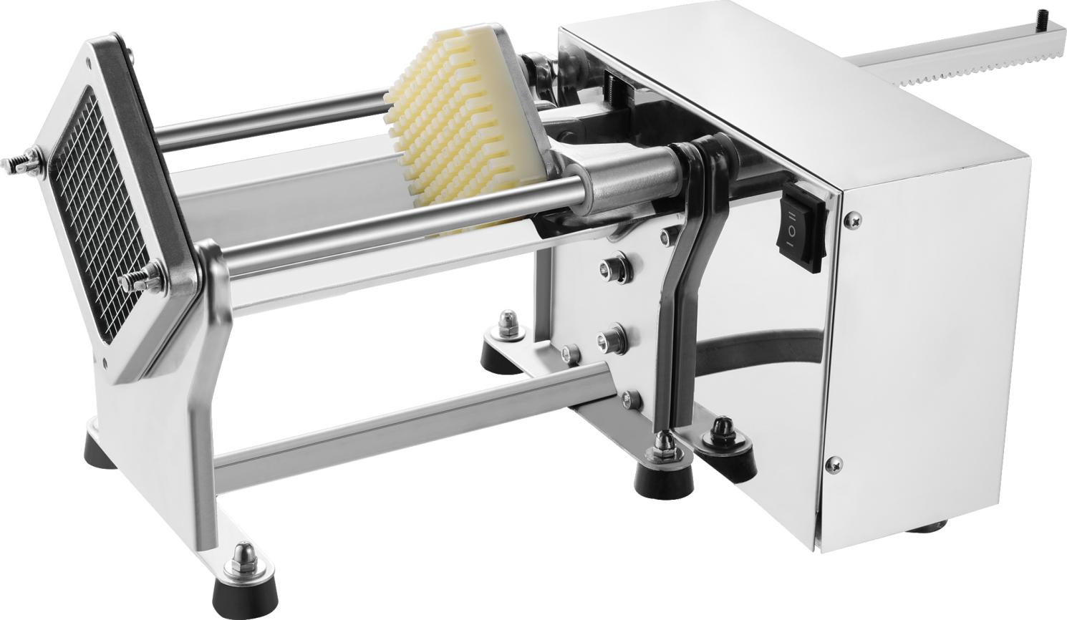

Please read the introduction before using

IMPORTANT SAFEGUARDS:
When using this potato chip machine, basic safety precautions should always be
followed including the following
1.Read all instructions.
2.To Protect against risk of electrical shock do not put in water or other liquid
3. Unplug from outlet when not in use, before putting on or taking off partes, and before cleaning.
4.Avoid contacting moving parts
5. Do not operate any appliance with a damaged cord or plug or after the machine
malfunctions, or is dropped or damaged in any manner. Return the machine to the nearest
authorized servo is facility for examination, repair or electrical or mechanical adjustmeln
6. Do not use outdoors
7. Do not let cord hang over edge of table or counter
8. Do not let cord contact bot surface, including the stove
9. Do not touch the moving parts when in operation
10. Blade is sharp. Handle carefully
11. If the power cord is damaged, it must be replaced by the service agent or a similarly
qualified person in order to avoid hazard
12. This machine is not intended for use by person(including children )with reduced physical
sensory or mental capabilities, or lack of experience and knowledge, unless they have
been given supervision of ins ruction concerning use of the appliance by a person
responsible for their safety
13. Children should be supervised to ensure that they do no play with the appliance
14.Care is needed when handing cutting blade during cleaning

SAVE THESE INSTRUCTIONS
Specificaion:
110V,220V,40W
Description:
1. Main body: full 201#stainless steel material
2. Control penal (with the buttons of "ON/OFF), the button is inching switch
3. Potato holde, three sets blade&mould Size for potato chip is:
6mm. 9mm 13mm
How to use:
1. plug in the machine to the power
2. Press the"NO/OFF"button, When press it, the pressing mould will
move, when stop pressing the button, it will stop mocing
3. lsert the potato into the potato holder, then press the NO/OFF button, keep on
pressing the button, unill the potato si finished cutting
4. Press the button to another side the pressing mould will life up, ther can repeat No
3 to begin another cycle
5. About changing the blade mould: If you need another size s potato chip, then adjust
the screws of the blade set and the black mould take out the blade and the black
mould, install another size blade &black mould
6. Cleaning:
Unplug the machine
clean the chamber with wet cloth. Do not clean hte blade by hand
Remove the blade from the machine for cleaning if necessary.

