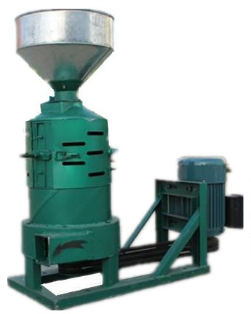

Modelo | Capacidad（kg/h) | Motor（Kw)
130 | 100-150 | 3
200 | 15 0-200 | 3-4
330 | 3 50-400 | 7/5/10

工作原理
粮食
从料斗
经插板
在重力作用下均匀的流到
集体内旋转的砂轮盖板上,
有推很翅甩到
机 体内圆锥面与砂轮间的碾白室中,
在碾白室 内由砂轮的研削,
壳与米脱离
壳被-部

Working Principle
Wheat, from the hopper, travel via board, move evenly under the influence of gravity to the chamber of grinding.
The grinding wheel cover plate rotating inside the collective,
There was a push
In the whitening room between the conical surface and the grinding wheel,
Grinding by grinding wheel in the whitening room,
Shell detached from rice
Shell Quilt

