Hammer Crusher

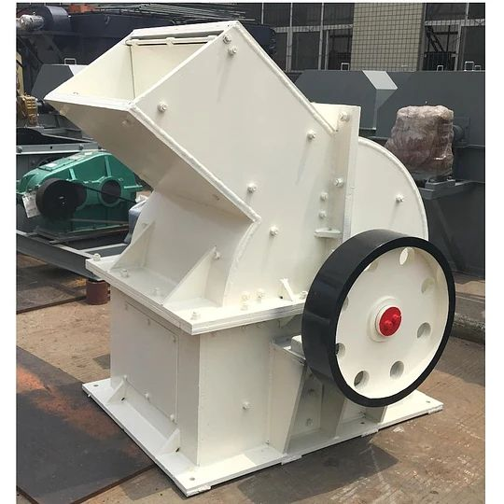
Hammer crusher uses the high-speed rotating hammer to collide and break the material. It has the characteristics of simple structure, large crushing ratio and high production efficiency. It can work in both dry and wet forms. It is suitable for the materials which the compressive strength less than 150MPa and the moisture content less than 15%. Hammer crusher is suitable for fine crushing of medium hardness and brittle materials in mining, slag metal recovery, cement, coal, metallurgy, building materials, highways, etc.

Hammer crusher diagram
Advantages and features
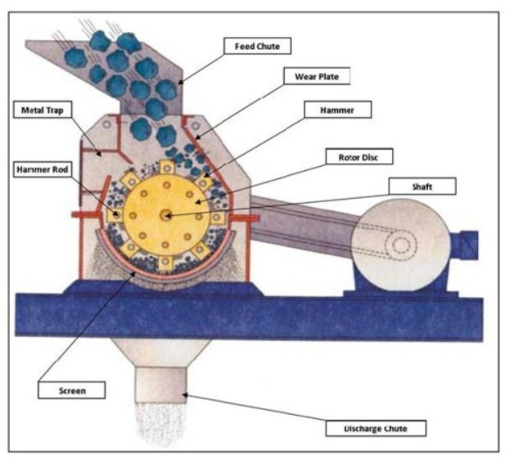

- Low cost, compact structure, easy maintenance
- High wear resistance hammer, high manganese steel casting, with high density, wear resistance, impact resistance
- Small investment, fast returns
- It not only has the advantages of large feeding size as jaw crusher, but also has the characteristics of small discharging size of sand making machine
- The grate design of the discharge outlet can directly screen the discharging material, and the particle size of the discharging material is uniform, a single hammer crusher can be a sand and stone production line independently.

Compact Structure  Low cost, high crushing ratio | High Wear Resistance Lining and Hammer  high density, wear resistance, impact resistance

Main Technical Parameters

Model | Rotor speed  (r/min) | Feed opening  (mm) | Feeding size  (mm) | Discharging size  (mm) | Capacity (t/h) | Motor power  (kw) | Weight (t)
PC400×400 | 1500 | 145×450 | ≤100 | 0-30 | 5-8 | 7.5 | 0.9
PC600×400 | 1000 | 295×450 | ≤100 | 0-35 | 10-12 | 18.5 | 1.03
PC600×600 | 1000 | 295×570 | ≤100 | 0-35 | 12-18 | 45 | 2.14
PC800×600 | 1000 | 350×570 | ≤120 | 0-45 | 20-25 | 55 | 2.45
PC800×800 | 1000 | 350×850 | ≤120 | 0-45 | 35-45 | 55 | 3.05
PC1000×800 | 1000 | 580×850 | ≤200 | 0-45 | 25-40 | 110 | 6.5
PC1000×1000 | 1000 | 580×1060 | ≤200 | 0-45 | 40-80 | 132 | 7.59
PC1250×800 | 750 | 650×850 | ≤200 | 0-45 | 20-50 | 132 | 11.7
PC1250×1250 | 750 | 650×1330 | ≤200 | 0-45 | 90-110 | 185 | 13.2
PC1400×1400 | 750 | 1050×1540 | ≤250 | 0-45 | 120-170 | 280 | 17.2
PC1600×1600 | 600 | 1500×1785 | ≤350 | 0-60 | 220-280 | 450 | 22.8

