Shaking Table Installation Manual

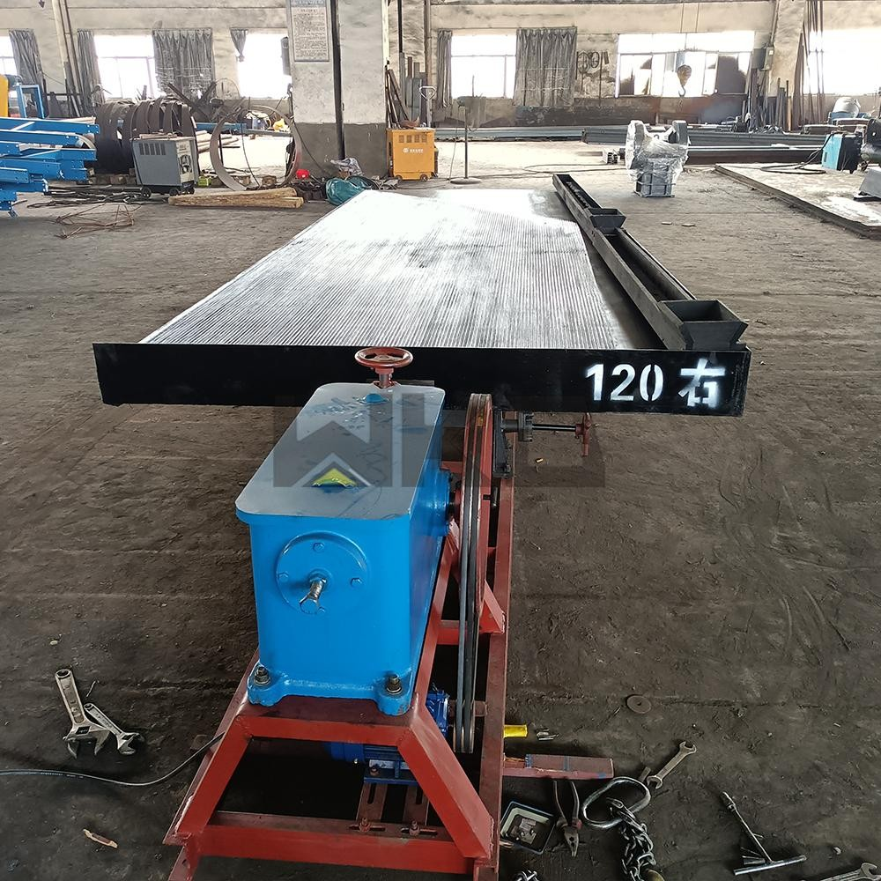

Please prepare the following accessories before assembly:

- Stand (1pc)
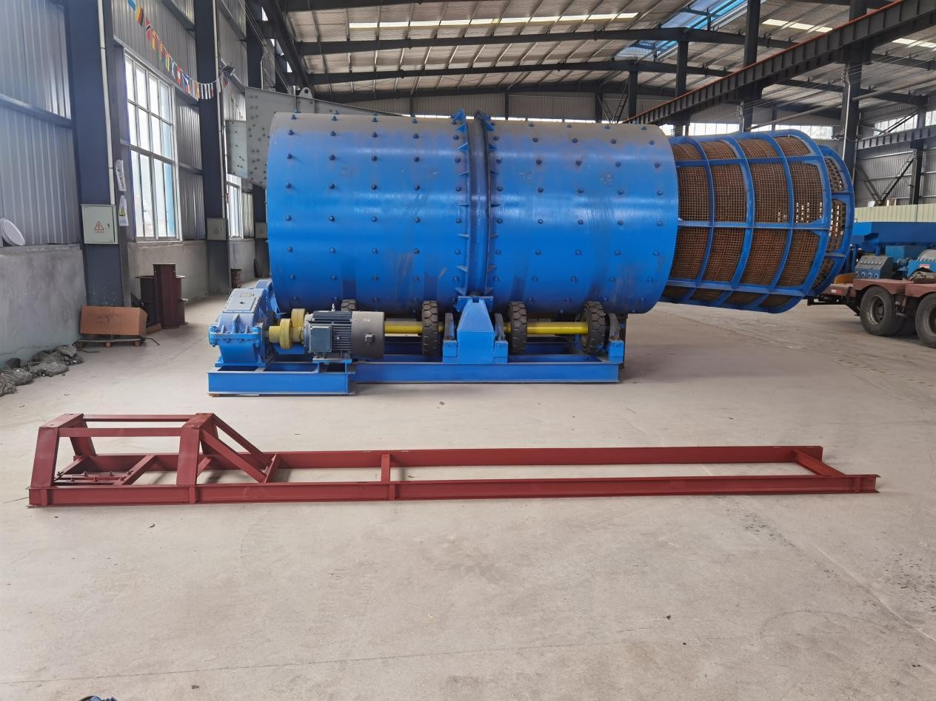
- Support (2pcs) + Gearbox (1pc)
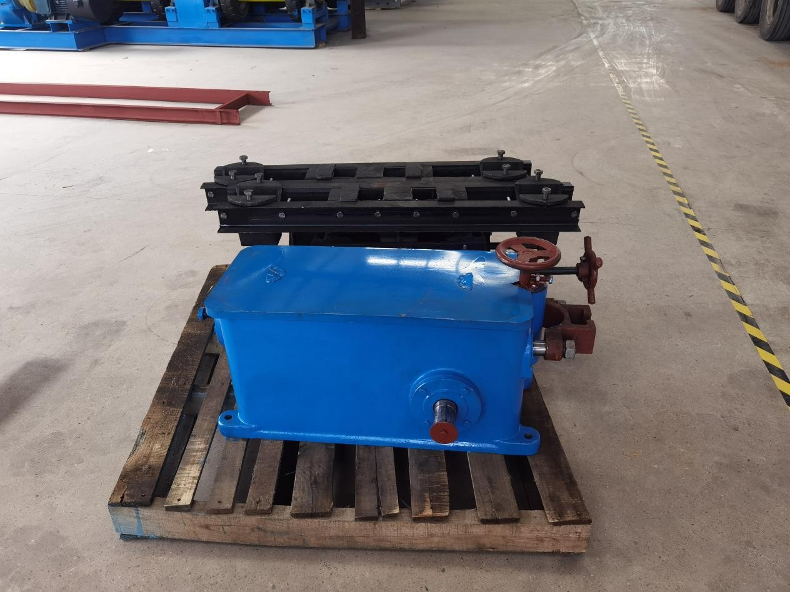

- Support Parts(4pcs+4pcs)
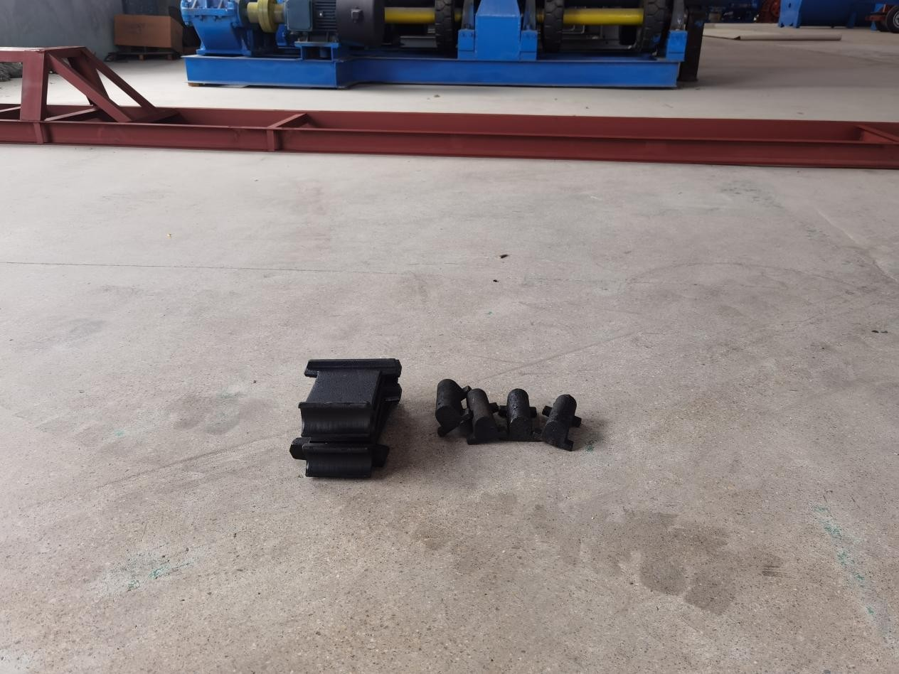
- Deck (1pc) + Water Feeding Chute(1pc+1pc)
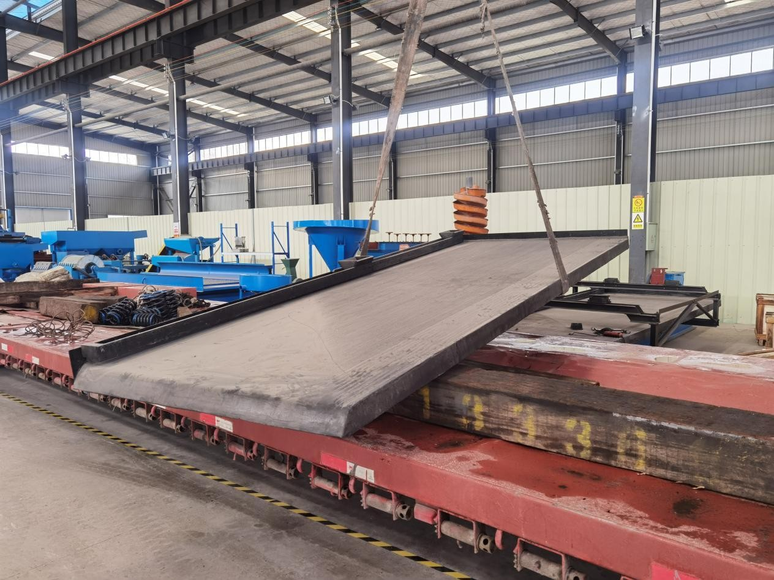

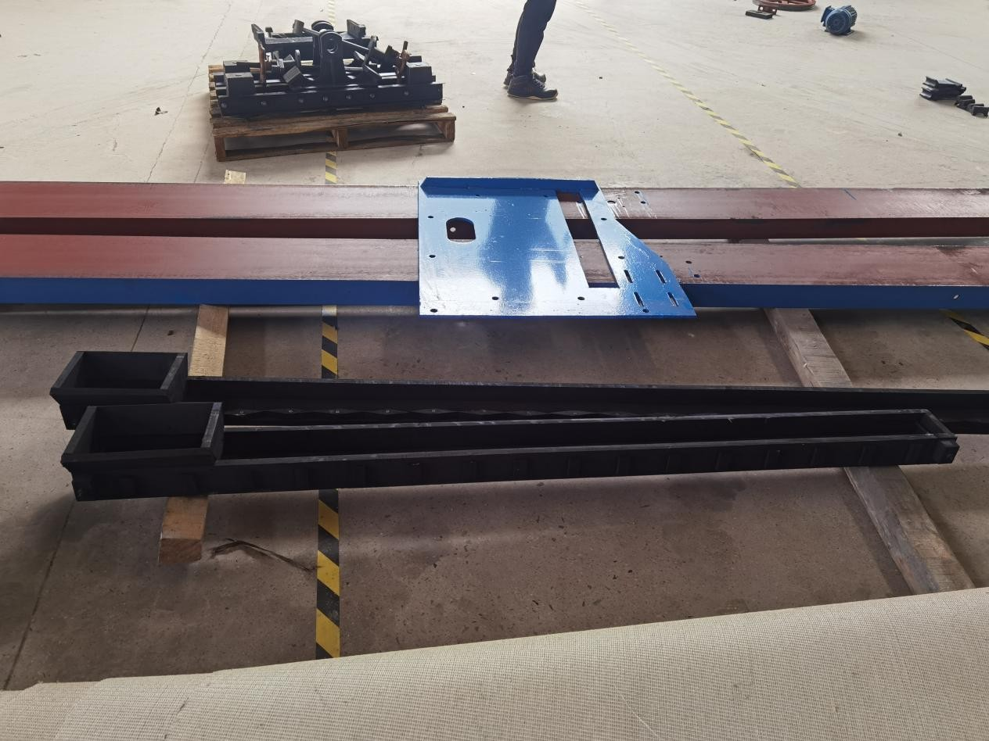
- Pulley(1pc)+Connector(1set)+Motor(1pc)+Belt (2pcs)
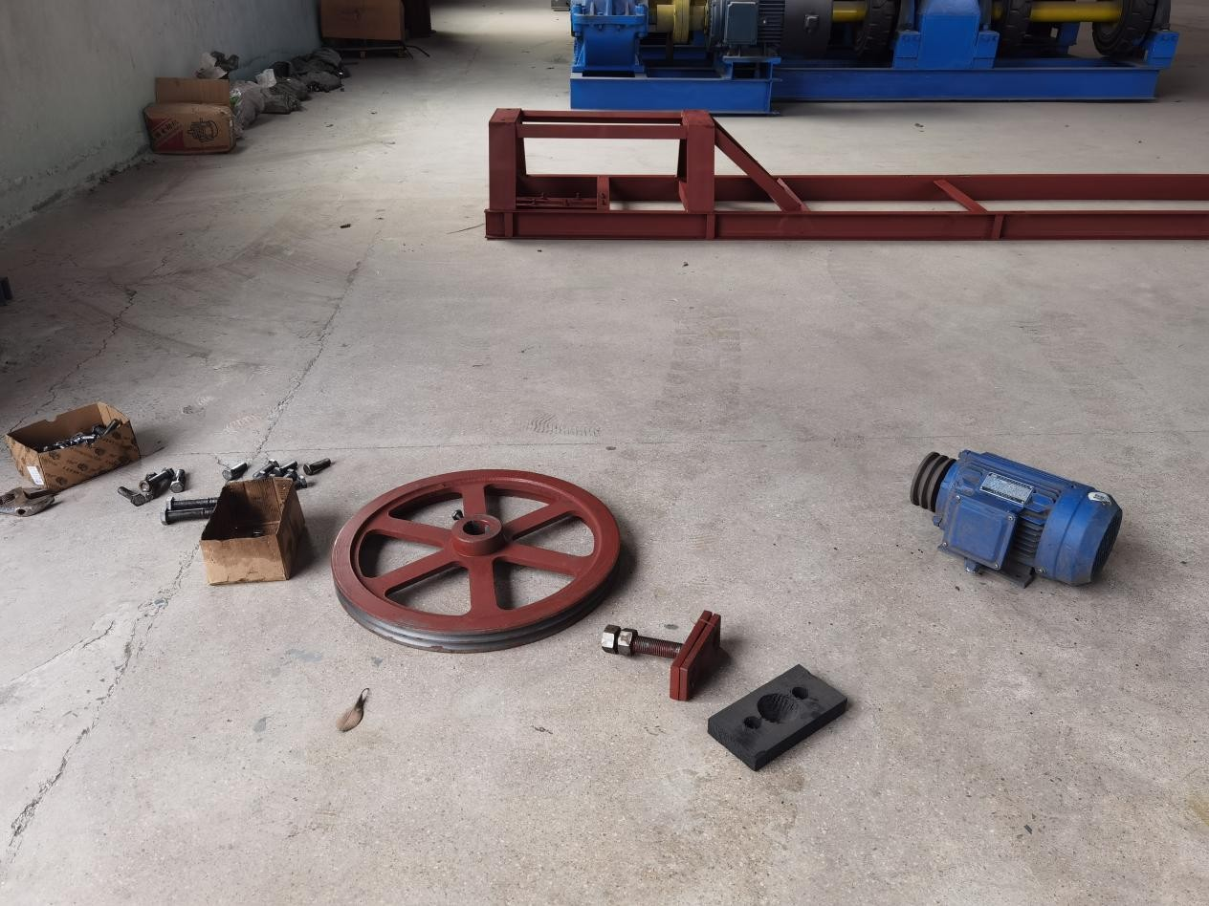

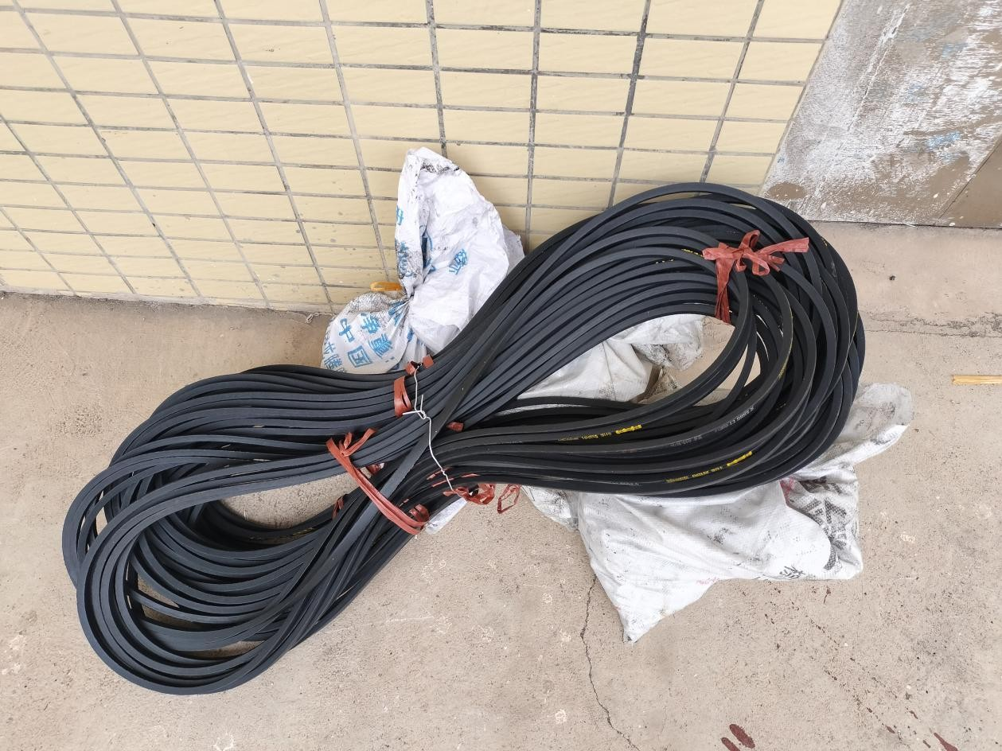

- Oil Pipe (1pc+1pc, inside the gearbox)
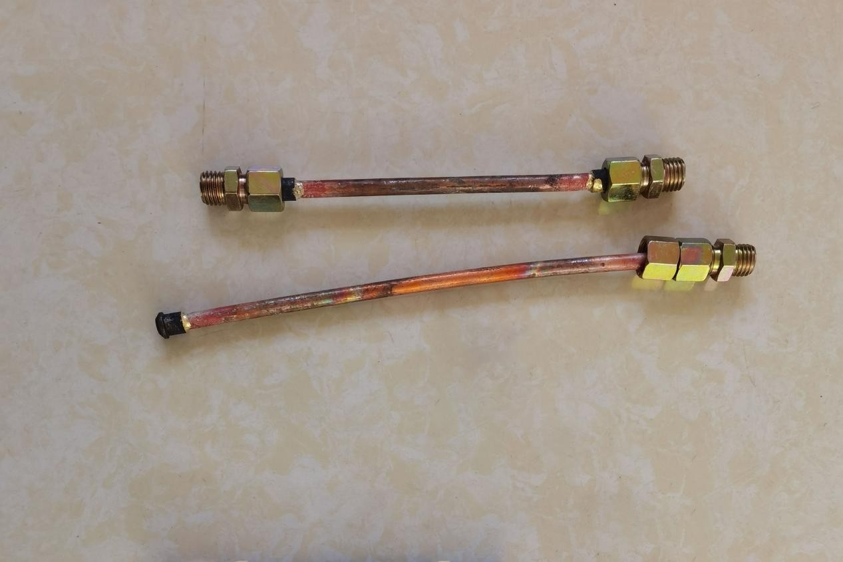

- Screws(8pcs+8pcs+4pcs+2pcs+2pcs)
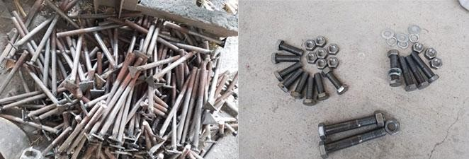
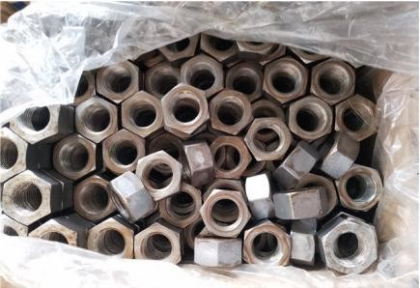

- Tools: Wrench+Hammer Lubricating Oil (20L)
- Installers: 3-4 person

Install Support
Fix the two supports with screws first, DO NOT lock them, may need to adjust the position later. 8 screws required.
Check the video 1-Install Support

Install Support Parts
Smaller first, then bigger. Add lubricating oil to wet smaller. Then apply lubricating oil on the bigger surface to keep the contact surface between it and the deck lubricated.
Check the videos 2-Install Support Parts-1 and 2-Install Support Parts-2.

Install Gearbox
Fasten the gearbox with screws, which must remain in the middle of the two support feet, and then lock it. 4 screws required.
Check the videos 3-Install Gearbox-1 and 3-Install Gearbox-2.

Install Deck
3-4 installers place the deck on the support, and must ensure that the deck is perpendicular to the support.
Check the videos 4-Install Deck-1 and 4-Install Deck-2.

Install Pulley

Remove the nut and washer, install the pulley and pin, and then install the washer and nut.
Check the videos 5-Install Pulley-1 and 5-Install Pulley-2.

Install Connector
Check the videos 6-Install Connector-1

Install Connector-2 Install Connector-3 Install Connector-4 Install Connector-5
Please check the videos carefully.

Adjust Deck
Make sure the bayonet is aligned and vertical, then tighten the screws on the support.
Check the videos 7-Adjust Deck-1, 7-Adjust Deck-2 and 7-Adjust Deck-3.

Install Motor+Belt
First use the belt to determine the position of the motor, the motor and pulley must be kept at the same level. Fix the motor and install the belt. The pulley needs to keep running in the same direction as the indication mark.

Check the videos 8-Install Motor+Belt-1, 8-Install Motor+Belt-2, 8-Install Motor+Belt-3 and 8-Install Motor+Belt-4.

Install Oil Pipe
The oil pipe is in the gearbox.

Check the videos 9-Install Oil Pipe-1, and 9-Install Oil Pipe-2.

Add Lubricating Oil
Pour the lubricating oil directly into the gearbox, over the leftmost black screw then stop. Neither less nor more.
Check the video 10-Add Lubricating Oil.

Install Water Feeding Chute
Feeding chute(short) in front, water chute(long) in the back. Check the video 11-Install Feeding Chute+Water Chute.

