
Screening Machine Instruction Manual

Features and Uses of the Screening Machine
Our company continuously improves the practicality of our screening machines based on user needs. The currently produced screening machines feature simple structure, easy mobility, straightforward operation, high workload, durability, low production costs, high efficiency, easy maintenance, among other advantages. They automatically separate processed mixtures such as sand, gravel, pebbles, river sand, weathered stone, and soil. They are suitable for mixing stations, road and bridge projects, construction sites, sand quarries, and sand and gravel plants. They can be used in both large projects and small sites. It is an ideal equipment for saving manpower and financial resources, improving project quality, accelerating project progress, and increasing economic benefits.
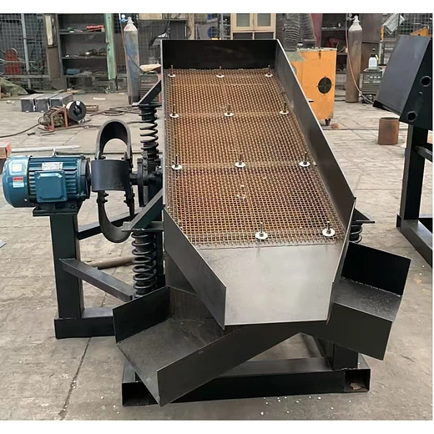
Screening Machine Installation
Choose a flat and solid ground, convenient for loading materials, loading trucks, and discharging waste, close to a power source.
First Use: Must fill the gearbox with sufficient gear oil. Grease the bearings adequately and apply oil to the gear meshing points. Adjust the conveyor belt to an appropriate tension. Ensure the three-phase power supply is correctly wired and the motor is securely fixed.
Starting the Screening Machine: First start the conveyor belt. After observing it runs normally, start the vibrating screen. Adjust the feed gate valve to achieve the required output. When stopping, you must stop the vibrating screen first. Wait until all material on the conveyor belt is completely discharged before stopping the conveyor belt. (Note: If operated incorrectly, sand on the conveyor belt may fall back. The sand on the conveyor belt must be cleared before restarting).
Screening Machine Maintenance
1、Check regularly. Lubricate rotating parts; dry running is prohibited.
2、Check the tension of the V-belts.
3、Regularly grease the bearings.
4、Regularly clean adhered sand from the screen mesh.
5、Protect the motor from rain.
Simple Troubleshooting
1、Conveyor Belt Misalignment: If the conveyor belt runs off track, first loosen the bearing screws. Then, tighten the screw on the side it is moving towards, or loosen the screw on the opposite side. After correction, tighten the bearing screws securely.
2、Waste Carrying Material: Clean adhered sand from the screen mesh or reduce the feed gate opening.
3、Starting Malfunction: Check if the power supply is normal, check for phase loss, check if terminals are loose, check if wires are aged or broken. (Note: Must turn off the main power supply before checking).
Screening Machine Debugging Work
1、Debugging: After installation of all components is completed and checked, trial operation can commence. Before trial operation, carefully check all parts are installed correctly per the drawings, all fasteners are secure, and ensure there are no obstacles around the screen body that might hinder the operation of the vibrating screen.
2、Keep the rectangular inspection door open. Manually rotate the screening drum via the hand crank and observe if the comb-type screen cleaning mechanism jams or rubs. If so, adjust using the adjustment bolts.
3、Check that all bearing seats and the gearbox are well lubricated. The gearbox oil level should be appropriate.
4、Power connections should be (firm and reliable), insulation should be good, and grounding should be correct.
Additional Important Notes for Using the Screening Machine
When using the screening machine, considerations such as processing capacity, screening material requirements, and compatibility with other equipment are necessary. Therefore, users need to clearly know requirements like feed inlet height and machine height limitations for proper equipment design and production.
During operation, do not overload the feed hopper. Excessive material can affect screening efficiency, potentially overload the motor, damage the vibrating feeder, impact the screen mesh, and shorten the service life of the screening machine.
When stopping the machine after use, it is best to wait until all material inside has been processed before shutdown. This prevents the motor from experiencing excessive load upon startup, which could burn it out. If operating outdoors, adequate protective measures must be taken to prevent water ingress into the motor compartment, which could cause motor failure upon starting.
If motor replacement is necessary during use, always replace it with a motor of the exact same model. Using a model that is too large or too small is detrimental to the normal operation of the screening machine.
Regularly inspect the wear-prone parts on the screening machine to prevent operational delays. Also, regularly check the bearing areas and add lubricating grease in time for maintenance, which can reduce operational resistance and wear between bearings.
After a period of use, check if the gear reducer lacks oil to avoid component wear and tear.
Before starting the equipment, always carefully check if there is any accumulated sand inside the screening machine. If present, it must be cleaned out promptly before starting. This ensures better operation of the screening machine.

