使用说明direction for use

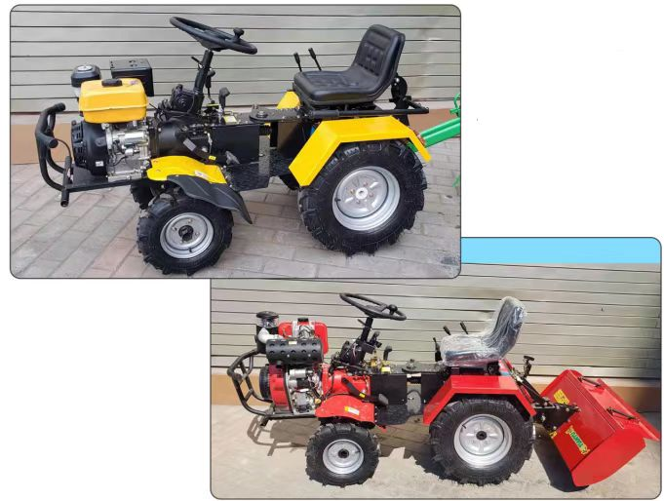

- 使用前机械各部位润滑油及燃油加注说明：
Instructions for lubricating oil and fuel filling in all parts of the machinery before use
1：柴油风冷发动机Diesel air-cooled engine
①夏季加注0#普通柴油，冬季加注-10#柴油（柴油加注量不宜超过油箱回油管高度）。Fill 0 # ordinary diesel in summer and-10 # diesel in winter (diesel fuel should not exceed the height of the tank return pipe).
②发动机箱内加注1.5L柴机油（春、夏季加注CC级S.A.E30号机油；秋、冬季加注CC级S.A.E10W30号机油），空滤器内加注同型号柴机油0.15L。
Fill 1.5L diesel oil in the engine box (CC S.A.E30 in spring and summer; CC S.A.E10W30 in autumn and winter) and 0.15L the same diesel oil in the air filter.
2：汽油风冷发动机Gasoline air-cooled engine
①加注92#普通汽油。Fill it with 92 # regular gasoline.
②发动机箱内加注1.3L汽机油机油，空滤器内加注同型号汽机油机油0.1L。Fill 1.3L engine oil and 0.1L engine oil in the air filter.
3：前置变速箱加注2.5L 85W/90重负荷变速箱齿轮油，后置变速箱加注1.5L 85W/90重负荷变速箱齿轮油。Fill the front transmission with 2.5L 85W / 90 heavy load transmission gear oil and the rear transmission with 1.5L 85W / 90 heavy load transmission gear oil.
4：传动减速箱加注0.2L 85W/90重负荷变速箱齿轮油。Fill the transmission gearbox with 0.2L 85W / 90 heavy load transmission gear oil.
- 机械使用前各部位检查说明：
Inspection instructions of each part before mechanical use:
1：检查各挂挡机构是否处于空挡位置。
Check whether each hanging gear mechanism is in the neutral position.
2：检查离合器踏板是否正常分离。
Check the clutch pedal for normal separation.
3：检查主要部位螺栓是否有松动。
Check whether the bolts in the main parts are loose.
- 发动机启动说明：Engine startup description:
1：柴油风冷发动机Diesel air-cooled engine
①打开油箱开关，油门开关加至1/3处。Turn on the fuel tank switch and add the throttle switch to 1 / 3.
②慢慢拉动启动手柄，直至拉不动，然后慢慢使之收回原处并放手，按下减压杆。Slowly pull the start handle until it fails, then slowly pull it back and let go, press the relief lever.
③旋转启动开关即可启动（发动机必须空车连续运转5分钟左右才能加载负荷）。Turn the start switch to start (the engine must run empty for about 5 minutes to load).
2：汽油风冷发动机Gasoline air-cooled engine
①打开油箱开关。Turn on the fuel tank switch.
②将熄火开关打开。Turn the flameout switch on.
③旋转启动开关即可启动（发动机必须空车连续运转5分钟左右才能加载负荷）。Turn the start switch to start (the engine must run empty for about 5 minutes to load).
④冷车启动时需要关闭风门。The air door needs to be closed when the cold car starts.
- 前置旋耕机工作档位操作说明：Operation description of working gear of front rotary tiller:
1：使用前置旋耕时首先将前轮胎拆下换上深耕锄或旱地刀，后轮胎换上铁轮。在前.后变速箱保持空挡状态下启动机器，踩下主离合器踏板，将前置变速箱档位操纵杆挂至慢档；将后置变速箱档位操纵杆挂至慢档，松开离合器踏板即可（根据实际工作需求切换快慢档）。When using the front rotary tillage, first remove the front tire for the deep ploughing hoe or dry land knife, and replace the rear tire with the iron wheel.before. Start the machine when the rear transmission remains neutral, press the main clutch pedal, hold the front transmission gear lever to the slow gear; hold the rear transmission gear lever to the slow gear, and release the clutch pedal (switch the fast and slow gear according to the actual working requirements).
2：路面行走状态时，只可使用一个变速箱驱动。The pavement walking state can be driven only with one gearbox.
3：倒挡操作时，空挡状态下踩下主离合器踏板，将前置倒挡控制杆拉至末端自动锁止，后置变速箱处于空挡状态然后松开主离合器踏板（需要后置变速箱倒车时，则需要将前置变速箱处于空挡位置）。During reverse operation, press the main clutch pedal in neutral state, pull the front reverse control lever to the end automatic lock, the rear gearbox is in neutral state and then release the main clutch pedal (when the rear gearbox needs to reverse, the front gearbox should be in the neutral position).
五.使用后置旋耕机时，前后轮胎不需要拆卸更换，前变速箱保持空挡状态，只需要使用后变速箱调整档位速度即可，同时通过电子液压手柄来控制旋耕机深度即可。When using the rear rotary tiller, the front and rear tires do not need to be removed and replaced, the front gearbox remains neutral, only need to use the rear gearbox to adjust the gear speed, and at the same time, the rotary tiller depth can be controlled through the electronic hydraulic handle.

