Z D-1 anti-theft cap capping machine

Contents

- Main characteristics and uses 1
- Main technical parameters 1
- Main structure and working principle 1
4. Adjustment and use.....................................................................................................................
2
  - Lubrication. 4
  - The machine is installed 4
  - Acceptance criteria 4
  - Instructions for ordering and purchasing 4
  - Schematic diagram of the capping head (Figure 1) 5
  - Schematic diagram of the main drive system (Figure 2). 6
  - Schematic diagram of lubrication of the cap head (fig. 3) 7
  - Schematic diagram of main lubrication (Figure 4) 8
  - Certificate of Conformity 9
  - List of accessories and tools 10

Please read this manual carefully before use
To ensure safe production, please ground the machine reliably!
Products are constantly updated and subject to change without notice

Main features and uses
  - Main features:
    - FW-1 (L) type anti-theft cap sealing machine is the most advanced twisted aluminum anti-theft cap and bottle mouth sealing special equipment in China.
    - The structure adopts four-jaw balanced head sealing, and the force is uniform.
    - It is equipped with an automatic positioning device at the mouth of the bottle, which overcomes a variety of drawbacks of positioning by the bottom of the bottle.
    - It has the function of deforming the shilling cap according to the shape of the neck and then rolling the thread and shrinking edge sealing.
    - Expanded scope of use for easy to pull caps, plastic caps, can bottle caps for sealing.
    - It has the advantages of compact and reasonable structure, stable operation, low noise, low energy consumption, convenient operation and adjustment, high work efficiency and good sealing quality.
  - Uses:
This machine is suitable for the mass production of wineries, beverage factories and pharmaceutical factories, if the machine is equipped with an automatic conveying device, it can realize automatic sealing and flow operation.

Main technical parameters
  - Bottle height: 180-300mm (dwarf bottle needs to add adapter).
  - Bottle diameter: Φ 50-Φ 120, cap diameter: Φ 20-Φ 32mm (pressure changer).
  - Maximum output: 1800 bottles/hour.
  - Motor power: 380V, 0.37kW
  - Total weight: 65kg
  - Dimensions: 670X220X940mm

Main structure and working principle
  - Machine structure: (see Drawings 1 and 2).
It is composed of two parts: the capping head (see Attached Figure 1) and the main transmission system (see Attached Picture 2).
  - How it works:

When working, the rotation of the motor (13) is input into the worm gear box (9) through the double pulley (16); Then it is output in two transmission chains; One is output by the worm gear, driving the crank slider mechanism composed of crank (8), connecting rod (7), sliding seat (10), column (2), positioning seat (6), etc., driving the cap head to reciprocate up and downMove; The other is output by a small pulley (12) at the upper end of the worm, and the depressurizing head shaft on the lid head is driven by a belt <19 >, the indenter < 17 > and the connecting shaft < 29 >Other components other than the center part do not rotate clockwise (looking from top to bottom).
-1-
The sliding seat (10) drives the rotating cap head down, and the 16> flared mouth of the guide bottle
tray < will be placed on the bottle tray (4).
The bottle is generally straightened, and further straightened by the inner cone of the indenter < 17> through the cap; Subsequently, the inner cylinder and the knurled outer circle of the bottle cap completely straighten the bottle; Then the indenter in the capping head < 17 > press the cap tightly, when the pressure between the cap and the bottle mouth is greater than the pre-pressure of the main spring <2>, the spring compression indenter < 17> through the inner hollow shaft < 7 >Prevent the lever bracket < 9>, guide bottle disc <16>, etc. from stopping the downward movement, but the upper peripheral parts such as the inner hollow shaft nut < 3> are installed in the sliding seat (10) continues to descend under pressure, the inner hollow shaft nut <3> and the lever bracket < 9 > relative movement, its spacing S is reduced, and the lever bracket < 9 >The upper lever is transmitted through the upper bracket <5> the upper roller < 4> and the inner hollow shaft nut <3> force the sealing lever < 10 >and embossed lever <25> at the same time shrink inward. When shrinking to a certain extent, the sealing wheel < 15 > contact with the bottle cap first, and under the action of the roller rolling that rotates the sealing wheel around the bottle cap and gradually clamps inward, the lower edge of the bottle cap is gradually turned and locked on the countertop under the bottle mouth blocking hoop.
When the sealing wheel is turned to greater than 0.5mm, the embossed wheel in the upper and lower positions in the screw starting groove of the cap <22 > begins to contact the cap and is clamped, because the roller tangential line at its contact with the cap is in the same direction as the spiral, inAs the roller progressively enters the rotation, it spirals along the outside of the cap. The fine spring on

the embossed shaft is compressed, but at this time the roller does not completely press the cap wall to the bottom of the bottle mouth thread, the deformation is small and the resistance of the inclined table of the spiral start groove, the roller will not advance with the bottle mouth pitch, can only move forward step by step.
When the sliding seat (10) is close to the bottom dead center, because the roller squeezes the cover wall with the bottle mouth, the sealing wheel lever shrinks to the maximum, the edge work is basically completed, the embossing wheel also presses the cover wall to the bottom of the threaded tooth, and the radial deformation of the cover reaches the maximum value The axial movement of the cap produced by the tilt roll is accelerated, and as the roller rolls forward, it will enter the thread valley at the mouth of the valley where the thread begins, because the roller working is in the same direction as the spiral and the roller will not ride on the peak, so it will advance in the valley to extrude the thread.
When the slide seat (10) is lowered to bottom dead center, the edge is tightened at its maximum and the embossing wheel is about to complete the thread.
When the sliding seat (10) begins to rise, the sealing wheel pressure gradually weakens, and the embossing wheel extrudes the unfinished complete thread; Continuing to rise, the sealing wheel lever gradually returns to the position under the action of the small pressure spring, the sealing wheel leaves the cap, and the embossing wheel extrudes the tail of the screw to complete all threads.
When the sliding seat (10) rises to a certain extent, the four rollers are completely detached from the bottle cap, the bottle is removed, and the capping process is all over. The machine rises back to top dead center to enter the next duty cycle.

Adjustment and use
  - Refer to the attached drawings for the following provisions Machine stroke: (i.e. crank swing diameter) T=45 mm
Natural depth: (distance between the bottom surface of the guide bottle cover and the working plane of the indenter) H=40mm -2-
Working stroke: (i.e. main spring compression) S=15mm
  - Machine Adjustment
    - The jog switch stops the machine at the top dead center, loosens the compression screw on the

positioning seat (6), and rotates the lead screw guide rod (3) with a No. 14 wrench so that the guide disc of the capping head < 16 > The distance between the lower plane and the upper plane of the bottle tray is greater than the height of the sealed bottle; Buckle the cap to the bottle mouth, and then put it on the flat tray (4) (or on the fork holder), measure the distance between the bottom of the guide bottle tray and the upper plane of the cap, and adjust the height of the cap head according to the measured value so that the spacing is equal to 34~36mmFor better .
    - Loosen the Allen screws on the four sealing wheel levers, and first adjust the upper and lower positions of the embossed wheel <22> so that the upper edge of the indenter <17> is not in contact when contractingis preferable; Then adjust the sealing wheel < 15> up and down position so that its working blade is slightly lower than the sealing step of the bottle top clamp.
Note: The bottle fork holder is a special bracket specially designed for plastic beverage bottles to position and support the bottle.
    - Rotate the double large pulley clockwise by hand (looking down from above) so that the cap head is lowered, and when there is a slight pressure between the working plane < 17 > the head and the upper plane of the cap, stop the rotation; Turn the bottle so that the bottle body plumbs, consistent with the center of the indenter, and fix the positioning fork (or fork holder).
    - Continue to rotate the large pulley to lower the capping head, the indenter < 17> and the cap is gradually pressed, the capping work begins, and the process is described in the working principle. In this process, first carefully observe the contact and sealing of the sealing wheel to see whether its working height is appropriate; Then look at the position of the embossing wheel in the thread starting groove and its entry into the thread valley.
    - After the blockade is completed, according to the observation situation and the actual blockade effect, it will be adjusted and retested.
    - In the test, if the sealing is found to be too loose and the thread is too shallow, it means that the spring pressure on the lever of the sealing wheel is too small, and the pressure can be increased by adjusting the pressure adjustment screw <23>, so as to achieve the purpose of pressing the cap thread and pressing the lower circle of the cap respectively. Note that when adjusting the pressure, the pressure of the two embossed wheels < 22 > of the roller thread is approximately equal, and the pressure of the two sealing wheels < 15> is also approximately equal. (Note: Only one embossing wheel < 22 > and

one sealing wheel < 15 > are drawn in the figure, and the symmetrical two do not appear in the figure.) If the pressure on the four springs on the four sealing levers is too large, the cap or the bottle mouth will be snapped.
    - When the pressure is increased but the problem of loose sealing and shallow thread cannot be completely solved, it means that the lower dead center of the machine is high and the working stroke is small, you can loosen the compression screw on the positioning seat (6), rotate the lead screw guide rod (3), slightly reduce the height of the lower dead center of the machine and increase the working stroke to improve it.
The above adjustments are all while testing, observing and analyzing the reasons, gradually adjusting to meet the requirements, and must not adjust too much at one time to prevent damage to the machine.

Lubricate
The lubrication point on the machine is shown in the attached lubrication diagram 1 and 2: J indicates the oil point, with No. 15 mechanical oil in summer and No. 5 mechanical oil in winter, once per shift.
The worm gear box uses No. 40 in summer and No. 20 mechanical oil in winter. Change every 1000
hours of operation. Check the oil level frequently and make up in time.

The machine is installed
This machine can be directly placed on the cement floor or countertop, and it is best to use it with foot bolts to fix it on the workbench. The lifting ring (15) on the upper part of the column (2) is used.

Acceptance criteria
  - Cosmetic Quality
    - The surface of the appearance shall be flat and should not have unevenness.
71.2 The surface of the sealing part is chrome-plated and beautiful.
  - Dry operation inspection
    - The machine runs smoothly, the transmission is normal, and there is no abnormal noise.
    - The upper and lower lifting and landing of the body is flexible, reliable, and there is no jamming phenomenon.

    - The electrical system is sensitive and reliable.
  - Seal Inspection
    - The closure of the bottle cap is not well sealed and does not leak.
    - The thread of the roller at the cap is clear and does not damage the surface of the cap.

Notice of ordering and purchase
Users need to provide several bottle samples and some caps when ordering, for the design and modification of individual parts to adapt to bottle shape and factory closure test. If there are other special requirements put forward, special related parts to meet the user. If the bottle type is not provided, it will be loaded and shipped according to the standard structure.
When purchasing accessories, it is necessary to write down what kind of parts and quantity.

Schematic diagram of the capping head

- 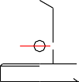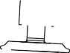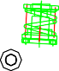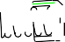Hollow shaft pulleys
- Press spring
- Inner hollow shaft nut
- Roller
- Upper stand
- Fastening screws
- Inner hollow shaft
- Blind hole wire plugging
- Liver holder
- Sealing leverage
- Lock pads
- Sealing wheel springs
- Fastening screws
- Sealing wheel wire
sleeve
- Sealing wheel
- Guide bottle tray
- Indenter
- Fastening screws
- Indenter shaft
- Connection screws
- Guide bottle disc column
- Embossed wheel
- 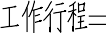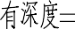Embossed wheel

Schematic diagram of main body rotation

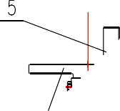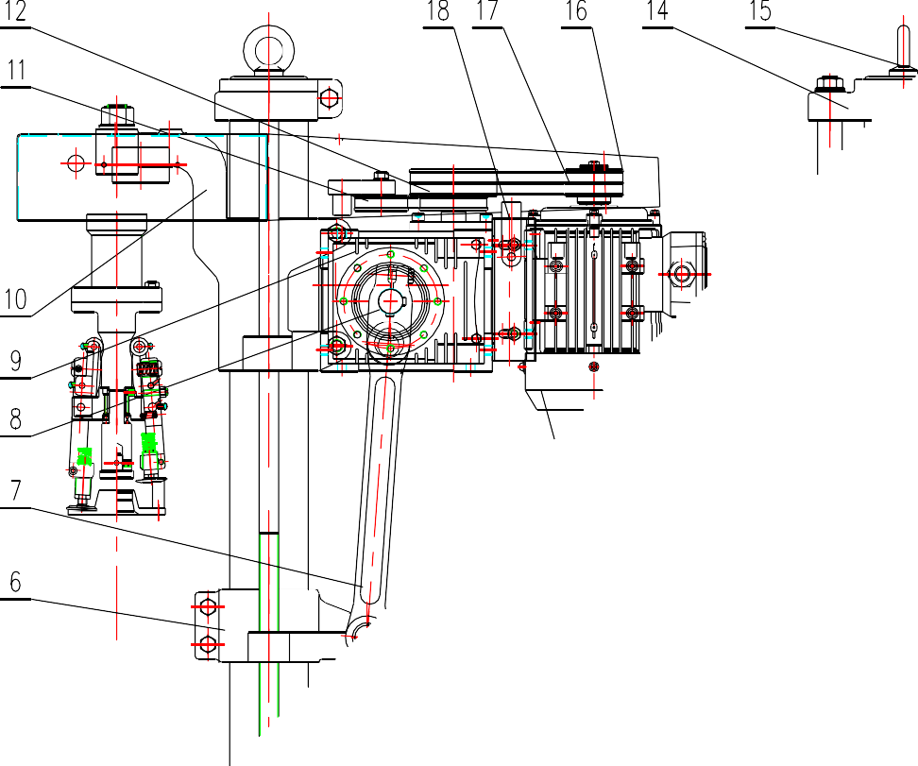

Figure II

  - Base 2 Column 3 . Lead screw guide 4 Bottle tray
5. Positioning Board 6 Positioning Seat 7. Linkage 8.
Crutches
9. Gearbox 10 Slide seat 11Tightening Wheel 12 Upper
pulley

13. Motor 14 Mounts 15 Rings 16. Motor belt
17. Twin Belt 18 Motor fixing plate 19Connect the shafts
.

Schematic diagram of lubrication of the capping head

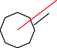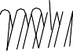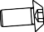

Figure III

J: Oil lubrication point, No. 15 mechanical oil in summer, No. 5 mechanical oil in winter, once per shift.

Schematic diagram of main lubrication

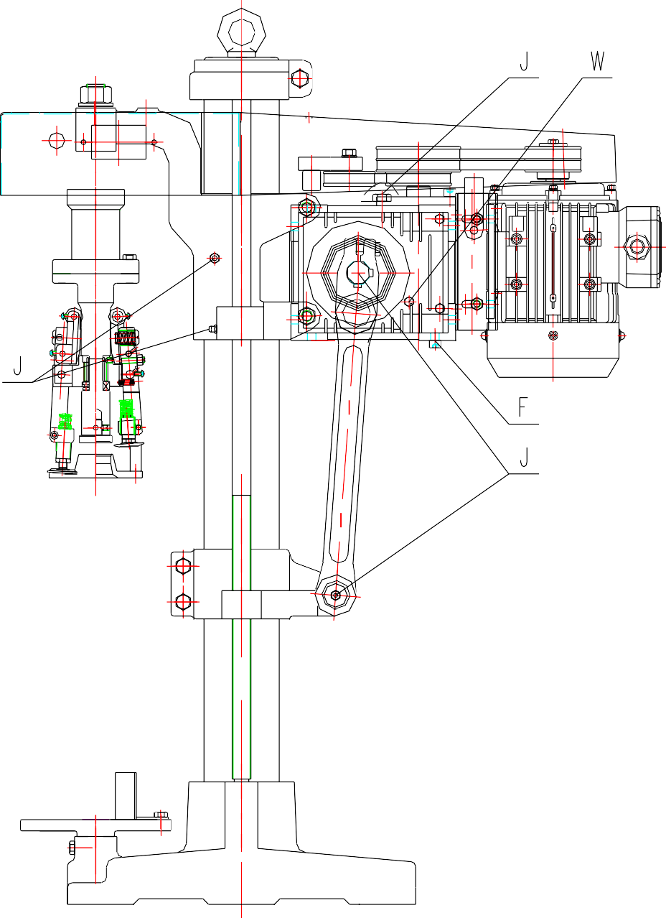

Figure IV

J: Oil lubrication point

F: Oil drain plug W: Oil level bolt

