Congratulations – you have decided to take the next big step in Motorized Biking....
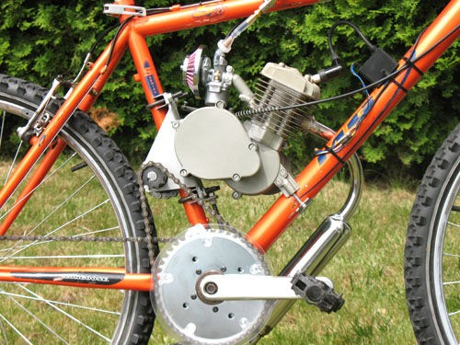

Disclaimer: Bicycle riding can be dangerous. Parts in no way approves of dangerous bike riding. Our kits and parts are strictly for the hobby enthusiast with a detailed mechanical knowledge of bicycles. People attempting this addition should have experience building motored bike kits and bicycles. The modifications shown are not for racing, speeding or nonlegal on or off highway use.

Your kit was packed with care, however to familiarize yourself with all the parts, be sure you have read through and matched all parts on the parts list. Parts List Attached.

Fit up is required and some minor filing on the rough surface of your engine case is required. Only minor cutting or drilling is required, however all bikes are different and care must be used to set up YOUR bike as shown in this manual. We are always here to help, so feel free to contact us.

Before we begin let's first visualize all the steps in the installation process.

PLEASE follow the detailed steps within this document, but for ease of assembly the rough steps will be outlined prior to starting:

- Remove engine and set on a steady, solid work surface.
- Remove pedals, crank arms, and crank shaft from bike.
- Install replacement crankshaft.
- Install new chain rings and front freewheel.
- Clean engine casting and install right side bearing plate and mounting plate on engine.
- Reinstall engine on bike.
- Assemble jackshaft and install.
- Hook up shortened engine chain on engine side and install left side bearing plate

- Install bike chain on the right side.
- Cut out and install clutch cover and chain guard.
- Make sure all connections are logical, all fasteners are tight and chains are properly tensioned.

Your bearing plates and motor mount come powder coated and do not require paint. Feel free to paint them if you choose. Remember to use standard painting practices, scuff and degrease the surface to be painted and use fuel resistant paint.
Here is a general list of tools and materials that you will need to complete this build: Chain breaker
Files (small and medium) Screwdrivers
Knife or tin snips Allen wrenches
Sockets and or box end/open end wrenches Thread locking material (such as Loctite) Contact cement
Drill and Emery paper
Other hand tools as needed

Failure to follow these instructions explicitly may result in loss of warranty.

Step 1

  - Remove engine and place on a solid, safe work bench.

Step 2

- Remove crank arms. This typically requires a crank removal tool. If you do not have one your local bike shop can do this for you.
- Undo retaining fasteners and carefully remove existing crankshaft, preserving all bearings and hardware. Remove all old grease, clean and re-grease bearings and races on new crank shaft.

Step 3

- Reinstall new crank shaft in reverse order as above. Do not over tighten the gland nuts. The shaft should spin quite freely but should not have side movement.
- Install the new left side crank. Do not over tighten the nuts.
- Install your freewheel to the crank by screwing it on in a clockwise direction.
Note: If your standard freewheel came with a black washer install it between the crank and the freewheel. Notice that one side of the washer has a groove in it. This should go up against the freewheel.
- Install your clear chain guard to the larger of the 2 chainrings. The chain guard should go against the flatter of the two sides. The tooth bevel should be on the opposite side of the chain guard.
- Slide the large chainring over the crank arm and on to the freewheel.
- Secure it with the 5 bolts so that the end of the bolts will be protruding past the

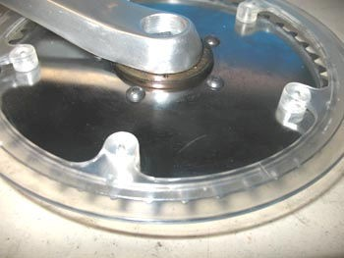
freewheel toward the inside of the bike.

Note the chainring is on top of the freewheel flange

- Next place the 5 spacers (6mm nuts) over the bolts up to the freewheel.
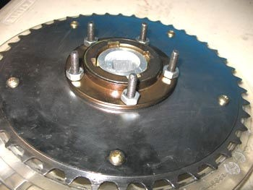
- Then slide the smaller sprocket onto the bolts with the bevel side of the teeth facing the other chainring. The goal here is to separate the chains as much as possible.
- Secure the small chainring with the 5 washers and locknuts.
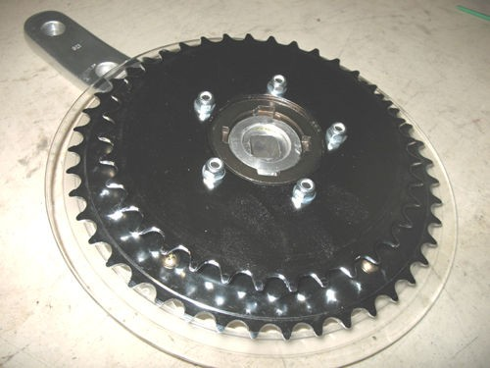
- Tighten the chainring assembly with the 5 locknuts and washers. Be sure that the bolts are tight against the outer chainring before installing the locknuts.
- Install the lower chain adjuster bracket using one of the clamps included in the kit. You can mount the bracket as shown or with the flat surface at the top. It should be

mounted as low in the frame as possible.
- Install the jump stop chain guard onto your seat tube. No need to tighten or adjust this, it will be done later.
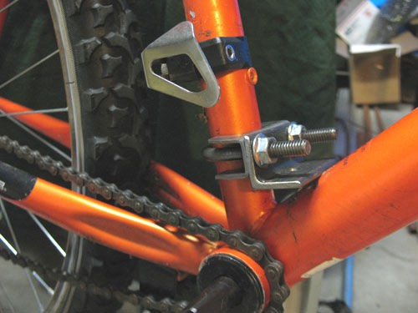
- Install the crank, freewheel and chainring assembly to the crank spindle. Do not over tighten the nuts. Be sure to put your bike chain around your bottom bracket before you install the right crank and freewheel assembly. The crankshaft and chainring should be complete.
- Install your bike chain to the small front chainring and adjust the Jump Stop chain guard. The chain guard should be parallel to your chain with about half of the guard sitting above the chain and there should be about 1/16 inch (1.5mm) clearance to the chain.
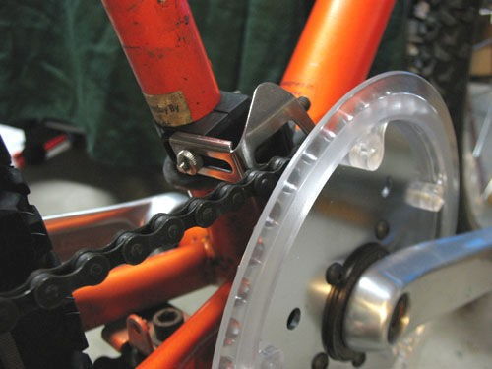
- For Freewheel maintenance, visit our download page.

Step 4

Prep engine for rear mount installation
  - Remove rear stock mount and studs. (The studs can be easily removed with double nuts or locking jaw pliers)
  - Remove the upper back clutch cover screw.
  - Assure that the engine has no casting flash or burrs that will interfere with the flush mounting of the mount. Use files and other tools as necessary to flatten any raised areas.

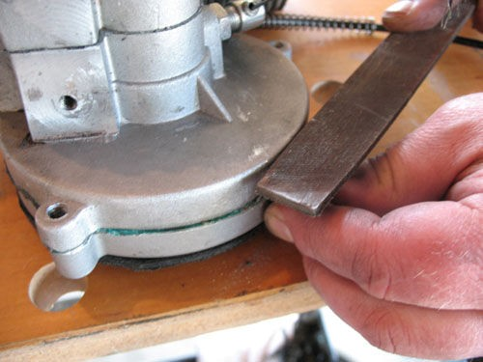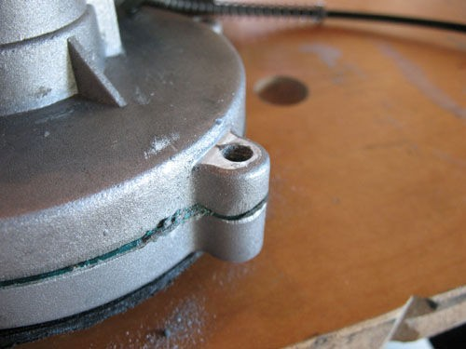

Flatten the back side of the upper rear clutch cover mount as shown above.
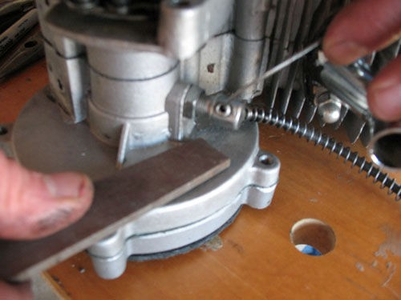
Remove any casting bump that will keep mount from mounting flush to the back of the clutch case.

Step 5

Install the rear mount and spacers. Insert the 2 long hex head bolts along with the 2 washers and lock washers. It is a good idea to make sure the rear of your engine is flat where the spacer will sit. File as necessary to get this as flat as possible. Install the smaller 2 hex head bolts through the larger aluminum plate and through the rear mount as shown and install the 2 lock nuts. Be sure the large aluminum plate lines up with the rear mount as shown.
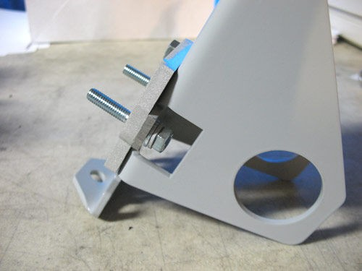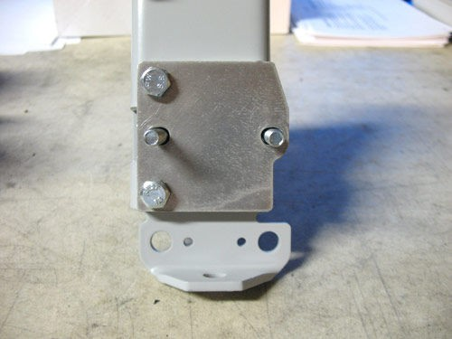

Slide the smaller aluminum spacer over the engine mounting bolts and attach to your engine.
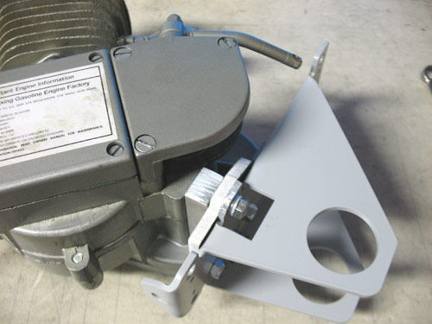
Due to the variations in the castings and hole locations of the different engines some modification to the mount may be necessary. Verify fit of the upper mounting hole.
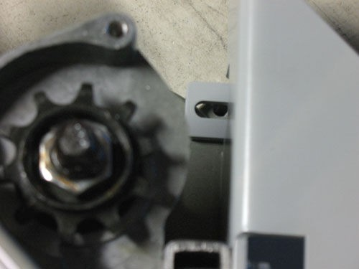
Note this hole is slotted. If you must alter this hole be sure that you also allow fore and aft
movement. This is requires when adjusting your chain.

Once the mount is installed, check for any space between the plate and where the bolt will exit the clutch housing. Add shim washers so that there is no gap and the plate rests flat against the back of the clutch housing.
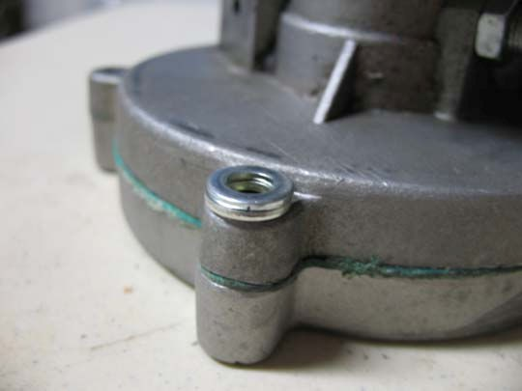
- Add the correct number of 6mm washers to get the mount to sit flat against the back of

the clutch case. Note there are thick ones and thin ones, use whatever combination works best so that the plate sits flat against the clutch case.
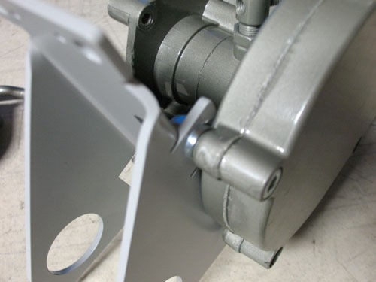

- Install one of the two supplied cap screws. Which one to use will depend on your engine. Some engines have wider clutch covers. You will need enough of the end of the bolt protruding past the mount to install the supplied lock nut. Install the nut at this time but do not tighten it down. This will been done after final chain adjustement.

Step 6

Jackshaft Assembly

Arrange 5/8” shaft, sprockets, keys, shim washers, spacer washers and bearings for assembly on shaft. Sand and file the shaft, sprockets and keys so that they can easily be assembled and disassembled by hand. As we fit these pieces together they will need to be easily slid along the shaft for adjustment and disassembly.
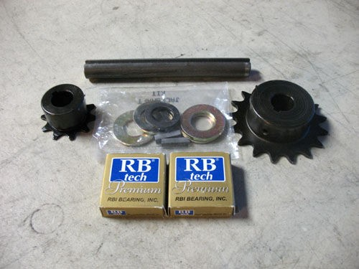
  - Install the bearings into the opening on the rear mounts. The lock rings on the bearings should be to the outside of both plates. Some sanding may be required to get the bearings to fit. They should fit snug but be able to be inserted by hand.
  - Slide the shaft through the bearings.

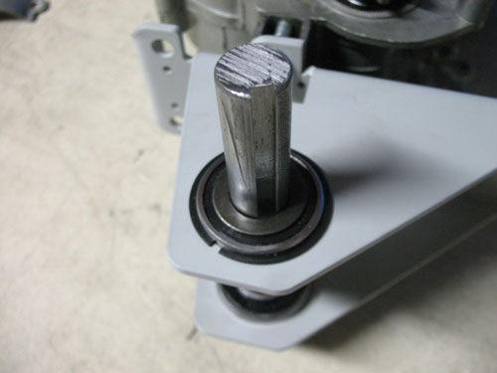
  - Install the larger sprocket onto the shaft after placing one of the thin shim washers and then two of the thicker spacer washers on. The sprocket hub should be toward the outside.

Step 7

Adjust engine chain

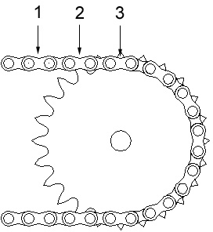
You will need to shorten the chain that came with your engine kit to 15 outer links. This counting method is shown in the diagram and will include the master link.
Install your chain onto your engine output sprocket. First remove the engines output sprocket cover. Then feed your chain onto the output sprocket. This is best done by removing your spark plug from your engine. Then use the spark plug wrench to turn the sprocket and feed the chain on. Fit the chain onto the left side sprocket and check your left side chain tension. If it is tight that is good. If it is loose then you can use one of the “T” spacers between the rear mount and the rear mount spacer to increase the tension.

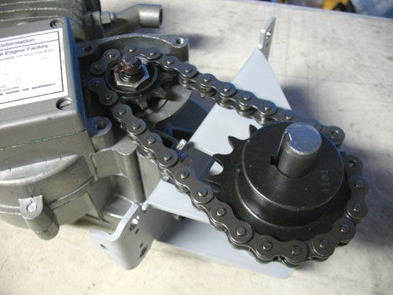
Remove the left side sprocket and shaft.

Step 8
Install engine on bike

Use normal engine installation logic, except the rear mount will be with 2 remaining clamps around the seat tube and through the rear mount. Do not tighten clamp nuts yet.
The engine will need to be removed shortly for final assembly.
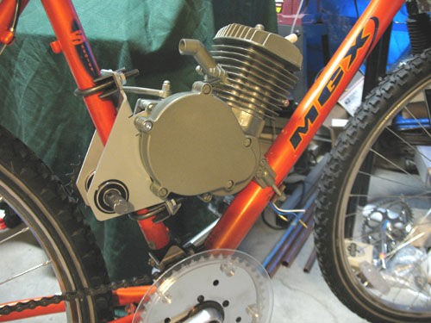
Measure the distance between the lower chain adjuster bracket and the tab on the lower part of the rear mount.
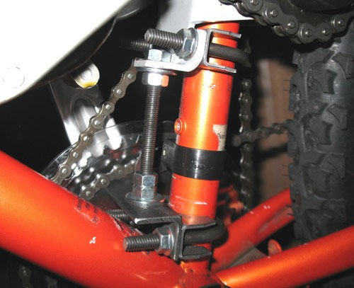

Add 1.5 inches to your measurement and cut the adjuster rod to that length

Note:
If you are not used to cutting threads you may want to put the 4 nuts in the middle of the rod so you won’t have to try and thread them onto an unfinished threaded end

Remove the engine from the bike and install the adjuster rod onto the rear mount.
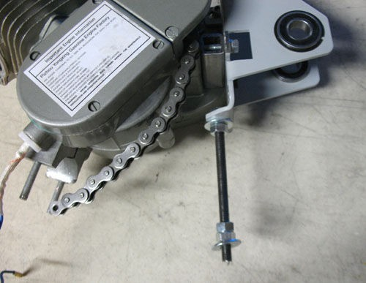
Sandwich the lower tab on the rear mount with two of the nuts. Use a washer on the bottom side. Do not tighten these down yet. The lower two nuts should also be threaded onto the rod at this time.

Reinstall the engine onto the bike. Slide the chain adjuster rod into the hole on the lower chain adjuster bracket. Be sure to install the washer on top of the lower bracket.

Here is a tip from Parts
Now that you are not using the stock rear mount strap, assuming it is one of the stamped steel ones. You can enlarge the 2 holes to match the U-bolt on the clamp. Slide the U-bolt through the holes and use the stock mount strap to provide extra support for the lower clamp. We choose the lower clamp since your seat tube does not have the added support of the seat post and may crimp if excess force is applied. This is especially true of aluminum frames.

Step 9

Jackshaft installation

Insert the shaft into the bearings. Add a thin shim washer and two thick spacer washers onto the left side of the shaft as we did before. Slide on the left side sprocket and the key. Install one shim washer and one spacer washer to the right side and slide the small sprocket and key onto the shaft with the hub facing inward. Position the shaft so there is about 1/8 of an inch protruding from the right side sprocket.

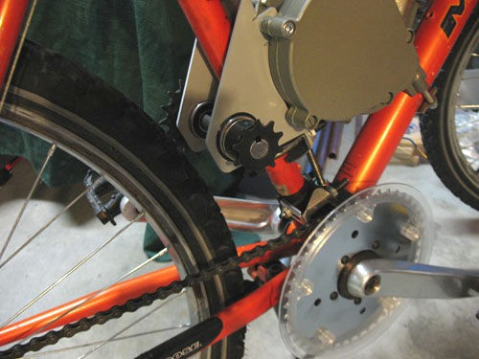

Check alignment of the right side sprocket and outer chainring. You can take a measurement using the seat post as a reference.

Just a note on the small sprocket to large chainring alignment: It is recommended to offset the small sprocket slightly to the right of a true straight alignment with the large chainring. This will accomplish 2 things. It will increase the gap between the 2 chains reducing the chance of them touching when in high gear and will keep the jackshaft from trying to be pulled to the right under high load.

Lightly tighten the set screws that are not over the keys.

Disassemble the jackshaft assembly and file flat spots onto the shaft where the set screws left marks.
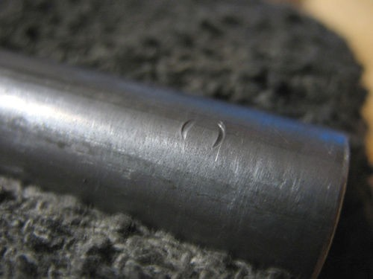
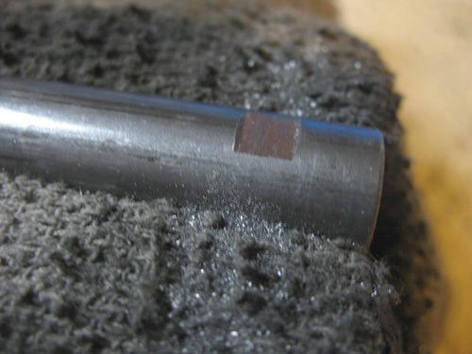
The flats do not have to be large but should be wide enough to allow lateral adjustment. Failure to do this step will cause you problems if you ever have to remove your sprockets or shaft.

Once this step has been completed reassemble the jackshaft like before. Connect the engine chain with the master link.

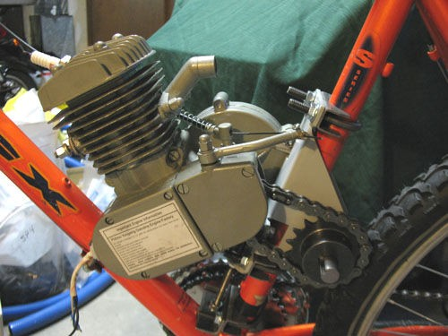

Remove the set screws and apply thread locking compound then tighten the set screws. Do not tighten the right sprocket yet.

Now would be a good time to install your clutch cable so you can rotate the shaft.

Step 10

Right side chain installation

Your engine should be loosely mounted to the frame at this point. The front stock mount should be very loose and the U-bolts on the rear mount should be just loose enough to allow the engine to slide along the seat tube.

    - Force the engine down as far as you can by pushing on the rear mount. Make sure the U-bolts or chain adjuster is not getting hung up not allowing the motor to move.
    - Drape your new bike chain over the small sprocket with one end of the chain hanging about 4 inches down toward the rear of the bike. Wrap the remaining chain around the large chainring and up to meet the other end. Now you need to decide how much chain will need to be removed. It may be better to go too short at this time rather than too long, however never overly force the chain on, you can damage the chain and freewheel. We have included a half link to assist in getting the most accurate chain length. It may or may not be necessary to use it.
    - Shorten your chain as required. Do not use the included master link with this chain. Although the chain is of good quality the masterlink will not hold up and can cause some interference. Use a chain breaker to shorten the chain as necessary.
    - Install the chain, the best method for this is to fully assemble the chain, place it inside the chainrings and onto the small jackshaft sprocket. Once it is on the small sprocket, start placing it on the front of the large chainring and slowly start turning the cranks until the chain has been installed. It will take some force to do this and your clutch on your engine will need to be disengaged so that the sprocket can rotate.

If your chain is loose after it has been installed, it may be too long. If it is only a little loose you may be OK.

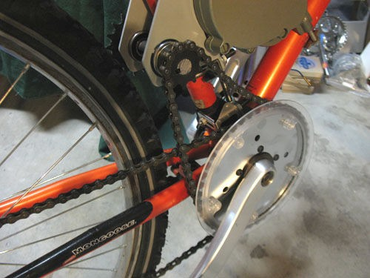

Step 11

Right side chain adjustment.

Tighten the upper set of nuts against the upper tab on the rear mount.
With your two motor mount clamps just loose enough for your engine to slide, start threading the lower nut against the bottom adjuster bracket until your chain becomes tight. Your chain should never have more than ¼ inch of slack in either direction. When you start running your bike, the force on the motor will twist it slightly and loosen the chain. You will find that you will probably have to adjust your rear mount two or three times until everything settles and the chain will remain tight. Remember to loosen your front mount and upper clutch case nut substantially before trying to adjust your rear mount.

Tighten the remaining lower nut on the adjuster rod against the lower nut with two wrenches to keep it from coming loose.

NOTE: it is best to start with your chain tight as it will loosen when riding.

Tighten your rear U-bolt mounts and your front mount. These U-bolt clamps must be tight. If they are not your mount will slip and twist on your seat tube. If you end up with more that 1/8 inch of space between your frame and your front mount you may want to rethink your front mount or your chain is too long so your motor has to be placed high on the seat tube to tighten the chain. You can space your front mount or try removing a link from your chain and readjust your engine. After tightening your mounts, ensure that the chain remains tight. If you

cannot find a good combination of chain length and engine adjustment you may need a half link.

Once your chain is adjusted remove the set screws on the upper jackshaft sprocket and apply thread locking compound and tighten them.

You may now also install the lock nut on the back side of the clutch housing. Remember to loosen this nut whenever you are making a chain adjustment and tighten once complete.
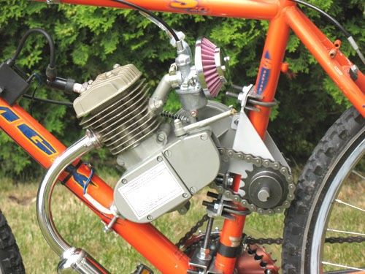

Step 12

Plastic Chain guard installation

      - Test fit the two pieces on your engine ensuring that when the 3 holes line up, the chain guard is protecting the small sprocket.
      - Insert the 3 T-nuts into the back side of the plastic clutch cover plate using a hammer to get them as flush as possible.
      - Clean your clutch cover with brake clean or rubbing alcohol to remove any oil or grease.
      - Apply a thin coat of contact cement to the engine clutch cover and the backside of the plastic clutch cover plate. The backside is the one with the large portion of the T- nuts showing.
      - Allow the contact cement to set up according to the manufactures instruction and place it on the clutch cover.
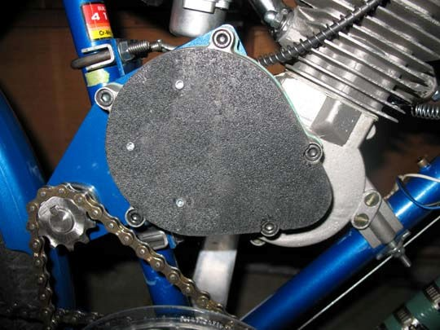

      - Install the chain guard by screwing it to the clutch plate.
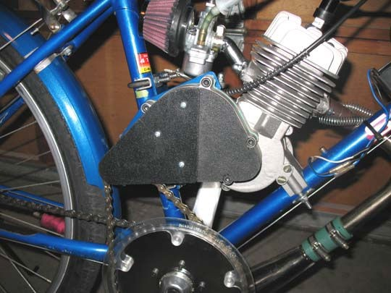

Operation

Your first ride

Take your bike out for a spin under pedal power. Make sure that everything is moving feely and that your shifting mechanism is working correctly. After a few minutes pedaling, double check that all your hardware is tight and check your chain tension. Readjust as necessary. You may find that in your top gear that the 2 chains get very close to each other. Pay close attention to this. Each bike is different and due to many factors these chains may touch which is an unacceptable condition. To increase the clearance you can try a few things. You can increase the space between your rear cassette and chain stays by adding a spacer to the right side of your axle and remove the same amount of space from the left side of the axle which will move the cassette closer to the center of the bike. You can also add a washer in between the front freewheel and the large front chainring to each of the 5 bolts which will space the chainrings farther away from the other. You can also adjust the small sprocket on the jackshaft farther away from the center of the bike, you can move this pretty far out of alignment before you run into problems with the chain.

Starting your engine

The first thing you will notice when trying to start your engine is that it is different than it was before. You can no longer just get the bike moving and release the clutch. You now have to pedal to start the engine. This will seem strange at first but it won’t take you long before you figure out a good technique for starting your engine. Here is our suggested method. Pedal your bike with the clutch in to get it moving at a decent pace in 1st gear, prop the crank for your preferred leg up at about 45 degrees, release the clutch, get out of the saddle and put your weight on the pedal of that crank, as the engine starts to turn keep pedaling through.
Once the engine starts to turn over it is pretty easy to continue pedaling. Do not jump on your pedals to start your engine. This puts excessive force on the freewheel and may cause it to fail.

Shifting

When attempting to shift your bike for the first time we recommend you back off the throttle

slightly before making a shift. This will relieve a little force from your derailleur and allow smooth shifts. Also be sure to roll the throttle back on slowly. Due to the slack that exists in the chains combined with the 2 freewheels your engine can free rev for a split second as you add power after a shift. This can cause excessive force to be applied to the drive train and cause damage to your rear axle, hub or cassette. With some practice you will be able to shift quickly and not overly stress the drive train.

Remember to downshift when coming to a stop. Using your clutch is only required when starting or stopping. It is a sure way to kill your engine if you attempt to start from a stationary position and find yourself if 6th gear instead of 1st.

Be sure to only ride for a few minutes and then double check all your hardware and chain tension. As was mentioned previously, the chain from the jackshaft to the chainring will need to be readjusted a few times as your motor settles.

Other operating tips

We highly recommend the following for safe operation.

A grip shifter or “rapid fire” shifter is an excellent addition to ensure safe operation of your motorized bicycle. It allows you to up-shift and down-shift easily without taking your hand off the handlebars.

A dual pull brake lever is also highly recommended. It will clear your bars up and allow easier access to your shifter.

Here is an example of a handlebar layout.
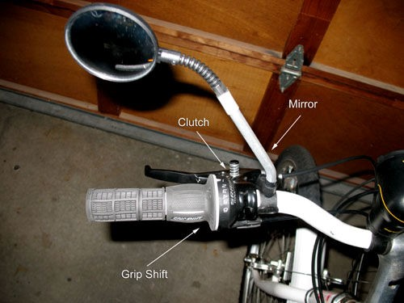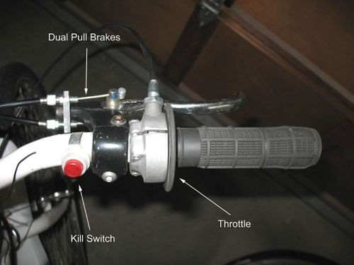

Maintenance

This kit is relatively maintenance free but you should maintain your chains, derailleur and front freewheel. Keep your chains clean and use appropriate lubrication on them, do not use WD- 40 on chains. Keep all moving parts of your derailleur especially the idler sprockets clean and well lubricated. Your front freewheel should also be lubricated periodically. We recommend that you follow our Freewheel maintenance instructions found on our website.

Parts list
Item | Description | Qty
1a | Crank L | 1
1b | Crank R | 1
1c | Freewheel | 1
2 | Bottom Bracket Spindle | 1
3 | 36t Sprocket | 1
4 | 44t Chainring w/chainguard | 1
5 | 5/8" x 5.25" Jackshaft | 1
6 | 5/8" Bearings | 2
7 | 17t Jackshaft Sprocket | 1
8 | 10t Jackshaft Pinion | 1
9 | 5/8" Bearing Washer | 4
10 | 5/8" Shim Washer | 4
11 | 6mm x 35mm Right Bracket Bolts | 1
12 | 6mm x 30mm Right Bracket Bolts | 1
13 | 6mm Lock Nuts | 1
14 | 6mm Nut | 5
15 | 6mm Washers | 5
16 | Bike Chain | 1
17 | 1 1/8" Muffler Clamp | 3
18 | Rear Motor Mount Spacer | 1
19 | Rear Motor Mount | 1
20 | 6mm x 35mm Rear Bracket Bolts | 2
21 | 6mm split lock washers | 2
22 | Clutch cover | 1
23 | Upper chain guard | 1
24 | 6-32 T-nuts | 3
25 | 6-32 x 1/4" screws | 3
27 | 5mm x 25mm sprocket bolts | 5
28 | 5mm washer | 5
29 | 5mm lock nut | 5
30 | 6mm shim washers | 1
31 | 3/16" x 3/16" sprocket key | 2
32 | Chain Adjuster Stud 6/16 | 1
33 | 5/16 Nuts | 4
34 | 5/16 Washer | 2
35 | Chain Adjuster Bracket | 1
36 | Jump Stop | 1
37 | 1/8 BMX Half Link | 1

