ROTARY SIEVE CT0611
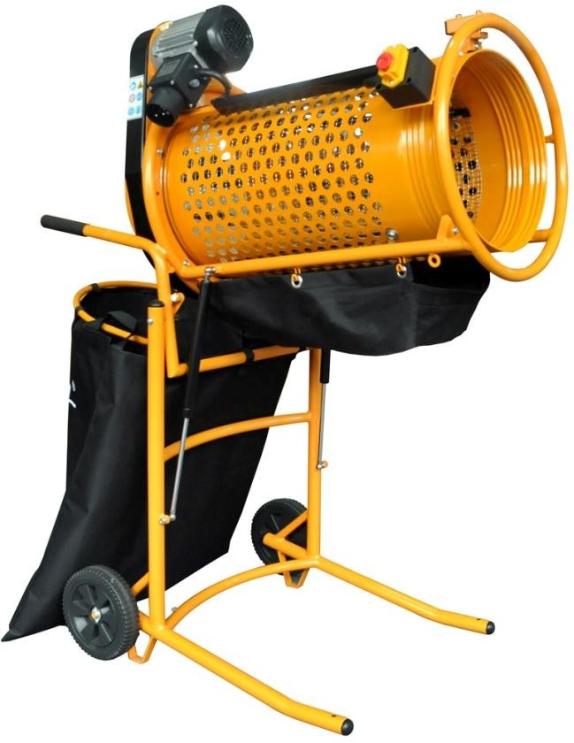

ORIGINAL MANUAL

Please not the included General Safety Notes and the following safety notes to avoid malfunctions, damage or physical injury.

- Make sure the voltage corresponds to the type label on the unit.
- Never leave the rotary sieve unsupervised when in use.Keep out of reach of children or persons in need of supervision.
- Persons with limited physical, sensorial or mental abilities or lack of know how and/or lack of knowledge are not allowed to use the unit,unless they are supervised and briefed for their safety by a qualified person.
- The rotary sieve is designed for operation under ambient temperatues between+5℃ and +40 ℃.The surrounding humidity should be less than 50% at a temperature of +40 ℃.The rotary sieve can be transported and stored under ambient temperatures between -25 ℃ and +55 ℃.
- Protect your eyes and wear ear protectors while working with the rotary sieve.
- Do not wear any loose clothing or jewellery.These can get caught up in moving parts.Non-slip footwear is recommended if working out of doors.Wear
a hair net if you have long hair.
- Do not grasp into the moving drum or other moving machine parts.
- Make sure all parts are securely mounted before switching on machine.
- Never try to stop moving parts by hand.
- Check all movable parts to ensure that they are still functioning perfectly and in compliance with specifications.The rotary sieve must be connected properly
and fulfil all requirements in order to ensure perfect operation of the machine.Make sure that the machine stands stable on firm ground.
- Please switch off the unit and unplug from the power supply before cleaning,
maintaining or when not in use
- When filling soil into the drum keep the shovel or garden fork clean of the drum and make sure the shovel or garden fork cannot become jammed.There is risk of injury.
- Switch off the rotary sieve during rest brakes.
- Do not operate the machine if it does not work correctly or has been damaged.
- Do not operate the rotary sieve on inclined surface, always take care the machine is standing as horizontally as possible.
- In case of operating the machine on slippery surface, please support the wheels with wedges.
- Do not disassemble the machine and do not try to repair it yourself, contact your customer support.

Rated Voltage | 230V
Frequency | 50Hz
Rated Power | 360W
Protection Class | Ⅰ
Degree of Protection | IP44
Weight approx. | 31kg
Dimensions Expanded | 1080x652x1350mm
Dimensions Folded | 870x652x950mm
Drum Diameter | 375mm
Drum Length | 785mm
Drum Rotation | 45min⁻¹
Mesh Width | 20mm
Sound Pressure Level | 89dB（A）
Sound Power Level | 100dB(A)

Always keep all labels on the rotary sieve clean and readable.

- Read the instruction manual before using the unit for the first time

- Wear safety goggles when working to protect the eyes from
- flying stons,etc.

- Wear hearing protection when working

- Always pull the power plug before cleaning,maintaining or when not in use

- Do not expose the unit to any jets of water such as garden hoses, high-pressure cleaners,etc,The unit is splash water proof(IP44)

- Caution! There is risk of being trapped.While working with the rotary sieve never touch any moving parts of the device.

- Confirms to applicable safety standards.
- Recycle unwanted materials instead of disposing of them. All appliances and packaging should be sorted and tendered at a regional recycling centre into to be processed in an ecological manner.

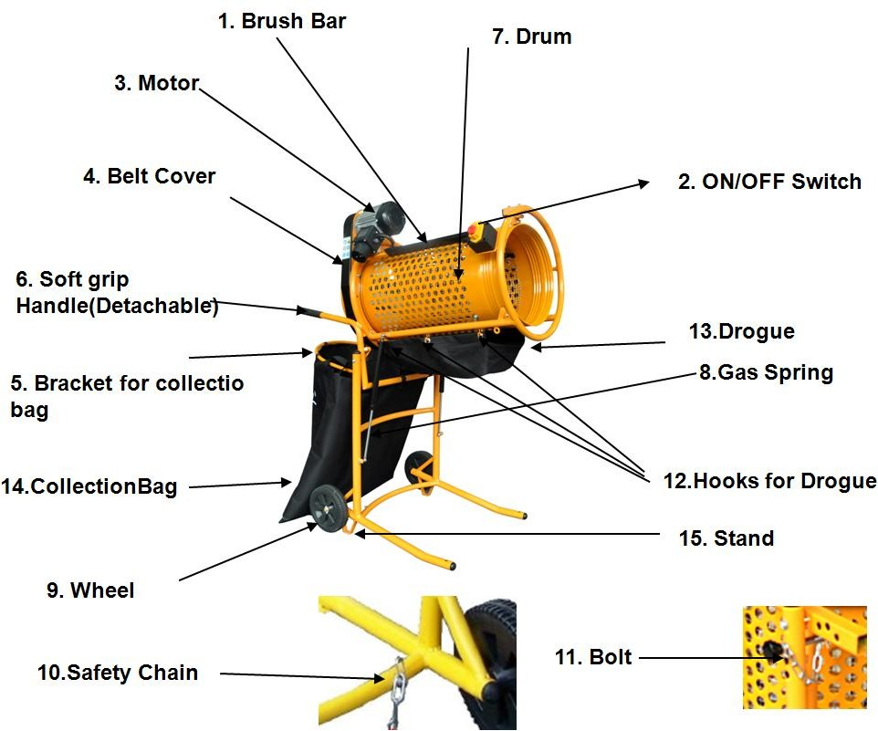

Before first Use
Unpack the rotary sieve and check all parts for damage in transit,Dispose off packaging material and store it out of reach of children,Plastic bags may become a deadly toy for small children.

Intended use
Only use the rotary sieve for the intended use. The rotary sieve can be used to sift compost,gardem soil or clumped sand,or to mix different soil types. Please also note the below mentioned hints in order to sift the material as thoroughly as possible.

Assembly
- Attach the handles to the rotary sieve, Disengage the drum by releasing the safety chain(10).
- Set the rotary sieve upright by holding on the handles and pushing your foot against the bottom bar.
- Hook the drogue(13)from booth sides on the provided hooks(12).
- Fold down the bracket for the collection bag(5). Wrap the hook and loop fasteners around the bracket. The rotary sieve is now assembled.
- Connect the extension cord with power mains and the power plug.The rotary sieve is now ready for use.When using extension cables,make sure that plug and coupling are splash-proof.Only use extension cables with a minimum cross section of 1.5mm² that are approved for outdoor operation.
- Make sure the rotary sieve stands as horizontally as possible.Withe the bolt(11) you can adjust the inclination angle for the drum.At the beginning adjust the drum as horizontally as possible.
- For switching on the engine,release the lid of the ON/OFF switch and lift up, press down the “ON ”switch .Fold down the lid.For switching off the engine,press on the red button switch.
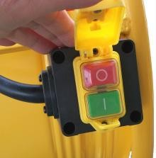
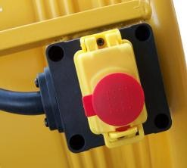
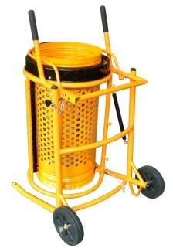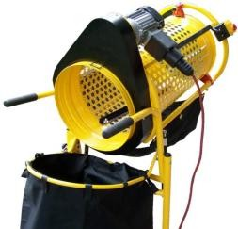

Hints for Using
- Before sifting the soil with the rotary sieve,make sure the soil is lightly wet.Dust-dry or very moist soil is not suitable to be sifted.Break down very clumpy soil prior to throw into the drum.

- Please note if the drum is tilted too much.too much soil will be thrown out.In this case make sure the rotary sieve stands as evenly as possible and the
drum is lying horizontally.If desired,collect the already sifted soil and throw it into the drum again in order to sift it thoroughly.

- When sifting large amounts of soil it is recommended to place a wheelbarrow under the drogue instead of the collection bag.Place it under the bracket for the collection bag in order to collect the sorted out rocky soil,stones,wooden components etc.and to overturn at the desired place.

- When throwing the soil into the drum,make sure to throw into the outside part of the drum,By doing this,the soil will stay as long as possible in the drum and can be sifted thoroughly.Make sure the shovel cannot get into the drum and become jammed.There is risk of injury.
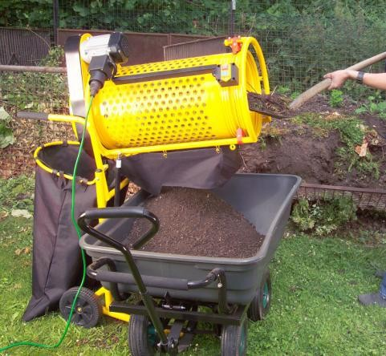

Maintenance
- Always check the condition of the rotary sieve first each time before using. Check the safety devices, switches and mains cable.Check for loose bolts and
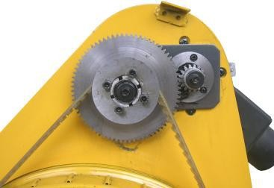
screws,poor alignment,contacting moving parts,broken parts and any other factors that could affect safe operation.
- Do not continue to use the machine if there
are any signs of damage.In this case,have it repaired by a qualified technician or contact the service department.

Replacing the Drive Belt
- Unscrew the three screws on the cover and remove housing.
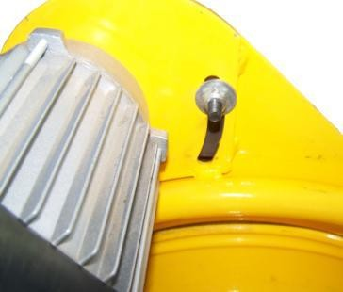
- Loosen the nut at the rear side of the housing by using a suitable open wrench and replace the drive belt with a new one of the same type.
- Lubricate the gearwheels with clean machine grease.
- Reattach the drive belt cover on the housing prior to use the rotary sieve again.

Cleaning and Storing
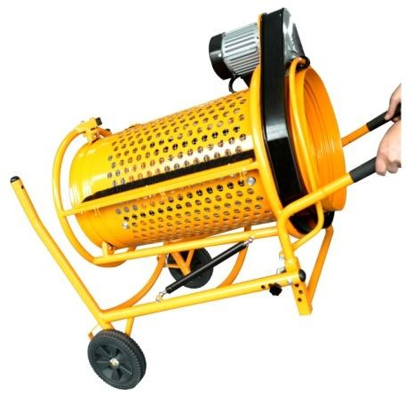
- Pull the power plug before cleaning or maintaining the rotary sieve.
- Clean the rotary sieve with a hand broom.For cleaning the motor housing use a dry cloth.
- Keep the rotary sieve dry and free from
stubborn dirt.Store the rotary sieve in a dry and frost-free location.
- Transport the rotary sieve as shown in
the picture

DISPOSAL & TRANSPORTATION

Disposal

Dear Customer,
Please avoid waste materials.

If,at some point,you intend to dispose of this article,please bear in mind that many of its components consist of useful materials which can be recycled.
For this reason, please do not throw it in the rubbish bin, but check with your local council for recycling facilities in you area.

Transportation

Do not put the rotary sieve upside down.

Made in China

