Manual Meat Slicer Instructions

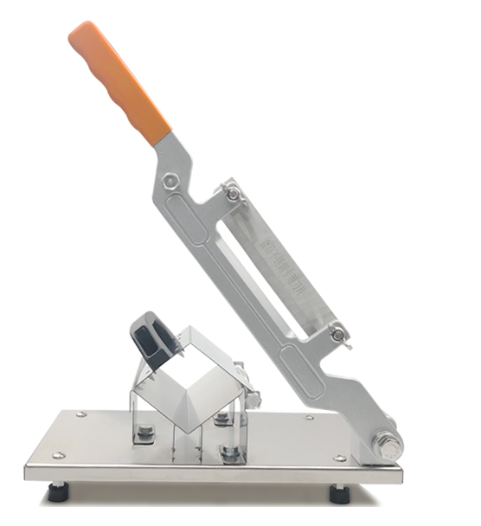

Thanks for using our company’s meat slicer, In order to better use of device, please read the instructions carefully before using.
PRODUCT DETAIL

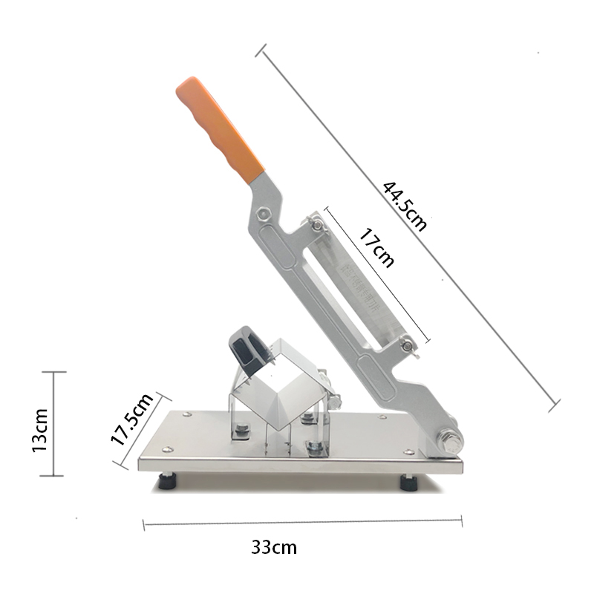

USE INSTRUCTIONS
1.Put the machine on the flat and smooth table when slicing, make sure the four sucking disc foots are stable, place the standard meat rolls or hard food material on the work table. Adjust the thickness through the gasket.
2.Press the meat with the meat box , Left hand press the meat and push the meat to the blade direction, Right hand hold the blade handle then press down the handle and cut the meat to slicer, Then lift up the blade handle.
MAINTENANCE
1.Keep food hygienic, the machine parts contact with food must be cleaned after use. Cleaners must be non-toxic, non-corrosive. wipe dry with a dry cloth after cleaning.
2.The machine use stainless steel blades, if not used for a long time, please wipe clean and keep dry.

