Fiber Laser Marking Machine

User Manual

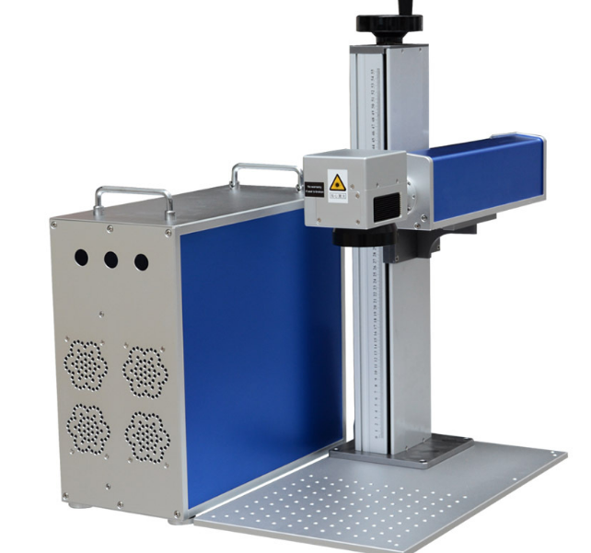

To make sure the normal operation of machine, please read the user manual carefully.

Function
(1) Applicable for metal and some non metal materials, like steel, aluminum, plastic etc.
(2) Support text, barcode, QR code, vector graphics, bitmap, regular and irregular serial number processing
(3) Support work: common marking, deep marking, bitmap photo marking etc.

2. Parameter
(1) Power supply: AC220V 50~60Hz
(2) Cooling way: Air cooling
(3) Power consumption: ≤800VA
(4) Grounding mode: Multi-point ground
(5) Power supply for laser source: 24V/15A（MW）
(6) Power supply for lens: ±15V/3A（MW）
(7) Power supply for control board: 5V/3A（MW）
(8) Laser control system: JCZ/EZCAD
(9) Computer （PC）
(10) Operating system: Windows 7 32bit
(11) Communication mode: USB
(12) Cabinet: Standard（can be customized）；
(13) Worktable: Aluminum board（Manual Two-dimension worktable optional）
(14) Indicator light：Red light
(15) Formats supported: PLT、DXF、BMP etc
(16) Adjustment for focus：Manual adjustment
(17) Adjustment range for repeat frequency: 30~60KHz for 20W~30W（20~80KHz for IPG laser source and some other sources）50~200 KHz for 50W~100W
(18) Adjustment range for power: 10~100%；
(19) Adjustment range for speed：1~7000mm/s（1~3000mm/s recommended）
(20) Marking range：110mmX110mm、150mmX150mm、175mmX175mm、200mmX200mm、300mmX300mm；（decided by lens）
(21) Up-down range：550mm、750mm、1200mm etc
(22) Interface: For master power, foot switch, USB, Rotary (Optional)
(23) Switch：Master power（Manual）、Laser source（Manual）、Lens（Manual）

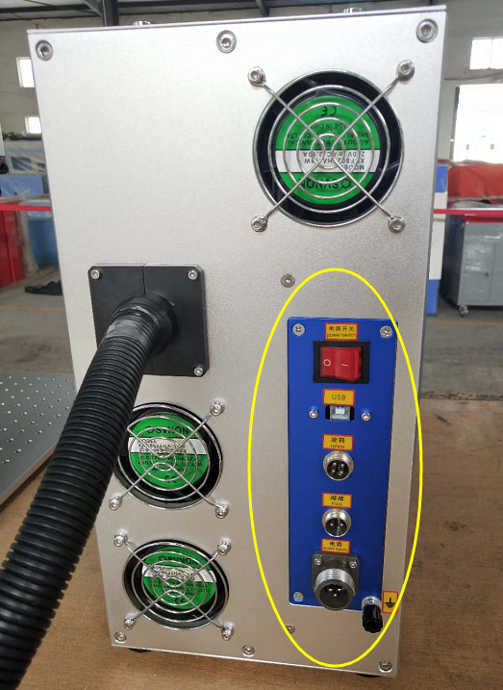

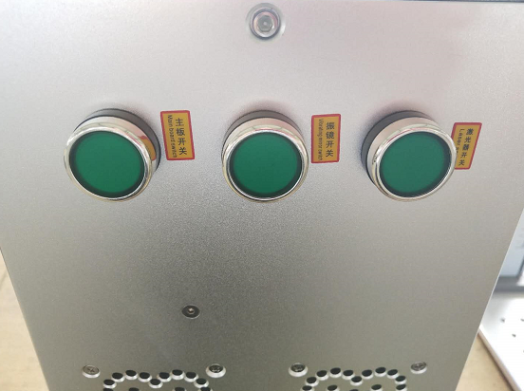

Power switch

Interface

3. Preparation before operation
(1) Power supply：AC220V 50~60Hz
(2) Suggest using voltage stabilizer not less than 1200VA
(3) Grounding tools: Profiles not less than 1m with good conductive, like copper or iron etc. One side is knocked into wet earth outside, and another side is connected with Grounding interface shown on machine.
(4) Environmental requirement: Temperature 1~35 ℃, Humidity 30%~80% non-condensing, With ventilation equipment, Non-violent vibration, No heating unit around, Clean and dust-free.
(5) Please read the user manual carefully before operation.

4. Connection for parts
(1) Please connect Master power cable and Foot switch with machine
(2) Please insert three-phase plug from master power supply into external power socket（If installed with voltage stabilizer, please insert the power plug into AC220 output on voltage stabilizer），As shown on Image below:
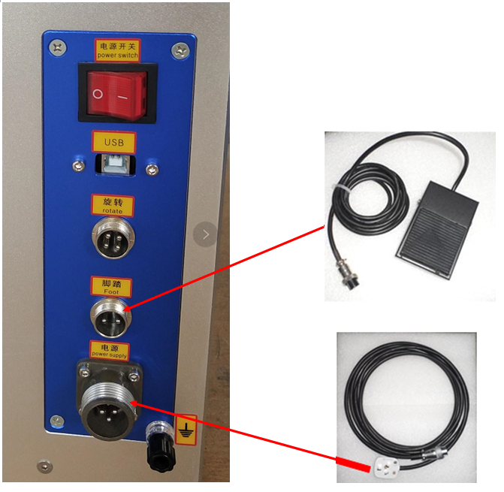
(3) If display is not connected, please connect the power supply and signal wire

5. Turn on machine
(1) Turn on master power switch
(2) Turn on scan switch
(3) Turn on laser switch
(4) Turn on mainboard switch
(5) Press power button on computer
(6) After computer on, please open the software, by double click icon of “EzCad2.exe” on desktop, as shown on Image below, then finish the starting.
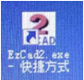

6. Operation steps

(1) Import the drawing（Vector graphic or Bitmap），or create a text by tools
(2) Fill the drawing from the first step, by using fill tools

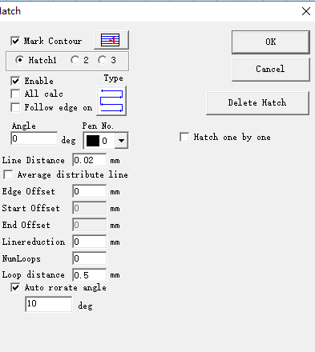Fill page is shown as below:

Please check the effect after filled below:

(3) Set speed, frequency, and power
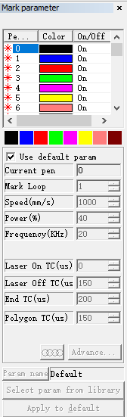
(4) Press Light button or F1, and preview the position that drawing will be marked.

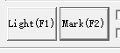

(5) Press Stop button, and end the preview, then press Mark button or F2, and start to mark the drawing.
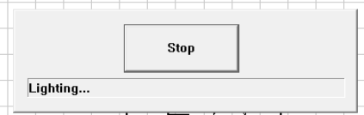

About the detailed parameters, please contact us, and we will sincerely make service for you.

7. Introduction for “Parameter F3”

All the settings are saved into “Parameter F3”, please press it, you can see Field/Laser Control/Port/Other. When our after-sale person needs the parameter, please kindly check it, thanks for your cooperation.

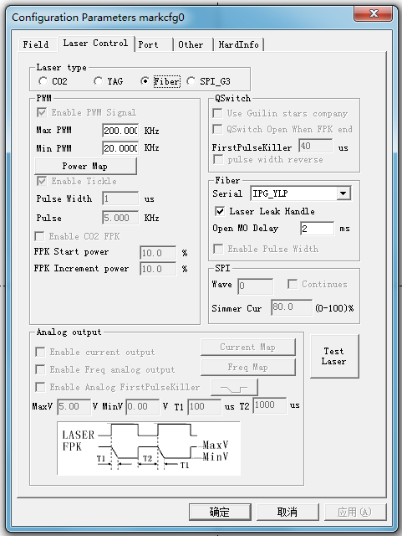
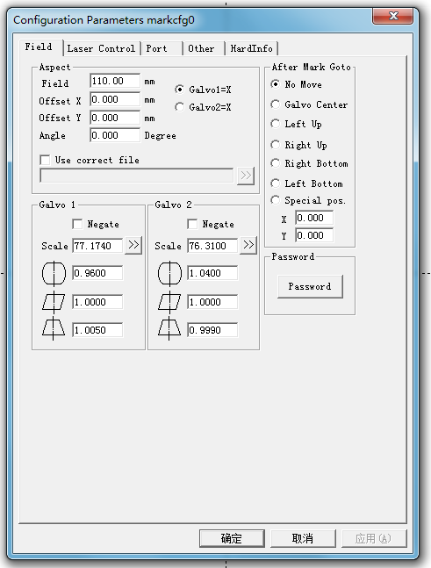

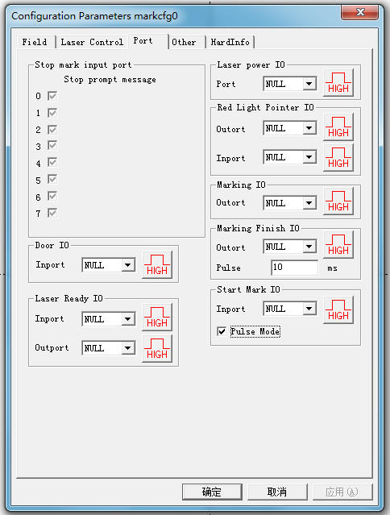

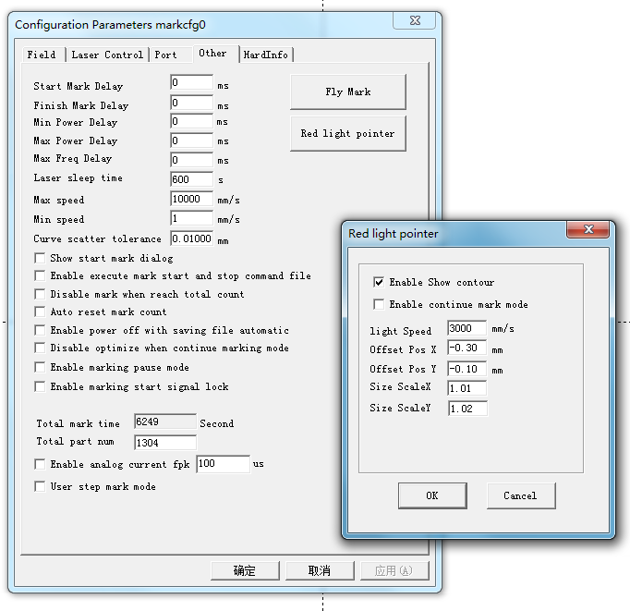

8. Common problems and solutions

(1) Dead power
Reasons: Power cable fails to connect well, or electric parts are damaged.
Solutions: Connect power cable well, or change electric parts.
(2) Laser scanning fails to response
Reasons: a. No power for scan switch
b. Do not remove the cover for lens
c. Signal wire for scan fails to connect well.
d. Failure for software or system
Solutions: a. Check electric circuit
b. Remove the cover for lens
c. Check the signal wire for scan
d. Restart computer or reinstall software
(3) When marking, it’s clear in some places, but unclear in some other places.
Reasons: a. Material surface is not parallel with the lens
b. It’s not clean for the scan and lens surface
c. The workpiece is dirty or curved
d. Scan or lens is damaged
Solution: a. Adjust the material surface, to make it parallel with the lens
b. Clean the scan and lens surface
c. Clean the workpiece, and avoid working on the curved surface
d. Change scan or lens
(4) Marking depth is not deep
Reasons: a. Percentage of power is set too small
b. Frequency is set too large
c. The material surface is out of focus
d. Marking speed is too large
e. Output power and voltage from laser power supply decreases
Solutions: a. Set the percentage of power larger
b.Adjust the frequency to the best
c. Adjust the focus
d. Make the marking speed lower
e. Change the laser power supply
(5) Software shows “fail to find control board or soft dog”
Reasons: a. Bad connect for control board and computer
b. Driver fails to be installed or deleted
c. Power supply for control board is abnormal
Solutions: a. Check the connection for control board and computer
b. Install the driver
c. Check the 5V power supply for control board
(6) When marking, the ALARM appears below:
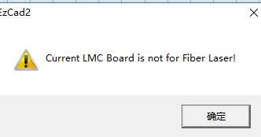
Reasons: Control board fails to connect with computer, or no power supply
Solutions: Check the connection and power supply for control board and computer

(7) When marking, the ALARM appears below:
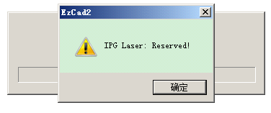
Reasons: Laser source fails to connect, or no power supply
Solutions: Check the connection for control board and laser source, or power supply for laser source

9. Turn off machine
(1) Close the software first（Before close, please click “file-save”, to save the file）， then close the computer
(2) Close the scan switch
(3) Close the laser switch
(4) Close the mainboard switch
(5) Close master power switch and emergency stop（Sometimes Emergency stop is master power switch）
(6) If installed with voltage stabilizer, please close the relevant switch

Close is finished

10. After sales and maintenance

When there’s something wrong with machine, please check the solutions in Article 8, if still can not be solved, please follow the steps below:

(1) Contact the after-sale person about the problems
(2) Within the warranty, damaged parts will be repaired free of charge, but except the following:
a. Damages because of war, natural disasters and other irresistible factors
b. Damages caused by the improper environment and operation
c. Exceed the warranty；
d. Disassemble the machine without the approval from manufacturer of supplier
e. Customer modifies the machine casually without permission from manufacturer or supplier, including appearance and function

