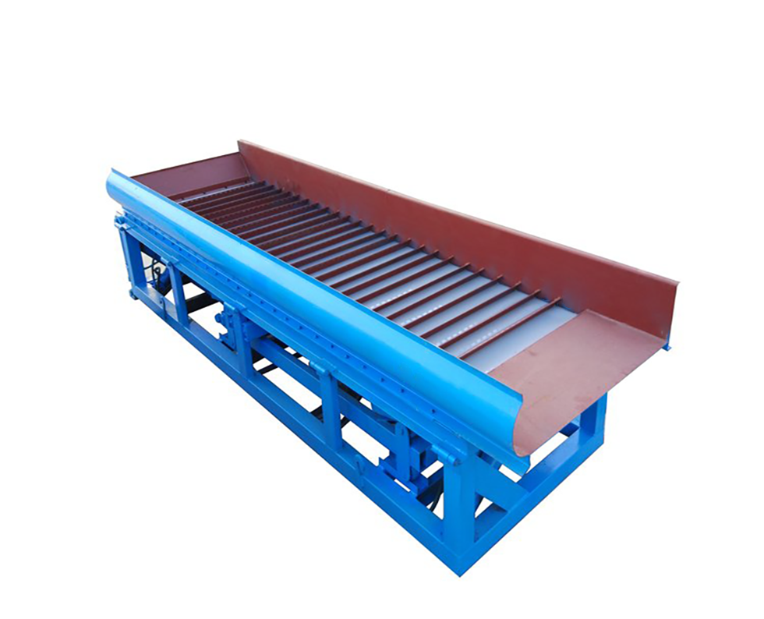
Product introduction
Vibrating gold sluice is a new type of alluvial gold separation equipment developed on the basis of the common gold sluice. It perfectly combines the advantages of common gold rush sluice box and jig machine, but overcomes their disadvantages, such as easy caking and silting-up on the common gold sluice and large water consumption on the jig machine. It's mainly used for the separation of placer gold ore. It has very good effect on fine gold and flaky gold, and has advantages of simple structure, reliable running, less faults, low energy consumption and water consumption. It's an excellent equipment for the placer gold ore, and can be applied to other heavy minerals.
Sluice uses the difference of specific gravity between gold and sand, slurry flow through the sluice, the gold because its weight will settle the bottom, the sand and other light objects float on the upper flow out of the sluice with the water. Sluice usually uses carpet to trap gold, due to caking and silting-up fast in the process, the gold recovery rate is only about 70%. Vibrating gold sluice basically retained the characteristics of common gold sluice, and change the steel plate to the rubber plate, plus simple eccentric bulging mechanism, make the rubber plate to do up and down movement repeatedly, the layering effect of each strip intervals is similar to the diaphragm jig, thereby solving caking and silting-up. The cyclical bulging can be more conducive for layering and desilting, making the recovery rate increased to about 90%.
Vibrating gold sluice working principle
When materials flow through strips with a certain height and interval on the sluice by water, it creates vortexes and pulsating water flow. The rotary movement of vortexes continuously precipitates the gold particles and other heavy minerals to the bottom layer. The turbulence action of the flow is weak at the bottom, and the solid concentration is large. Therefore, the light materials are difficult to enter the bottom, only the fine gold and heavy minerals can through the gap of the upper layer and enter the bottom to form a heavy mineral layer. Because the heavy mineral layer can't discharge automatically, as the working time increases, the sediment at each strip interval become more and more, become more and more dense, it forms caking finally, thus affecting the layering of subsequent materials, lead to the separation effect getting bad gradually. Vibrating gold sluice directly acts on the sedimentation layer and the slurry through the diaphragm at the bottom, when the diaphragm rises, the material particles rise as well, and the sedimentation layer gets in a loose state. When the diaphragm falls, a certain suction effect formed, the material particles get settle according to the specific gravity. The gravity of natural gold is several times larger than gangue minerals, so it quickly precipitates to the bottom and to be recovered. Due to the barrier of strip and the protection of natural mineral layer, the recovered gold at the bottom layer will not be carried away by the slurry flow again.
Advantages and features
1. Low price, small investment, large capacity and high separating efficiency;
2. Low energy consumption and water consumption;
3. Simple operation and stable running;
4. High recovery rate, can recover both granular gold and flaky gold, as well as fine gold less than 0.02mm;
5. Strong adaptability, can work in any geological structure and any gold mining area.
