MachineModel：
P50 semi-automatic powder and granule packing machine

Machinedescriptions
Applicable materials:
Powder and granule materials, microparticles, sand with a diameter of not more than 50 mm, refractory materials,
Applicable packing bags:
Woven bags, sacks, paper bags, cloth bags, and plastic bags.
Installation method:
The scale body is directly connected to the storage bin without additional steel frames. The installation process is simple and occupies little space on the ground.
Machine advantages:
Simple operation, High packing speed, high precision, high
efficiency, stable operation, simple maintenance and continuous
operation.

Machine specifications
Applicable materials | Water control within 40% of the powder materials, granules, organic fertilizer
Weighing range (kg) | 20-50kg
Weighing speed(bag/h) | 160-260
Weighing accuracy | 0.2%
Power supply | 380V/220V 50Hz (Can be customized)
Air supply | 0.4～0.6Mpa 1m3/h
Air source | Choosing an air compressor with a capacity of 0.25 m3/min or above.
Air consumption | 0.4～0.6Mpa 1m3/h
Working environment | 0℃～＋40℃
Power consumption | 1.67Kw
Computer control instrument | Computer programmed controller 3D
Pneumatic Components | Taiwan Yadke, Jia ling, etc
Feeding mechanism | Belt feed
Manufacturing materials | Carbon steel junction fuselage structure and the contact part with the material is stainless steel steel
Weight (kg) | 446

Details

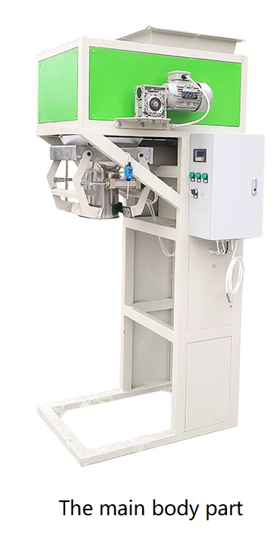

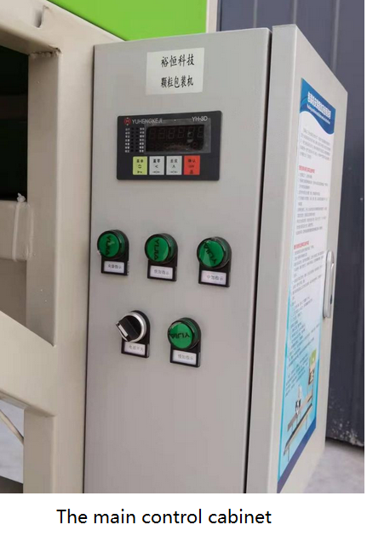

A computer-programmed control instrument with High measurement accuracy, stable performance, and digital display. Chinese, English and French languages. Automatic setting of control parameters, automatic drop correction, super differential alarm, fault diagnosis, etc

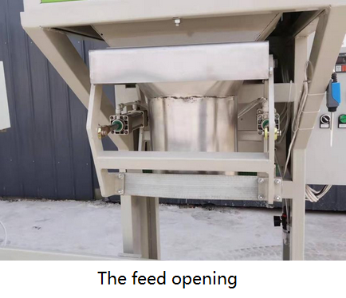

Manufacturing materials： The out layer of the machine adopts an electrostatic injection plastic process. The feed opening is made of smooth stainless steel, wear resistance, high fluidity, hygienic, corrosion resistance, and extended equipment service life.

Schematic diagram of mechanical parts

NO. | Name | Brand | Unit | Qty | Dimensions（mm）
1 | The main packing part | P50 powder and granule packing machine | piece | 1 | 1100*1050*2710
3 | Feeder | Deshengxiang | piece | 1
4 | Control cabinet | Y | piece | 1
5 | Control instrument | 3D | piece | 1

Applicable packing bags
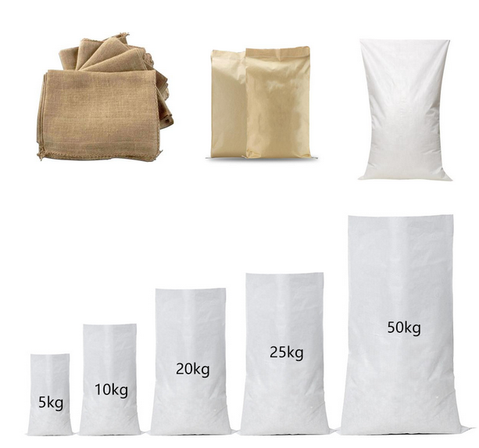

Applicable packing materials
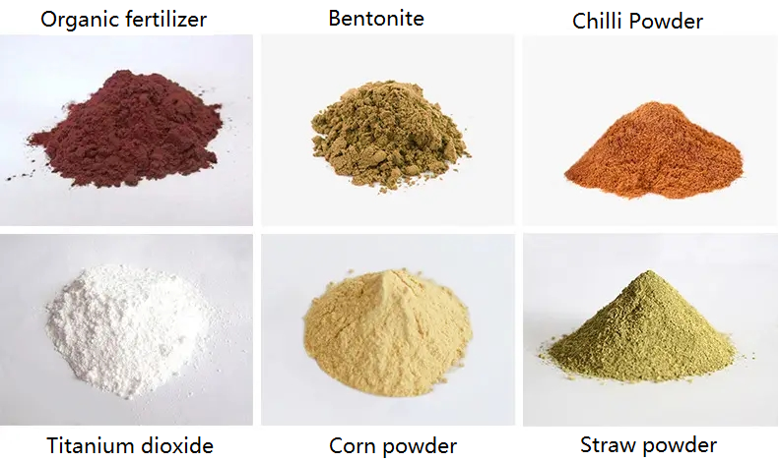

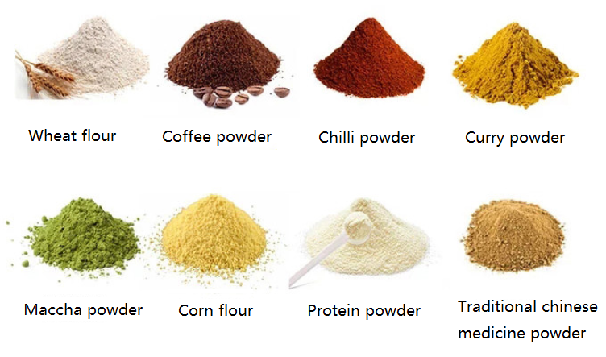

Applicable scenes
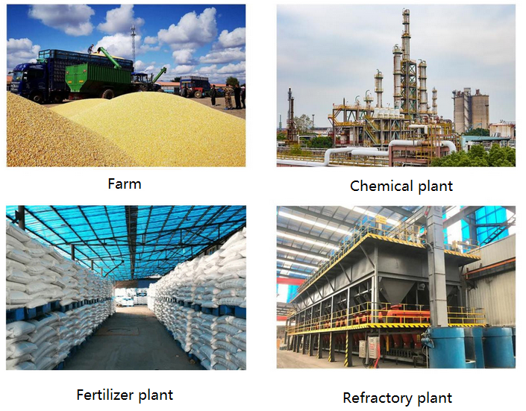
The compatible supporting types of machinery

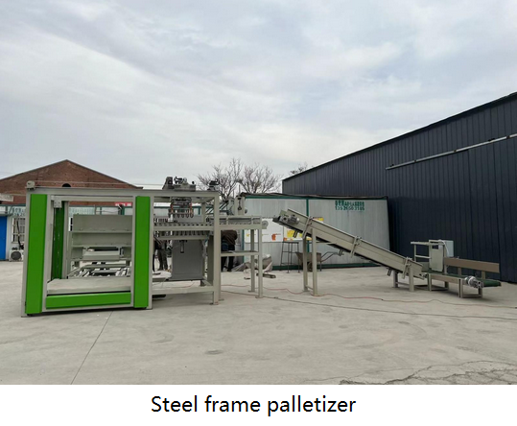
Scope of application:
Suitable for grain, feed, fertilizer, chemical flour and other bagged goods palletizing and handling industries.
Advantages:
Suitable for all packaging bags, automatic palletizing, fast palletizing speed, high palletizing accuracy, high degree of automation, simple operation, and saving labour cost.

Machine configuration:
Main palletizing engine, coding roller conveyor, plastic conveyor, climbing belt conveyor, etc

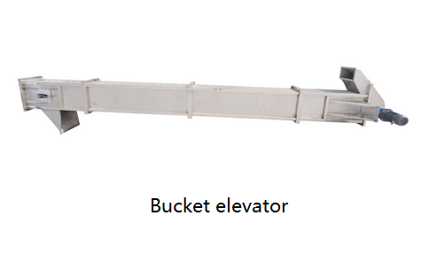

The bucket elevator is suitable for lifting from low to high positions. After the feed enters the hopper through the shaking table, the machine automatically runs continuously and sends it upward. Transmission speed and lifting heightcan be adjusted according to the customer’s needs. The hoppers are designed and manufactured by our R&D team. PP non-toxic hopper makes this bucket elevator more widely used. All sizes are designed and manufactured according to actual needs. Machine, computer measuring machine design, suitable for food, medicine, chemical products, screws, nuts and other products lifting and feeding, can be recognized by the signal of the packaging machine control machine automatic stop and start.

