**STUMP GRINDERSG24/SG24-PRO**



OPERATOR'S MANUAL

**TABLE OF CONTENTS**

**INTRODUCTION------------------------------------------------------------------------------ 2**

**INTENDED USE------------------------------------------------------------------------------- 3**

**TECHNICAL SPECIFICATIONS---------------------------------------------------------- 3**

**GENERAL SAFETY RULES--------------------------------------------------------------- 4**

**PERSONAL SAFETY------------------------------------------------------------------------ 5**

**TOOL USE AND CARE--------------------------------------------------------------------- 6**

**STUMP GRINDER SET-UP PROCEDURES------------------------------------------ 7**

**MAINTENANCE-------------------------------------------------------------------------------8**

**REPLACING TEETH------------------------------------------------------------------------- 9**

**STUMP GRINDER ASSEMBLY& PARTS LIST------------------------------------- 10~13**

Page 1_ of _13

**INTRODUCTION**

|  |  |  |  |
| --- | --- | --- | --- |
| **OWNER'S RECORD**  Please take a moment to record the following information about your stump grinder.  If you need to call for assistance, please be ready to provide your model number.  This information will allow us to help you more quickly when you call.  **MODEL NUMBER**   |  | | --- | |  |   **SERIAL NUMBER**   |  | | --- | |  |   **DATE OF PURCHASE**   |  | | --- | |  | |

Congratulations on your purchase and welcome to . This manual gives you the necessary information about your machine so you will be able to use it properly.

The entire manual must be read and understood before you start using the machine.

If any questions should arise that are not covered by this manual, please contact .

This machine is designed for certain applications only. We strongly recommend this machine is not modified and/or used for any application other than that for which it was designed. If you have any questions relative to a particular application, DO NOT use the machine until you have first contacted us to determine if it can or should be performed on the product.

For technical questions and replacement parts, please contact .

Page 2_ of _13

**INTENDED USE**

This stump grinder is designed for grinding stumps using a tractor PTO at 540 RPM.

**TECHNICAL SPECIFICATIONS**

|  |  |  |
| --- | --- | --- |
| **Model** | **SG24** | **SG24-PRO** |
| Recommended HP | 30 HP - 50 HP | |
| Rotor Size | 24" | |
| Number of Teeth | 36 | 54 |
| Tooth Construction | Carbide steel bolt-in | |
| Required PTO Speed | 540 RPM | |
| Cutting Wheel Speed | 950 RPM | |
| Cutting Height | 18” above ground | |
| Cutting Depth | 8” below ground | |
| Maximum Cutting Depth (per pass) | 6” | |
| Maximum Horizontal Cut | 26” | |
| Swing Arc | 40° | |
| Hitch Category | Cat. I or II | |
| Shipping Weight | 280kg | |

Page 3_ of _13

**GENERAL SAFETY RULES**

|  |
| --- |
| **WARNING!**  Read and understand all instructions. Failure to follow all instructions  listed below may result in electric shock, fire and/or serious injury. |

|  |
| --- |
| **WARNING!**  The warnings, cautions, and instructions discussed in this instruction  manual cannot cover all possible conditions or situations that could  occur. It must be understood by the operator that common sense and  caution are factors which cannot be built into this product, but must  be supplied by the operator. |

**NOTE:** All the laws and any regulation having jurisdiction covering the safety

requirements for use of the machine take precedence over the statements in this manual. Users of this machine must adhere to such regulations.

Only people that have read and understood these instructions are able to use the stump grinder.

Inspect the stump grinder and tractor at the beginning of every working day and repair any defects.

Stop the engine and make sure that the machine will not start accidentally while repairing defects or doing maintenance.

Do not remove the stump grinders safety devices or make them inactive.

Always locate buried wires, cables, and pipelines before grinding.

Page 4_ of _13

**PERSONAL SAFETY**

**Stay alert,** watch what you are doing and use common sense when operating the machine. Do not use the machine while you are tired or under the influence of drugs,alcohol or medication. A moment of inattention while operating machines may result in serious personal injury.

**Dress properly.** Do not wear loose clothing, dangling objects, or jewelry. Keep your hair, clothing and gloves away from moving parts. Loose clothes, jewelry or long hair can be caught in moving parts. Air vents often cover moving parts and should be avoided.

**Use safety apparel and equipment.** Use safety goggles or safety glasses with side shields which comply with current national standards, or when needed,

a face shield. Use a dust mask in dusty work conditions. This applies to all persons in the work area. Also use safety shoes, hardhat, gloves, dust collection systems, and hearing protection when appropriate.



**Do not over reach.** Keep proper footing and balance at all times.

**Remove adjusting keys or wrenches** before connecting to the power supply or turning on the tool. A wrench or key that is left attached to a rotating part of the tool may result in personal injury.

**Never conduct any maintenance or make any other adjustments when the**

**engine isrunning.** Always shut the engine off, remove the ignition key, and keep the engine off beforecarrying out any of the aforementioned procedures. Consult your engine manual for safeshutdown procedures to prevent accident ignition.

**Never** allow passengers on the stump grinder.

Page 5_ of _13

**TOOL USE AND CARE**



**Always** be sure operator is familiar with proper safety precautions and operation techniques before using machine.

**Do not force the machine.** Machines do a better and safer job when used in the manner for which they are designed.

**Storing the machine.** When the machine is not in use, store it in a dry, secure place or keep well covered and out of the reach of children. Inspect the machine for good working condition prior to storage and before re-use.

**Maintain the machine.** It is recommended that the general condition of the machine be examined before it is used. Keep the machine in good repair by adopting a program ofconscientious repair and maintenance in accordance with the recommended procedures found in this manual. If any abnormal vibrations or noise occurs, turn the machine off immediately and have the problem corrected before further use.

**Cleaning.** Use a pressure washer to clean the carbide teeth while taking care not to pressure wash the bearings as this may introduce water into areas of the machine that will result in malfunction or damage.

**Use only accessories that are recommended** by the manufacturer. Accessories that may be suitable for another machine may create a risk of injury when used on this machine.

**Always** operate the machine with all safety devices and guards in place and in working order. DO NOT modify or make changes to safety devices. DO NOT operate the machine if any safety devices or guards are missing or inoperative.



**Never leave the machine running unattended.**

**Never use the machine to grind anything other than stumps** or for any purpose other thangrinding stumps as described in this manual.

Page 6_ of _13

**STUMP GRINDER SET-UP PROCEDURES**

**TRIMMING THE PTO SHAFT**

The stump grinder is shipped with a PTO shaft that can be fitted to most tractors. The

PTO shaft may need to be trimmed depending on your tractor and configuration. Follow the below steps to ensure that the PTO shaft is fitted to your tractor correctly.

1. Attach the stump grinder to the tractor, but do not install the PTO shaft.

2. Raise the stump grinder using the tractors 3 point hitch system so that the shaft on the tractor is level with the shaft on the stump grinder.

3. Measure the distance between the locking grooves on the shaft of the tractor and stump grinder (**A**) as shown below.



1. Measure the distance between the locking pins on the PTO shaft itself when it is in thecompressed/shortest length (**B**) as shown below.



5.If (**A**) is at least 1” longer than (**B**), the PTO shaft will not need to be cut.

1. If dimension (**B**) is longer than (**A**), the PTO shaft will need to be cut. The below equation may be used to calculate the correct amount to trim.

**(B-A) + 1 INCH = C (AMOUNT TO CUT)**

7. Once (**C**) has been calculated; this amount will need to be cut off of **BOTH** halves of the PTO shaft.

8. After both halves of the PTO shaft have been cut, use a file to remove any burrs or sharp edges and slide the shaft together ensuring it telescopes in and out freely. The PTO shaft can now be attached to the stump grinder and tractor, ready for use.

Page 7_ of _13

**MAINTENANCE**

1. Proper and routine maintenance is critical to operator safety, achieving proper stump grindingresults and in prolonging the life of the machine.

2. For cleaning and maintenance of the stump grinder, switch off the tractor PTO shaft and turn theengine off.

3. Inspect the unit before each use for loose nuts and worn cutting teeth. Also clean any build up ofdebris.

4. After 2 hours of operation, check for loose nuts and worn cutting teeth. Tighten and replace asnecessary.

5. Grease the bearings and the pivot pins on the main housing as needed before each use. Do notover grease the the bearings as this will blow out the seals and cause premature bearing failure.

6. Inspect the clutch plates on the PTO shaft periodically to ensure that they are not seizedtogether. Refer to “***PTO Shaft Clutch Run In***” in the “***Stump Grinder Set Up Procedures***”section of the manual.

Page 8_ of _13

**REPLACING TEETH**

1. Disconnect the PTO shaft from the tractor and set the stump grinder on a flat and level surface.

2. Remove the lock nut using a wrench or socket.

3. Remove the cutting tooth.

4. Install a replacement tooth and lock nut using a torque wrench set to 160 ft-lbs (215 Nm)

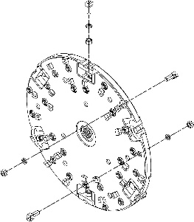

Page 9_ of _13

**STUMP GRINDER ASSEMBLY& PARTS LIST**

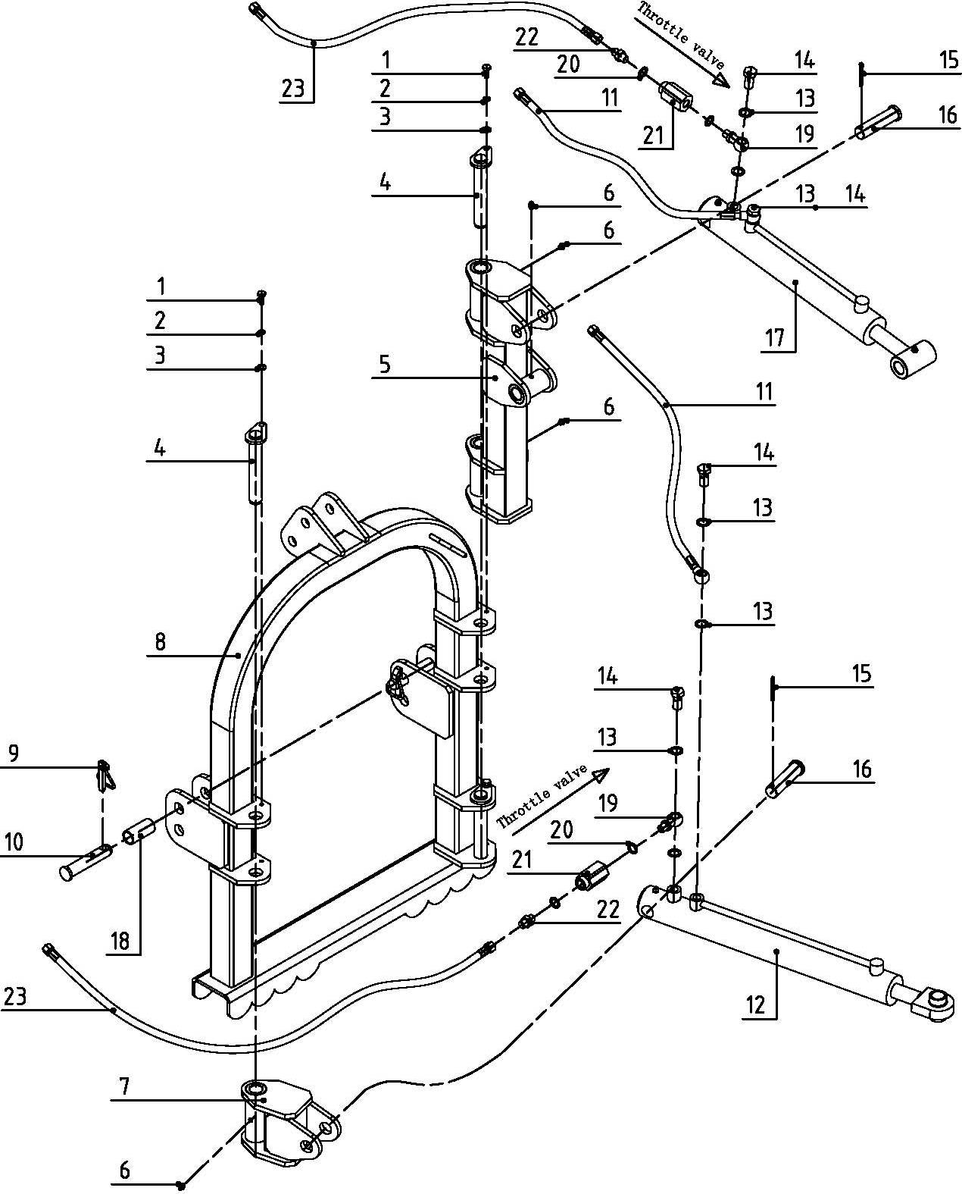

Page 10_ of _13

|  |  |  |  |
| --- | --- | --- | --- |
| NO. | PART NO. | Name & Specifications | Quantity |
| 1 | GB／T5783-2000 | Bolt M8×20 | 3 |
| 2 | GB/ T93-1987 | Spring washer 8 | 3 |
| 3 | GB／T97．1-2002 | Plain washer 8 | 3 |
| 4 | SG24.01.011 | Pin weldment | 3 |
| 5 | SG24.01.012 | Swing frame weldment | 1 |
| 6 | JB/T7940.1-1995 | Oil cup M8 | 4 |
| 7 | SG24.01.013 | Pivot cross | 1 |
| 8 | SG24.01.014 | 3-Pt. toke weldment | 1 |
| 9 |  | Lock pin | 2 |
| 10 | SG24.01.101 | Pin for lifting | 2 |
| 11 | SG24.01.015 | Hose, Horizontal | 2 |
| 12 | SG24.01.016 | Hydraulic cylinder, Horizontal | 1 |
| 13 | JB/T 982-1977 | Gasket 16 | 8 |
| 14 | BH5.60.110 | Hollow bolt 16 | 4 |
| 15 | GB／T91-2000 | Cotter pin 5×40 | 2 |
| 16 | SG24.01.102 | Pin | 2 |
| 17 | SG24.01.017 | Hydraulic cylinder | 1 |
| 18 | SG24.01.103 | Sleeve | 2 |
| 19 | BH5.60.108 | Ball adapter | 2 |
| 20 | JB/T 982-1977 | Gasket 14 | 4 |
| 21 | MK6 | Throttle valve | 2 |
| 22 | BH5.60.109 | Adapter 14-14 | 2 |
| 23 | SG24.01.018 | Hose | 2 |

Page 11_ of _13

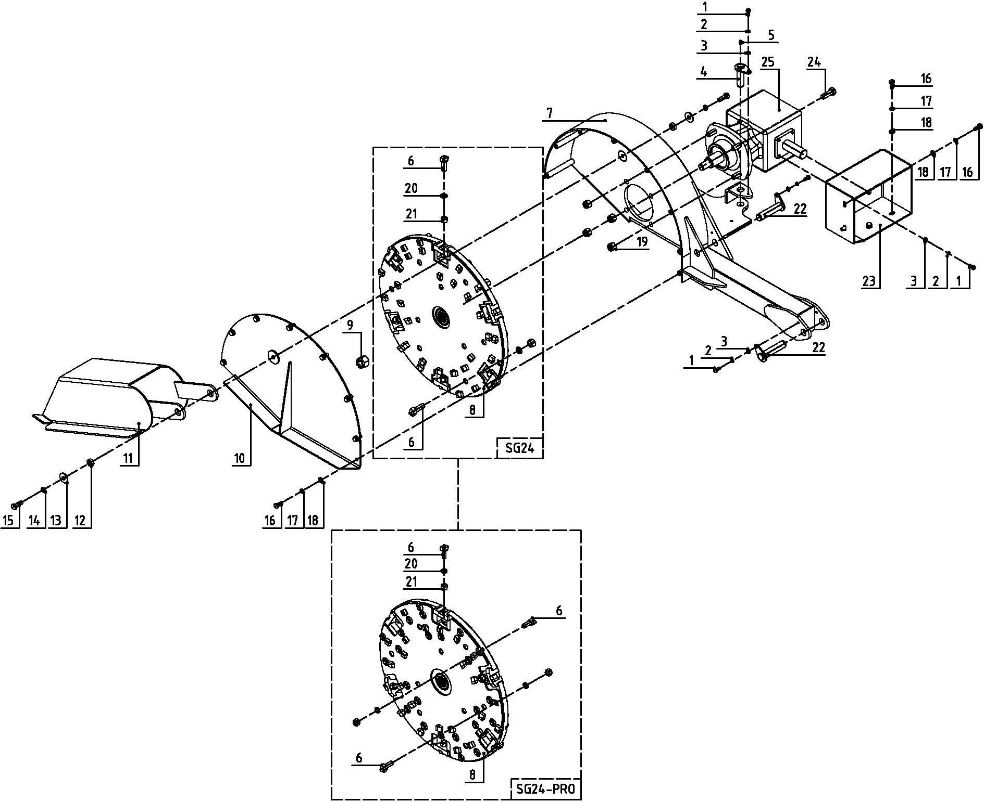

Page 12_ of _13

|  |  |  |  |
| --- | --- | --- | --- |
| NO. | PART NO. | Name & Specifications | Quantity |
| 1 | GB／T5783-2000 | Bolt M8×20 | 7 |
| 2 | GB/ T93-1987 | Spring washer 8 | 7 |
| 3 | GB／T97．1-2002 | Plain washer 8 | 7 |
| 4 | SG24.02.011 | Pin weldment | 1 |
| 5 | JB/T7940.1-1995 | Oil cup M8 | 1 |
| 6 | SG24.02.012 | Carbide tooth weldment | 36 (SG24) |
| 54 (SG24-PRO) |
| 7 | SG24.02.013 | Housing weldment | 1 |
| 8 | SG24.02.014 | Grinder wheel weldment, SG24 | 1 |
| SG24-PRO.02.014 | Grinder wheel weldment, SG24-PRO | 1 |
| 9 | GB/T6178-1986 | Slotted nut M24 | 1 |
| 10 | SG24.02.015 | Wheel guard weldment | 1 |
| 11 | SG24.02.016 | Guard weldment | 1 |
| 12 | SG24.02.101 | Sleeve | 2 |
| 13 | GB／T96.2-2002 | Plain washer 12 | 2 |
| 14 | GB/ T93-1987 | Spring washer 12 | 2 |
| 15 | GB／T5783-2000 | Bolt M12×35 | 2 |
| 16 | GB／T5783-2000 | Bolt M10×25 | 12 |
| 17 | GB/ T93-1987 | Spring washer 10 | 12 |
| 18 | GB／T97．1-2002 | Plain washer 10 | 12 |
| 19 | GB／T889．1-2000 | Lock nut M16 | 4 |
| 20 | GB/ T93-1987 | Spring washer 14 | 36 (SG24) |
| 54 (SG24-PRO) |
| 21 | GB／T6171-2000 | Nut M14*1.5 | 36 (SG24) |
| 54 (SG24-PRO) |
| 22 | SG24.02.018 | Pin | 2 |
| 23 | SG24.02.017 | Lid, shield | 1 |
| 24 | GB／T5783-2000 | Bolt M16×50 | 4 |
| 25 | XH50.169Z.01L | Gearbox assembly (1：1.77) | 1 |

Page 13_ of _13