- Usage and application scope
JC walnut peeler machine can remove green skin with high efficience, we have vertical type and horizontal type, the vertical type machine multi-strand wear-resistant solid rope, combined with water washing function, finished walnut are very clean and nice.
- Main structure and working principle
Add 2/3 water into the vertical barrel, start the power, pour into 25~35kg walnut, after about 3 minutes, open the discharge outlet (keep the machine working on). After all walnuts are out, close discharge door, add water again and go on process other walnuts. While the horizontal type can work continuously.
- Technical parameter
Model: JCHP-500
Capacity: 800 kg / h
Feeding inlet: 62*50*11 cm
Power: 2.2-3 KW, single phase
Main shaft speed (rpm): 1400r/min
Material: walnut with skin, green walnut
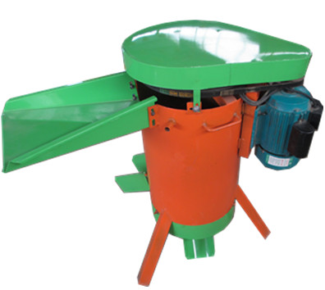
Model: JCQH-60
Capacity: 800 kg / h
Feeding inlet: 65cm
Power: 2.2 KW, single phase
Main shaft speed (rpm): 1440r/min
Material: walnut with skin, green walnut
