OWNER’S/OPERATOR’S MANUAL
BACKPACK BRUSHCUTTER

Introduction Attention Statements

The 35-series of hand power tools has been designed and built to de- liver superior performance and reliability without compromise to quality, comfort, or durability.
high performance engines represent the leading edge of 2-cycle engine technology, delivering excep- tionally high power from remarkably low displacement and weight. As an owner/operator, you’ll soon discover for yourself why is simply in a class by itself!
IMPORTANT!
The information contained in this manual describes units available at the time of publication.

Inc. reserves the right to make changes to products without prior notiﬁcation, and without obligation to make alterations to units previously manufactured.

Contents PAGE
Attention Statements 2
General Safety Instructions 3
Checking Unit Condition 3
Unit Description 5
Speciﬁcations 5
Assembly 6
Mixing Fuel 9
Starting the Engine 10
Starting a Flooded Engine 10
Stopping the Engine 11
Engine Idle Adjustment 11
Using a Brushcutter Blade 12
Cutting Grass (trimmer head) 13
Maintenance 14
Spark Arrester 15
Long Term Storage 16
Blade Sharpening 16
Troubleshooting Guide 17
Throughout this manual are “Special Attention” statements.

WARNING!
A statement preceded by the trian- gular attention symbol and the word “WARNING” contains information that should be acted upon to prevent serious bodily injury.

CAUTION!
A statement preceded by the word “CAUTION” contains information that should be acted upon to prevent mechanical damage.
IMPORTANT!
A statement preceded by the word “IMPORTANT” is one that possesses special signiﬁcance.

NOTE:
A statement preceded by the word “NOTE” contains information that is handy to know and may make your job easier.
Read and follow this operators manual. Failure to do so could result in serious injury.

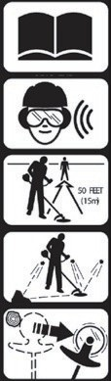
Wear eye and hearing protection at all times during the operation of this unit.

Keep bystanders
at least 50 feet (15 m) away during operation.

Beware of thrown or ricocheted objects.

Beware of blade thrust. A jammed blade can cause the brushcutter to jerk suddenly and may cause the operator to lose control
of the unit.
IMPORTANT!
The operational procedures described in this manual are intended to help you get the most from this unit as well as to
protect you and others from harm. These procedures are guidelines for safe operation under most conditions, and are not intended to replace any safety rules and/or laws that may be in force in your area. If you have questions regard- ing your power tool, or if you do not understand something in this manual, your dealer will be glad to assist you. You may also contact , Inc. at the address printed on the back of this manual.

General Safety Instructions Checking Unit Condition

Work Safely
Brushcutters operate at very high speeds and can do serious damage or injury if they are misused or abused. Never allow a person without training or instruction operate this unit!
WARNING!
Use Good Judgment
NEVER operate the engine when transporting the unit.
NEVER operate the engine indoors! Make sure there is always good ven- tilation. Fumes from engine exhaust can cause serious injury or death.
ALWAYS use the proper cutting tool for the job.
ALWAYS stop the unit immediately if it suddenly begins to vibrate or shake. Inspect for broken, missing or improperly installed parts or attach- ments.
NEVER extend trimming line beyond the length speciﬁed for your unit.
ALWAYS keep the unit as clean as practical. Keep it free of loose vegeta- tion, mud, etc.
ALWAYS hold the unit ﬁrmly with both hands when cutting or trimming, and maintain control at all times.
ALWAYS keep the handles clean.
ALWAYS disconnect the spark plug wire before performing any maintenance work.
ALWAYS, if a blade should bind fast in a cut, shut off the engine immedi- ately. Push the branch or tree to ease the bind and free the blade.

WARNING!
Never make unauthorized attach- ment installations.

Stay Alert
You must be physically and mentally ﬁt to operate this unit safely.

NEVER operate the unit with the cutting attachment shield or other protective devices (harness, ignition switch, blade retention clip, etc.) removed!

WARNING!
A cutting attachment shield or other protective device is no guarantee of protection against ricochet. YOU MUST ALWAYS GUARD AGAINST FLYING DEBRIS!
Use only authorized parts and accessories with your brushcutter. Do not make modiﬁcations to this unit without the written approval of , Inc.

WARNING!
Never operate power equipment of any kind if you are tired or if you are under the inﬂuence of alcohol,
drugs, medication or any other sub- stance that could affect your ability or judgement.
WARNING!
Minimize the Risk of Fire
NEVER smoke or light ﬁres near the unit.
ALWAYS stop the engine and allow it to cool before refueling. Avoid overﬁlling and wipe off any fuel that may have spilled.
ALWAYS inspect the unit for fuel leaks before each use. During each reﬁll, check that no fuel leaks from around the fuel cap and/or fuel tank. If fuel leaks are evident, stop using the unit immediately. Fuel leaks must be repaired before using the unit.
ALWAYS move the unit to a place well away from a fuel storage area or other readily ﬂammable materials before starting the engine.
NEVER place ﬂammable material close to the engine mufﬂer.
SAFETY
ALWAYS make sure the cutting attach- ment is properly installed and ﬁrmly tightened before operation.
NEVER use a cracked or warped cutting attachment. If a properly installed attach- ment vibrates, replace the attachment with new one and re-check.
ALWAYS stop the engine immediately and check for damage if you strike a foreign object or if the unit becomes tangled. Do not operate with broken or damaged equipment.
NEVER allow the engine to operate at high RPM without a load. Doing so could damage the engine.
NEVER operate a unit with worn or dam- aged fasteners or attachment holders.
NEVER cut with a dull blade. Doing so will increase the risk of blade thrust and may also cause equipment damage.

BP3502A
BP3501A
The Properly Equipped Operator
SAFETY
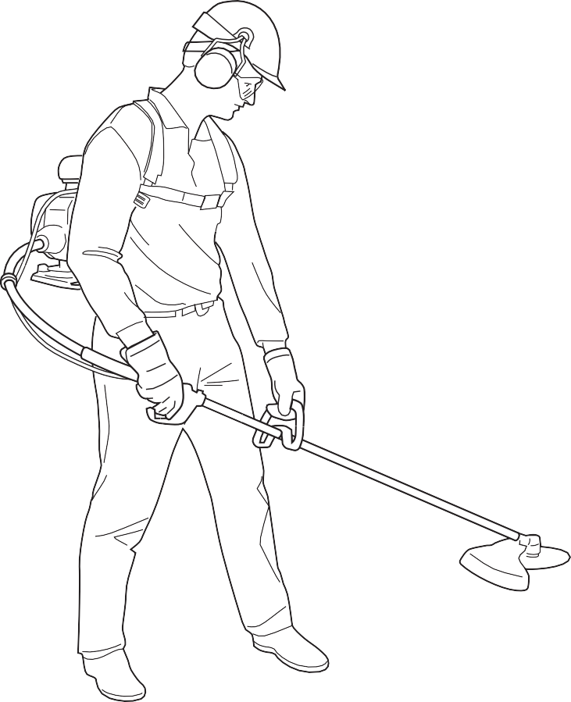
Figure 1
Always make sure the appropriate cutting attachment shield is correctly installed and in good condition.
Wear appropriate footwear (non-skid boots or shoes): do not wear open-toed shoes or sandals. Never work barefooted!
Keep away from the rotating trimmer line or blade at all times,
and never lift a moving attachment above waist-high.
Always wear eye
protection such as goggles
or safety glasses to shield against thrown objects.

Always operate with both hands ﬁrmly gripping the
unit.

Keep a proper footing and do not overreach. Maintain your balance at all times during operation.
Wear hearing protection devices and a broad-brimmed hat or helmet.
Wear close-ﬁtting clothing to protect legs and arms. Gloves offer added protection and are strongly recommended. Do not wear clothing or jewelry that could get caught in machinery or under- brush. Secure long hair so
that it is above shoulder level. NEVER wear shorts!

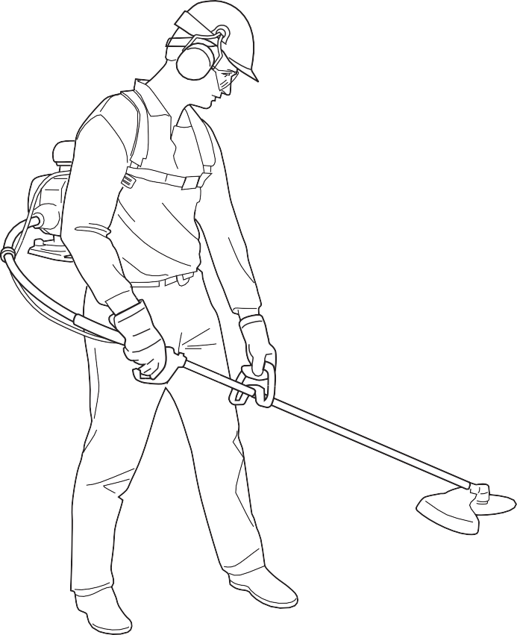Be Aware of the Working Environment
Figure 2
If contact is made with a hard object, stop the engine and inspect the cutting attachment for damage.
Beware of a coasting blade when brushcutting. A coasting blade can injure while it continues to spin after the throttle trigger is released or after
the engine is stopped.
ALWAYS clear your work area of trash or hidden debris that could be thrown back at you or toward a bystander. When operating in rocky terrain or near electric wires or fences, use extreme caution to avoid contacting such items with the cutting attachment.
Be constantly alert for objects and debris that could be thrown either from the rotating cutting attachment or bounced from a hard surface.
Reduce the risk of bystanders being struck by ﬂying de- bris. Make sure no one is within 50 feet (15 meters)—that’s
about 16 paces—of an operating attach- ment.
Be extremely careful of slippery terrain, especially during rainy weather.
Make sure bystanders or observers outside the 50-foot “danger zone”
wear eye protection.

50
FEET
Avoid long-term operation in very hot or very cold weather.

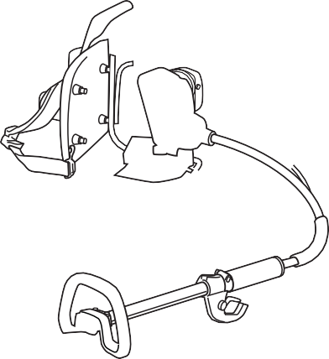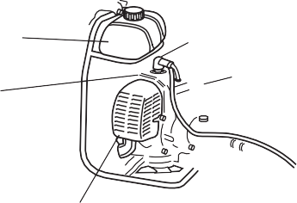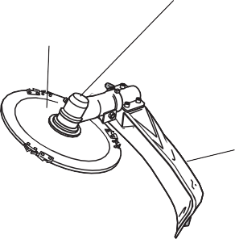Unit Description
Figure 3
Cutting Attachment Shield
C35 BRUSHCUTTER
Throttle Trigger
Handle
Brushcutter Blade
Gearcase
Outer Tube
Ignition Throttle Switch Assembly
BP3503A
Mufﬂer
Spark Plug
Air Cleaner

Flex Cable
Fuel Tank
Cylinder Cover
Using the accompanying illustrations as a guide, familiarize yourself with this unit and its various components. Un- derstanding this unit helps ensure top performance, long service life, and safer operation.
DESCRIPTION

WARNING!
Do not make unauthorized modiﬁca- tions or alterations to this unit or its components.
IMPORTANT!
BACKPACK brushcutter units do not have the spark arrester installed in the muf- ﬂer. Before placing the brushcutter in service, check local, state and federal regulations to determine if a spark arrester is required in your area. See page 15 for details.

Speciﬁcations

Engine Model ....................................................... SK35F Engine
Dry Weight
(less cutting attachment and guard).................21.3 lbs./9.7 kg Type.................................... 2-cycle, vertical cylinder, air cooled Bore x Stroke........................................................36mm x 33mm
Displacement................................................... 33.6.cc/2.1 cu. in.
Maximum Power Output................ 1.8 hp @ 7500 RPM (min-1) Operating RPM Range......................... 4,500-7,000 RPM (min-1)
Transmission Type ...................... Automatic centrifugal-clutch
through bevel gears
Fuel/Oil Ratio.............................................. 25:1
Premium 2-cycle mixing oil Fuel Tank Capacity ..........................................40.6 oz./ 1200 ml
Carburetion............................................................. TK, ﬂoat type
Ignition ........................... Fully electronic, transistor controlled Spark Plug............................................................. Champion CJ8
Air Cleaner.............................................................Foam element
Starting Method ..................................................... Recoil starter
Stopping Method................................................... Toggle switch

Speciﬁcations subject to change without notice

Prior to Assembly
Before assembling this product, please make sure you have all the components required for a complete unit:
- Engine Assembly (Powerhead).
- Outer Tube Assembly.
- Cutting Attachment Shield.
- Handle.
- Tool bag including: Hex wrenches and a combination spark plug wrench and cutting attachment shield mount- ing hardware.
Carefully inspect all components for damage.
IMPORTANT!
The terms “left,” “left-hand,” and “LH”: “right,” “right-hand,” and “RH”; “front” and “rear” refer to directions as viewed by the operator during normal operation of this product.

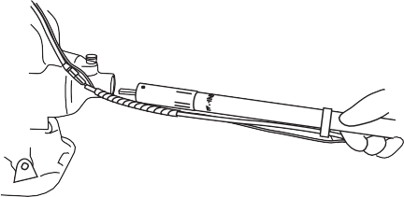Assembly: Driveshaft/Powerhead
BP3506
Figure 6
Flex Cable Housing
Groove
O-Ring
Rear Handle
BP35 Brushcutter
Release Knob Locking
Hole “Engine Side”
Label

Throttle Cable
Cable Holder
Powerhead

Figure 4

7/8"

Figure 5

  - Place the powerhead on a ﬂat surface.
BP3505
ASSEMBLY
  - Route the “engine side” of the ﬂex cable through the cable holder.
  - Remove the two protective covers from the ﬂex cable and insert the ﬂex cable housing marked “engine end” into the powerhead with the locking hole facing up. See Figure 4.
  - Lift up on the ﬂex cable release knob and slide ﬂex cable housing all the way in until it bottoms in the case and the release knob locks into the lock- ing hole in the ﬂex cable housing. See Figure 5.
  - From the opposite end, rotate and push the drive cable to engage it into the clutch drum. See Figure 5.
NOTE:
BP3507
No more than 7/8” (22 mm) of the ﬂex cable should protrude from the ﬂex cable housing when properly installed.

  - Remove the Phillips head screw from the rear hand grip and slide the O-ring end of the ﬂex cable housing into the rear of the outer tube handle until the groove on the housing lines up with the hole for the Phillips head screw. See Figure 6.
IMPORTANT!
It may be necessary to rotate the output shaft of the gearcase to fully engage the drive cable into the lower tube assembly.

  - Install and tighten the Phillips head screw ﬁrmly.

Throttle and Handle Assembly

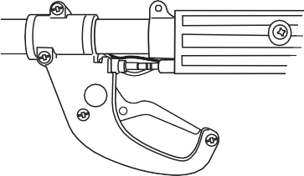Install the Throttle Cable
BP3510
BP3508

Cable Guide

Figure 9

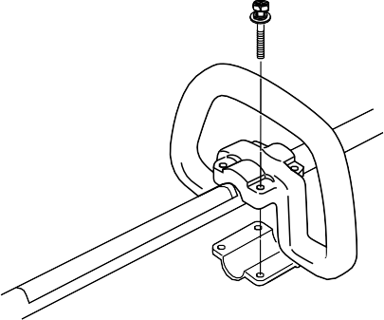Install the Handle
Figure 11
Lower Clamp
Outer Tube
Handle Position Label
Clamp Retaining Screw

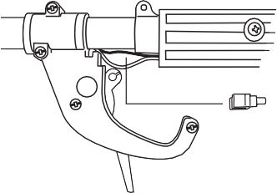
Cable Guide
Throttle Lever
Figure 7
Loosen screws

    - Loosen the two screws securing the throttle assembly and slide it forward on the outer tube. See Figure 7.
    - 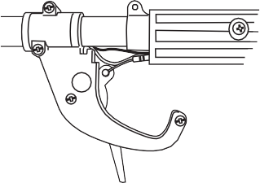Remove the cable guide to allow the throttle trigger to swing out. See Figure 7.
BP3509

Cable End
Throttle Cable
Figure 8

    - Slide the throttle cable through the hand grip and insert the cable end into the recess in the throttle trigger. See Figure 8.
    - Install the cable guide and slide the throttle assembly back into place. Tighten the screws securely. See Figure 9.

    - Connect the powerhead and stop switch wire terminals.
BP3511

Figure 10

      - Use a Phillips head screwdriver to remove the lower clamp retaining screws from the handle. Separate the clamp from the handle.
BP3504
      - Position the handle on the outer tube behind the handle positioning label. Reassemble the lower clamp to the handle in the reverse order of disas- sembly. See Figure 11.
      - Firmly tighten the (4) handle retain- ing screws. See Figure 11.

Adjust Throttle Cable Free Play

Checking Free Play Adjusting Free Play
BP3514

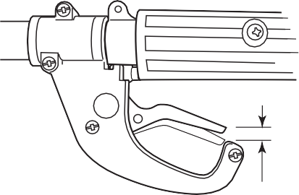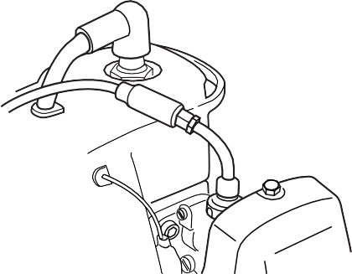
7mm Free Play
Figure 12
BP35 Brushcutter
Cable Adjuster

Cable Locknut

Adjuster Cover

Figure 13

        - Test the throttle lever for smooth op- eration. If any stiffness or binding are noted, the cause must be identiﬁed and corrected before the brushcutter can be placed in service.
        - Test the throttle lever for proper “free play” of approximately 7mm in the idle position. See Figure 12. If neces- sary, adjustments can be made at the carburetor.
- Temporarily move the adjuster cover to expose the cable adjuster.
- Loosen the cable locknut and then turn the cable adjuster in or out until proper free play is achieved.
See Figure 13.
- Tighten cable adjuster locknut and move adjuster cover back into place.

Install the Cutting Attachment Shield

WARNING!
NEVER operate the unit without the cutting attachment shield installed and tightly secured!

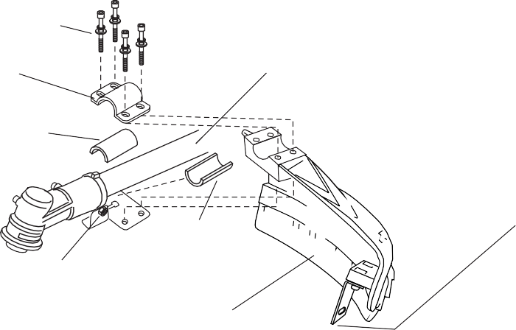Sub-Shield.
Shim
Cutting Attachment Shield Mounting Plate
Cutting Attachment Shield
Figure 14
Nut
Figure 14A
Hex Screws
Shim
Line Cutter
Outer Tube
Socket-head Cap Screws

Bracket
(when trimmer head is in use)
  - Attach the shield extension to the cutting attachment shield.

WARNING!
NEVER use this machine without
sub-shield when using a trimmer head.

Install the Cutting Attachment Shield.
- Insert the cutting attachment shield between the outer tube and the cutting attachment shield mounting plate. See Figure 14.
NOTE:
It may be necessary to loosen the retain- ing nut and clamp screw to adjust cutting attachment shield mounting plate.
- Fit the two shims and the bracket over the outer tube and loosely install the four socket-head cap screws. See Figure 14.

CAUTION!
Make sure the clamp screw and retaining nut are securely tightened before tightening the four socket- head cap screws.
- 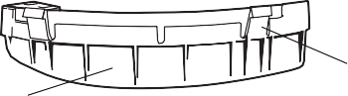Tighten the four socket-head cap screws to secure the cutting attach- ment shield.
Cutting Attachment Shield

Hook Receiver

Hook
Sub-shield

To Change Position of Line Cutter.
CAUTION!
Make sure the sub-guard is com- pletely hooked at the hook receiver.
ASSEMBLY
The line cutter can be positioned in
2 positions to obtain different line length for cutting.
- Remove the 2 hex screws with a 4mm hex wrench. See Figure 14A.
- Rotate line cutter. See Figure 14A.
- Reinstall the two hex screws and tighten them securely.

WARNING!
The line cutter is very sharp. Wear gloves to protect your hands when handling.
NOTE:
Be careful to not lose the 2 nuts in the cutting attachment shield, they are not captured.

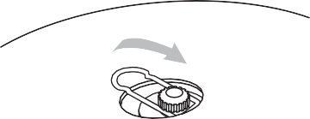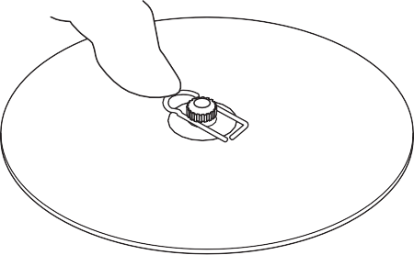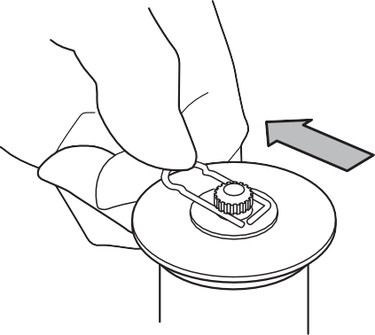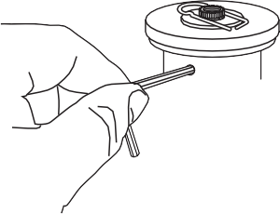Assembly
Figure 15
Slip the blade into place
B
Output Shaft
Hex Wrench
Shaft Bolt
Bolt Guard Holder B
Safety Clip

Holder A
C

Center the safety clip
A

Slide the safety clip off-center

Install the Blade (BACKPACK)
NOTE:
The BACKPACK is shipped with Holder A, the safety clip, Holder B, shaft bolt, and bolt guard installed. The shaft bolt is a LEFT- HAND THREAD AND IS REMOVED IN A CLOCKWISE ROTATION!
- With the gearcase output shaft fac- ing up, rotate the output shaft and Holder A until the hole in Holder A aligns with the matching hole in the gearcase ﬂange, and then lock the holder to the gearcase by insert- ing the long end of the hex wrench through both holes. See Figure 15.
35011
35010
ASSEMBLY
- Remove the shaft bolt, bolt guard and Holder B. See Figure 15.
- Slide the safety clip off center on the gearcase shaft. See Figure 15A.
NOTE:
When installing certain blades, it may be necessary to temporarily remove the
safety clip.
- Slide the blade over the safety clip and onto the ﬂange on Holder A. See Figure 15B.
35012
35013
- 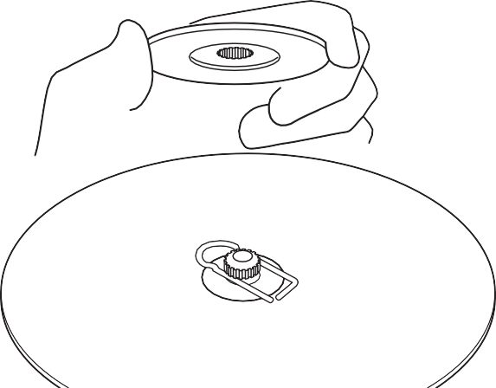Lock the blade on the shaft by centering the safety clip. See Figure 15C.
Figure 16
Cutting Blade
Install Holder B
35014
CAUTION!
Install the blade so the printed surface is visible to the operator while the brushcutter is in the normal operating position.
- Install Holder B on the gearcase shaft. See Figure 16.

WARNING!
Never operate the brushcutter without the safety clip installed and both holders tightly secured and ﬂat against the blade surface!
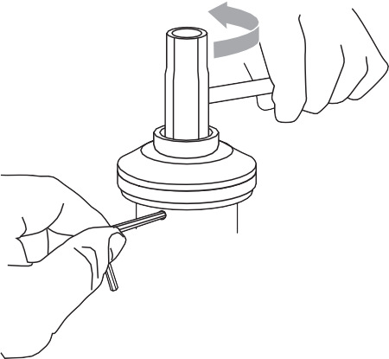 IMPORTANT!
Tighten the assembly

Combination Spark Plug/Screwdriver Wrench

Holder B

Bolt Guard

Hex Wrench
Figure 17
The machined recess in Holder B must completely surround the safety clip, and both holders must be ﬂat against the surface of the blade.
35015
- Lock Holder A to the gearcase by inserting the long end of the hex wrench through both holes as done in step 1 and tighten the shaft bolt securely with the combination spark plug wrench. See Figure 17.
- Remove the hex wrench.
The BP35 should now be completely assembled.

Assembly

Installing a Trimmer Head
NOTE:
The BACKPACK is shipped with Holder A, the blade retainer (safety clip), Holder B, shaft bolt, and bolt guard installed. The shaft bolt is a LEFT-HAND thread. Remove it by turning CLOCKWISE!
- Remove the shaft bolt, bolt guard, Holder B, safety clip and the existing cutting attachment.
- With the gearcase output shaft fac- ing up, rotate the output shaft and Holder A until the hole in Holder A aligns with the matching hole in the gearcase ﬂange, and then lock the holder to the gearcase by insert- ing the long end of the hex wrench through both holes. See Figure 18A.
- Using the combination spark plug wrench, remove the shaft bolt, bolt guard, Holder B and the safety clip. (The bolt guard, shaft bolt and safety clip are not used with a trimmer head). See Figure 18A.

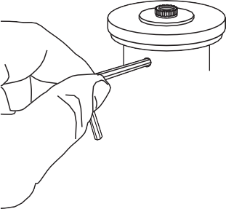

- Install Holder B on the gearcase shaft. The splined hole on Holder A must engage with the gearcase shaft.
35008
ASSEMBLY
A | Shaft Bolt | B | Hand-tighten Trimmer Head
Bolt Guard (not used)  (not used)  Holder B  Safety Clip (not used)  Holder A  35007  Output Shaft  Figure 18 |  | (counter-clockwise to install)  Hex Wrench

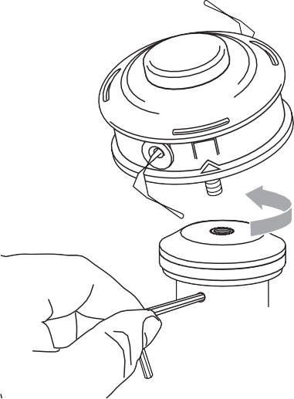
- Using the hex wrench to secure Holder A , install and hand-tighten the trimmer head (counter-clockwise to install). See Figure 18B.
- Remove the hex wrench from the gearcase and holder.

Mixing Fuel
CAUTION!
- Some gasolines contain alcohol as an oxygenate! Oxygenated fuels may cause increased oper- ating temperatures. Under certain conditions, alcohol-based fuels may also reduce the lubricating qualities of some mixing oils. Nev- er use any fuel containing more than 10% alcohol by volume!
- Generic oils and some outboard motor oils may not be intended for use in high-performance air cooled 2-cycle engines, and should never be used in your Shindaiwa engine!
  - Use only fresh, clean unleaded gaso- line with a pump octane rating of 87 or higher.
  - Mix gasoline with 50:1 Premium 2-cycle mixing oil or with an equivalent high quality 2-cycle mixing oil.

Example of 50:1 mixing quantities:
  - 1 gallon of gasoline to 2.6 oz. mixing oil.
  - 5 liters of gasoline to 100 ml. mixing oil.
IMPORTANT!
Mix only enough fuel for your immedi- ate needs! If fuel must be stored longer than 30 days and One oil with fuel stabilizer is not used, it should ﬁrst be treated with a fuel stabilizer such as STA-BIL™.
CAUTION!
This engine is designed to oper- ate on a 50:1 mixture consisting of unleaded gasoline and a premium 2-cycle mixing oil only. Use of non- approved mixing oils can lead to
excessive maintenance costs and/or engine damage.
Filling the Fuel Tank

- Place the unit on a ﬂat, level surface.
WARNING!
Minimize the Risk of Fire!
- STOP the engine before refueling.
- ALWAYS allow the unit to cool before refueling!
- Wipe all spilled fuel and move the unit at least 10 feet (3 me- ters) from the fueling point before restarting!
- NEVER start or operate this unit if there is a fuel leak.
- NEVER start or operate this unit if the carburetor, fuel lines, fuel tank and/or fuel tank cap are damaged.
- NEVER smoke or light any ﬁres near the unit or fuels!
- NEVER place any ﬂammable material near the engine mufﬂer!
- NEVER operate the engine with- out the mufﬂer and spark arrester in place and properly functioning!
- Clear any dirt or other debris from around the fuel ﬁller cap.
- Remove the fuel cap, and ﬁll the tank with clean, fresh fuel.
- Reinstall the fuel ﬁller cap and tighten ﬁrmly.

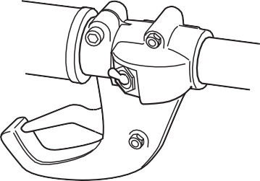Starting the Engine

Ignition ON

Figure 19

- 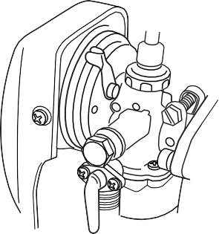While holding the unit ﬁrmly with your left hand, use your right hand to pull the starter handle slowly upward until you feel the starter engage. See Figure 23.
Choke Closed

Figure 22
- Start the trimmer by pulling the starter handle upward rapidly.

1. Move the ignition switch to the “ON” position.
BP3521
BP3522

- 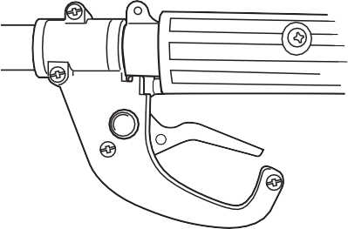(Cold Engine Only) Choke the engine by moving the choke lever up towards the spark plug (choke is closed). See Figure 22.
Figure 20
Throttle Lever
Lock Button
BP35 Throttle Assembly
CAUTION!
The recoil starter can be easily dam- aged by abuse!
- Always engage the starter before attempting to start the engine.
- Never pull the starter cord to its full length.
- Always rewind the starter cord slowly.

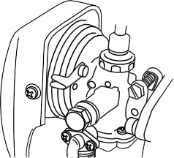When the engine starts or ﬁres–
BP3520
Choke Open

Figure 24

WARNING!
KEEP WELL CLEAR OF THE CUT- TING ATTACHMENT! THE CUT- TING ATTACHMENT MAY ROTATE WHEN THE ENGINE IS STARTED!
- Place the trimmer on the ground during all starting operations.
- Make sure you have a secure footing, and keep a ﬁrm grip on the unit as well.
- Keep all bystanders and pets well clear of the brushcutter during starting.
OPERATION

  - Set the throttle lever to “fast idle” by performing the following:
    - Squeeze and hold throttle lever (toward the handgrip).
    - Depress and hold throttle lever lock button.
    - 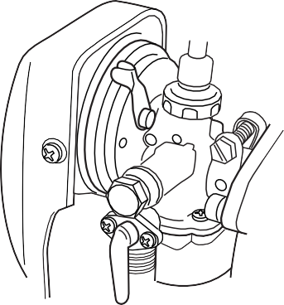While holding the throttle lever lock button, release throttle lever.

Figure 21 Fuel Cock Open

- Open the choke by moving the choke lever down. See Figure 24.
BP3524
- 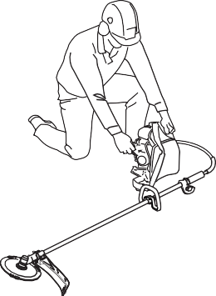If the engine does not continue to run, repeat the starting procedure as previously described.

Make sure the cutting attachment is clear of obstructions!

Figure 23
- When the engine starts, clear excess fuel from the combustion area by rev- ving the engine several times with the throttle lever.
BP3523

WARNING!
The cutting attachment will rotate as the engine accelerates!

3. Open the fuel cock by moving the lever to the down position See Figure 21.
BP3521

Starting a Flooded Engine
- Disconnect the spark plug lead, and then use the spark plug wrench to remove the spark plug (turn counter-clockwise to remove). See Figure 25.
- If the spark plug is fouled or is soaked with fuel, clean or replace the plug as necessary. For spark plug speciﬁca- tions and gapping procedure, see page 14.
- Pull the starter rope several times with the choke open and at wide open throttle to clear excess fuel from the combustion chamber.
10. Operating the throttle will automatic- ally disengage the fast-idle setting.

If the engine does not start–

WARNING!
Never start engine from the operating position!
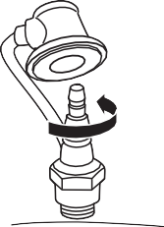Repeat the appropriate starting procedures for a hot or cold engine. If the engine still fails to start, use the following procedure for “Starting a Flooded Engine”.

Turn counter- clockwise to remove
Spark Plug

Figure 25

- Replace the spark plug and tighten it ﬁrmly with the spark plug wrench. If a torque wrench is available, torque the spark plug to 148-165 inch-pounds (170-190 kg/cm).

CAUTION!
Incorrect spark plug installation can result in serious engine damage!
- Repeat the starting procedures for a warm engine.
- If the engine still fails to start or ﬁre, refer to the troubleshooting chart at the end of this manual.
3526

Stopping the Engine

Engine Idle Adjustment
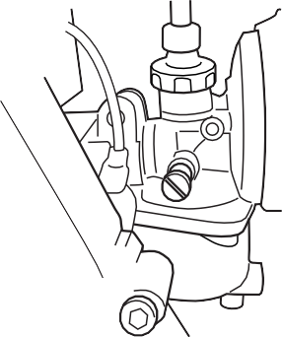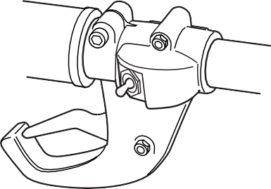The engine must return to idle speed whenever the throttle lever is released. Idle speed is adjustable, and must be set low enough to permit the engine clutch to disengage the cutting attachment when the throttle is released.
BP3525

Idle Adjusting Screw

Figure 27

Ignition OFF

Figure 26

WARNING!
The cutting attachment must NEVER rotate at engine idle! If the idle speed cannot be adjusted by the procedure described here, have the unit in- spected at an authorized Shindaiwa dealer.

Idle the engine brieﬂy before stopping (about 2 minutes), then push the ignition switch to the off position to stop the engine. See Figure 26.
BP3526

- Place the unit on the ground, then start the engine and allow it to idle 2-3 minutes until warm.

- If the attachment rotates when the engine is at idle, reduce the idle speed by turning the idle adjustment screw counter-clockwise
See Figure 27.
- If a tachometer is available, the engine idle speed should be ﬁnal adjusted to 2,750 (±250) RPM (min-1).
OPERATION

Left Hand Operation
Some users of the BACKPACK may wish to operate the unit left handed. It is very important to follow these instructions if you wish to do so.

  - Loosen the exhaust outlet clamp and rotate the exhaust outlet approxi- mately 90 degrees counterclockwise as viewed from the top of the power head.

  - Tighten the clamp screw ﬁrmly to prevent the outlet from moving out of position.
  - 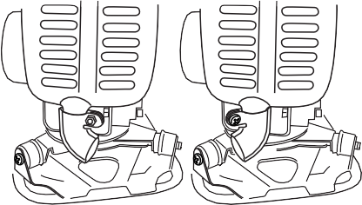Put unit on, and in the operating posi- tion, check exhaust outlet to make sure exhaust ﬂow is out and to the side of the operator. Readjust if neces- sary. See Figure 28.
BP3527
RH Operation
LH Operation
Figure 28
Exhaust Outlet
Clamp Screw

Shoulder Straps
Figure 29
B
A

Adjust the Shoulder Straps:
    - Place the Brushcutter on your back with the straps loosened.
    - To tighten straps, push the outer strap through the buckle from the top until the loop formed is approximately the amount of adjustment necessary. See Figure 29A.
    - While holding the lower outer strap, grasp the buckle and pull upward until the strap is tight in the buckle. See Figure 29B.
    - To loosen, Reverse this procedure.

Using a Brushcutter Blade

Blade Thrust
OPERATION
‘Blade thrust’ is a sudden sideways or backward motion of the brushcutter. Such motion may occur when the blade jams or catches on an object such
as a sapling tree or tree stump. BE CONSTANTLY ALERT FOR BLADE THRUST AND GUARD AGAINST ITS EFFECTS!

Engine Operating Speeds
Operate the engine at full throttle while cutting. Best fuel efﬁciency is obtained by releasing the throttle when swinging back after a cut.

WARNING!
- Before working with a blade- equipped unit, always inspect and clean the area of objects that
could interfere with or damage the blade.
- Never use a blade near side- walks, fence posts, buildings or other objects that could cause injury or damage.
- Never use a blade for purposes other than those for which it was designed.
- Whenever you strike a hard object with a blade, always stop the brushcutter and carefully inspect the blade for damage. NEVER OPERATE THE BRUSHCUTTER WITH A DAMAGED BLADE!
- Always make sure the cutting attachment shield is properly installed before operating the unit.
- To prevent possible engine damage, do not allow the brushcutter to run at high speeds without a load.
- 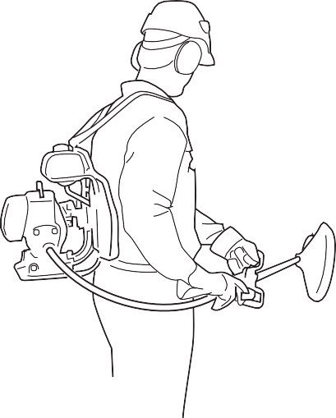Avoid operating the attachment at low speeds. Doing so can lead to rapid clutch wear. In addition, slow-speed operation tends to cause grass and debris to wrap around the cutting at- tachment.
Cut on the left side of the blade. KEEP YOUR BODY OUTSIDE THE PATH OF BLADE ROTATION

Figure 31
The blade rotates counter-clockwise. For best performance and to minimize being struck by debris, move the blade from right to left while advancing on your work.
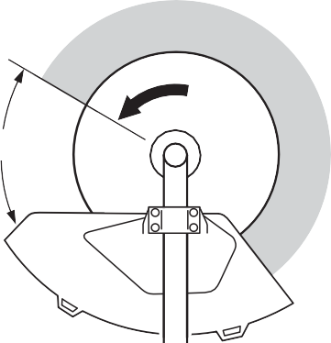Position the blade so cuts are made between the blade’s 8 o’clock and 10 o’clock positions (as viewed from above). DO NOT cut between the 10 o’clock and 5 o’clock positions (shaded area). See Figure 30.
BP3531A

Ten O'clock
Blade Rotation
OK To Cut

Eight O'clock

Five O'clock
Figure 30

Vertical cuts
Hold the brushcutter with the blade at a 90° angle to the ground so the blade’s bottom edge rotates toward the opera- tor. Move the blade from top to bottom through the cut, and cut only with the bottom edge of the blade. See Figure 31.

WARNING!
When making vertical cuts, never allow the blade to exceed waist height.

WARNING!
When cutting wood with a blade, feed the blade slowly. Never strike or “slam” a spinning blade against the wood.
WARNING!
DO NOT use 2-tooth or NON- Shindaiwa approved 4-tooth cutting blades with Shindaiwa brushcutters.

Cutting Grass
Your BACKPACK Brushcutter may be ﬁtted with one of several trimmer head models, each with features for speciﬁc applications and/or opera- tional requirements.
For proper operation, always refer to the instructions accompanying the trimmer head being used. Available trimmer head styles include:
  - Semi-automatic. Trimmer line is indexed when the operator taps the trimmer head on the ground during operation.
  - Manual. The operator indexes line manually with the grass trimmer stopped.
  - Fixed. The operator must stop the unit and add new lengths of trimmer line manually.
  - Flail. This device, designed for clear- ing weeds and light brush, features three nylon blades attached to the head by pivots.

CAUTION!
Do not push the rotating line into trees, wire fences or any material that could tangle or break line ends.

Engine Operating Speeds
Operate at full throttle while cutting grass.

CAUTION!
Operation at low RPM can lead to premature clutch failure.

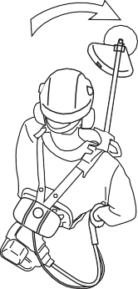

BP3529A

Figure 32
Hold the unit so the trimmer head is angled slightly into the area to be cut. To ensure maximum trimmer-line service life, cut only with the tip of the trimmer line. To prevent grass clippings from being thrown back towards the operator or wrapping around the gearcase, swing the unit’s trimmer head from left to right while cutting. Keep the trimmer head horizontal. See Figure 32.

Edging
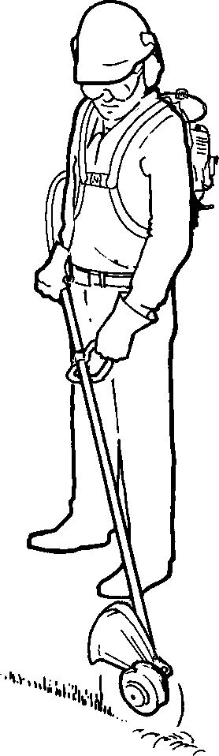Tilt the handle about 100° to the left (from hori- zontal) and move forward, holding the unit so that the trimmer head cuts vertically.

Figure 33
See Figure 33.
OPERATION

General Maintenance

WARNING!
- Never repair a damaged blade by welding, straightening, or by modifying its shape. An altered blade may break during opera- tion, resulting in serious personal injury.
- DO NOT use 2-tooth or NON- Shindaiwa approved 4-tooth cutting blades on Shindaiwa trimmers or brushcutters.
- Blades are not interchangeable between Shindaiwa edgers and trimmer/brushcutter models. Operating any unit with a blade or attachment not approved for that unit can be hazardous and may cause serious injury.

WARNING!
Before performing any maintenance, repair or cleaning work on the unit, make sure the engine and cutting attachment are completely stopped. Disconnect the spark plug wire before performing service or mainte- nance work.

Mufﬂer
Make sure the mufﬂer is well secured and in good condition. A worn or dam- aged mufﬂer is a ﬁre hazard and may also cause hearing loss.

Spark Plug
Keep the spark plug and wire connec- tions tight and clean.

Fasteners
Make sure nuts, bolts, and screws (except carburetor adjusting screws) are tight.

WARNING!
Non-standard parts may not oper- ate properly with your unit and may cause damage and lead to personal injury.

Blades
Keep blades sharp and check blade condition frequently. If a blade’s per- formance changes suddenly, stop the

NOTE:
Using non-standard replacement parts could invalidate your warranty.
engine and check the blade for cracks or other damage. Replace a damaged blade IMMEDIATELY!

Daily Maintenance
MAINTENANCE

Prior to each work day, perform the following:

  - Remove all dirt and debris from the engine, check the cooling ﬁns and air cleaner for clogging, and clean as necessary.
- Carefully remove any accumulations of dirt or debris from the mufﬂer and fuel tank. Dirt build-up in these areas can lead to engine overheating, ﬁre, or premature wear.
- Check for loose or missing screws or components. Make sure the cutting attachment is securely fastened.
- Check the entire unit for leaking fuel or grease.

10-Hour Maintenance

Every 10 hours of operation (more frequently in dusty or dirty conditions):
  - 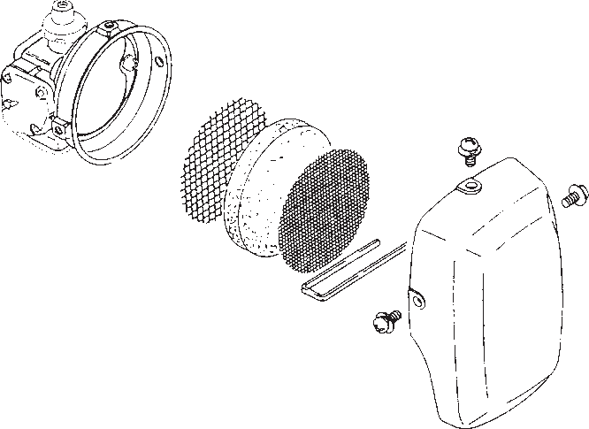Remove the air cleaner element from the carburetor and clean it thor- oughly with soap and water. Let dry before reinstalling the element. See Figure 34.
Clip
Figure 34
Inner Screen
Outer Screen
Air Cleaner Remove (3) Element Screws
CAUTION!
Do not operate the unit if the air cleaner or element is damaged, or if the element is wet.

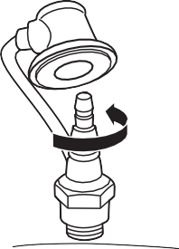10/15-Hour Maintenance
Figure 35
Clean the spark plug and check the gap at the electrode.
0.024-inch (0.6 mm)
Turn counter- clockwise to remove
Spark Plug

Every 10 to 15 hours of operation:
Remove and clean the spark plug.
    - Adjust the spark plug electrode gap to 0.024-inch (0.6 mm). If the plug must be replaced, use only a Champion CJ8 or equivalent spark plug of the cor- rect heat range. See Figure 35.
3535
3526
CAUTION!
Before removing the spark plug, clean the area around the plug to prevent dirt and debris from getting into the engine’s internal parts.

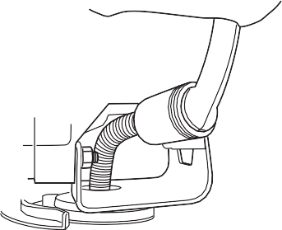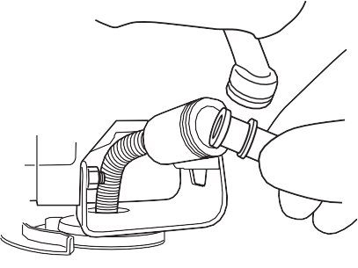50-Hour Maintenance

Cable (clean and grease)

Shaft Tube

Figure 38

Fuel Filter

Figure 37
Every 50 hours of operation (more frequently in dusty or dirty conditions):
    - 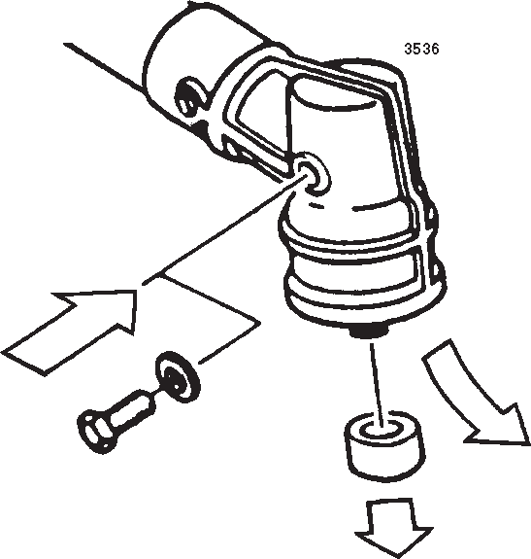Remove and clean the cylinder cover and clean grass and dirt from the cylinder ﬁns.
BP3537
Figure 36
Gear Shaft Collar
Old Grease
New Grease

    - Remove the cutting attachment, holder and the gear shaft collar. Remove the ﬁller plug from the side of the gearcase and press new grease into the gearcase until the old grease has been pushed out. Use only lith- ium-base grease such as Gearcase Lubricant or equivalent. See Figure 36.
BP3535

- Pull apart the fuel ﬁlter hose at the joint and remove the fuel ﬁlter to clean or replace as necessary See Figure 37.
  - Lubricate the ﬂex cable as follows:
- Disconnect the ﬂex cable from the powerhead. Slide the ﬂexible cable out of the ﬂex cable housing.
- Wash the cable thoroughly in a solvent bath, and then coat the entire cable with Premium Gearcase Lubricant.
- Install the cable into the ﬂex cable housing, then reconnect the ﬂex cable assembly to the powerhead.
NOTE:
For maximum cable life, the ﬂexible cable should be reversed “end-for-end” during reinstallation.
MAINTENANCE

Spark Arrester

Installation
IMPORTANT!
BACKPACK brushcutter units do not have the spark arrester installed in the muf- ﬂer. Before placing the brushcutter in service, check local, state and federal regulations to determine if a spark ar- rester is required in your area.

  - Obtain a spark arrester and gasket from an authorized dealer.
  - Remove the (3) socket-head cap screws retaining the mufﬂer cowl and remove the cowl. See Figure 39.
  - Remove the spark arrester outlet cap by removing the (2) outlet cap screws.
  - Install the spark arrester gaskets, screen and cap. Tighten the (2)
3538

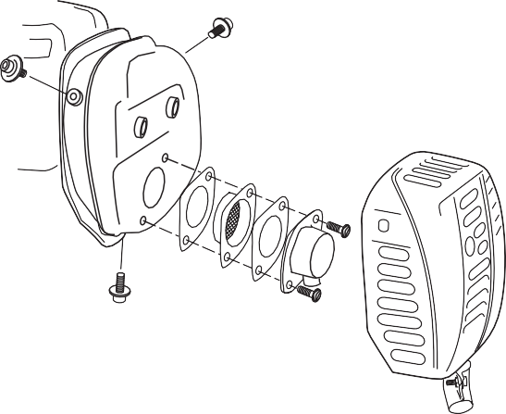
Outlet Cap Screws
Outlet Cap
Figure 39
Gasket
Mufﬂer Cowl (secured by 3 socket-head cap screws)
Mufﬂer

Spark Arrester Screen
Socket-head Cap Screws
Mufﬂer Maintenance

outlet cap screws securely. See Figure 39.
  - Reinstall the mufﬂer cowl and tighten the (3) socket-head cap screws securely.
If the engine becomes hard to start or
has low power, the spark arrester screen should be inspected and cleaned.
- Remove the (3) socket-head cap screws retaining the mufﬂer cowl and remove the cowl. See Figure 39.

WARNING!
Never operate the unit with a dam- aged or missing mufﬂer! Operating with missing or damaged exhaust components is a ﬁre hazard and could also damage your hearing.
- Remove the spark arrester screen by removing the (2) screws to the exhaust outlet cap.
- Remove the spark arrester screen and clean with a stiff bristle brush.
- Reinstall the spark arrester screen
and cap. Tighten the (2) screws securely.
- Reinstall the mufﬂer cowl and tighten the (3) socket-head cap screws securely.
IMPORTANT!
If carbon deposits are severe or if no performance improvement is noted, this unit should be inspected by an autho- rized servicing dealer.

Long Term Storage
Whenever the unit will not be used for 30 days or longer, use the following pro- cedures to prepare it for storage:
- Clean external parts thoroughly.
- Drain all the fuel from the fuel tank.
IMPORTANT!
All stored fuels should be stabilized with a fuel stabilizer such as STA-BIL™.

To remove the remaining fuel from the fuel lines and carburetor and with the fuel drained from the fuel tank;

- Pull apart the fuel ﬁlter hose at the joint and drain all fuel into an ap- proved fuel container. See page 15 (fuel ﬁlter replacement).
- Start and run the engine until it stops running.
- Repeat steps 1 and 2 until the engine will no longer start.

- Remove the spark plug and pour about 1/4 ounce of 2-cycle mixing oil into the cylinder through the spark plug hole. Slowly pull the recoil starter 2 or 3 times so oil will evenly coat the interior of the engine. Rein- stall the spark plug.
- Before storing the unit, repair or replace any worn or damaged parts.
CAUTION!
Gasoline stored in the carburetor for extended periods can cause hard starting, and could also lead to increased service and mainte- nance costs.
- Remove the air cleaner element from the carburetor and clean it thoroughly with soap and water, let dry and reas- semble the element.
- Store the unit in a clean, dust-free area.

Blade Sharpening
When the cutting edges of the blade become dull, they can be resharpened with a few strokes of a ﬁle.
MAINTENANCE
In order to keep the blade in balance, all cutting edges must be sharpened equally.

Tornado™ Blade
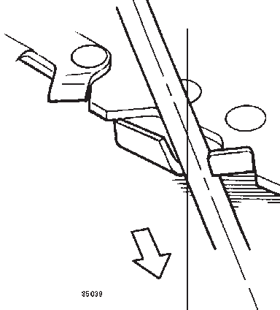To sharpen the cutters on a Tornado Blade, use a 7/32-inch round ﬁle. File

Round File
30°
Figure 40
the leading edge of each tooth to a razor edge. The top plate of each tooth should angle back 30°. See Figure 40.

WARNING!
Sharpen only the cutting teeth of a blade. DO NOT alter the contour of the blade in any way.

Multiple-tooth Circular Blade
Use a round ﬁle to maintain a radius of
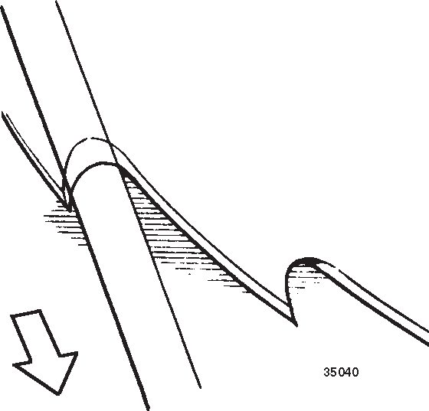0.04 to 0.06” (1 to 1.5 mm) at the base of each tooth. Cutting edges must be offset equally on each side. See Figure 41.

Round File

Figure 41

Troubleshooting Guide
ENGINE DOES NOT START

What To Check Possible Cause Remedy
NO
Does the engine crank?
Faulty recoil starter.

YES
NO
Good compression?

YES
NO
Does the tank contain fresh fuel of the proper grade?

YES YES
NO
Is fuel visible and moving in the return line when priming?
Is there spark at the spark plug wire terminal? |  | NO
YES

Fluid in the crankcase Internal damage.
Loose spark plug. Excess wear on cylinder, piston, rings.
Fuel incorrect, stale, or contaminated; mixture incorrect.

Check for clogged fuel ﬁlter and/or vent.

The ignition switch is in “O” (OFF) position. Shorted ignition system.
Faulty ignition unit.
If the plug is wet, excess fuel may be in the cylinder.
Check the spark plug.
The plug is fouled or improperly gapped.

The plug is damaged internally or of the wrong size.
Consult with an authorized servicing dealer.

Tighten and re-test. Consult with an authorized servicing dealer.
Reﬁll with clean, fresh unleaded gasoline with a pump octane of 87 or higher, mixed with Premium 2-cycle mixing oil at a 50:1 gasoline/oil ratio.
Replace fuel ﬁlter or vent as required. Restart.

Move switch to “I” (ON) position and re-start. Consult with an authorized servicing dealer.
Crank the engine with the plug removed, replace the plug, and restart.

Clean and gap the spark plug to 0.024 inch (0.6mm). Restart.

Replace the plug with a Champion CJ8 or equivalent type spark plug of the correct heat range. Restart.

LOW POWER OUTPUT

What To Check Possible Cause Remedy

Operator is overworking the machine. Carburetor mixture is too lean.
Is the engine overheating?
TROUBLESHOOTING
Improper fuel ratio.

Fan, fan cover, cylinder ﬁns dirty or damaged. Carbon deposits on the piston or in the mufﬂer. Clogged air cleaner.
Engine is rough at all speeds. May also have black smoke and/or unburned fuel at the exhaust.
Loose or damaged spark plug.

Air leakage or clogged fuel line. Water in the fuel.
Piston seizure. Faulty carburetor and/or diaphragm. Overheating condition.
Engine is knocking.
Improper fuel.

Carbon deposits in the combustion chamber.
Shorten trimmer line. Cut at a slower rate. Consult with an authorized servicing dealer.
Reﬁll with clean, fresh unleaded gasoline with a pump octane of 87 or higher, mixed with Premium 2-cycle mixing oil at a 50:1 gasoline/oil ratio.
Consult with an authorized servicing dealer. Clean or replace the air ﬁlter.
Tighten or replace the plug with a Champion CJ8 or equivalent type spark plug of the correct heat range. Restart.
Repair or replace fuel ﬁlter and/or fuel line. Reﬁll with fresh fuel/oil mixture. See page 9.

Consult with an authorized servicing dealer.

See above.
Check fuel octane rating; check for presence of alcohol in the fuel. See page 9.
Refuel as necessary.
Consult with an authorized servicing dealer.

Troubleshooting Guide (continued)
ADDITIONAL PROBLEMS

Symptom Possible Cause Remedy

Clogged air ﬁlter. Clogged fuel ﬁlter. Lean fuel/air mixture. Idle speed set too low. Switch turned off.
Poor acceleration.
Engine stops abruptly.
Fuel tank empty. Clogged fuel ﬁlter. Water in the fuel. Shorted spark plug or loose terminal.

Ignition failure. Piston seizure.
Ground (stop) wire is disconnected, or switch is defective.
Engine difftcult to shut off.
Overheating due to incorrect spark plug.

Overheated engine. Engine idle too high.
Cutting attachment rotates at engine idle.
TROUBLESHOOTING
Broken clutch spring or worn clutch spring boss. Loose attachment holder.
Warped or damaged cutting attachment. Loose gearcase.
Excessive vibration.
Bent main shaft/worn or damaged bushings. Shaft not installed in powerhead or gearcase. Broken shaft.
Cutting attachment will not rotate.
Damaged gearcase.
Clean or replace the air ﬁlter. Replace the fuel ﬁlter.
Consult with an authorized servicing dealer. Adjust: 2,750 (±250) RPM (min-1).
Reset the switch and restart. Refuel. See page 9.
Replace ﬁlter. Drain; replace with clean fuel. See page 9.
Clean or replace spark plug with a Champion CJ8 or equivalent type spark plug of the correct heat range. Restart. Tighten the terminal.
Replace the ignition unit. Consult with an authorized servicing dealer. Test and replace as required.

Replace spark plug with a Champion CJ8 or equivalent type spark plug of the correct heat range.
Idle engine until cool. Set idle: 2,750 (±250) RPM (min-1). Replace spring/shoes as required, check idle speed. Inspect and re-tighten holders securely.
Inspect and replace attachment as required. Tighten gearcase securely.
Inspect and replace as necessary. Inspect and reinstall as required.

Consult with an authorized servicing dealer.

NOTES:

