BUSH MOWER
OPERATOR'S MANUAL

INDEX

- WARNING 01
Safety 01
Operating Personnel 01
Warning labels on the bush mower and implements 02
Literature 04
- INFORMATION 05
Identification of manufacturer, bush mower and implements 05
Interchangeable tool 05
Customer service 05
For your safety 06
Improper use 06
Modes of operation 07
- FEATURES 08
General features 08
Equipment. 08
Plumbing 08
Accessories on request 08
Requested tractor. 09
- HOISTING 10
Check on delivery. 10
Hoisting 10
- INSTALLATION 11
Connections 11
Cardan shaft. 12
Check and determination of the cardan shaft length 12
Cardan shaft connection with recovery safety pin 14
Cardan shaft connection with freewheel 15
Connection of the cardan shaft with collar. 17
Bush mower - tractor organization check 19
Transversal position to the direction 19
Longitudinal position to the direction 19
Bush mower without hydraulic shrinkage ( Fig. 4-7 A/B ). 20
- STARTING 21
Starting 21
Control device signaling 23
Work interruption 24
Short stops 24
Long stops. 24
In case of bush mower disconnection: 24
Road carriage 24
Bush mower in stand position. 25
- TROUBLE SHOOTING. 26
Trouble shooting 26
- MAINTENANCE 30
After the first 30/50 hours of operation 30
Every 4 hours of operation. 30
Every 8 hours of operation. 30
After the first 50 hours of operation 30
After the first 120 hours of operation 30
Every 250 hours of operation. 30
Every 300 hours of operation. 30
Every 1000 hours of operation. 30
Storing the bush mower 31
After long period inactivity. 31
Replacement shredder head cutters. 32
Machine demolition and recovery of reusable material 33

0. WARNING

READ THIS SECTION BEFORE OPERATION !
DURING OPERATION IS TOO LATE

Safety

All users of bush mowers and relating implements must be aware that moving mechanical parts (linear or rotary) may cause serious injuries to people and extensive damage to properties.

All users must:
- follow the indications found in this manual;
- avoid improper use of the bush mower and its implements;
- avoid replacing or tampering with safety devices;
- carry out on a regular basis maintenance works;
- use only original spare parts, especially for safety-related components.

To this purpose it is necessary that:
- the original use and maintenance manual of the bush mower and relevant implements be available;
- such documentation be carefully read and the indications be therefore followed. Fur- thermore, properly trained personnel must be assigned.

Operating Personnel

According to their level of competence and responsibility the users of the bush mower can be classified as:

OPERATOR - The operator does not need extensive technical knowledge, but is trained to carry out the bush mower routine operations: for instance starting, stopping at the end of the work, routine maintenance works (cleaning, simple jamming), adjustment opera- tions.

QUALIFIED TECHNICIAN - The qualified technician is assigned to special maintenance and repair works.

It is important that each operator act strictly within the limits of his specific competence and responsibility.

Warning labels on the bush mower and implements

Pay special attention to the following adhesive labels placed on the bush mower and implements indicating dangerous conditions.:

CAUTION: do not remove or make illegible the decalcomanias below

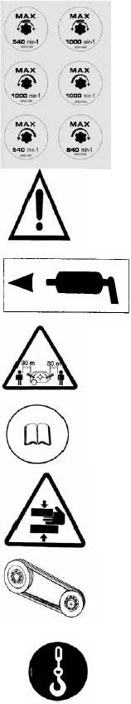
Maximum speed and direction or rotation of overdrive shaft. Follow strictly this indication as a higher speed of
    - the overdrive shaft may cause severe damage to the bush mower and implements. This is a view taken from the rotating part front side.

    - Generic hazard: do not get near when the bush mower is operating.

    - Greasing points where grease must be injected periodi- cally.

    - Warns people to keep at safety distance.

    - Warns the operator to read this manual before performing any operation.

    - Crushing and shearing danger.

    - Drive belt tension adjustment.

    - Hooking point for bush mower and implements hoisting.

I Warns people against hooking, keep away hands from rotating tools.

- Warns people against crushing, don’t stop between tractor and machine.

- Danger of fall of the suspended loads, do not stay under raised parts of the machine.

- Before carrying out in- terventions on the ma- chine, shut down the motor of the tractor and take out the igni- tion key.

- Warns against crush- ing of the limbs, don’t put the hands near to the rotating tools.
- Danger of wounding from liquids in pres- sure, follow the indica- tions brought back in the use and mainte- nance book

- Fall danger, don’t climb or let yourself carry on from the ma- chine.

- Warns against crush- ing, dangerous area because of displace- ment of the machine

- Warns against wound- ing of the hands, wait until the stop of the ro- tating tools before touch them.

- Danger of tractor cab crushing, make sure the arm does not touch the cab.

Danger warnings
For the safety of people and property this manual has been provided with special symbols to warn the users of potential hazards:

DANGER !

INDICATES A SERIOUS DANGER FOR THE LIFE OF THE OPERATOR AND OTHER
PEOPLE

CAUTION
Indicates a risk of injury to the operator or other people

WARNING

Indicates a risk of damage, even severe, to the bush mower and/or its implements

- INFORMATION

Introduction
This section provides identification data of the manufacturer and of the bush mower. The information supplied is recommended to all users of the bush mower: OPERATORS and QUALIFIED TECHNICIANS.

Identification of manufacturer, bush mower and implements
A name plate (Fig. 1-1 ) with the data relating to the manufacturer and the bush mower is applied on the machine in a clearly visible location.
Made In China
Model
Serial No:
Date MFD
CE

Fig. 1-1 Name plate

Interchangeable tool
Definition of interchangeable tool. Equipment mounted subsequently to the resale on one moving unit (tractor) modifying its main function.

Customer service
Contact the manufacturer who will direct you to the nearest authorized service facility.

For your safety
- Both operator and technician must know well the machine;
- Read indications manual before using the machine;
- Do not remove safety guards while the bush mower and/or the implements are in mo- tion;
- Make sure the implements never touch the ground during work;
- When the bush mower is operating it is recommended to keep at a 30 meter safety dis- tance;
- the tractor cannot work in the immediate vicinities of escarpments, pits or diggings, since the land could yield.
- Before performing any operation on the bush mower, such as cleaning or maintenance operations, disconnect the tractor power take-off, wait for the rotor come to a complete stop, stop the engine and disengage the cardan shaft on the tractor side;
- Do not allow anybody (people or animals) on the bush mower during transport or opera- tion;
- Do not wear flapping dresses
- Do not leave the workplace unattended. If the operator must itself be absented, close the tractor cabin with the key, in the case the tractor is supplied with, otherwise it’s ad- visable to disconnect the pto shaft;
- Do not attempt to add or remove material from the bush mower either with tools or with your hands or feet while the rotor is running;
- Having to leave the bush mower parked.
- Never connect the power take off when the motor is switched-off;
- Use protected cardan shafts.
- Attention: operating in the vicinity of overhead electrical lines be careful about possible contacts with electrical threads and possibility to prime the voltaic arc.
- The operator does not have to use alcoholic or drugs that can change or alter its alert and the coordination.

Improper use
The bush mower and/or the implements must NOT be used to:
- Lift weights of any kind, whether people, animals or properties;
- Carry out digging or demolition works;
- Advance in a direction reverse to the one agreed upon. The working direction of the
bush mower is the same as the direction of travel of the tractor (to be specified when placing the order);
- Work after dark, unless the machine operation is constantly monitored by skilled opera- tors equipped with appropriate beacons as required by law;
- The equipment does not have to be used in presence of wind with a speed of more than 50 Km/h
- The equipment does not have to be used in closed rooms and atmospheres unsuit- able to ventilation and evacuation of the drainage smoke of the tractor.
- The equipment cannot work underground neither in rooms with explosive atmos- pheres.
- Do not use the implement in water. Failure to comply with the above prescriptions, will invalidate any form of warranty coverage.

Modes of operation
The bush mower may operate in four modes (Fig. 1-2) :
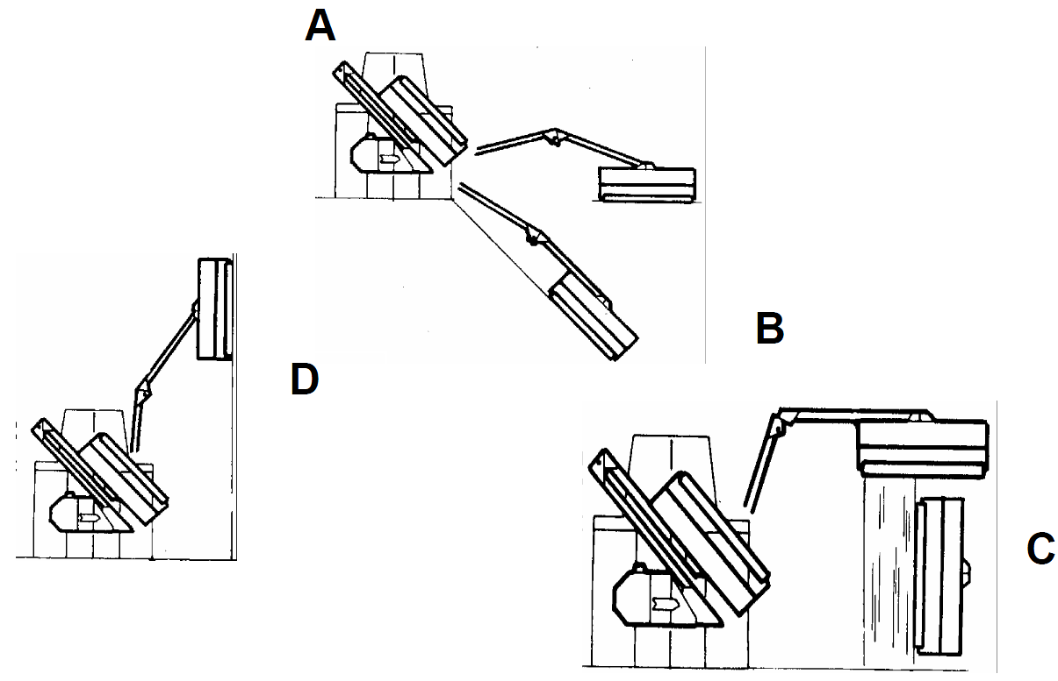
C
D
B

Fig. 1-2 Modes of operation

- With the shearing head or other tool in horizontal or inclined position touching the ground ;
- With the shearing head or other tool in horizontal position and lifted from the ground (for operating on hedges) ;
C-D With the shearing head or other tool lifted from the ground and in inclined position upwards until standing along the vertical.

A mode of operation is the safest one advised . However, if necessary, before operating in B, C
and D modes is indispensable :
  - To scour previously the working area ;
  - To be assisted by other people on the round who must check the working area.

FEATURES

Introduction
This section provides an overview of the bush mower features. All users of bush mower are recommended to read this section: OPERATORS and QUALIFIED TECHNICIANS assigned to maintenance works.

General features
Bush Mowers built in order to optimise the operator’s visibility of the terminal tool. If requested they may be equipped with a hydraulic telescopic terminal. The use is addressed to public parks and gardens’ maintenance and to a service use.

Equipment
  - Teleflexible distance hand drive to move arms and cable for ignition end inversion of the terminal tool with anti-inversion safety device;
  - Terminal tool;
  - Floating device on terminal tool(ground self-levelling);
  - Safety device against overburden due to bumps or overwork ;
  - Control valve of the accidental fall for breaking of the hydraulic pipes;
  - Terminal tool rotation, with maximum angle according to the model.

Plumbing
  - Oil tank with adequate filtration system;
  - Multiplier;
  - Terminal tool pump;
  - Jacks control pump;
  - Terminal tool control motor with features according to the assembled tool;
  - Terminal tool control distribution system with relative safety valve;
  - Arms control distribution system with relative safety valve;
  - Oil level indicator.

Accessories on request
  - Shredder heads;
  - Rotor hoes;
  - Branch-shearing heads;
  - Stirrup frame;
  - Hedges Bar;
  - Cutter bars (for shrubs or wood Ø max. = cm 2);
  - Bi-blade Cutter bars (for grass Ø max = cm 1 );
  - Electrical control;
  - Servoproportional control; Electroproportional control.
  - Heat exchanger;
  - Tractor Stirrup turnbuckle;
  - Cardan shaft;
  - Bumper with lights;
  - Kit suspension 1° arm.

Dimensions during operation
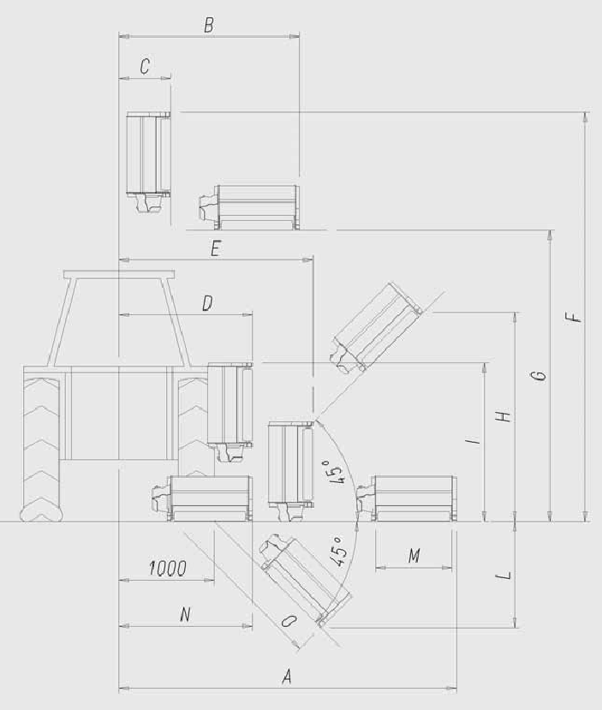
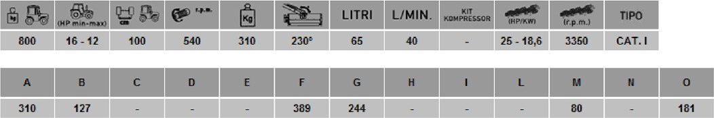

HOISTING

Introduction
The aim of the present chapter is to supply the information for the removal and the raising of the bush mower and its accessories. The information of this section are destined to QUALIFIED TECHNICAL PERSONNEL and with adapted acquaintances in order to oper- ate in suitable way and conditions of emergency in the undercarriage use of elevator, crane
and other equipment needed. The shift operation necessary can be carried out through a raising equipment, with capacity adapted to the weight to be raised, using a lifting accessory (stirrup, cricket, etc.) to interpose between the hook of the raising equipment and the hooking point of the equipment, specially realized for such purpose.
All the raising, loading, transport and unloading must obligatorily be completed in the respect of the safety rules and the operator appointed for the crane must however be acquainted of the basic safety rules concerning operating with cranes.

Check on delivery
Upon receipt check supply for compliance with the shipping documents and make sure it did not suffer damages during transport. Please promptly notify any discrepancy or damage.

Hoisting

CAUTION
Before hoisting the bush mower and/or implements, make sure that:
  - The lifting apparatus is suitable for the weight of the bush mower and/or implements;
  - The whole area involved in the handling operations of the bush mower and/or imple- ments - including the transport vehicle parking area and the bush mower and/or imple- ments storage area - is inspected in advance in order to locate any “danger zones” such as electric lines and water or gas ducts. Any lines or ducts within the work area must be marked out and shut off;
  - All operators keep at a safe distance to avoid being hit by ejected machine parts.
On bush mowers and accessories special pictograms show the correct insertion points for crane hook or bridge crane.
For the lifting hook to the eyelet on the bush mower only if the machine doesn’t need reassembly.

DANGER !

FOLLOW STRICTLY THE INDICATIONS ABOVE. HANDLING PRACTICES OTHER
THAN THOSE PRESCRIBED MAY RESULT IN BOTH SEVERE DAMAGE TO THE MACHINE AND SERIOUS INJURIES TO OPERATING PERSONNEL.

Introduction

INSTALLATION

The purpose of this section is to provide information for a correct coupling and installation of the bush mower. The information found in this section is intended for the QUALIFIED TECHNICIAN, to carry out the first coupling and to determine the cardan shaft length, and for the OPERATOR for routine operation of the bush mower.

Connections

WARNING

Before connecting tractor and bush mower make sure that speed and rotation direction of the tractor PTO shaft correspond to the ones reported on the bush mower.

WARNING

Follow strictly this indication. A higher amount of revolutions may cause damages to the bush mower..

WARNING

Tractor PTO must be equipped with double clutch. Otherwise transmission must occur trough a cardan having free wheel even if tractor PTO has electrical or hydraulic.

DANGER !

IN ORDER TO AVOID OPERATOR’S (AND TRACTOR’S) DAMAGES IT IS INDISPENSABLE TO PROTECT ALL CONCERNING AREAS WITH PLEXIGLAS OR
METALLIC NETS E.G..

Cardan shaft

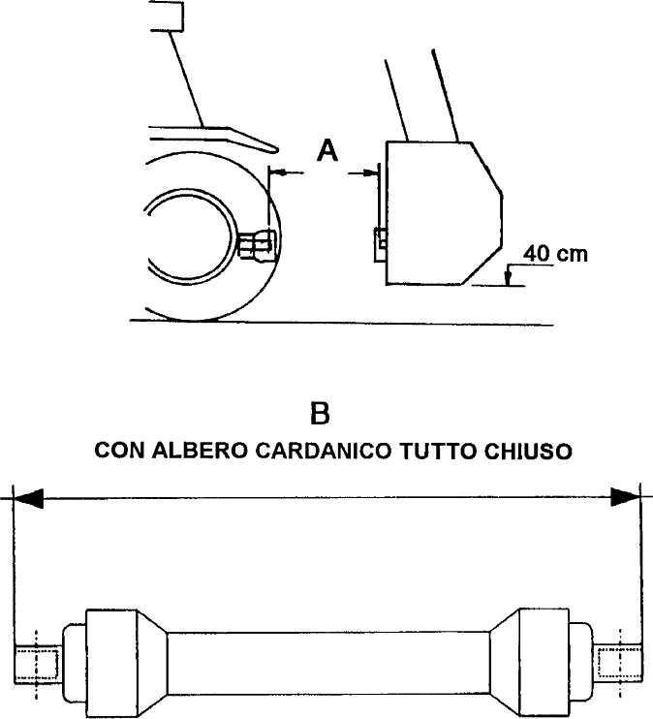

Fig. 4-1 Determinate distance between bush mower and tractor cardan shaft

Check and determination of the cardan shaft length
These operations must be carried out :
  - Upon receipt of the bush mower.
  - when changing tractor.
Personnel required: 1 QUALIFIED TECHNICIAN Proceed as follows:
  - Make sure the tractor has been properly connected to the bush mower three-point link- age frame ;
  - Lift the bush mower at 40 cm high (Fig. 4-1);
  - Measure the distance between the output shaft of the bush mower gear box and the output shaft of the tractor, dimension A (Fig. 4-1);
  - Measure the cardan shaft in fully closed position, dimension B (Fig. 4-1).

CONDITIONS:

If B is equal to A

WARNING
Once the cardan shaft has been connected to both the tractor and the bush mower, lift and lower the bush mower very slowly to check proper sliding of the cardan shaft and especially to make sure that the conditions represented in Fig. 4-2-A e 4-2-B are met.
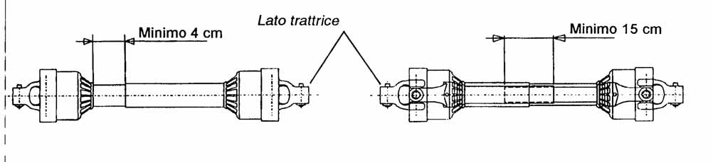

A B
Fig. 4-2 Correct working condition of the cardan shaft If B is shorter than A

WARNING
Once the cardan shaft has been connected to both the tractor and the bush mower, lift and
lower the bush mower very slowly to check proper sliding of the cardan shaft and especially to make sure that the conditions represented in Fig. 4-2-A e 4-2-B are met.

If B is longer than A

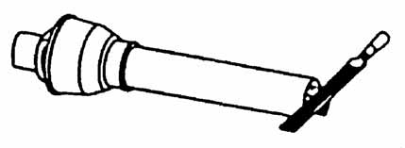
Separate the two sections of the cardan shaft.
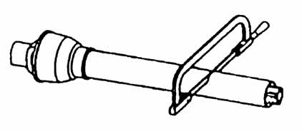
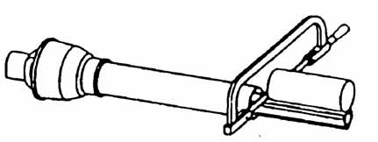

A B

C
Fig. 4-3 Correction of the cardan shaft

CAUTION
Operations below must be effected on both parts of the cardan shaft.

  - Cut off the portion of the plastic protection corresponding to B “minus” A as in Fig. 4- 3-A;
  - Use the part of the protection removed as a reference measure and cut off the portion of shaft in excess as in Fig. 4-3-B;
  - Remove burrs (Fig. 4-3-C), then clean and grease accurately the sliding shaft.
  - Reassemble the two sections of the cardan shaft;

WARNING
Once the cardan shaft has been connected to both the tractor and the bush mower, lift and lower
the bush mower very slowly to make sure that the conditions represented in Fig. 4- 2-A and 4-2-B are met.

Cardan shaft connection with recovery safety pin
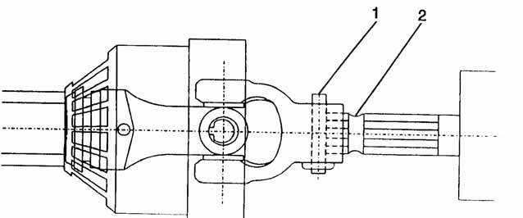

WARNING

Fig. 4-4 Connection of the cardan shaft with spring return safety pin

Before connecting the shaft, make sure the safety pin 1 (Fig. 4-4) slides freely, otherwise it must be cleaned and lubricated as necessary.

THE CARDAN SHAFT MUST BE CONNECTED TO THE BUSH MOWER FIRST THEN TO THE TRACTOR, VERIFYING THE RIGHT SIDE OF THE CARDAN SHAFT.
  - Engage the cardan shaft onto the gear box spline shaft and push it until it stops (Fig. 4- 4);
  - Press safety pin 1 home with your thumb and, while keeping it pressed, advance the cardan shaft by approximately 2 cm.
  - Reduce the pressure on the pin without taking your thumb away and keep inserting the cardan shaft slowly. When pin 1 engages into housing 2 of the spline shaft, you will feel a light pressure under your thumb produced by the pin, indicating that the connec- tion has been successfully completed.
  - Seize the cardan shaft and pull strongly to make sure it is locked. • . Repeat the operation from the tractor’s side.

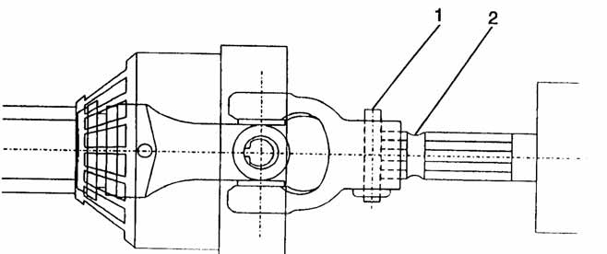
Cardan shaft connection with freewheel

- TRACTOR SIDE

- 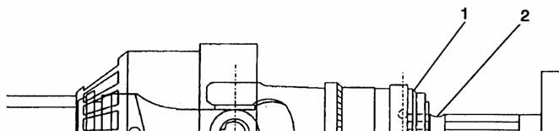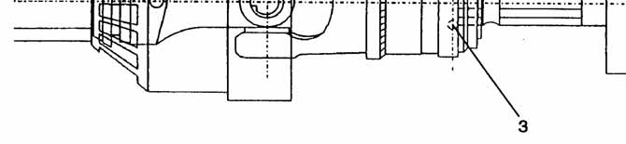BUSH MOWER
SIDE

Fig. 4-5 Cardan shaft connection with freewheel

WARNING

Before connecting the shaft, make sure the safety pin 1 (Fig. 4-5-A) and the ring 1 (Fig. 4-5-B) slide freely, otherwise it must be cleaned and lubricated as necessary.

THE CARDAN SHAFT MUST BE CONNECTED TO THE BUSH MOWER FIRST THEN TO THE TRACTOR.

- Engage the cardan shaft onto the gear box shaft and push it until it stops (Fig. 4-5-B).
- Pull ring 1 and, while keeping it pulled, advance the cardan shaft by approximately 2 cm.
- Release ring 1 and keep inserting the cardan shaft. When balls 3 engage into housing 2 of the spline shaft, a click will indicate that the connection has been successfully completed.
- Seize the cardan shaft and pull strongly to make sure it is locked.

Repeat the operation from the tractor’s side.

Perform the operation on the tractor side.
  - Engage the cardan shaft onto the gear box spline shaft and push it until it stops (Fig. 4- 5-A)
  - Press safety pin 1 home with your thumb and, while keeping it pressed, advance the cardan shaft by approximately 2 cm.
  - Reduce the pressure on the pin without taking your thumb away and keep inserting the cardan shaft slowly. When pin 1 engages into housing 2 of the spline shaft, you will feel a light pressure under your thumb produced by the pin, indicating that the connec- tion has been successfully completed.
Seize the cardan shaft and pull strongly to make sure it is locked.
DANGER !

IF NOT CORRECTLY ENGAGED THE CARDAN SHAFT CAN BE EXTREMELY DANGEROUS FOR PEOPLE STANDING NEARBY AND CAUSE SEVERE DAMAGE TO BOTH THE TRACTOR AND THE BUSH MOWER.

Connection of the cardan shaft with collar

- 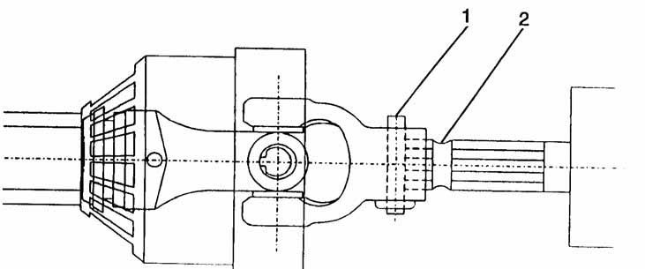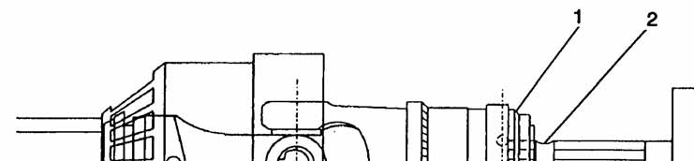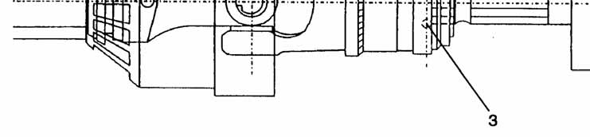BUSH MOWER
SIDE

- TRACTOR SIDE

Fig. 4-6 Cardan shaft connection with collar
WARNING

Before connecting the shaft, make sure the safety pin 1 (Fig. 4-6-A) and the ring 1 (Fig. 4-6-B) slide freely, otherwise it must be cleaned and lubricated as necessary.

THE CARDAN SHAFT MUST BE CONNECTED TO THE BUSH MOWER FIRST THEN TO THE TRACTOR.

- Engage the cardan shaft onto the gear box shaft and push it until it stops (Fig. 4-6-B).
- Pull ring 1 and, while keeping it pulled, advance the cardan shaft by approximately 2 cm.
- Release ring 1 and keep inserting the cardan shaft. When balls 3 engage into housing 2 of the spline shaft, a click will indicate that the connection has been successfully completed.
- Seize the cardan shaft and pull strongly to make sure it is locked.

Perform the operation on the tractor side.
  - Engage the cardan shaft onto the gear box spline shaft and push it until it stops (Fig. 4- 6-A)
  - Press safety pin 1 home with your thumb and, while keeping it pressed, advance the cardan shaft by approximately 2 cm.
  - Reduce the pressure on the pin without taking your thumb away and keep inserting the cardan shaft slowly. When pin 1 engages into housing 2 of the spline shaft, you will feel a light pressure under your thumb produced by the pin, indicating that the connec- tion has been successfully completed.
  - Seize the cardan shaft and pull strongly to make sure it is locked.

DANGER !

IF NOT CORRECTLY ENGAGED THE CARDAN SHAFT CAN BE EXTREMELY DANGEROUS FOR PEOPLE STANDING NEARBY AND CAUSE SEVERE DAMAGE TO BOTH THE TRACTOR AND THE BUSH MOWER.

Bush mower - tractor organization check.

DANGER !

INDICATIONS BELOW MUST BE CARRIED OUT BY TECHNICIANS OR QUALIFIED PEOPLE ABLE TO UNDERSTAND THEIR IMPORTANCE IN ORDER TO AVOID ANY DANGEROUS OPERATION.

To combine bush mower and tractor some shrewdness must be applied in order to avoid wrong and dangerous unbalance of the machines.
Before combining check:

Transversal position to the direction
Check preventively every assembly which must be adequate to safety rules against eventual overturn.

Longitudinal position to the direction
Being this position less predictable, assembly must avoid dangerous situations, ensuring machines balance. For machines equipped with hydraulic shrinkage in standstill position.

Bush mower without hydraulic shrinkage ( Fig. 4-7 A/B ).
On bush mower without hydraulic shrinkage, check may occur only in transversal position.

- Move the tractor on a flat zone ;
- Open fully the bush mower in working position as in fig. 4-7 A e FIG 4.7 B. Lift the terminal tool from the ground at maximum 2 - 4 cm
- Check tractor stability ensure that wheels remain always on the ground when bush mower is at condition of the maximum tightness, as in fig 4-7 A e 4-7 B controlling with pulses the screw jack of the arm 1
- In case of the preparation to submit to M.C.T.C. testing (traffic), all technical conditions by tractor manufacturer and by traffic regulation must be met.

Fig. 4-7 A
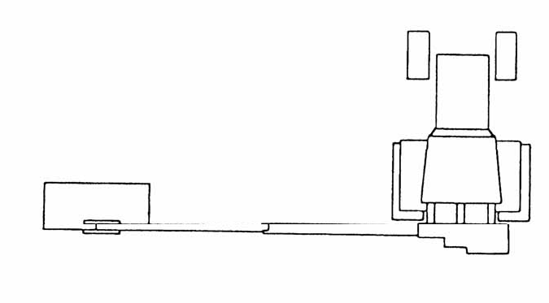
Fig. 4-7 B

STARTING

Introduction
The purpose of this section is to describe the bush mower setting procedures before work starts. These operations may be carried out by the OPERATOR assigned to the bush mower and more generally by all QUALIFIED TECHNICIANS.

Starting

WARNING

In winter, before starting to work, let pumps and accessory control motor idle for at least 15 minutes.
In summer , if oil temperature exceeds 70°C, stop the machine and substitute the oil of the hydraulic plant with another oil, more suitable to high temperatures. If the problem persists equip the bush mower with a HEAT EXCHANGER.

WARNING
  - If different types of the tractor are used, make sure they always meet the conditions re-
lating to the cardan shaft length as indicated in Section 4.
  - Keep the tractor to a slow rotation running.
  - Start the bush mower raised from the product that must be shred.

Before starting the bush mower, make sure that the rotor tools are not touching the ground. Any contact of the rotor tools with the ground, may:
  - produce vibrations harmful for the bush mower;
  - cause them to wear quickly;
  - subject the final drive to severe stresses.

CAUTION

Before starting the bush mower, make sure the cardan shaft is correctly coupled as
described in paragraph 4.2.2 or 4.2.3.

WARNING

Check the oil piping condition. If weared out substitute the pipes asking to the QUALIFIED TECHNICAL PERSONNEL.
Remove the eventual safety devices which block the arm.
Before starting the bush mower ensure that eventual oil cocks are open. If a cock is closed this could cause serious damages during the machine start.

Ensure to have removed all safety devices used for transport.

WARNING
Check , through the led, the oil level in the tank.
If necessary fill it up with hydraulic oil ISO 68.

WARNING
Ensure that use conditions of the bush mower do not compromise any part of the bush
mower.

WARNING
Do not use the terminal tool under immersion.

DANGER !

BEFORE STARTING , ENSURE THAT IN WORKING AREAS CANNOT CREATE
CONDITIONS FOR FIRE OR BURST .

Control device signaling

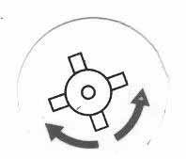
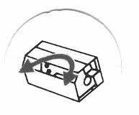
A B

Terminal tool control lever

C

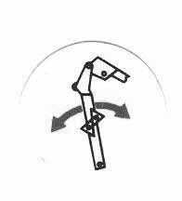
Hydraulic take-off control lever

E

Second arm control lever
Control lever for the inclination of the terminal tool.

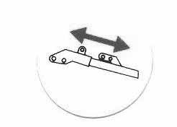
D
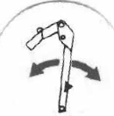

First arm control lever

Work interruption

Short stops
      - Disengage the power take-off and stop the implement;
      - Stop the tractor in a safe area;
      - Rest the implement in horizontal position on the ground;
      - Lock the operator’s cab before leaving.

Long stops
  - Rest the terminal tool.
  - Make the terminal tool touch the ground in horizontal position
  - Disengage the PTO and disconnect the cardan shaft supporting it with the appropriate bar.
  - Stop the tractor in a safe area.
  - Leave the driving seat only after having removed the ignition key.
  - Fence the tractor and the bush mower.

In case of bush mower disconnection:

  - Stop the tractor in a safe area and on cement floor.
  - Disconnect the connecting rods, stirrups or fastening frames in addition .
  - Lower the stand feet and fasten them with the appropriate pins.
  - Lower the hoisting arms until stand feet lean on the ground. Pressure on the ground is lower than 400kPa
  - Draw back completely the eventual hydraulic take-off and move bush mower arms to the position in Fig. 5-1 making sure that the supporting arm for the terminal tool is in its maximum vertical position. The terminal tool must stand on the ground in horizontal safe position.

IMPORTANT:
  - Disengage the third point ;
  - Disengage the hoisting arms;
  - Disconnect the disconnect the cardan shaft supporting it with the appropriate bar.
  - Disconnect the cables for power supply +/- (in case of electrical control or device e.g. headlights, radiator, etc).
  - Remove the control device from the tractor cab.

Road carriage
Before beginning the road carriage of the bush mower particularly on the road, put the safety equipment supplied with it.
During the road transfers, moderate the speed to avoid damages on holders, fixing supports of the bush mower to the tractor. It is an obligation respect the overall dimensions limit and fit signals, panels and lights, as foreseen from the Road circulation rules.

WARNING

TIGHT THE CHAINS AS MUCH AS POSSIBLE.

Bush mower in stand position.

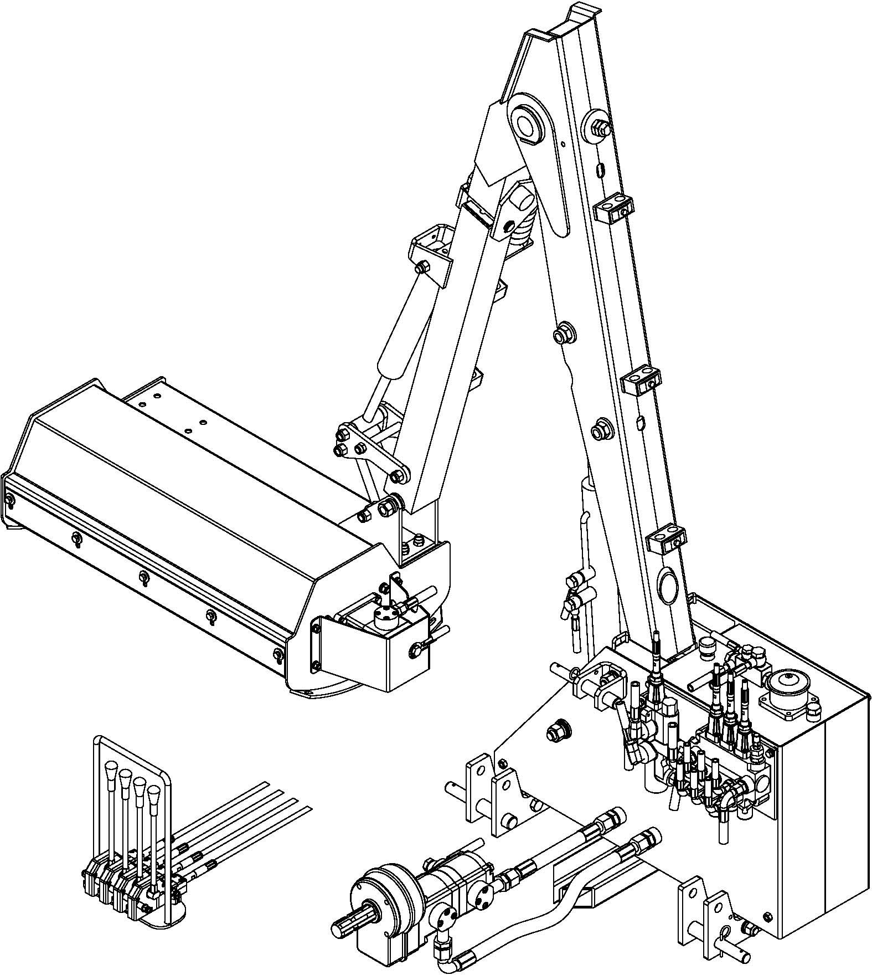

Fig. 5-1

TROUBLE SHOOTING

Introduction
This section provides a guide to solve the problems that may arise during the bush mower operation.

6.1 Trouble shooting
For any problem, stop immediately the bush mower and, with the terminal tool completely resting, make a systematical comparison between the current conditions of the bush mower and the standard conditions expected (e.g. a new machine).

CAUTION

Before disengaging a tube of the hydraulic plant, ensure that the plant is not under
pressure. A leak of oil under pressure may cause serious damages.
For the safety of operators, the machine must be fully resting and firmly parked on the ground.
No jackscrews partially open and under pressure. For this purpose with the PTO arrested and the cardan shaft disconnected, discharge all jackscrews from the pressure by operating on control devices in both directions.

The OPERATOR OR THE QUALIFIED TECHNICIAN must be provided with personal pro- tection equipment such a gloves, masks, glasses, etc., as required by safety standards

PROBLEM | POSSIBLE CAUSE | ACTION | TROUBLE SHOOTER
All arms of the bush  mower do not work. | Pump does not let oil  out | In order to check the pump  working operate in the following way: check with a debimeter the correct flow of oil. Then check the pressure with a ma- nometer comparing it with the one indicated on the tally Fig. 1-  1 P.MAX. JACKSCREWS PUMP (BAR). If pressure is cor- rect the problem is inside the distributor. | M

PROBLEM | POSSIBLE CAUSE | ACTION | TROUBLE SHOOTER
All arms of the bush mower do not work. | Hydraulic distributor blocked | In order to check the distributor working operate in the following way: Ensure that the pipe from the pump is correctly inserted. Disen- gage the waste pipe and check the oil flows with the right intensity. If this does not occur , replace the distributor. | M  M
 | Pressure control valve blocked. | Replace the valve.
The accessory or the terminal tool stopped or does not properly work | Pressure control val- ve sprung. | Put the lever for terminal tool control in neutral position and, only for shredder head or rotary hoe, make the motor turn on the opposite direction in order to unlock the tool. Restore the correct gear and restart. If still  does not work, call assistance. | O
It is impossible to  control a single movement | Incorrect oil flow to the cylinder. | Check the correct oil flow pres- sure in pipe out-put. | M
 | Distance control ca- ble broken. | Replace the cable. | M
 | Cursor eyelet broken. | Replace the cursor.
 |  |  | M
 | Pressure control valve  blocked. | Replace the valve.
 |  |  | M
It is impossible to  control a single movement in a elec- trical control machine | Ignition key position.  Emergency button position. | Check.  Check. | O  O
 | Fuse. | Check.
 |  |  | O
 | Wires cut. | Check.
 |  |  | M
 | Defective switches and handlebars . | Check. | M

PROBLEM | POSSIBLE CAUSE | ACTION | TROUBLE SHOOTER
Control lever blocked in one position | Wearing of the cursor caused by filth or rust. | Replace. Do not use even fine sand paper to take rust off oth- erwise cursor will be irremedia- bly damaged. | M
Fan in machines with  heat exchanger does not work (fan status only at temperature of 45-50 C degrees). | Fuse broken.  Electric valve burned | Sostituire il fusibile.  Sostituire electric valve. | M  M
Irregular cut | Wrong rotation direc- tion | Invert direction. | O
 | Tools weared out or broken. | Replace cutters. | O
 | Wrong placement of the supporting roll. | Set roll height. | O
Fast wearing of tools | Tools touch the ground. | Set cut height operating on the roll. | O
Unusual noises coming from the bush mower | Poor lubrication of rotor bearings | Grease bearing | O
 | Oil level of tank too low. | Top up level | O
 | Oil level of overdrive too low. | Top up level. | O
 | Incorrect speed of  tractor power take- off. | Check power take-off speed (540 rpm) | O
 | Foreign bodies caught in the rotor | Remove foreign body | O
PROBLEM | POSSIBLE CAUSE | ACTION | TROUBLE SHOOTER
Excessive vibrations | Incorrect speed of tractor power take- | Check power take-off speed  :540 rpm or 1000 rpm. | M
 | off.
 | Excessive and ir- | Replace all tools. | M
 | regular wear of tools.

 | Cutters worn or bro-
 | ken | Replace all tools. | M
 | Different weight for
 | opposite tools. | Check the weight gap stays in a tolerance of5%. | M
Rotary hoe dos not work properly | Tools weared out.  Hydraulic motor does not work properly. | Replace all tools. Replace the motor. | O M
Branch- shearing  bar does not work properly. | Pressure switch. | Call assistance intervention.  Call assistance intervention | M
 | Electric valves do not work properly, or do not effect the inver-  sion properly. |  | M
 | Jackscrew does not work properly. | Carry out the maintenance of  the jackscrew | M
 |  | Call assistance intervention
 | Hydraulic distributor does not effect the inversion properly. |  | M

MAINTENANCE
Introduction
The purpose of this section is to outline the methods and frequency of the maintenance works.

WARNING
The maintenance works recommended in this section should be considered the minimum required to keep the bush mower in good condition and to improve its efficiency. Additional maintenance works may be suggested by the user’s experience according to the workload, the operating environment and the type of the material to be cut.

CAUTION

All maintenance operations must be carried out only when :
  - Bush mower is resting;
  - Cardan shaft is disconnected from the tractor and tractor power take-off is dis- engaged.
  - Hydraulic plant not under pressure

After the first 30/50 hours of operation
  - Check the perfect lock of nuts, connectors, pipes and clips. Recheck every 100 hours of operation.

Every 4 hours of operation
  - Inject grease ISO XM2 into lubricators .

Every 8 hours of operation
  - Grease all the joints of arms and jackscrews ;
  - Grease the cardan shaft joints ;
  - Grease all the parts in movement of the bush mower.

After the first 50 hours of operation
  - In case of machine equipped with Kit Active Kompressor replace the cartridge filter n.2.

After the first 120 hours of operation
  - Check the oil level in the overdrive through the related light; if necessary fill it up with SPARTAN E 150 oil or similar.

Every 250 hours of operation
  - Replace the cartridge filter.

Every 300 hours of operation
  - Replace the oil into the overdrive (SPARTAN E 150).

Every 1000 hours of operation
  - Replace the oil and the cartridge filter into the tank.

WARNING
Check daily the oil level in the tank. If necessary fill it up with ISO 68 oil.

CAUTION

The oil for hydraulic circuits is particularly harmful. Before starting any operation, filling or replacement, operator must be equipped with individual protection means.

Do not dissipate in environment the used oil, ask to a skilled agency for the dis- posal. Follow strictly the current rules regarding the disposal of toxic harmful waste.

Storing the bush mower
The bush mower does not require special storage conditions. If the machine is to remain inoperative for a fairly long time (3 to 4 months) it is very important that it be thoroughly cleaned, carefully washed, dried and lubricated.

After long period inactivity
After long inactivity of the bush mower, unscrew the oil drain plug placed under the tank and let the condensation water come out, before starting the machine.

WARNING
Water spoils irremediably pumps and jackscrews. It is indispensable to remove it..

Replacement shredder head cutters
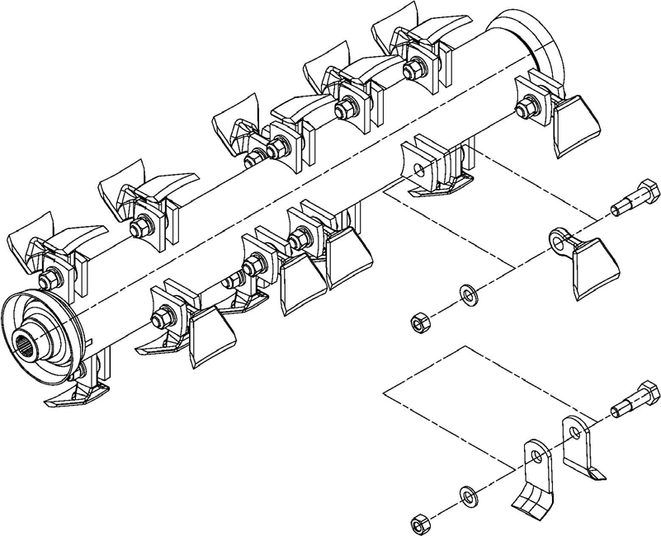
Fig. 7-1 Replacement shredder head tools

Personnel required: 1 SKILLED TECHNICIAN
Replace cutters which must have the same weight. A weight gap not higher than 5 grams is tolerable.
If weights are respected the replacement of all cutters does not determine any problem. If only one cutter must be replaced we recommend to replace also its diametrically opposite one. In this way the balance of the rotary tool is not altered.

DANGER !

Rotor maintenance is an extremely dangerous phase. Before introducing hands or tools into the shredder compartment you must:
  - Wait until the complete arrest of the rotor;
  - Place firmly the shredder on the ground;
  - Disengage the PTO, stop the engine and take off the ignition keys from the
board, remove the cardan shaft, wear gloves and clothes which are up to standard concerning accident.
After the tool replacement have been made, before starting the bush mower the operator has to make sure that all the screws are tightened.

Even one loosened screw may be seriously dangerous.

Machine demolition and recovery of reusable material

Bush mower arms are basically made of the following materials:
- Steel
- Cast iron
- Aluminum
- Copper
- Different plastic materials
- Mineral oil and grease

At the moment of demolition, all material must be divided in the six categories and disposed up-to-standard.
These materials are all reusable in order to obtain once more raw materials or reusable byproducts.

AM80.01.001 Base Assembly

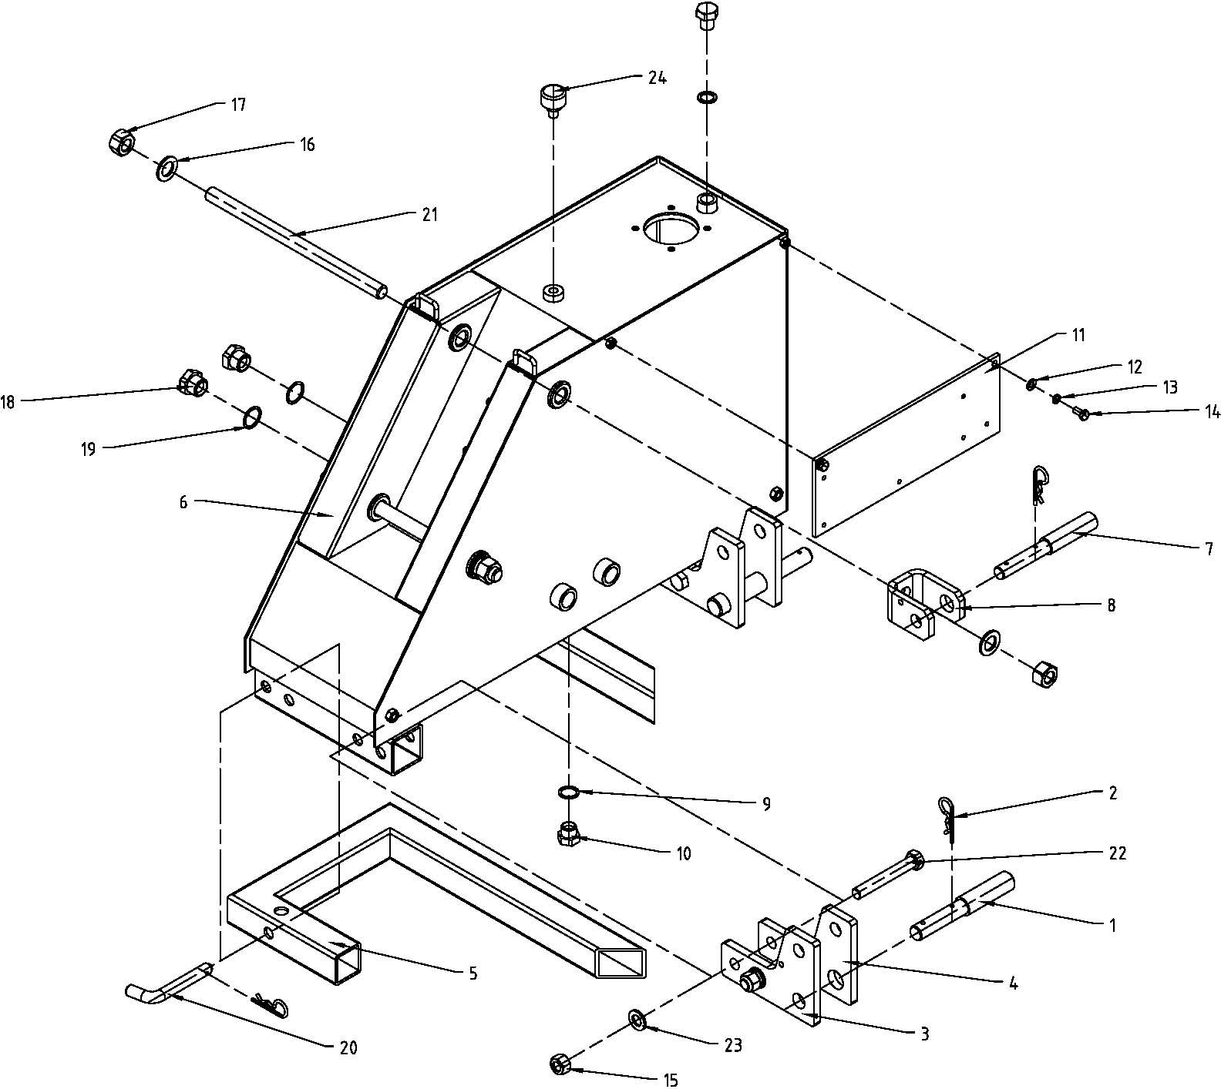

AM80.01.001 Base Assembly Parts List

REF | PART NUMBER | DESCRIPTION | 名称 | QTY
1 | AM80.01.101 | Pin shaft | 下悬挂销 | 2
2 | AM80.01.102 | Spring pin 4*72 | R 销 4*72 | 5
3 | AM80.01.103 | Suspension plate (R) | 下悬挂板（右） | 2
4 | AM80.01.104 | Suspension plate (L) | 下悬挂板（左） | 2
5 | AM80.01.011 | Base plate | 底座焊合件 | 2
6 | AM80.01.012 | Oil box | 油箱焊合件 | 1
7 | AM80.01.105 | Pin shaft | 上悬挂销 | 1
8 | AM80.01.106 | Bracket | 上悬挂座 | 1
9 | JB/T1002-1977 | Seal washer 18 | 密封垫圈 18 | 2
10 | JB/ZQ4451 | Plug M18x1.5 | 螺塞 M18x1.5 | 2
11 | AM80.01.108 | Valve seat | 阀座板 | 1
12 | GB/T97.1-2002 | Plain washer 8 | 垫圈 8 | 2
13 | GB/T93-1987 | Spring washer 8 | 垫圈 8 | 2
14 | GB/T5783-2000 | Bolt M8*16 | 螺 栓 M8*16 | 2
15 | GB/T889.1-2000 | Locking Nut M16 | 锁紧螺母M16 | 4
16 | GB/T97.1-2002 | Plain washer 20 | 垫圈 20 | 4
17 | GB/T889.1-2000 | Locking Nut M20 | 锁紧螺母M20 | 4
18 | AM80.01.109 | Plug M27x1.5 | 螺塞 M27x1.5 | 2
19 | JB/T1002-1977 | Seal washer 27 | 密封垫圈 27 | 2
20 | AM80.01.110 | Pin | 插销 | 2
21 | AM80.01.111 | Bolt pin | 双头螺纹销 | 2
22 | GB/T5782-2000 | Bolt M16*110 | 螺 栓 M16*110 | 4
23 | GB/T97.1-2002 | Plain washer 16 | 垫圈 16 | 4
24 | C-M12 | Air filter C-M12 | 空滤C-M12 | 1

AM80.02.001 Boom Assembly
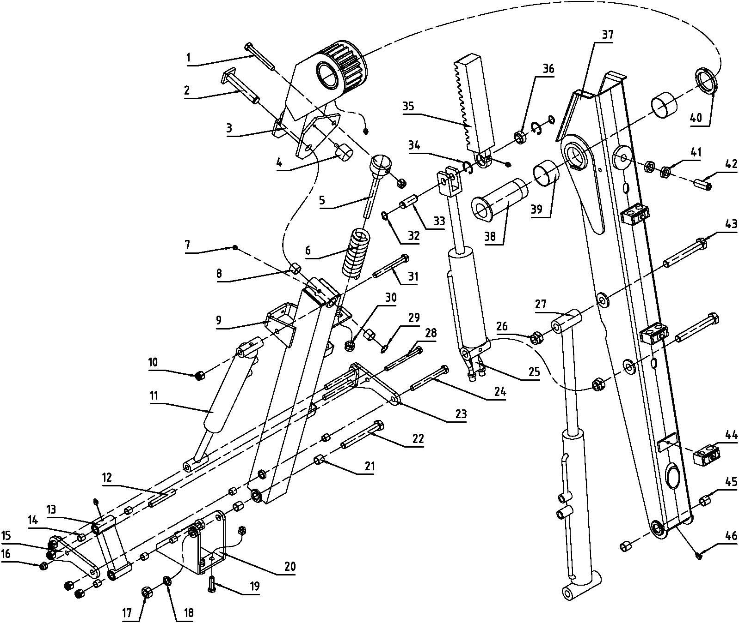

AM80.02.001 Boom Assembly Parts List

REF | PART NUMBER | DESCRIPTION | 名称 | QTY
1 | GB/T5782-2000 | Bolt M14x120 | 螺栓 M14x120 | 1
2 | AM80.02.013 | Front arm shaft | 摆臂销轴焊合件 | 1
3 | AM80.02.012 | Swing frame weldment | 摆座焊合件 | 1
4 | AM80.02.111 | Rubber cushion | 螺栓橡胶垫 | 1
5 | AM80.02.110 | Spring shaft | 弹簧销轴 | 1
6 | AM80.02.109 | Spring | 弹簧 | 1
7 | JB/T7940.1-1995 | Oil cup M8 | 油杯 M8 | 6
8 | SF-2 | Sleeve 22*26*20 | 衬套 22*26*20 | 2

9 | AM80.02.014 | Front arm weldment | 摆臂焊合件 | 1
10 | GB/T889.1-2000 | Locking Nut M14 | 锁紧螺母 M14 | 6
11 | AM80.02.107 | Front arm cylinder | 摆臂油缸 | 1
12 | AM80.02.108 | Steel collar | 连接套管 | 1
13 | AM80.02.017 | Link weldment | 内连接板焊合件 | 1
14 | SF-2 | Sleeve 14*18*15 | 衬套 14*18*15 | 6
15 | AM80.02.015 | Link-I | 外连接板焊合件一 | 1
16 | GB/T889.1-2000 | Locking Nut M12 | 锁紧螺母 M12 | 5
17 | GB/T6170-2000 | Nut M18 | 螺母 M18 | 1
18 | GB/T93-1987 | Spring washer 18 | 弹垫 18 | 1
19 | GB/T5783-2000 | Bolt M12x40 | 螺栓 M12x40 | 4
20 | AM80.02.018 | Hanging weldment | 连接座焊合件 | 1
21 | SF-2 | Sleeve 18*22*20 | 衬套 18*22*20 | 2
22 | GB/T5782-2000 | Bolt M18x140 | 螺栓 M18x140 | 1
23 | AM80.02.016 | Link-II | 外连接板焊合件二 | 1
24 | GB/T5782-2000 | Bolt M14x130 | 螺栓 M14x130 | 4
25 | AM80.02.102 | Rack cylinder | 齿条油缸 | 1
26 | GB/T889.1-2000 | Locking Nut M20 | 锁紧螺母 M20 | 2
27 | AM80.02.101 | Boom cylinder | 悬臂油缸 | 1
28 | GB/T5782-2000 | Bolt M12x130 | 螺栓 M12x130 | 1
29 | GB/T894.1-1986 | Circlip 22 | 轴用挡圈 22 | 1
30 | GB/T889.1-2000 | Locking Nut M16 | 锁紧螺母 M16 | 1
31 | GB/T5782-2000 | Bolt M14x100 | 螺栓 M14x100 | 1
32 | GB/T894.1-1986 | Circlip 20 | 轴用挡圈 20 | 2
33 | AM80.02.103 | Rack shaft | 齿条销轴 | 1
34 | GB/T893.1-1986 | Circlip 35 | 孔用挡圈 35 | 2
35 | AM80.02.104 | Rack | 齿条 | 1
36 | GB/T9163-1994 | Bearing GEEW20ES | 向心关节轴承 GEEW20ES | 1
37 | AM80.02.011 | Boom weldment | 悬臂焊合件 | 1
38 | AM80.02.106 | Swing shaft | 摆座销轴 | 1
39 | SF-2 | Sleeve 60*64*40 | 衬套 60*64*40 | 2
40 | GB/T810-1988 | Small round Nut M60x2 | 小圆螺母 M60x2 | 1
41 | GB/T6172.1-2000 | Thin Nut M20 | 六角薄螺母 M20 | 2
42 | AM80.02.105 | Set Screw | 自制紧定螺钉 | 1
43 | GB/T5782-2000 | Bolt M20x140 | 螺栓 M20x140 | 2
44 | AM80.02.019 | Pipe clamp | 管夹组合件 | 5
45 | SF-2 | Sleeve 20*24*20 | 衬套 20*24*20 | 2
46 | JB/T7940.2-1995 | Oil cup 90°M8 | 油杯 90°M8 | 1

AM80.03.001 Cover Assembly

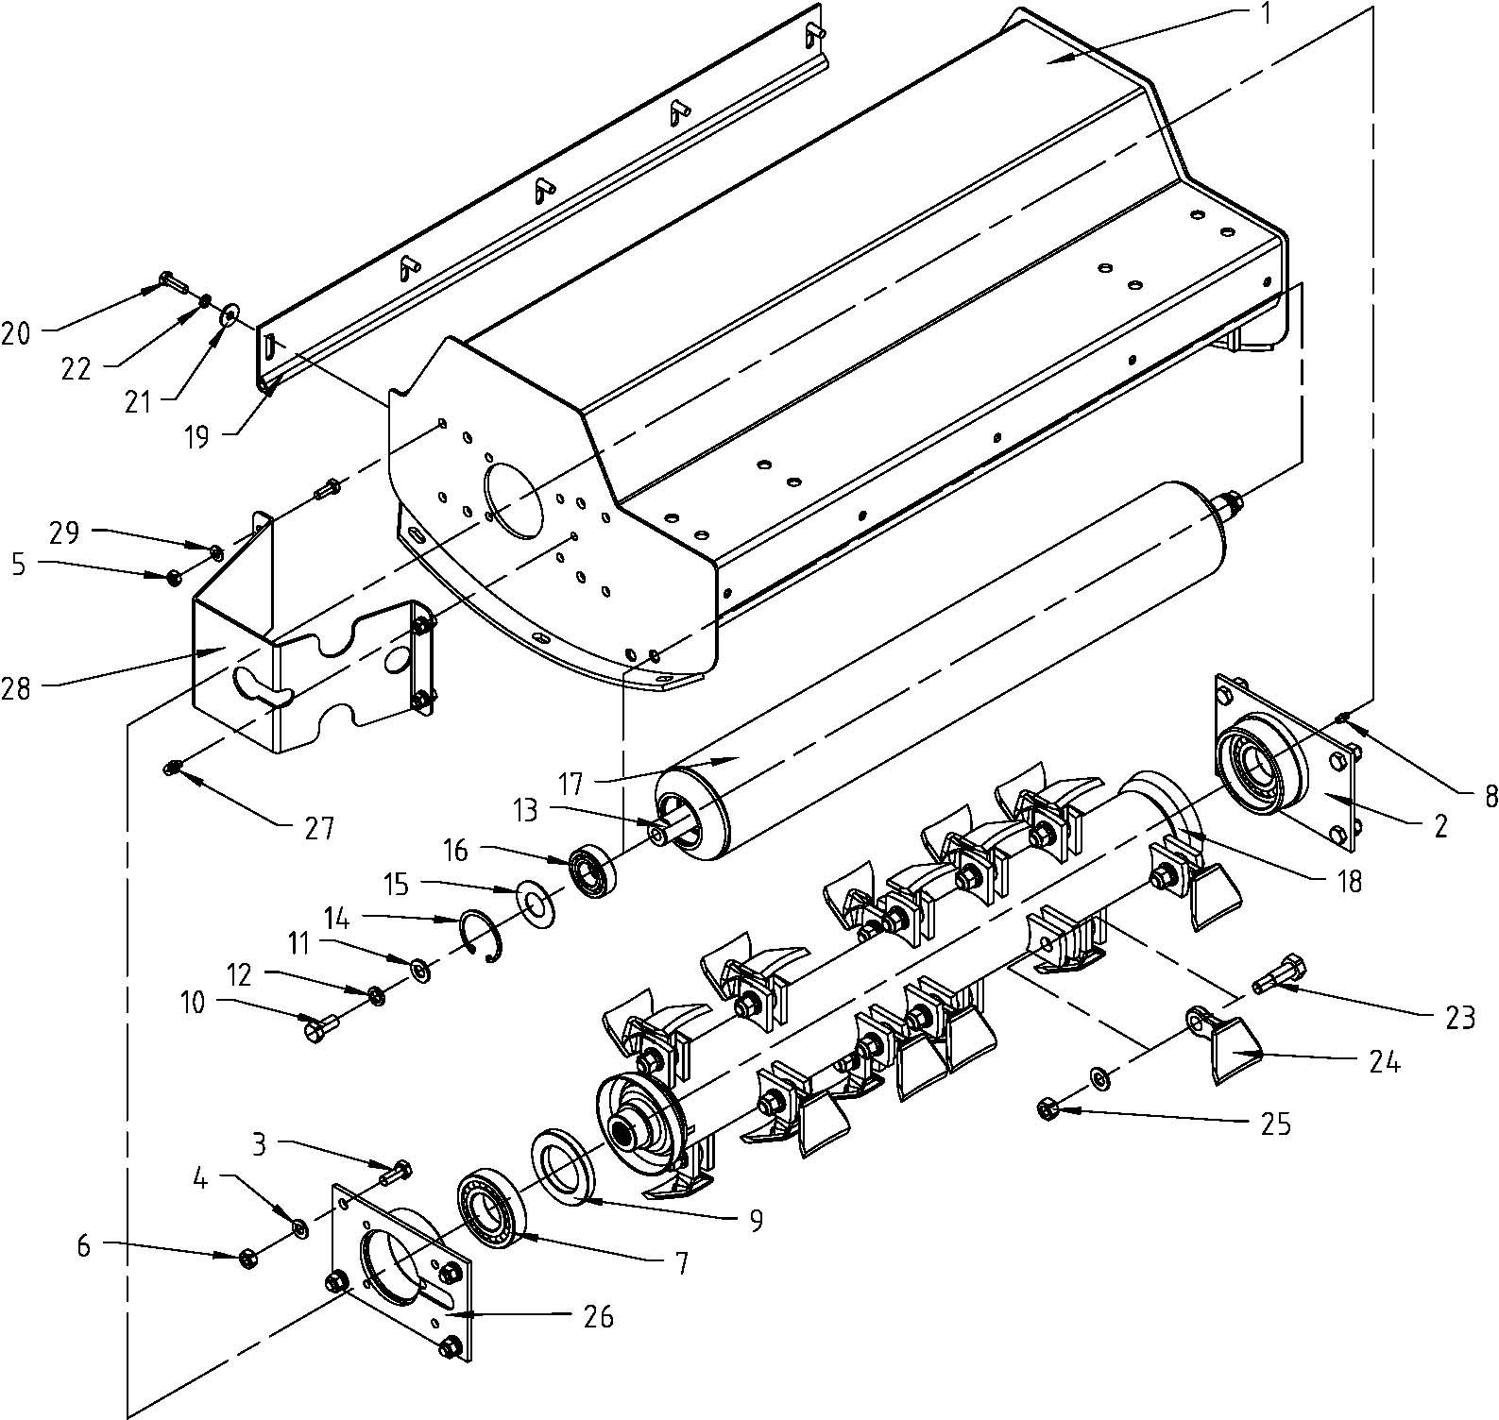

AM80.03.001 Cover Assembly Parts List

REF | PART NUMBER | DESCRIPTION | 名称 | QTY
1 | AM80.03.011 | Cover | 机罩焊合件 | 1
2 | AM80.03.012 | Base plate (R) | 右轴承座焊合件 | 1
3 | GB/T5783-2000 | Bolt M10*25 | 螺栓 M10*25 | 8
4 | GB/T97.1-2002 | Plain washer 10 | 垫圈 10 | 8
5 | GB/T889.1-2000 | Locking Nut M8 | 锁紧螺母M8 | 4
6 | GB/T889.1-2000 | Locking Nut M10 | 锁紧螺母M10 | 8
7 | GB/T281-1994 | Bearing 1208 | 调心球轴承 1208 | 2
8 | JB/T7940.1-1995 | Oil cup M8 | 油 杯 M8 | 1
9 | GB/T13871-1992 | Oil seal FB50*80*10 | 油 封 FB50*80*10 | 2
10 | GB/T5783-2000 | Bolt M12*25 | 螺栓 M12*25 | 2
11 | GB/T97.1-2002 | Plain washer 12 | 垫圈 12 | 18
12 | GB/T93-1987 | Spring washer 12 | 垫圈 12 | 2
13 | AM80.03.101 | Roller Shaft | 滚筒轴 | 1
14 | GB/T893.1-1986 | Circlip 52 | 孔用挡圈 52 | 2
15 | AM80.03.102 | Washer | 垫圈 | 2
16 | GB/T276-1994 | Bearing 6205-2RS | 双密封圈轴承 6205-2RS | 2
17 | AM80.03.013 | Roller | 滚筒焊合件 | 1
18 | AM80.03.014 | Blade axle | 刀轴焊合件 | 1
19 | AM80.03.103 | Fender | 挡板 | 1
20 | GB/T5783-2000 | Bolt M8*20 | 螺栓 M8*20 | 9
21 | GB/T96.1-2002 | Plain washer 8 | 大垫圈 8 | 5
22 | GB/T93-1987 | Spring washer 8 | 垫圈 8 | 5
23 | GB/T5782-2000 | Bolt M12*50 | 螺栓 M12*50 | 16
24 | AM80.03.105 | Blade | 小锄 | 16
25 | GB/T889.1-2000 | Locking Nut M12 | 锁紧螺母M12 | 16
26 | AM80.03.015 | Base plate (L) | 左轴承座焊合件 | 1
27 | JB/T7940.2-1995 | Oil cup 90°M8 | 油杯 90°M8 | 1
28 | AM80.03.106 | Motor shade | 马达罩 | 1
29 | GB/T97.1-2002 | Plain washer 8 | 垫圈 8 | 4

AM80.04.001 Hydraulic System Assembly

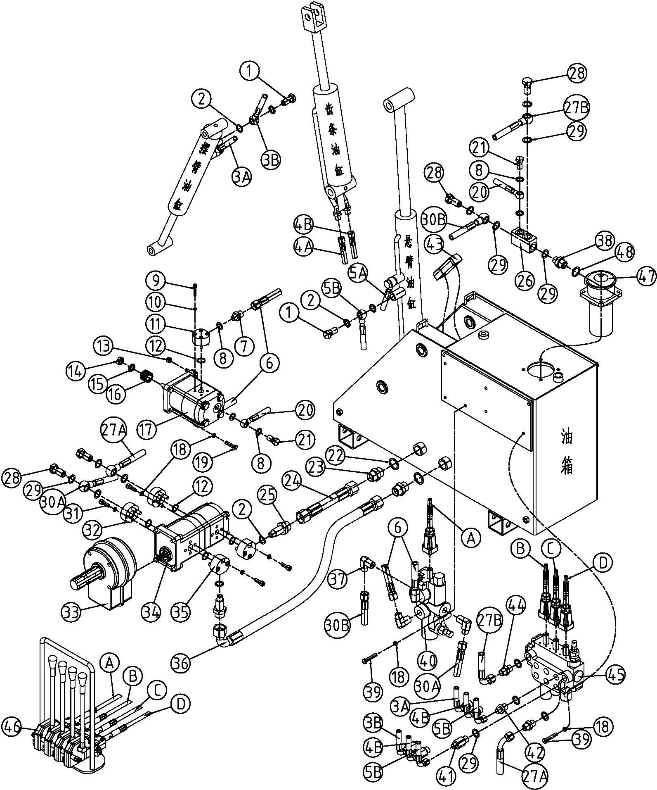

AM80.04.001 Hydraulic System Assembly Parts List
REF | PART NUMBER | DESCRIPTION | 名称 | QTY
1 | BH5.60.110 | Hollow bolt 16 | 空心螺栓 16 | 4
2 | JB/ZQ4454 | Gasket 16 | 密封垫 16 | 10
3 | AM80.04.011 | Hose, Valve- Front arm cylinder | 三联阀-摆臂油缸油管 | 2
4 | AM80.04.012 | Hose, Valve- Rack cylinder | 三联阀-齿条油缸油管 | 2
5 | AM80.04.013 | Hose, Valve- Boom cylinder | 三联阀-悬臂油缸油管 | 2
6 | AM80.04.014 | Hose, Control Valve- Motor | 换向阀-马达油管 | 2
7 | AM80.04.101 | Adapter 14-18, Motor | 马达接头 14-18 | 2
8 | JB/ZQ4454 | Gasket 14 | 密封垫 14 | 6
9 | GB/T70-85 | Bolt M6x30 | 内六角螺钉 M6x30 | 8
10 | GB/T93-1987 | Spring washer 6 | 弹垫圈 6 | 8
11 | AM80.04.102 | Flange, Motor | 马达法兰 | 2
12 | GB3452.1 | O-ring 8x23x2.5 | O 形圈 18x23x2.5 | 6
13 | GB/T889.1-2000 | Locking Nut M8 | 锁紧螺母 M8 | 2
14 | GB/T6173-2000 | Nut M14*1.5 | 薄螺母 M14*1.5 | 1
15 | GB/T93-1987 | Spring washer 14 | 弹垫圈 14 | 1
16 | AM80.04.103 | Spline housing, Motor | 马达花键套 | 1
17 | CMW-F210-CFZS | Motor | 齿轮马达（双向、泄油） | 6
18 | GB/T93-1987 | Spring washer 8 | 弹垫圈 8 | 24
19 | GB/T5783-2000 | Bolt M8*35 | 螺栓 M8*35 | 4
20 | AM80.04.015 | Hose, Motor- Oil filter | 马达-滤油器油管 | 1
21 | AM80.04.104 | Hollow bolt 14 | 空心螺栓 14 | 2
22 | JB/ZQ4454 | Gasket 27 | 密封垫 27 | 2
23 | AM80.04.105 | Adapter 27-27, Oil tank | 油箱出口接头 27-27 | 2
24 | AM80.04.016 | Hose, Oil tank- Gear pump(F306) | 油箱-后泵油管 | 1
25 | AM80.04.106 | Adapter 16-27, Gear pump(in) | 泵进油接头 16-27 | 2
26 | AM80.04.107 | Adapter, Oil filter | 滤油器四通 | 1
27 | AM80.04.017 | Hose, Valve | 三联阀油管 | 2
28 | BH5.60.101 | Hollow bolt 18 | 空心螺栓 18 | 4
29 | JB/ZQ4454 | Gasket 18 | 密封垫 18 | 17
30 | AM80.04.018 | Hose, Control Valve | 换向阀油管 | 2
31 | GB/T70-85 | Bolt M8x25 | 内六角螺钉 M8x25 | 16
32 | AM80.04.108 | Flange, Gear pump(out) | 泵出油法兰 | 2
33 | PG-3 | Gearbox | 齿轮箱 | 1
34 | CBWL-F320/F306-CFH | Gear pump | 齿轮泵 | 1
35 | AM80.04.109 | Flange, Gear pump(in) | 泵进油法兰 | 2

36 | AM80.04.019 | Hose, Oil tank- Gear pump(F320) | 油箱-前泵油管 | 1
37 | AM80.04.110 | Elbow Adapter, Control Valve | 换向阀直角接头 | 4
38 | BH5.60.107 | Adapter 22-18 | 接头 22-18 | 1
39 | GB/T5782-2000 | Bolt M8*45 | 螺栓 M8*45 | 6
40 | X-20 | Control Valve, Single Spool | 换向阀 | 1
41 | AM80.04.111 | Long Adapter 14-18, Valve | 三联阀长接头 14-18 | 3
42 | AM80.04.112 | Short Adapter 14-18, Valve | 三联阀短接头 14-18 | 3
43 | YWZ-76 | Oil level indicators with thermometer | 液位液温计 | 1
44 | AM80.04.113 | Adapter 18-18, Valve | 三联阀接头 18-18 | 2
45 | ZD20-E15L-T/OOQ | Valve, ZD20-E15L-T/OOQ | 三联阀(不带压力输出口) | 1
46 | AM80.05.001 | Push and pull cable operator Assembly | 推拉索操纵器总成 | 1
47 | RFA-25 | Oil filter | 滤油器 | 1
48 | JB/ZQ4454 | Gasket 22 | 密封垫 22 | 1

AM80.05.001 Push and pull cable operator Assembly
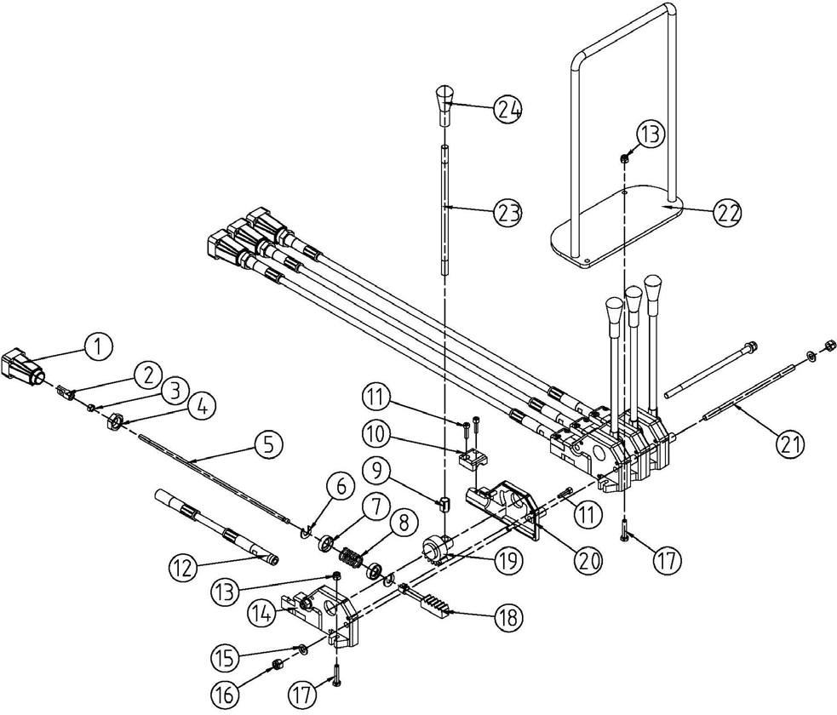

AM80.05.001 Push and pull cable operator Assembly Parts List
REF | PART NUMBER | DESCRIPTION | 名称 | QTY
1 | AM80.05.102 | Spindle guard | 连接座套 | 4
2 | AM80.05.101 | Adapter | 连接头 | 4
3 | GB/T6170-2000 | Nut M6 | 螺母 M6 | 4
4 | GB/T6173-2000 | Nut M16*1.5 | 薄螺母 M16*1.5 | 4
5 | AM80.05.012 | Soft shaft | 软轴 | 4
6 | AM80.05.106 | Plain washer | 垫圈 | 8
7 | AM80.05.107 | Washer | 挡圈 | 8
8 | AM80.05.108 | Spring | 压簧 | 4
9 | AM80.05.111 | Nut | 长螺母 | 4
10 | AM80.05.103 | Cover | 小盖 | 4
11 | GB/T70-85 | Bolt M5x20 | 内六角螺钉 M5x20 | 20
12 | AM80.05.011 | Hose | 软轴管 | 4
13 | GB/T889.1-2000 | Locking Nut M6 | 锁紧螺母 M6 | 2
14 | AM80.05.104 | Shell, Left | 左壳体 | 4
15 | GB/T97.1-2002 | Plain washer 8 | 垫圈 8 | 4
16 | GB/T889.1-2000 | Locking Nut M8 | 锁紧螺母 M8 | 4
17 | GB/T5783-2000 | Bolt M6*30 | 螺栓 M6*30 | 2
18 | AM80.05.109 | Rack | 齿条 | 4
19 | AM80.05.110 | Gear | 齿轮 | 4
20 | AM80.05.105 | Shell, Right | 右壳体 | 4
21 | AM80.05.114 | Pin | 连接杆 | 2
22 | AM80.05.013 | Bottom plate weldment | 座板焊合件 | 1
23 | AM80.05.112 | Handle | 手柄杆 | 4
24 | AM80.05.113 | Plastic handle | 手柄套 | 4

