Rotary Drum Scrubber

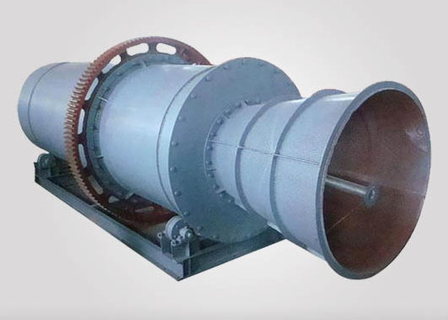
When the slime content of raw ore is over 40% and most of clay is sticky, the ordinary washer is difficult to effectively and fully disperse the clay, resulting in complicated washing process and increased cost. At this time, a more efficient ore washer--rotary scrubber becomes an indispensable equipment. The rotary scrubber uses a rotating cylinder and internal scraper, water, as well as natural pebbles and rocks in the material, to disintegrate clay, lumps and soft oxides.

Depending on the user's needs, there are different transmission modes and cylinder lining types for the user to choose:
- The transmission mode can be gear transmission or tire transmission
- The cylinder liner can be non-liner, rubber liner or polyurethane liner
- If there's no specific instructions before the purchase, we will provide gear transmission and non-liner
Rotary drum scrubber diagram
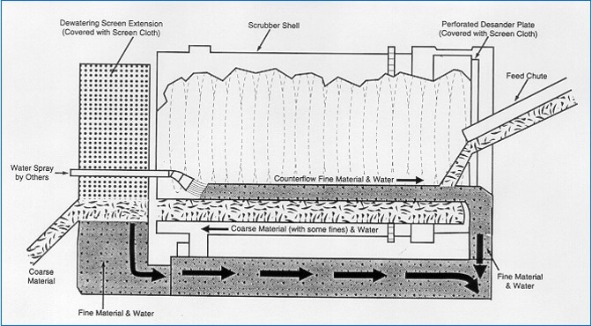

Advantages and features
- Large processing capacity, strong clay washing ability
- The long cylinder makes longer washing time of material, let it completely dispersed
- Stable and reliable running without personnel operation
- The cylinder is made of thickened steel plate to ensure the strength and rigidity

- High pressure spray water flushes the inner wall of the cylinder
- The maximum feed size is 230mm

Thickened Cylinder  Strong rigidity, impact resistance and long service life | Supporting Mode of Cylinder  Steel roller or tire are available, high quality, long service life
No lining, Steel Lining or Rubber Lining are Available  The unique lifting plate design can continuously drop materials, accelerate clay loosening and  achieve good washing effect | Steel Screen or PU Screen are Available  High screening efficiency, wear resistance, easy to replace

Gear Drive Mode Available  It adopts high quality gear, wear-resistant tooth surface, small wear and long service life | Tire Drive Mode Available  It adopts heavy duty solid rubber tire, high load capacity and wear resistance

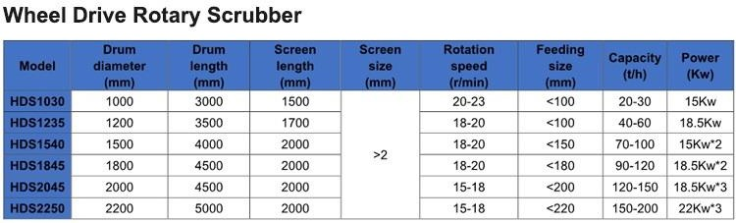
Main Technical Parameters

Model | Drum Size (m) | Screen size (mm) | Feeding size (mm) | Water pressure  (Mpa) | Every ton of ore water required  (m3/t) | Capacity (t/h) | Rotation speed (r/min) | Power (Kw) | Weight (Kg)
RXT1030 | Φ1.0×3.0 | ≥5 | ≤100 | 0.4-0.5 | 1.5-4 | 20-30 | 25-28 | 15 | 4800
RXT1230 | Φ1.2×3.0 | ≥5 | ≤100 | 0.4-0.5 | 1.5-4 | 30-50 | 23-25 | 18.5 | 5800
RXT1545 | Φ1.5×4.5 | ≥5 | ≤150 | 0.4-0.5 | 1.5-4 | 50-100 | 18-22 | 30 | 6900
RXT1560 | Φ1.5×6.0 | ≥5 | ≤150 | 0.4-0.5 | 1.5-4 | 70-120 | 18-22 | 37 | 8300
RXT1845 | Φ1.8×4.5 | ≥5 | ≤170 | 0.4-0.5 | 1.5-4 | 90-130 | 20-21 | 45 | 11800
RXT1860 | Φ1.8×6.0 | ≥5 | ≤170 | 0.4-0.5 | 1.5-4 | 100-140 | 20-21 | 45 | 12800
RXT2060 | Φ2.0×6.0 | ≥5 | ≤210 | 0.4-0.5 | 1.5-4 | 120-160 | 19-20 | 55 | 14800
RXT2265 | Φ2.2×6.5 | ≥5 | ≤230 | 0.4-0.5 | 1.5-4 | 160-200 | 19-20 | 55 | 16500

