Product introduction
Spiral classifier is widely used for ore distribution with ball mill to formed closed-circuit circulation in mineral processing plant, ore and slime classification in gravity separation plant, or particle size classification in metal ore separation process, and dewatering or desliming in ore washing process. According to the number of spirals, it can be divided into single spiral classifier and double screw classifier. According to liquid level the spiral classifier can be divided into high weir type and submersion (or sinking) type. The overflow weir of high weir classifier is higher than the center of the spiral axis at lower end, but lower than the upper edge of the spiral blade. The length of liquid level is short, so its surface can directly get the stirring effect by the spiral blade, therefore it suitable for coarse particle classification, usually the classified particle size is over 0.15mm. The spiral blade of submersion classifier at lower end completely submerged under the liquid level, the classifying area is big and smooth, suitable for fine particle classification, which is less 0.15mm. Its overflow productivity is bigger.
Spiral classifier working principle
The motor drives the spiral axis to rotating through the reducer, the pulp from ball mill enter into the spiral classifier from one side at front-end, at the front-end of spiral classifier forms a deep slurry pool, inside the spiral blade keep rotating let the pulp gets enough agitating, that causes the fine particles flow on the top of water, and cross the overflow weir and go into the discharge chute, but the coarse particles sink to the bottom of tank, and lifted up by rotary spiral blade go to the end of spiral classifier, from discharge chute return to the ball mill for re-grinding.
Single spiral classifier diagram
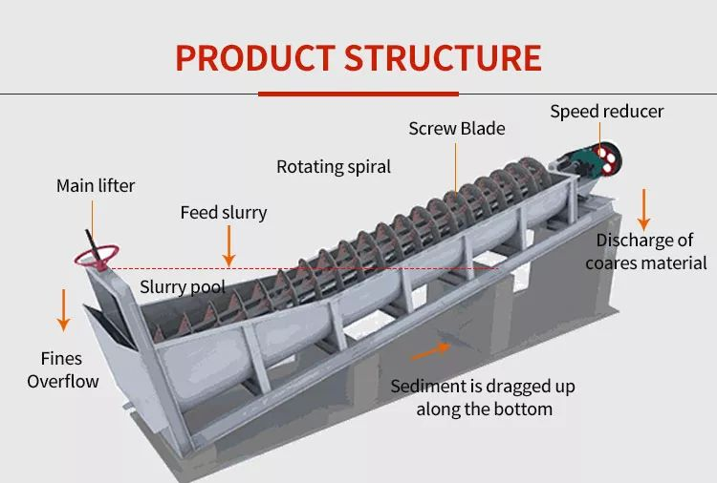
Advantages and features
1. Simple structure, stable and reliable running, easy operation;
2. The head of shaft is cast iron, it’s durable;
3. Easy powder content control, and the content of 0.00--0.75mm powder can be adjusted between 2% and 15%;
4. Replaceable casting blade, low maintenance rate;
5. The base adopts channel steel, and the tank is made of thick steel plate, good quality and high wear resistance.
