Conveyor
User Manual
SAFETY AND OPERATION INSTRUCTIONS

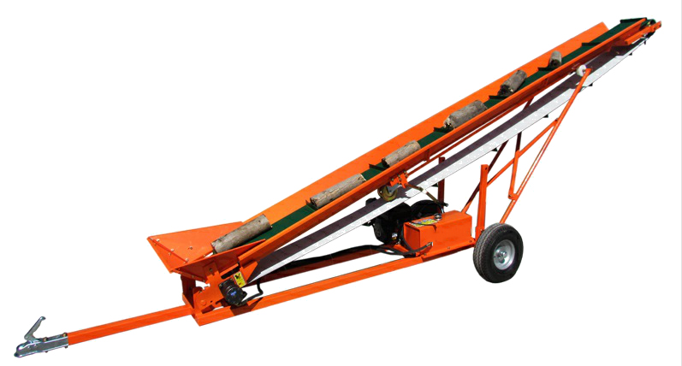

IMPORTANT: Read safety rules and instructions carefully before operating equipment.

CAUTION
BEFORE, DURING AND AFTER OPERATION
—Before using, make sure that the main body of the engine is added lubricating oil, and the engine fuel tank adds gasoline.

—Besides, there is a hydraulic tank beside the engine, so we need to inject a certain amount of hydraulic oil to ensure that the oil level is higher tha n the oil outlet.

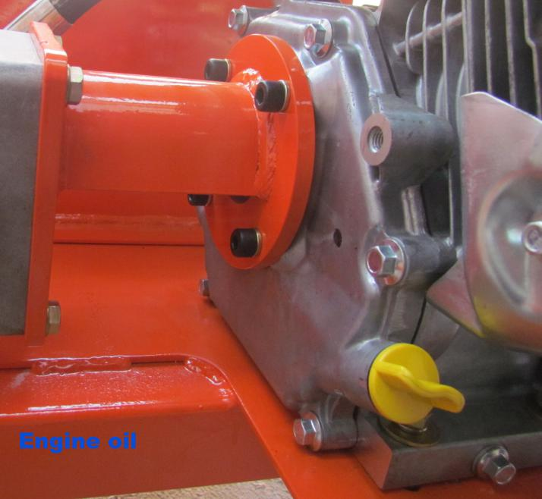

SAFETY
• Wear safety equipment when operating conveyor
• Goggles
• Hard hat
• Gloves
• Etc.
• Never operate conveyor under influence of drugs or
alcohol.
• Keep area under conveyor clear of obstructions
• Do not allow kids to operate or play around conveyor
• Do not stand under conveyor while it is running
• Do not put hands on running belts or chains
• Never run without guards in place

TOWING
• Requires a 2 inch ball for towing
• Make sure conveyor is empty no debris or material
that may fall off when towing
• Use safety chains while traveling
• Use safety flags to properly mark conveyor while traveling
on roads or highways
• Raise the conveyor bed by manual winch to a height higher,
•This conveyor is only suitable for yard or close to yard so towing great distances are not recommended

BEFORE OPERATION
• Have conveyor on level ground
• Check gas and oil levels
• Be sure conveyor is stable
• Block wheels to prevent rolling
• Make sure area under conveyor is clear of any
obstructions
• Lower support legs and secure with locking bolts
• Look over conveyor to assure everything is in proper
working order.
• Make sure belt or chain is clear for easier start up.
MAINTENANCE AND ADJUSTMENTS
• Do not over grease the bearings
• Grease bearings with single pump after 40 hours of use
• Keep sliders greased
• Keep pivot point at height adjustment greased
• Engine - See engine manual

WARRANTY
• Motor - 1 years
• Conveyor - 6 months against manufacturer defects
•Warranty is for 6 months from purchase date and is for replacement parts only (no labour charges apply ) and it is a back to our depot warranty which means if you did have a failure which we could not remedy on site you would need to return to our depot where we would repair or replace the conveyor if needed

ADJUSTING BELT/CHAINOPERATING CONVEYOR
• Set conveyor at desired speed
• Make sure conveyor is running properly before loading
• While conveyor is running be sure there is nothing
underneath the drop point.
• Depending on speed you are loading the conveyor
determines the speed you set the belt or chain.
• Be sure not to block opening of the conveyor

HEIGHT ADJUSTMENT
• To use manual winch to adjust conveyor height, see follow picture.
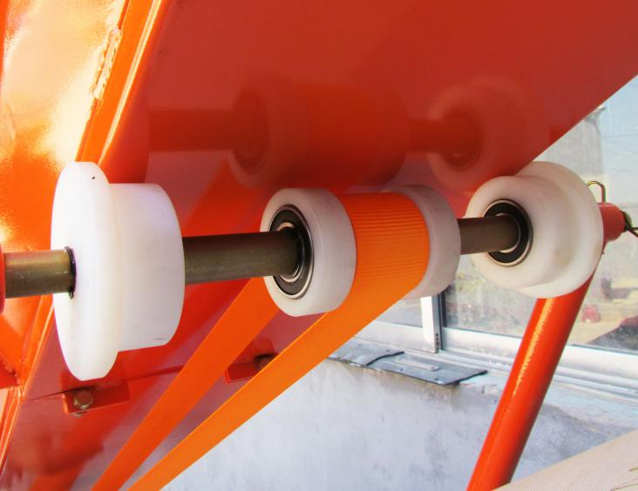
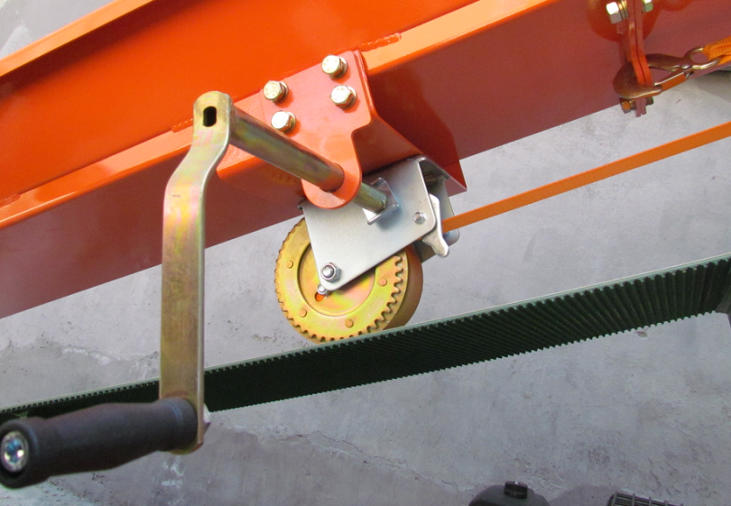

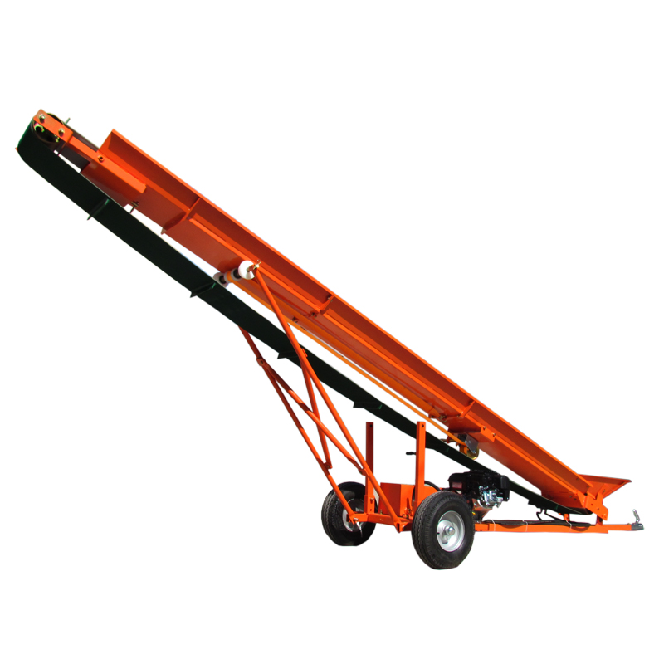
Assemble:
According follow drawing to finish assembling conveyor.

First step:
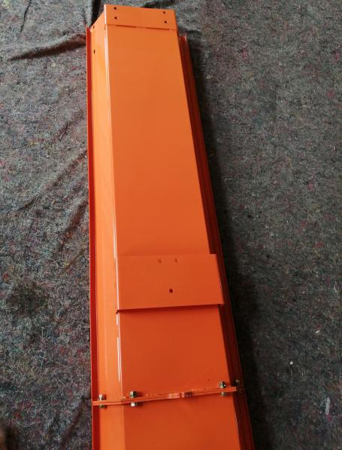

Assembly conveyor transport

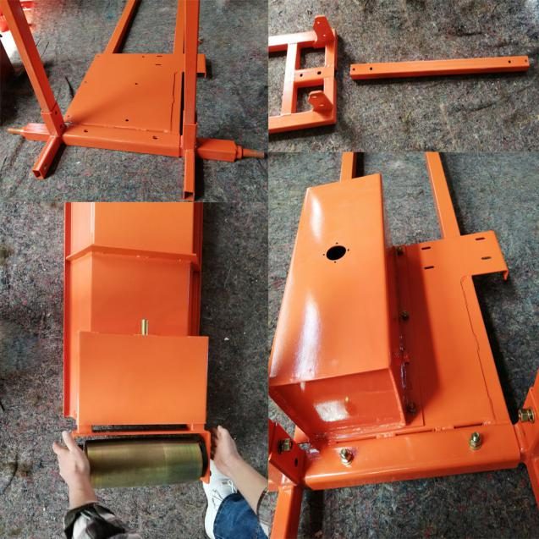
Second step:

Assembly frame parts
Third step:
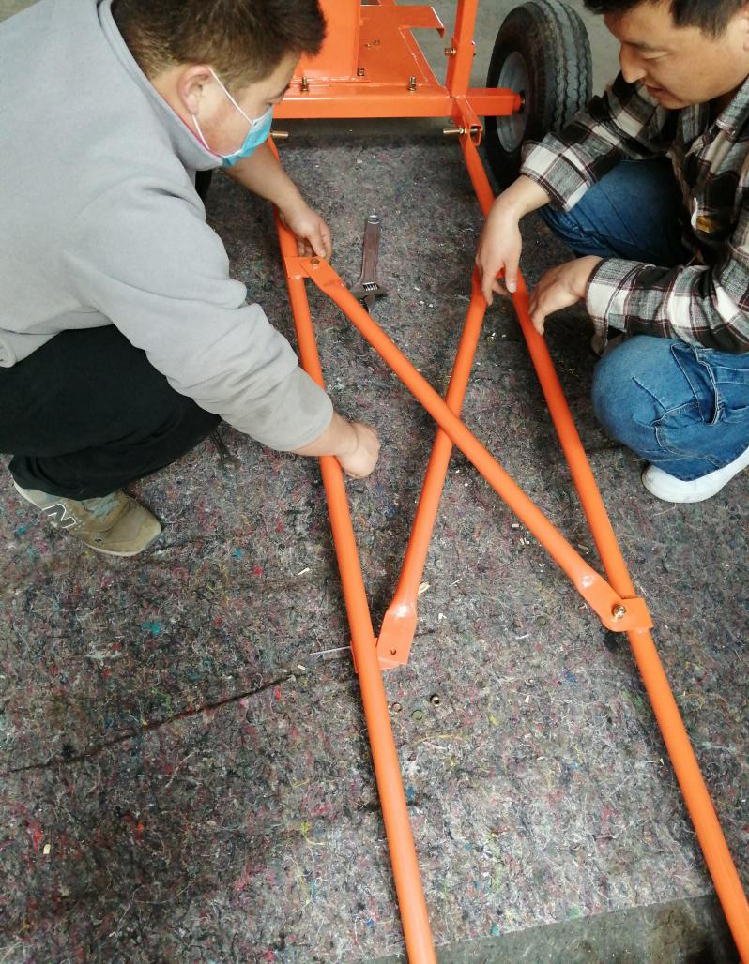

Assembly bar

Fourth step:
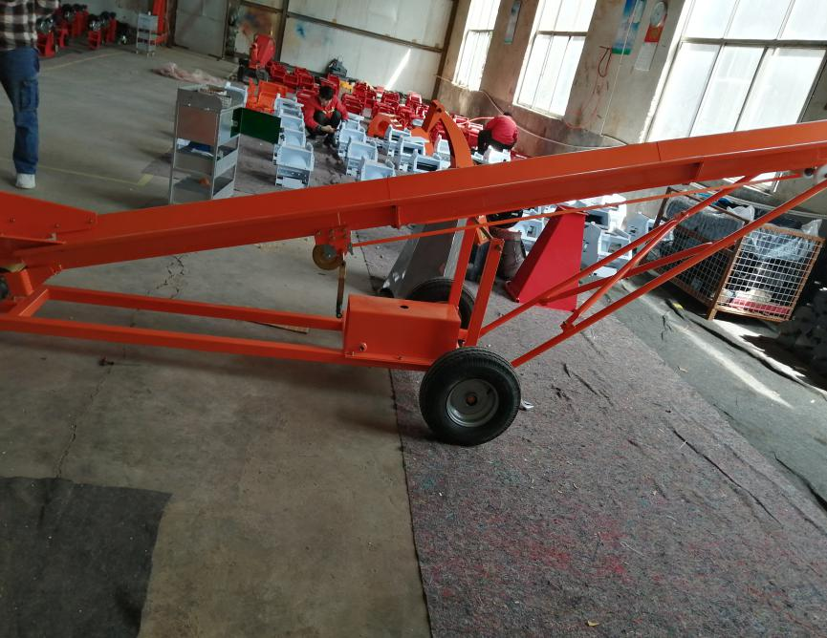

ssembly wheels/belt

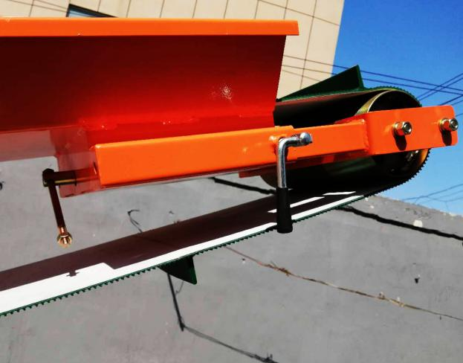
• How do you adjust tracking
• If belt or chain loosens adjust from
top of conveyor (do not adjust from
bottom)
• Use ¼ turn at a time until belt or
chain is realigned.

• To lower conveyor take manual winch handle and turn slowly.
• Note: Turning release valve too quickly could cause
conveyor to drop too fast and may cause injury.

TECHNICAL SPECIFICATIONS
Engine brand | Briggs & Stratton
Horse power | 6.5HP Petrol 4 Stroke Engine
Engine start | Recoil
Max.Height | 2.8M
Belt Width/thickness | 300mm/5mm
Belt Travel Speed | 0.7m/s
Hydraulic Oil Tank Capacity | 12L
Hydraulic driven Pump | 5.3 Gallon Per Minute
Tire | 5.7-8
Height adjust | Use Manual winch adjust.
Net Weight | 285kg
Package Size | 2250*600*730mm
Color | Orange

