Operation Manual
Mobile Branch Grinder
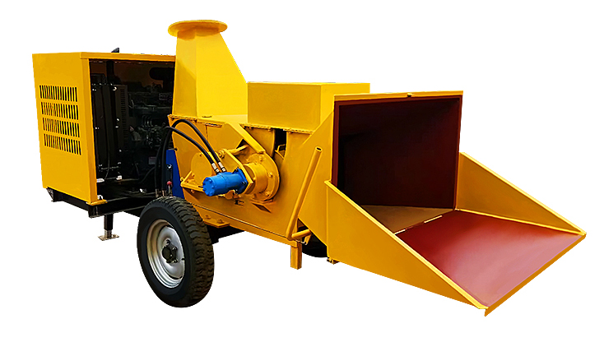

Please go through the operation manual and the specifications before operating or maintaining the product.
Chapter 1: Safety Rules……………………………………….1  Labels………………………………………………………….2  Keep Safe Yourself and People around You………………..…3  Safety of Kids and Pets……………………………………….4  Safety of Fuel, Power and Machinery…………………………4  General Safety………………………………………………….5  Precautions for Users…………………………………….…….5  Chapter 2: How to Set the Mobile Branch Grinder…………….6  Operation Units and Functions of the Product………………….6  Specifications and Description………………………………….8  How to Add Engine Oil and Fuel of the Product……………….8  Chapter 3: How to Operate the Mobile Branch Grinder………10  Precautions before Starting the Engine………………………..10  Processing Materials………………………………………..…10  Start the Engine………………………………………..……….11  Turn off the Engine…. …………………………………………11  Precautions during Operation……………………………….….12  Chapter 4: Maintenance of the Mobile Branch Grinder………..13  Regular Maintenance Checklist…………………………………13  Movable Cutter grinding…………………………………………14  Chapter 5: Troubleshooting………………………………………15  Chapter 6: Basic Operation Skills and Precautions………………17 | Steps of Operation Key Points and Precautions  - Pull up and brake - Pull up the branch grinder at the worksite and stop it on flat ground, put down the hand-operated landing leg and make sure the branch grinder is reliably parked; - Do not proceed with following steps unless it is confirmed that the branch grinder is reliably parked and braked.  - Check abnormalities of the machine - Check whether the machine has oil leakage or penetration; - Check whether the handle of movable parts work reliably; - Check whether pipelines and circuits are good; - Check whether the discharging port are placed in correct direction (do not point at any person).  - Check the oil level and add oil (if initial use) - Add engine oil (diesel engine oil CD-4) until reaching the middle place of the dipstick; - Add diesel oil (subject to working hours, do not add too much) but not exceed the filter of the oil filler; - Add hydraulic oil (until reach the middle place of the dipstick). No. 46 hydraulic oil, add 70% to the fuel tank, with a scale on it  - Start the engine - Start the engine (see Chapter 3 for details) - Throttle up the engine slowly and turn the engine control handle to the maximum (can be adjusted based on actual operation experience);  - Open the feed bucket and operate the joystick - Open the forwarding bucket; - Operate the feed control handle downward until it doesn’t move, which means the handle is fixed and feeding operations can be conducted; - Operate the feed control handle to the mid-place until being fixed and the feed roller stops working; - Operate the feed control handle upward until being fixed, the feed roller then turns reversely to discharge.  - Feeding speed control and operation skills - The machine starts chipping after the hydraulic system runs normally; - More then one branches can be fed if small branches less than 50mm, pull out the branches and re-feed if get stuck; - Feed one by one if branch bigger than 50mm; if timber diameter bigger than 100mm, operate the feed joystick by hand and follow the principle of “repeated feed and stop, multiple-segment feed”.  - Stop operating - Stop running of the feed roller and turn off the engine after the end of grinding. - Remove wood chips and impurities at the intake of the machine and close the bucket after the engine stops totally; - Before towing away the machine, take up the hand-operated jack and landing leg, fold the leg by 90º and protect it with the safety pin. Hinge the machine to the trailer and move the grinder to the next worksite.  Reverse if arrow up  Stop feeding if arrow in the middle  Feed if arrow down  Fig 5 Sketch map of the joystick
Checklist for Troubleshooting  Fault Possible Reason  The cutter runs slowly - The engine runs too slowly, which results in the belt slipping, please throttle up more on the engine; - Check whether the belt is loose or damaged; replace the belt; - Check whether the blade is damaged or worn out, replace the blade  The belt slips - Whether the belt pulley has notches? - The belt is loose, replace the belt. - The belt pulleys are not aligned good (not on the same plane)  Overheat of the engine The belt is burnt The cutter doesn’t run - Stop the engine immediately; - Rotate the cutter roller to check whether it runs flexibly; - Check whether the transmission belt is loose; - Remove residues in the cutting chamber and make clean the discharging bucket.  The machine vibrates abnormally - Check whether the cutter blade has damage; - Check whether all the bolts are fastened reliably; - Check whether the bearings are damaged.  The wood swings sharpy when grinding - The cutter blade is blunt and shall be replaced; - Fault of the carrier roller under the press roller, shall be replaced; - Check the speed of the engine which shall work at full speed.  Slow feeding - The cutter blade is blunt and shall be replaced. - Fault of the carrier roller under the press roller, shall be replaced; - Check the speed of the engine which shall work at full speed.  The motor runs but the cutter doesn’t run - The belt is loose; the transmission belt shall be tensioned;  The tyre runs too much on the left or on the right side when walking - Check the tyre pressure and make it meets related requirements. |  | Danger! failure to comply with these rules will lead to severe injuries or even death.  Warning! Do not do these things, or very sever injuries or even death can be caused!  Attention! Do avoid dangerous conditions, or slight or moderate injuries will be caused!  Attention! Failure to comply with these rules will result in machine or property loss.  - Before using this mobile branch grinder, please read carefully the safety specifications and the operation manual and get familiar with the rules of operation and maintenance so that to guarantee the work status and good performance of the machine;  - Check thoroughly the place you will work and do remove impurities as much as possible. Check the oil pipeline, power line, and electric control system and keep away from them. If such things are caught by the machine unexpectedly, the machine will be damaged.  - This is a high-power machine and all the movable parts run at high speed. Make sure you have dress up correctly and safety measures have been taken before operating, so that to avoid or minimize the risk of getting injured.  - Improper operation may get the operate being caught by the feed port or the discharging port of the machine and finally result in personal injury.  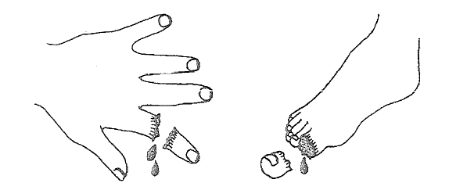
This mobile branch grinder carries following labels as the reminder for correct and safety use of the machine. The follows are labels for the operation and safety of the machine. When installing the machine or before operating the machine, please do make yourself familiar with the contents shown on these labels and get familiar with their place on the machine. Missing or damaged labels shall be replaced immediately.  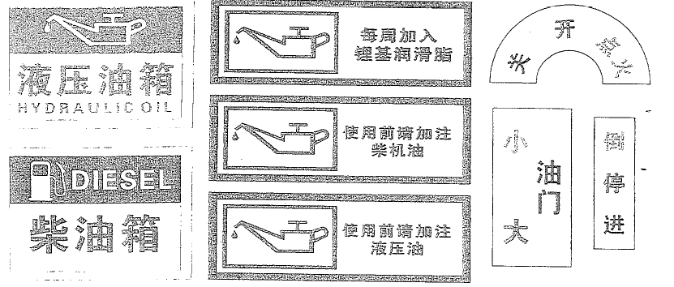  Hydraulic Oil Add lithium-based grease on weekly basis OFF ON Ignite  DIESEL Add diesel oil before using Small Accelerator Big Reverse Neutral Forward  Add hydraulic oil before using. No. 46 hydraulic oil, add 70% to the fuel tank, with a scale on it |  | Most of the problems can be solved easily. See the following Checklist for Troubleshooting to find the solutions.  Even after the stalling of the engine, the cutter roller will run for a while due to inertia. Turn off the engine and wait until all the movable parts stop reliably. Wait for another 5 minutes and then move or re-start the branch grinder.  Checklist for Troubleshooting  Faults Possible Reasons  The engine doesn’t start (please refer to the engine manual) - Whether the accumulator is power off? - Whether the oil tank is empty? - Whether the starter has fault?  The engine has insufficient power or doesn’t run stably (please refer to the engine manual) - Whether the accelerator at normal running position? - Whether the fuel is sufficient? - Whether the air filter is dirty? - Are you using clean diesel oil? - Is there proper amount of engine oil in the engine? - Is there sufficient water in the water tank of the engine? - Whether the diesel engine has severely worn-out cylinder? - If faults exist still, call the local dealer for help.  Smoke comes out from the engine - Check the engine oil level and adjust as appropriate; - Whether the machine works on flat ground? - Whether the air filter needs to be cleaned or replaced? - Whether the main engine has too much running resistance? - If faults exist still, call the local dealer for help.

Movable Cutter Grinding  - Manual grinding might result in changes in the angle of the blade. Do use the grinding machine or professional tool sharpener.  - Keep the angle of the original blade unchanged so that to get the optimal performance. Changes in the blade angle may not go exceed +5º.  - The massive heat generated from grinding may damage the cutter. Do cool with the water when grinding the machine to protect the blade from getting overheated, or the service life of the blade will be impaired.  - Send the blade to the machining center for correct grinding or use a grinding machine.  - The times of grinding a cutter can endure depends on the amount of materials to be grinded or the compensation to the dent or notch. Do avoid to mix too much impurities into the material to be grinded, or the blade will get dented.  - Too many times of grinding might result in the blade shorter than the cutting diameter of the cutter roller and finally lead to sharp decrease of the cutting speed or poor feeding. Please replace the cutter at this time.  Attention: We provide blades with great tolerance. The blade has double sides and double cutting edges. If it is found that one side of the blade cannot be used, please turn to use the cutting edge at the other side. | Keep Safe Yourself and People around You  This is a high-power machine and all the movable parts run at high speed. Do operate the machine in safe ways, or improper operation may result in severe injury of yourself and people around you.  Please always take following preventive measures when using the machine:  - Wear goggles or safety glasses when operating the machine so that to keep your eyes safe from flashing residues;  - Do not put on loose clothes or jewelries at the time of working because such things might be caught into the feed port by the machine.  - Gloves are recommended when you are operating the machine and make sure the gloves are proper and have no loose sleeves or excessive thread ends.  - Use non-slip pedal when using the machine. A safety boots will make things better. Do not walk without shoes on your feet or have slippers.  - Put on long trousers when operating the machine.  - Do protect your ears with ear protectors or earplugs rated performance of 20dba at the least.  - Do not leave the machine to anybody who is not familiar with operation instructions of the machine. Your machine can be operated by people who are reliable and familiar with the machine.  - When the machine is running, do keep your hands, foot or any part of your body away from the feed port, the discharging port, or near to or behind any running parts. Keep the discharging area far away from human, animal, building, glass, or anything which may hinder successful discharging or may lead to injuries or damages. The natural wind may change the direction so please care for the wind. If it is necessary to push the materials into the bucket of the grinder, do use a small and straight stick but not your hand.  - Keep the observers (if any) at least 10m from the discharging port. Because the residues might be flied away at extremely high speed. For the purpose of safety, please do keep kids and pets away from the worksite. Do not let kids operate the machine; do turn off the engine when anyone or any animal is approaching the machine.  - The cutter may keep running for a while due to inertia even after turning off the engine. If the engine is turned off, please do not move or re-start the branch grinder in 5 minutes after the reliable stop of the engine.  - Do not use the machine, including the feed port and the discharging port when the protective shield is not determined or not available on site.  - Do not operate the engine when dismantling the air filter or the carburetor because such dismantling may result in fire disaster. Do not clean the air filter with flammable solution.  - Do operate the machine always in the operation area (see Chapter 3 for operation details). Do not stand at the side of the discharging port when the engine or the cutter is running.  - Do not lift, move or deliver the machine when the engine or the cutter is running. Turn off the engine and wait until all the moving parts stop running reliably (the cutter may keep running for a while due to inertia even when the engine is turned off) and wait for another 5 minutes then before restarting the engine.  - The silencer and the engine will get overheated after running and thus lead to severe burning. Please do not touch them unless necessary.  - When clear areas with steel wire or other things. Do not insert such things into the material buckles, or the cutter will be damaged.  - Do not dismantle, bend, cut, assemble, weld, or change in whatever ways the standard parts on the machine in whatever conditions, including all the protective shields and protective measures. Refitting the machine may result in personal injury or property damage, or even invalidate the warranty.

Safety of Kids and Pets  Failure to care for the kids and pets nearby might result in tragic incidents. Kids can easily be attracted by the machine and never assume that kids will stay at the place where you see them in the last minute. Do always take following measures all the time:  - Keep kids and pets at least 30m away from the worksite and make sure they are under the custodian of a responsible adult person.  - Please stay alert and turn off the machine if any kid or pet goes into the work area.  - Do not let any kid operate the branch grinder.  Safety of Fuel, Power, and Machinery  Fuel is a highly flammable solution. Although diesel oil is safer than gasoline, it can be ignited and lead to fire or explosion easily. Do not ignore the hazards of diesel oil. Please always comply with following rules and precautions:  - Do not start the engine in a closed area or an area without proper ventilation because the exhaust gas of the engine contains carbon monoxide which is a colorless and odorless fatal toxic gas.  - Keep all the fuel and oil in a container designed and kept specially for the purpose of storing them and keep them away from heat source or open fire and keep them away from the touch of kids.  - Oil pipes or hoops made of rubber shall be replaced if they are damaged or worn out or have been used for 5 years.  - Turn off the engine and make the engine cools down totally before adding the fuel in the open air.  - Do not adjust or repair the engine or the cutter roller when they are running. Stop the engine and wait until all the moving parts stop totally (the cutter roller may run for a while due to inertia even after the engine is turned off) and the wait for another 5 minutes before conducting adjustment or repair.  - Do not adjust the settings of the speed regulator of the engine unless you are authorized to do that. The speed regular controls the maximum safe running speed and protect the engine. Overspeed running is dangerous for the engine and will result in danger of the engine and other movable parts. | You should make regular maintenance on your mobile branch grinder so that to get the optimal performance. As for the maintenance of the engine, please refer to the maintenance manual of the engine. See the checklist shown below for the frequency and schedule of maintenance.  -----------------------  The cutter will keep running for a while due to inertia even after the stalling of the engine. Turn off the engine and wait until all the running parts stop totally and then wait for another 5 minutes before moving or re-starting the branch grinder.  Regular Maintenance Checklist  Note: The time schedule listed below are the longest maintenance interval under normal operation conditions. More maintenance shall be conducted if harsh conditions.  Item Before Use Every 25 Hours Every 40 Hours  Check the engine oil level of the engine √  Check whether any bolts are loose √  Check whether the cutter roller runs flexibly √  Visual check whether the cutter is damaged √  Clean the outer parts and the cooling fins of the engine √  Check or replace the air filter √  Check the typre pressure √  Check the engine oil of the engine 5 hours later Initial use check √  Check the tension and state of the belt 1 hour later Initial use check √  Check the cutting-edge of the fixed cutter and movable cutter √  Check or replace the transmission belt √  Add lithium-based grease to each bearing √  Check the blade and connecting bolts √  Check bolts on the bearing set of the cutter roller √  Check the quality and quantity of hydraulic oil. No. 46 hydraulic oil, add 70% to the fuel tank, with a scale on it √  The cutter may keep running for a while due to inertia after the stalling of the engine. Turn off the engine and wait until all the moving parts stop totally and wait for another 5 minutes before moving or re-starting the branch grinder.  Lubricating oil is added before the mobile branch grinder leaving the factory. The operator needs only to add grease to the bearing set at regular intervals.
Precautions during Operation  ------------------  - Common knowledge shall be used when operating the machine. Learn to identify the changes of sound in the even of overload. If the machine is blocked, to prevent damage of the drive system, you are required to operate the feed control joystick immediately to stop feeding or reverse the feed press roller to discharge the materials and then re-feed.  - Do not feed the residual fragments, generated from grinding of big branches, into the feed port with iron shovel because such fragments may have impurities which may result in damage of the machine.  The machine is designed for the grinding of timbers only. The movable cutter at the rotating cutter roller will cut the branches fed into the bucket into “fragments”. The branch grinder can, in continuous work, cut dry or wet branches with diameter not greater than _mm.  - Your mobile branch grinder can process dry branches or wet branches with diameter up to _ mm.  - The timber contacting the feed press roller will be fed automatically and no manual labor is needed to insert the branch into the feed port.  - Wet branches can be cut more rapidly than dry branches and can be handled more easily and wear the cutter weaker;  - Soft timbers can be more easily cut by hard timbers.  - Your operation experience will guide you how to regular the feed speed of different timbers.  - When grinding branches, some branches may have too many twigs, and big twigs may get stuck at the feed port. At this time, please cut off bigger twigs.  - Tie up twigs will improve the cutting performance of the machine.  - Branches with diameter smaller than _mm can be fed in multiple; or can be feed one by one only if bigger than _ mm or more.  - Make sure the grinder has finished processing all the materials fed into the feed port and discharged the same before turning off the engine.  - If the machine runs not so well, the cutter used for cutting may have worn out and needs to be replaced or grinded. Do not use blunt cutter by force, because it may reduce the grinding efficiency sharply and lead to damage of the branch grinder.  - Overload at the feed port will lead to reduced speed of the rotor. If you hear that the engine is rotating at lower speed, please stop feeding more materials until the engine has recovered to the full speed. | General Safety  ------------------------  Operating the machine safely is of critical importance because it will avoid and reduce the risk of danger effectively. Unsafe operation will lead to lots of dangers. Make sure you have always taken the following protective measures:  - Do keep in mind that the operator or user shall be responsible for the danger to other people, the property of other people, or themselves.  - The mobile branch grinder is a professional machine but not a toy. Do act very carefully all the time. This machine is originally designed for the grinding of branches but not any other purpose.  - Operate the machine only on flat ground. Do not operate it on wet or humid ground or ground with mud or ice. Do operate carefully to avoid falling down of sliding.  - Make sure your face and your body are back to the discharging port so that to avoid all the unexpected injuries after processing the materials.  - Behave very carefully when adding the materials into the bucket. Do not mix any metal, rock or impurities into the materials, or it will lead to personal injury or machine damage.  - Do not stack up processed materials at the discharging area because it will impair the future discharging and even result in backflushing of the discharging port.  - If you are leaving the operation area and need to remove all the leaves or residues of processed branches from the machine, please turn off the machine and wait until all the moving parts stop totally (the cutter roller may keep running for a while due to inertia even after turning off the engine) and wait for another 5 minutes before taking away the materials, leaves and residues from the machine.  - The engine shall be turned off when moving the machine.  - Keep the engine away from flammable materials when the engine is at high temperature.  - Do not touch the machine when the silencer is still heated.  - Please refer to the manufacturer’s specifications for details about correct operation and installation of accessories.  - If, due to collision with other objects, the internal structure of the grinder has abnormal sound or vibration, stop the engine machine and wait until all the moving parts stop totally (the cutter roller may keep running for a while due to inertia even after turning off the engine) and wait for another 5 minutes and then check whether the machine is blocked or damaged because abnormal vibration is always the signal of fault, and finally clean or replace damaged parts.  - Do not change the safety devices and you should check periodically whether it works normally.  - Be careful of potential traffic threats. Do not carry passengers on your machine.  - Do not try to overload the machine or process materials out of proposed range (refer to Chapter 3 “Processing Materials”) because it may lead to personal injury or machine damage.  - Do not operate the machine in a rush or careless attitude. Stop the machine and check carefully if you have doubts about the work status of the machine.  - Do not operate the machine under the influence of alcohol or drugs.  - Use the machine in daytime only.  - Keep tight all the nuts and bolts and keep the machine always at good work state.  Precautions for Users  The checklist cannot include all the dangers or precautions. The operator shall rely on common knowledge to operate the mobile branch grinder safely in case of event out of those described in the manual and call the local dealer for help.
This chapter explains several simple steps of assembly you need to follow before using the machine. learning the control systems and functions of the mobile branch grinder shown in Fig.1 will help a lot. Please call the local dealer whenever you have any questions.  Operating Devices of the Product and Their Functions  Taillight assembly  Discharging port  Discharging height control joystick  Discharging port direction control joystick  Feed bucket  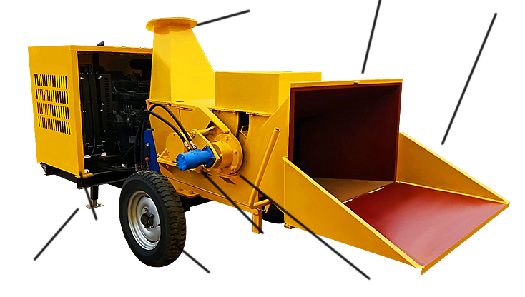Fig.1  Engine protection shield  Side cover  Hand-operated stent  Tyre  Hydraulic motor  Hydraulic tank |  | Start the Engine  - Make sure the accelerator control handle is at “RUN” (Fig.4);  - Turn on the electric start switch on the front control panel to ignite and start the engine.  - Pull downward the accelerator control joystick to the middle between the slow-speed and rapid-speed (Fig.4).  - Pull downward the accelerator control joystick after the engine finishes preheating and runs stably, until the joystick moves to high-speed position (Fig.4) and gets locked tightly, and you can start operating now.  Turn to STOP to stall Electric-start switch  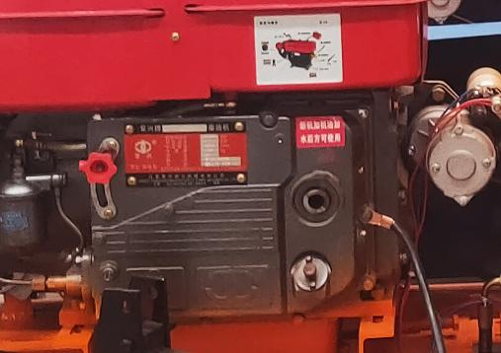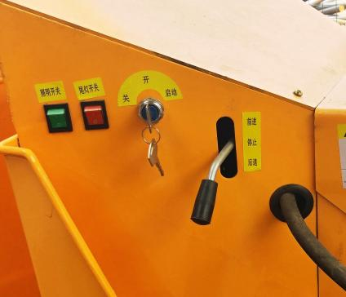  Accelerator joystick engine oil filler & dipstick Crank port Fig.4  Stop the Engine  The cutter roller will keep running for a while due to inertia after stopping the engine. Stop the engine and wait until all the movable parts stop running totally. Wait for another 5 minutes then before moving or cleaning the machine.  Before stopping the engine, make sure the materials are all grinded and discharged from the machine so that to avid difficulties in future starting.  When the materials are all grinded and discharged, loose the accelerator joystick and move it slowly to STOP and tighten (Fig.4). Since the diesel engine runs totally depending on compression ignition, you cannot release the accelerator joystick unless the engine stops totally. Release the joystick and turn it to “RUN” and fasten (Fig.4) for easy starting in the future. Tightly lock the joystick to prevent missing.
Precautions before Starting the Engine  ------------------------------  - This machine is designed to process timber. Do not use it for any other purposes because it may lead to severe damaged.  - Contacting the moving parts in the machine may lead to severe personal injury. Do not put your hands, face, foot or clothes into the feed bucket or the feed port or near to the belt cover.  - Stop the engine and wait until all the moving parts stop reliably (the cutter roller may keep running for a while after the engine is turned off) and wait for another 5 minutes and then proceed to next activities. Do remove blocked materials with timber sticks only.  - Whenever you are to use the mobile branch grinder, check the oil level earlier to see whether it is necessary to add diesel engine oil (refer to Page 10, Chapter 2 “Add Engine Oil and Fuel”);  - Check the diesel oil level and add diesel oil according to actual needs (refer to Page 9, Chapter 2 “Add Engine Oil and Fuel”);  - Make sure the accelerator control joystick is at “ON”;  - Remove scraps on the machine before using the machine every time.  --------------------  Directions for Operation  Check whether the movable cutter is worn out and make sure all the bolts are tight before using the machine every time.  Check the water level in the water tank and make sure the engine oil and the fuel are sufficient.  Before using the mobile branch grinder, make sure the feed port is fixed reliably with bolts and so it is with the discharging port.  Processing Materials  - Always wear goggles or safety glasses with side cover when you are working, so that your eyes will be kept from damaged resulted by flashing scraps.  - Do not wear loose clothes or jewelries, or they can be caught into the moving parts or being damaged by the feed press roller.  - Gloves are recommended when cutting materials. Make sure your gloves are proper without loose sleeve or lacing.  - Put on shows with non-sliding bottom when using the grinder. Labor boots are recommended and do not operate the machine when you are barefooted or have slippers.  - Put on clothes with long sleeves and long trousers when operating the machine, or you can be scratched by branches.  - Use earplugs or ear protectors with rated value of at least 20dba to protect your hearing. |  | 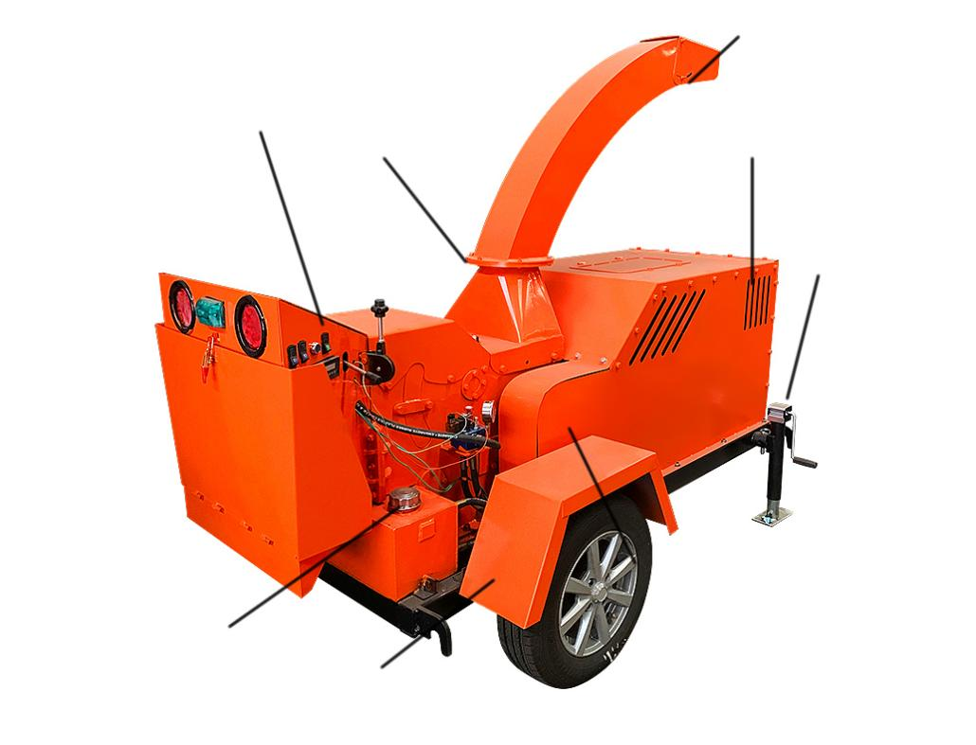  Belt cover  Splash guard  Oil filler  Trailer stand (dismantled when delivered)  Discharging height control joystick  Silencer and filter  Operation panel  Discharging direction control joystick  Fig.2
Specifications of the Product  Engine model  Horsepower 32HP  Starting Electrical start  Engine oil volume 2.5L  Fuel tank capacity 20L  Working capability 1-3ton/hour  Wheel specifications 165/70R13  Number of movable cutters 3  Number of fixed cutters 1  Material of chipping cutter H12  Adjustable knife-grinding plate 是  Cutter roller 300mm  Blade length 300mm  Weight of machine 800kg  Applicable engine oil and fuel  Required Properties  Engine Turbocharging柴油机  Oil tank 20L  Note: to prevent confuse, labels are recommended to be pasted on the container of the gasoline and the diesel oil.  - You should add oil before starting the engine. The machine has no fuel when leaving the factory. Oil traces can be left from tests in the factory but you must add oil before starting the engine. Do add oil slowly into the engine oil tank and check the dipstick frequently to prevent overfilling.  - To get correct reads when check the oil level, you should:  - Put the machine on a flat surface.  - Push down the dipstick all the time to guarantee that you can get correct read of oil level. |  | Add engine oil  - Put the machine on a flat ground and take out the dipstick (clean the end of the dipstick with wipe (Fig.2));  - The machine leaves the factory without oil. Please add 2.3-2.5L of CF-4 diesel oil (recommended by the engine manufacturer) and wait for one minute for the engine oil to settle down.  - Wipe clean the dipstick and insert it into the engine and turn it clockwise for 1/4 circle to lock it reliably so that correct reads can be obtained. Take it down to check the oil level (Fig.3);  - If the oil level is low, add proper amount of engine oil in one time. Re-check the dipstick until the oil reaches the marked level. Do not add too much oil.  - Mount the dipstick again at the end of the above steps.  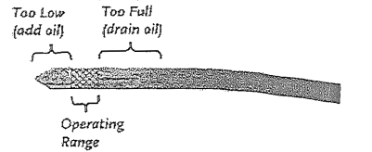  Fig.3  Add gasoline  - Take down the oil tank cover and add nearly 20L of diesel oil into the oil tank to make it full.  Be careful that don’t add too much oil before starting the engine. Re-mount the oil cap. For more details, please refer to the user manual of the engine.  Note: To add the diesel oil, please stop the engine and make it cools down for at least two minutes and then open the oil cap.  Add coolant liquid:  - Add coolant liquid (can be replaced by clear water) into the water tank until the floater fully rise up. The coolant oil can be replaced with clear water. Empty the water tank if low temperature in winter, or the water tank may be broken due to freeze.  Note: Care for the water level in the water tank all the time so that to avoid the cylinder score and other faults due to lack of coolant liquid.  Always keep proper water in the water tank. Stop the machine if the water tank becomes extremely hot due to lack of water and don’t add water until the engine totally cools down, or hot water will splash out and make you burnt.

