STEP I： STEP II：

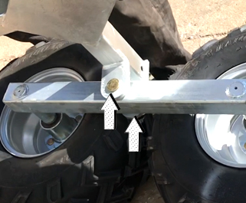
ASSEMBLE & FIX THE STICK OF WHEEL ON THE FRAME
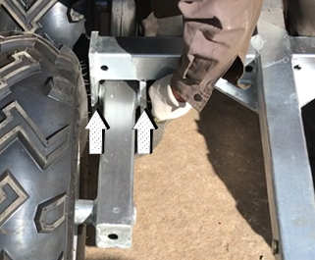
ASSEMBLE & FIX ANOTHER SIDE STICK
STEP III： STEP IV：

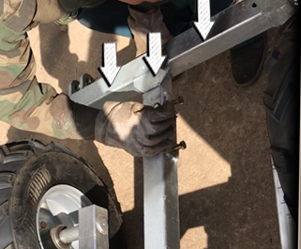
INSERT AND FIX THE REAR TUBE INTO THE FRAME
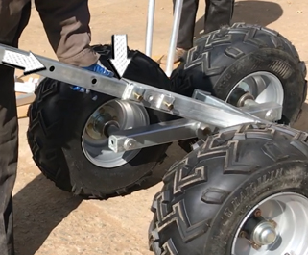
INSERT AND FIX THE CENTER TUBE INTO THE FRAME
STEP V： STEP VI：

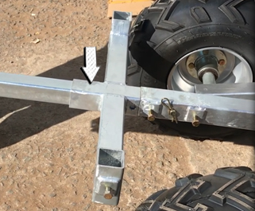
INSERT AND FIX THE FRONT TUBE INTO THE FRAME
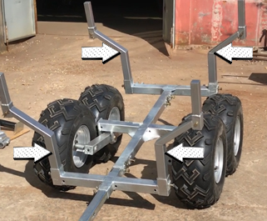
INSERT AND FIX THE TUBES INTO THE FRAME AROUND

STEP VII： STEP VIII：

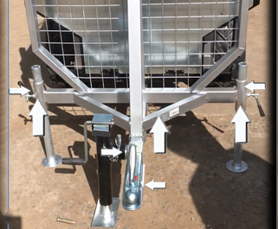
ASSEMBLE & FIX FENCE/JACK/ATV COUPLER
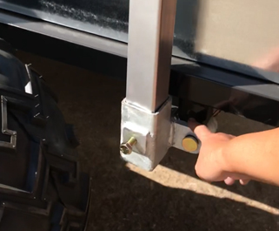
ASSEMBLE & FIX BOX (BOLTS AT THE BOTTOM OF BOX)
STEP IX： STEP X：

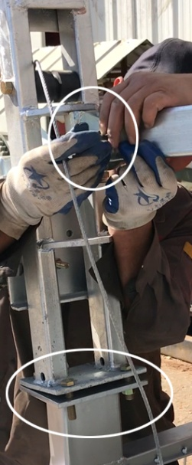
ASSEMBLE & FIX THE CRANE PART
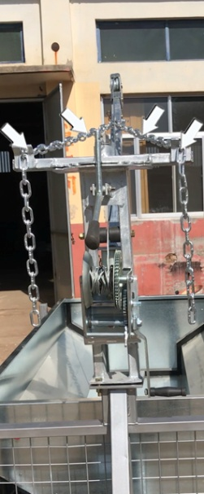
ASSEMBLE & FIX THE CHAIN OF CRANE

NOTICE:

1. Assemble securely to prevent injury.
2. Please tighten all the screws to avoid the looseness of the screws.
3. Please check whether the tire pressure is okay before using.
…

